Mastercard Gateway Test App
Embedded Checkout — Configurable — Application User Guide
Version 1.0.0

Executive Summary
This document is a step-by-step guide for Sales and CTS (Customer Technical Support) teams to validate this payment scenario in the Mastercard Gateway MTF (Merchant Test Facility) environment.
This demo shows the embedded Hosted Checkout, where the gateway payment options are rendered inside the merchant page rather than via a full-page redirect. It offers a Simple Mode and an Advanced JSON Mode for full control of the INITIATE_CHECKOUT payload. This walkthrough uses Google Pay with 3-D Secure V2; card, PayPal and Apple Pay follow the same pattern.
Configuration
Step 1: Configure the session
Set the API configuration (Merchant ID, e.g. TESTMIDtesting00, API Base URL and Version), then the Order Configuration (amount, currency, description), Merchant Information and Return URL. Select Proceed to Secure Checkout.
Note: Use ORDER_PLACEHOLDER for the order id — it is auto-generated with a unique timestamp at checkout time. Credentials are stored locally in your browser.
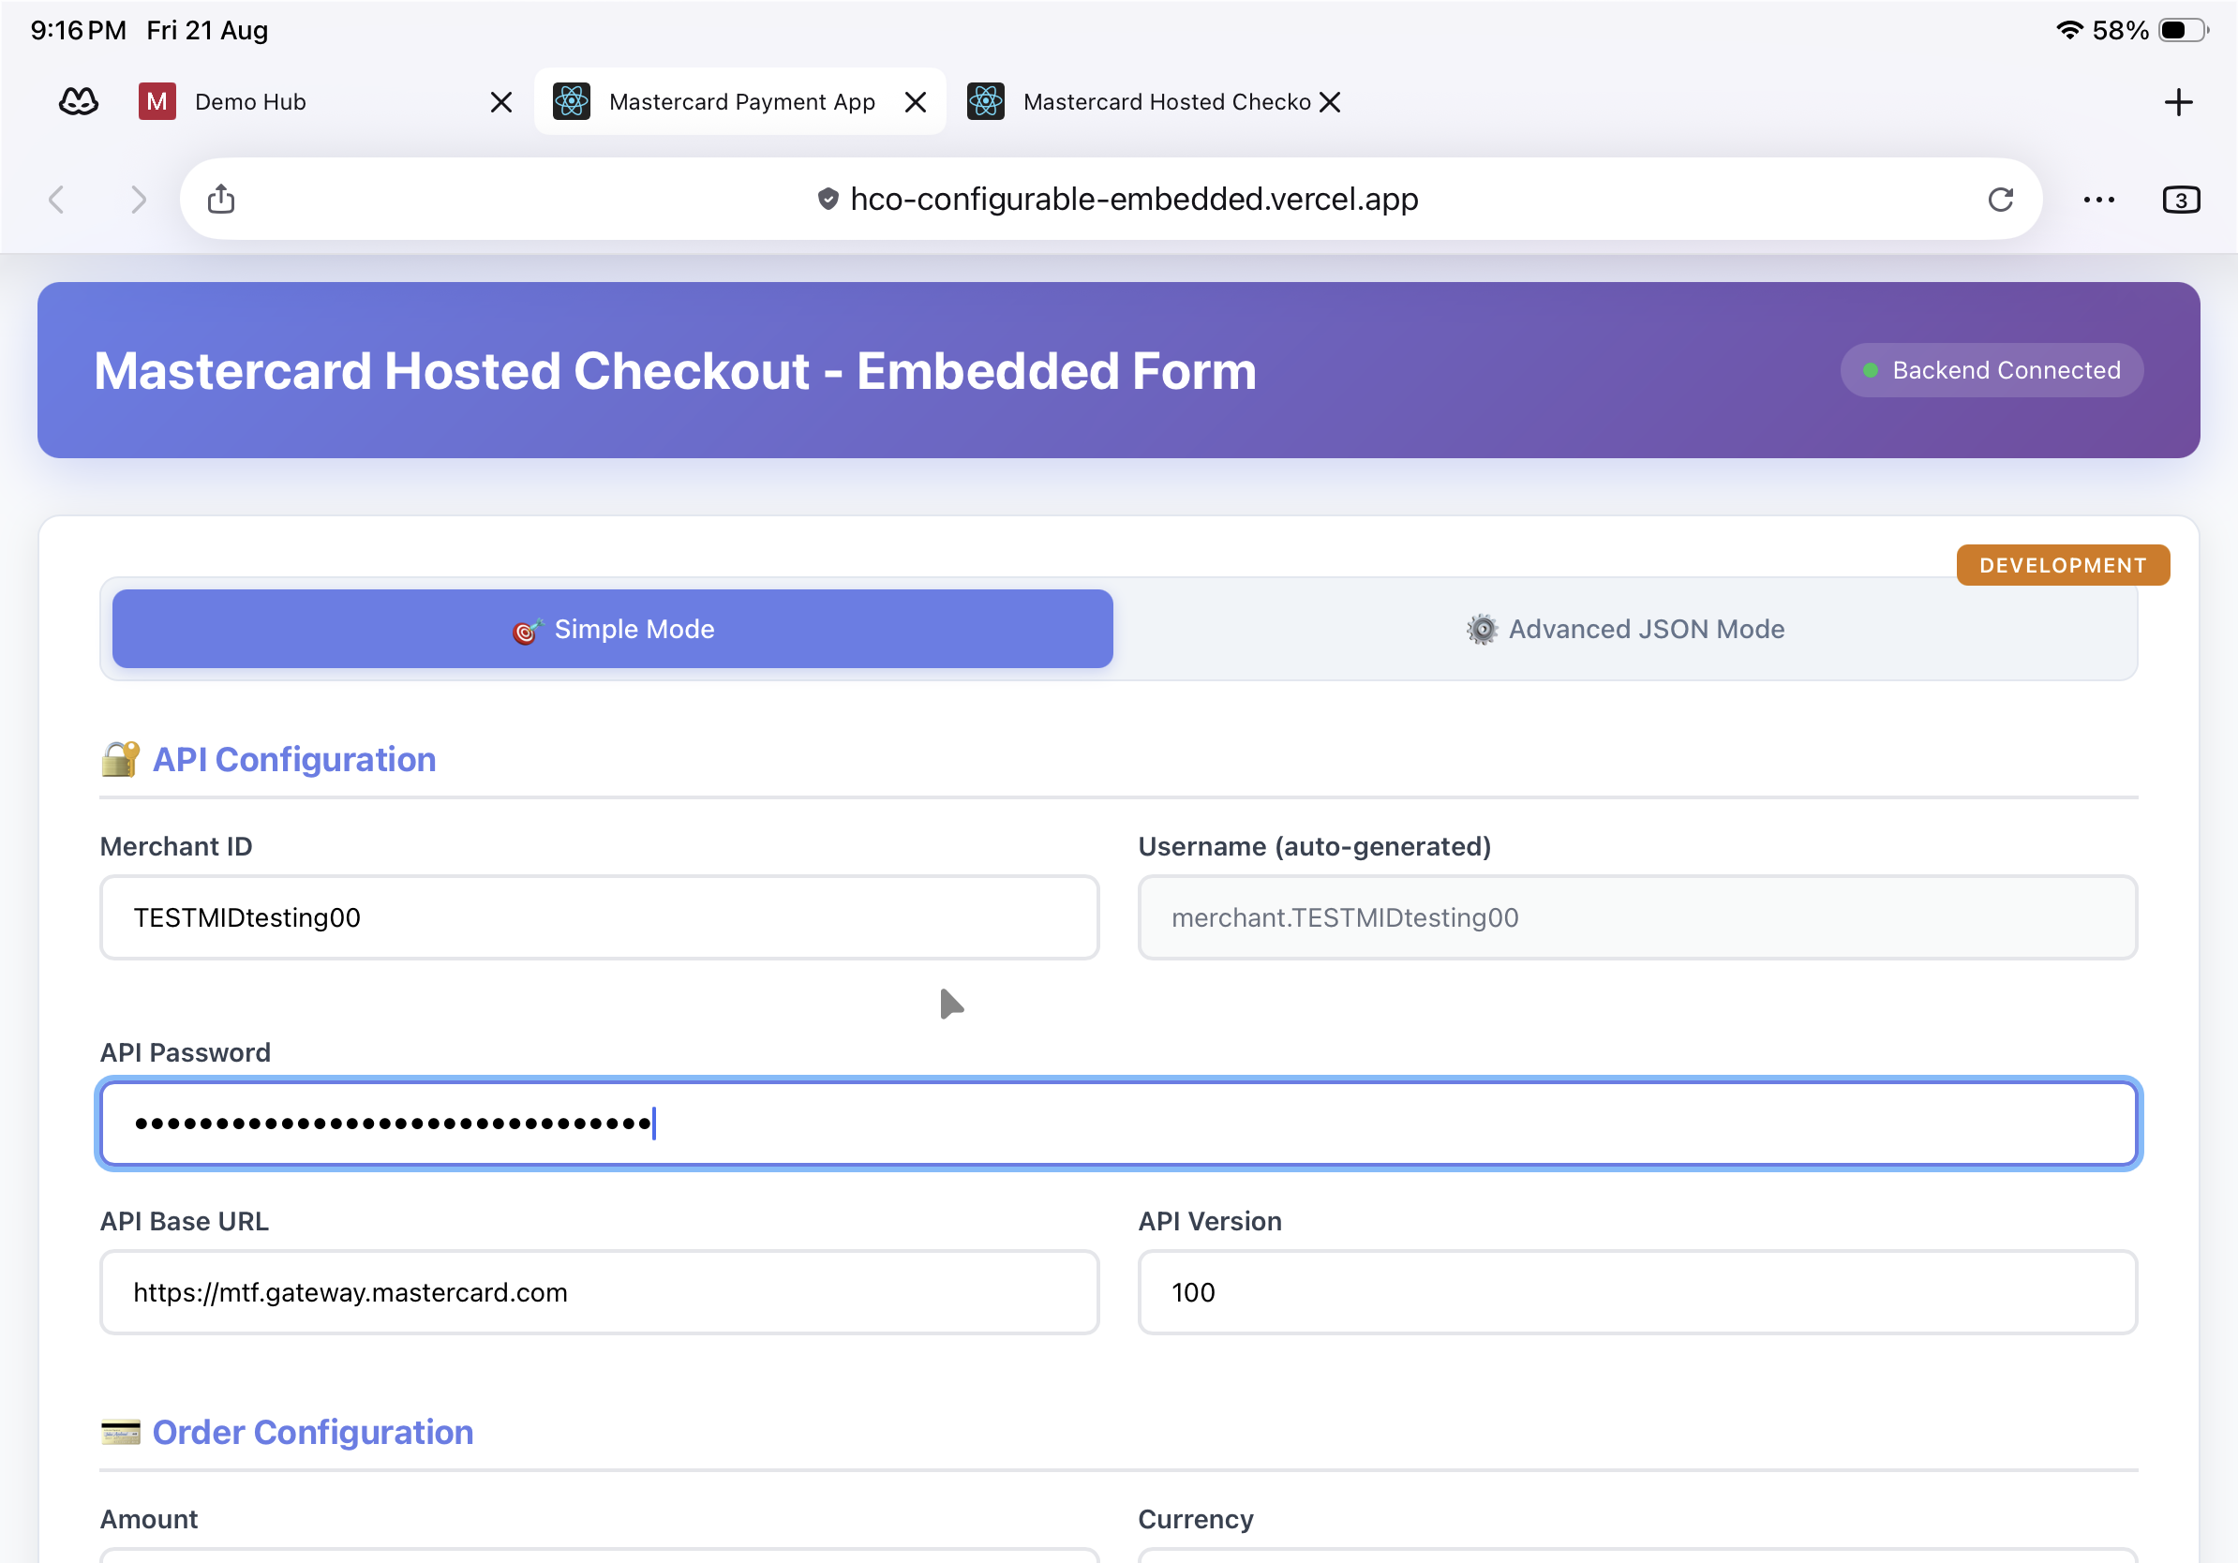
Configuration (Simple Mode) — API Configuration and Order Configuration.
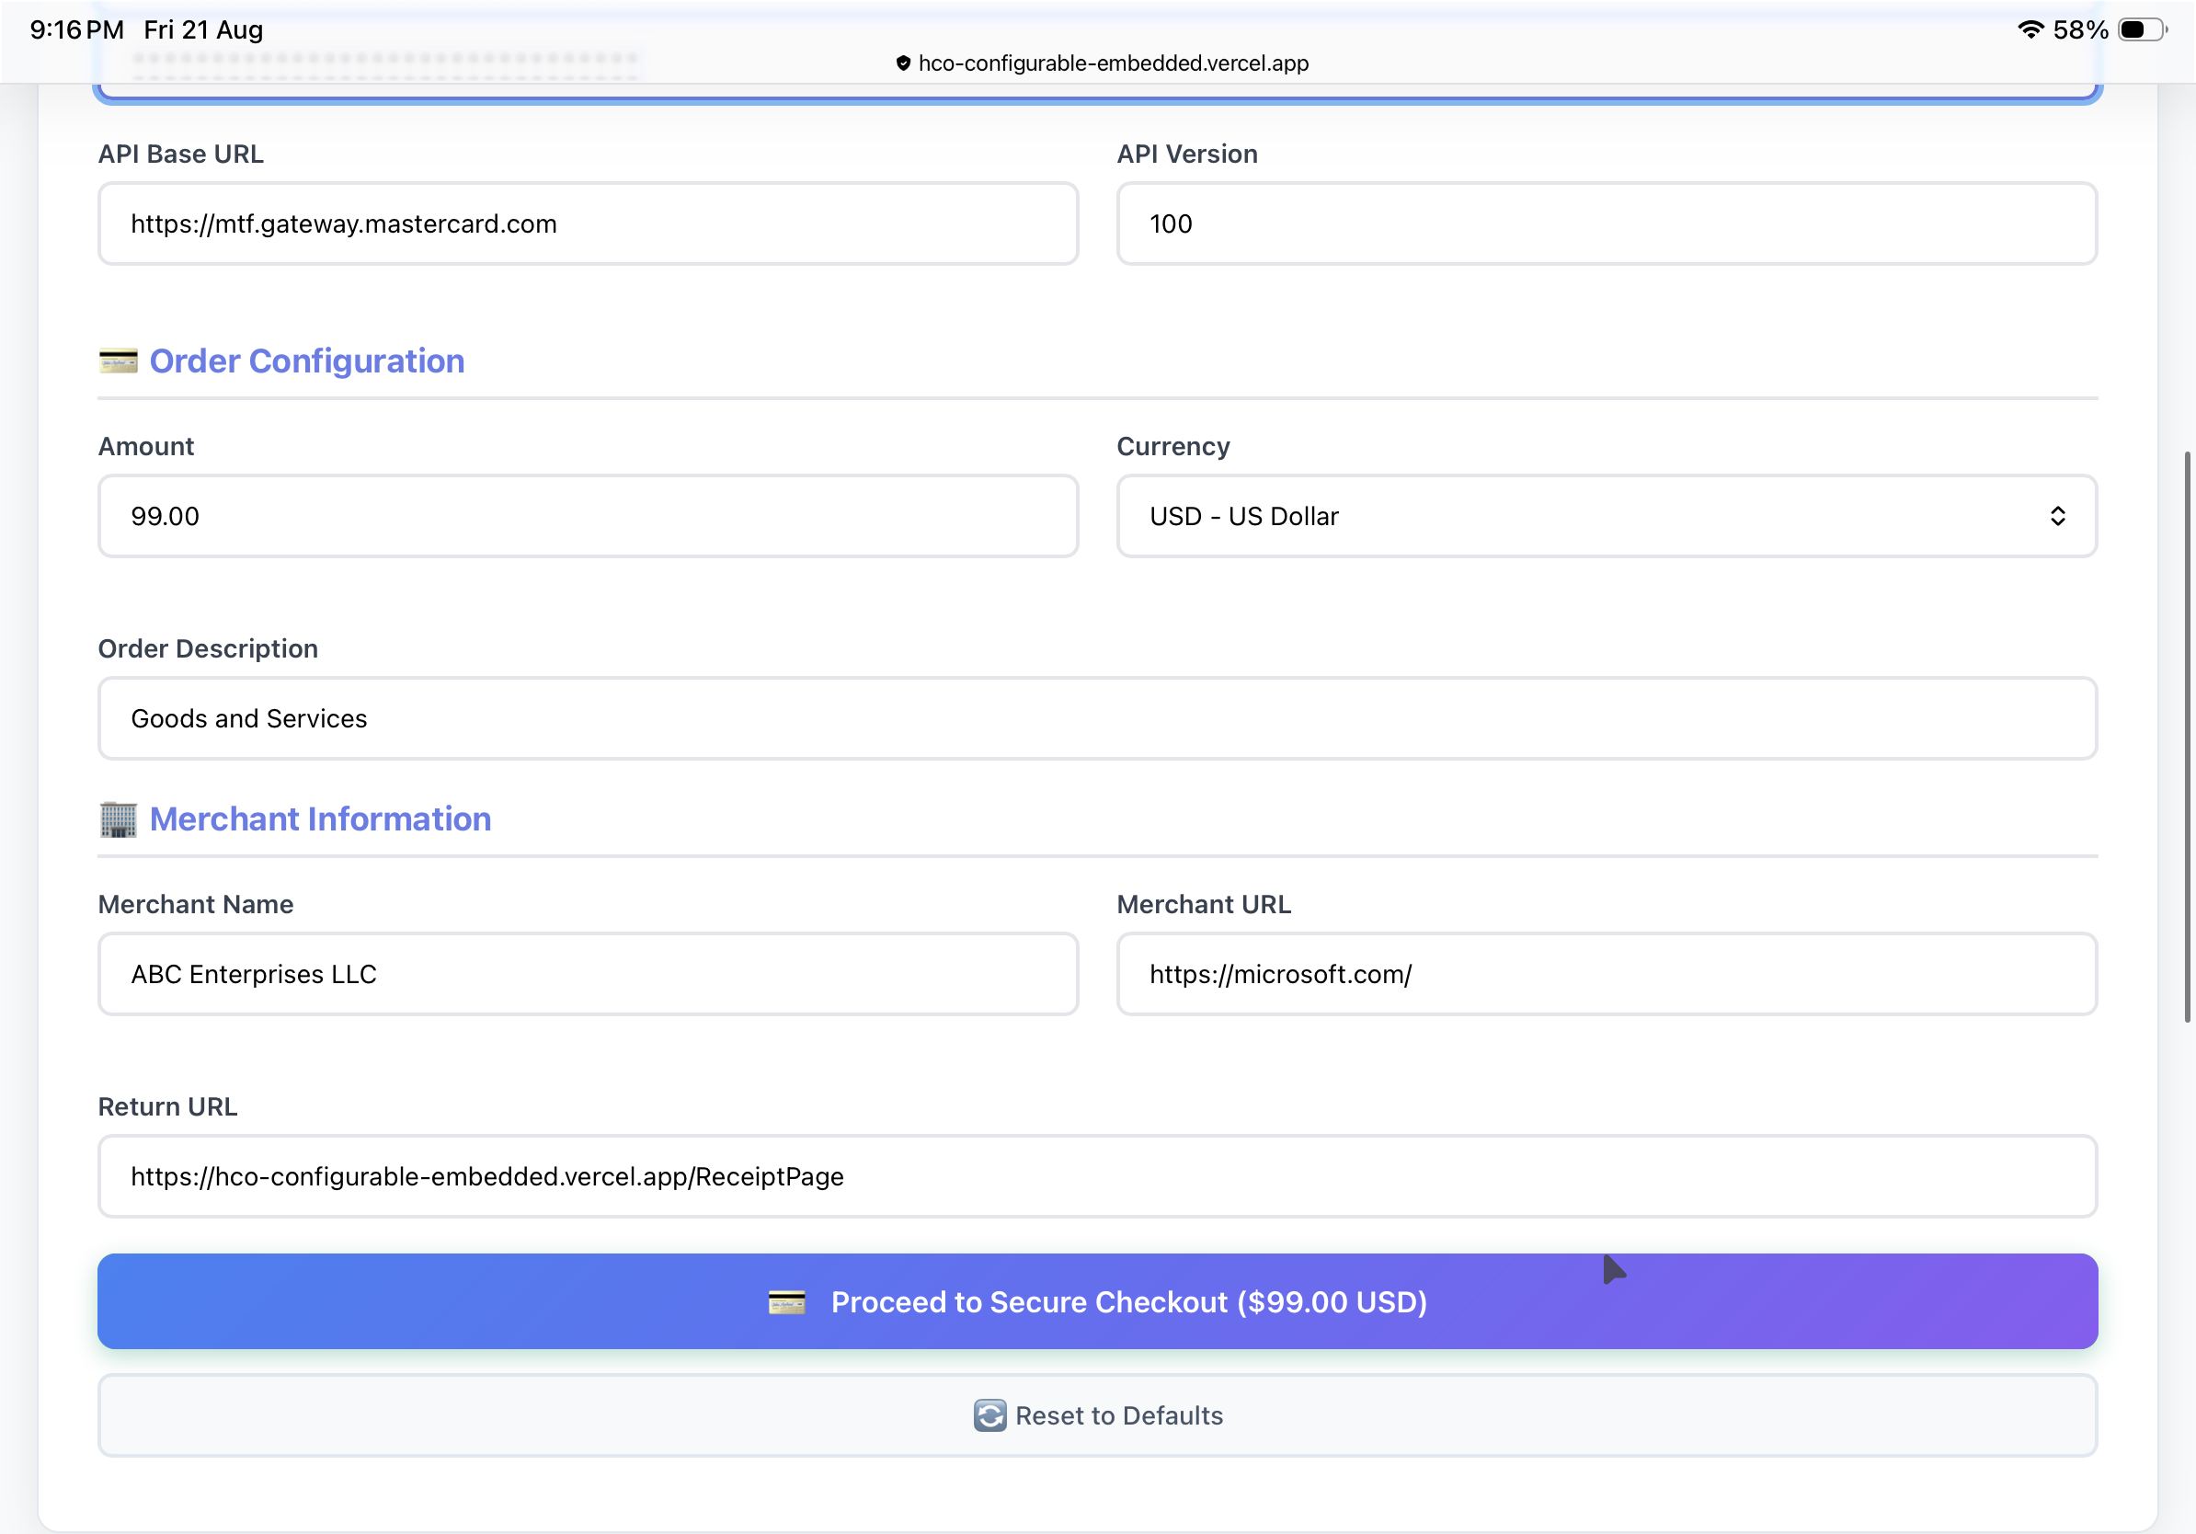
Configuration — order, merchant information and return URL; Proceed to Secure Checkout.
Step-by-Step Flow
Step 2: Open the embedded form
The payment options render inside the merchant page (“Mastercard Hosted Checkout — Embedded Form”). A Backend Connected indicator and the Session id confirm the session was created.
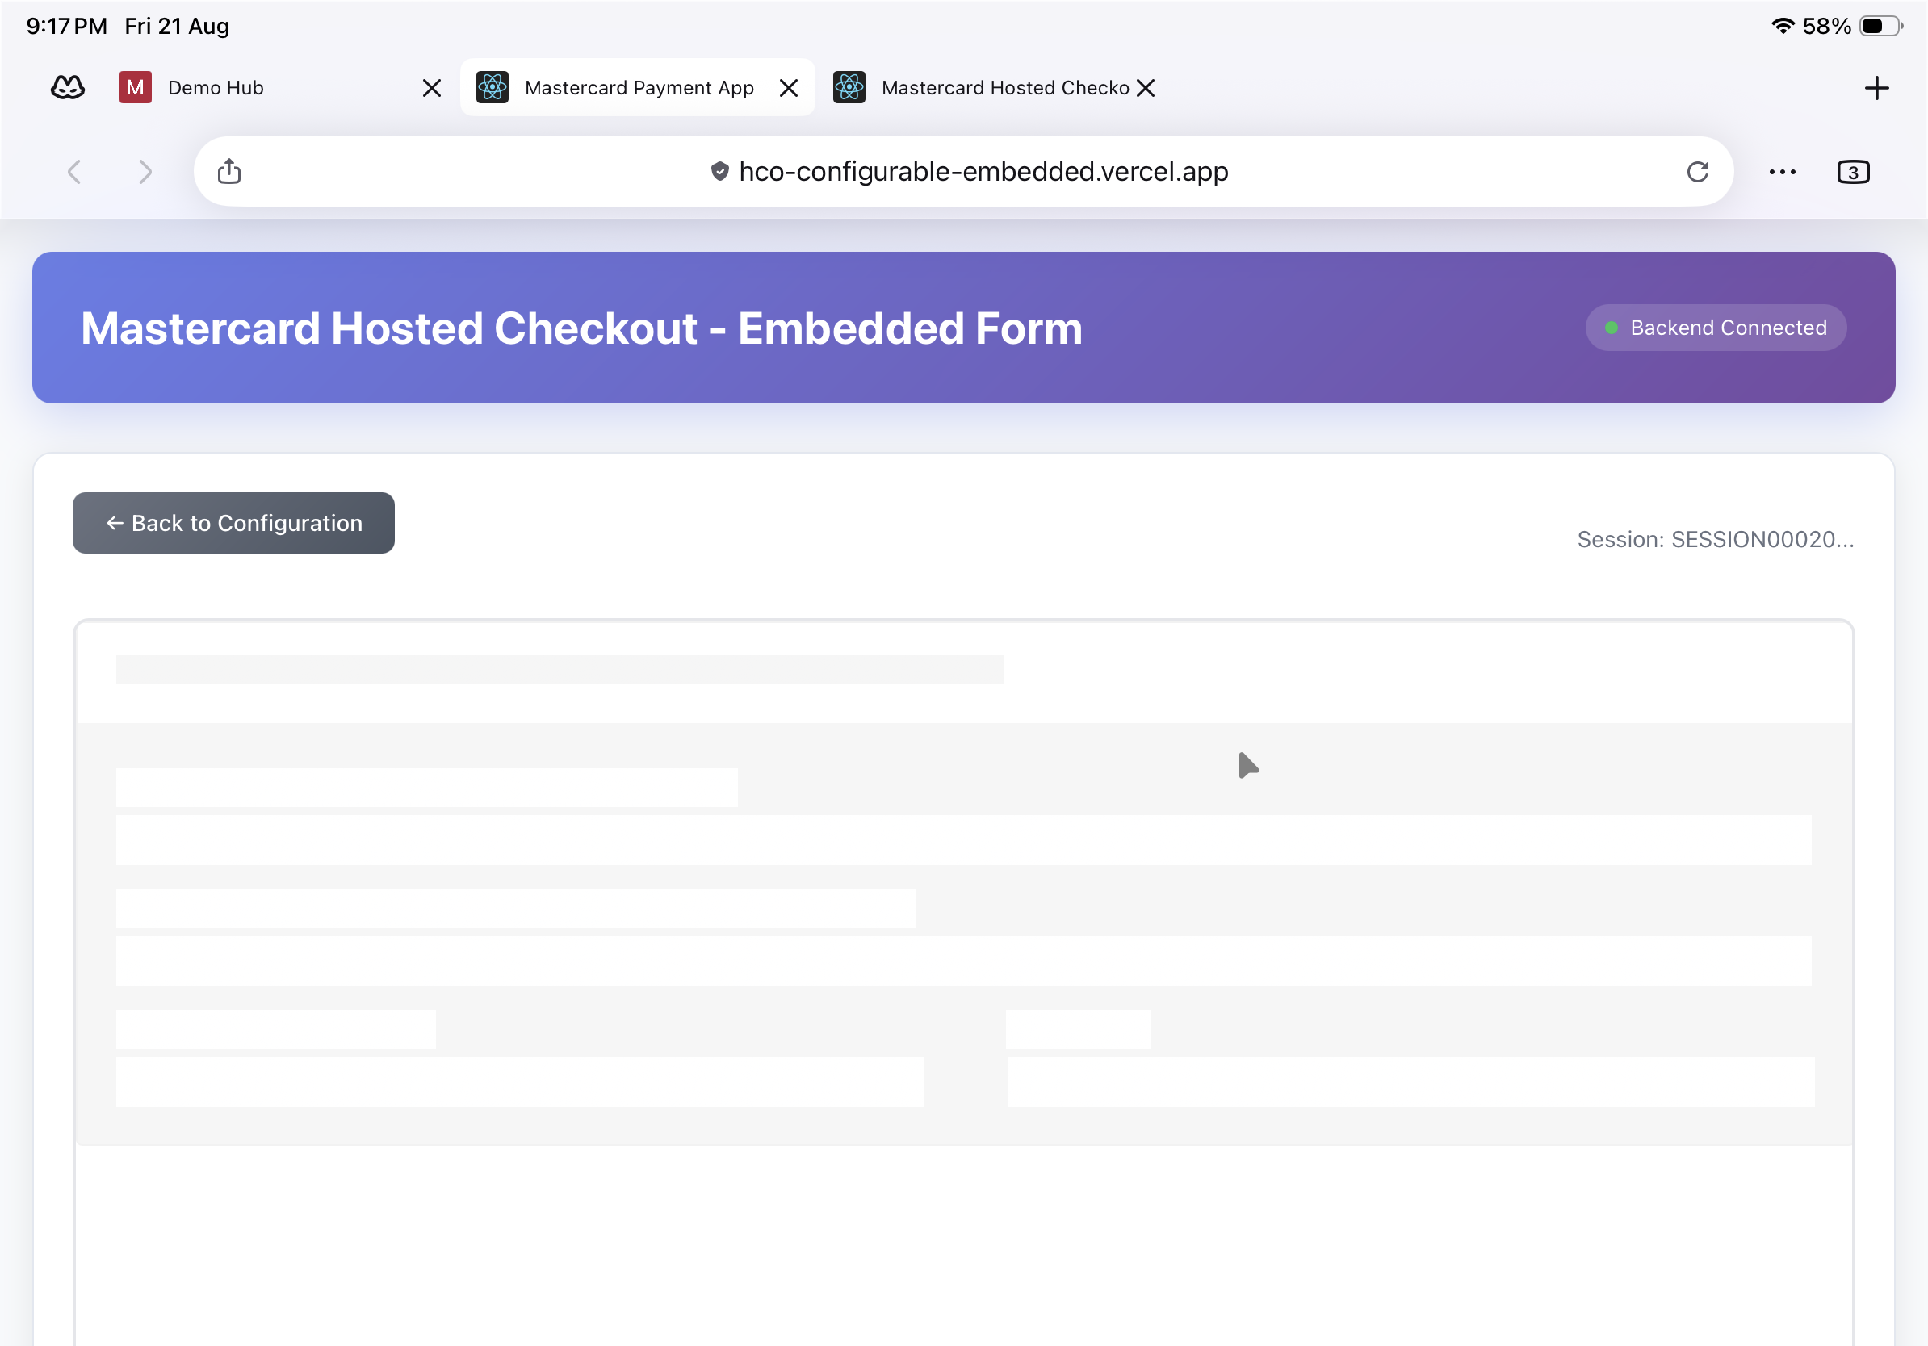
Embedded form initialising — Backend Connected with an active session.
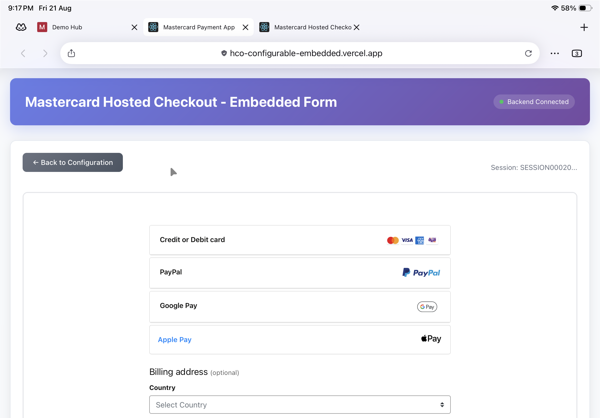
Embedded payment options rendered in the merchant page, with billing address.
Step 3: Pay with Google Pay
Select Google Pay and choose Buy with G Pay, then confirm in the Google Pay sheet (test environment — the card won’t be charged).
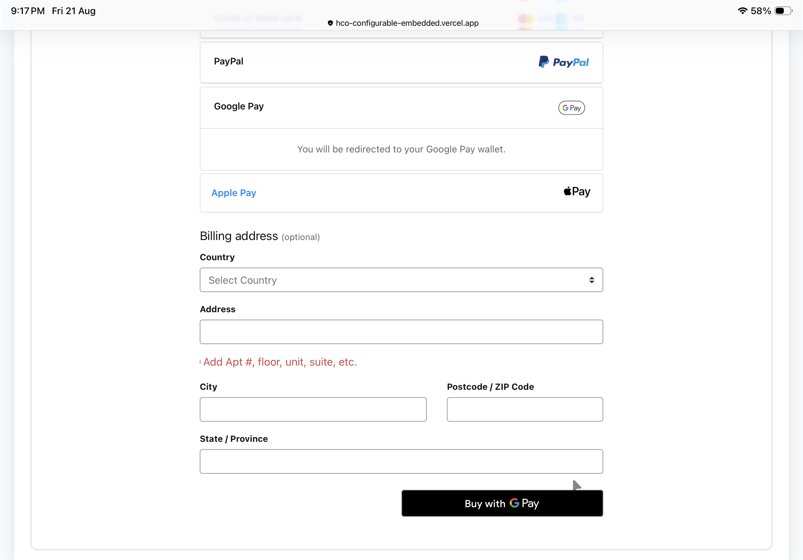
Google Pay selected — Buy with G Pay.
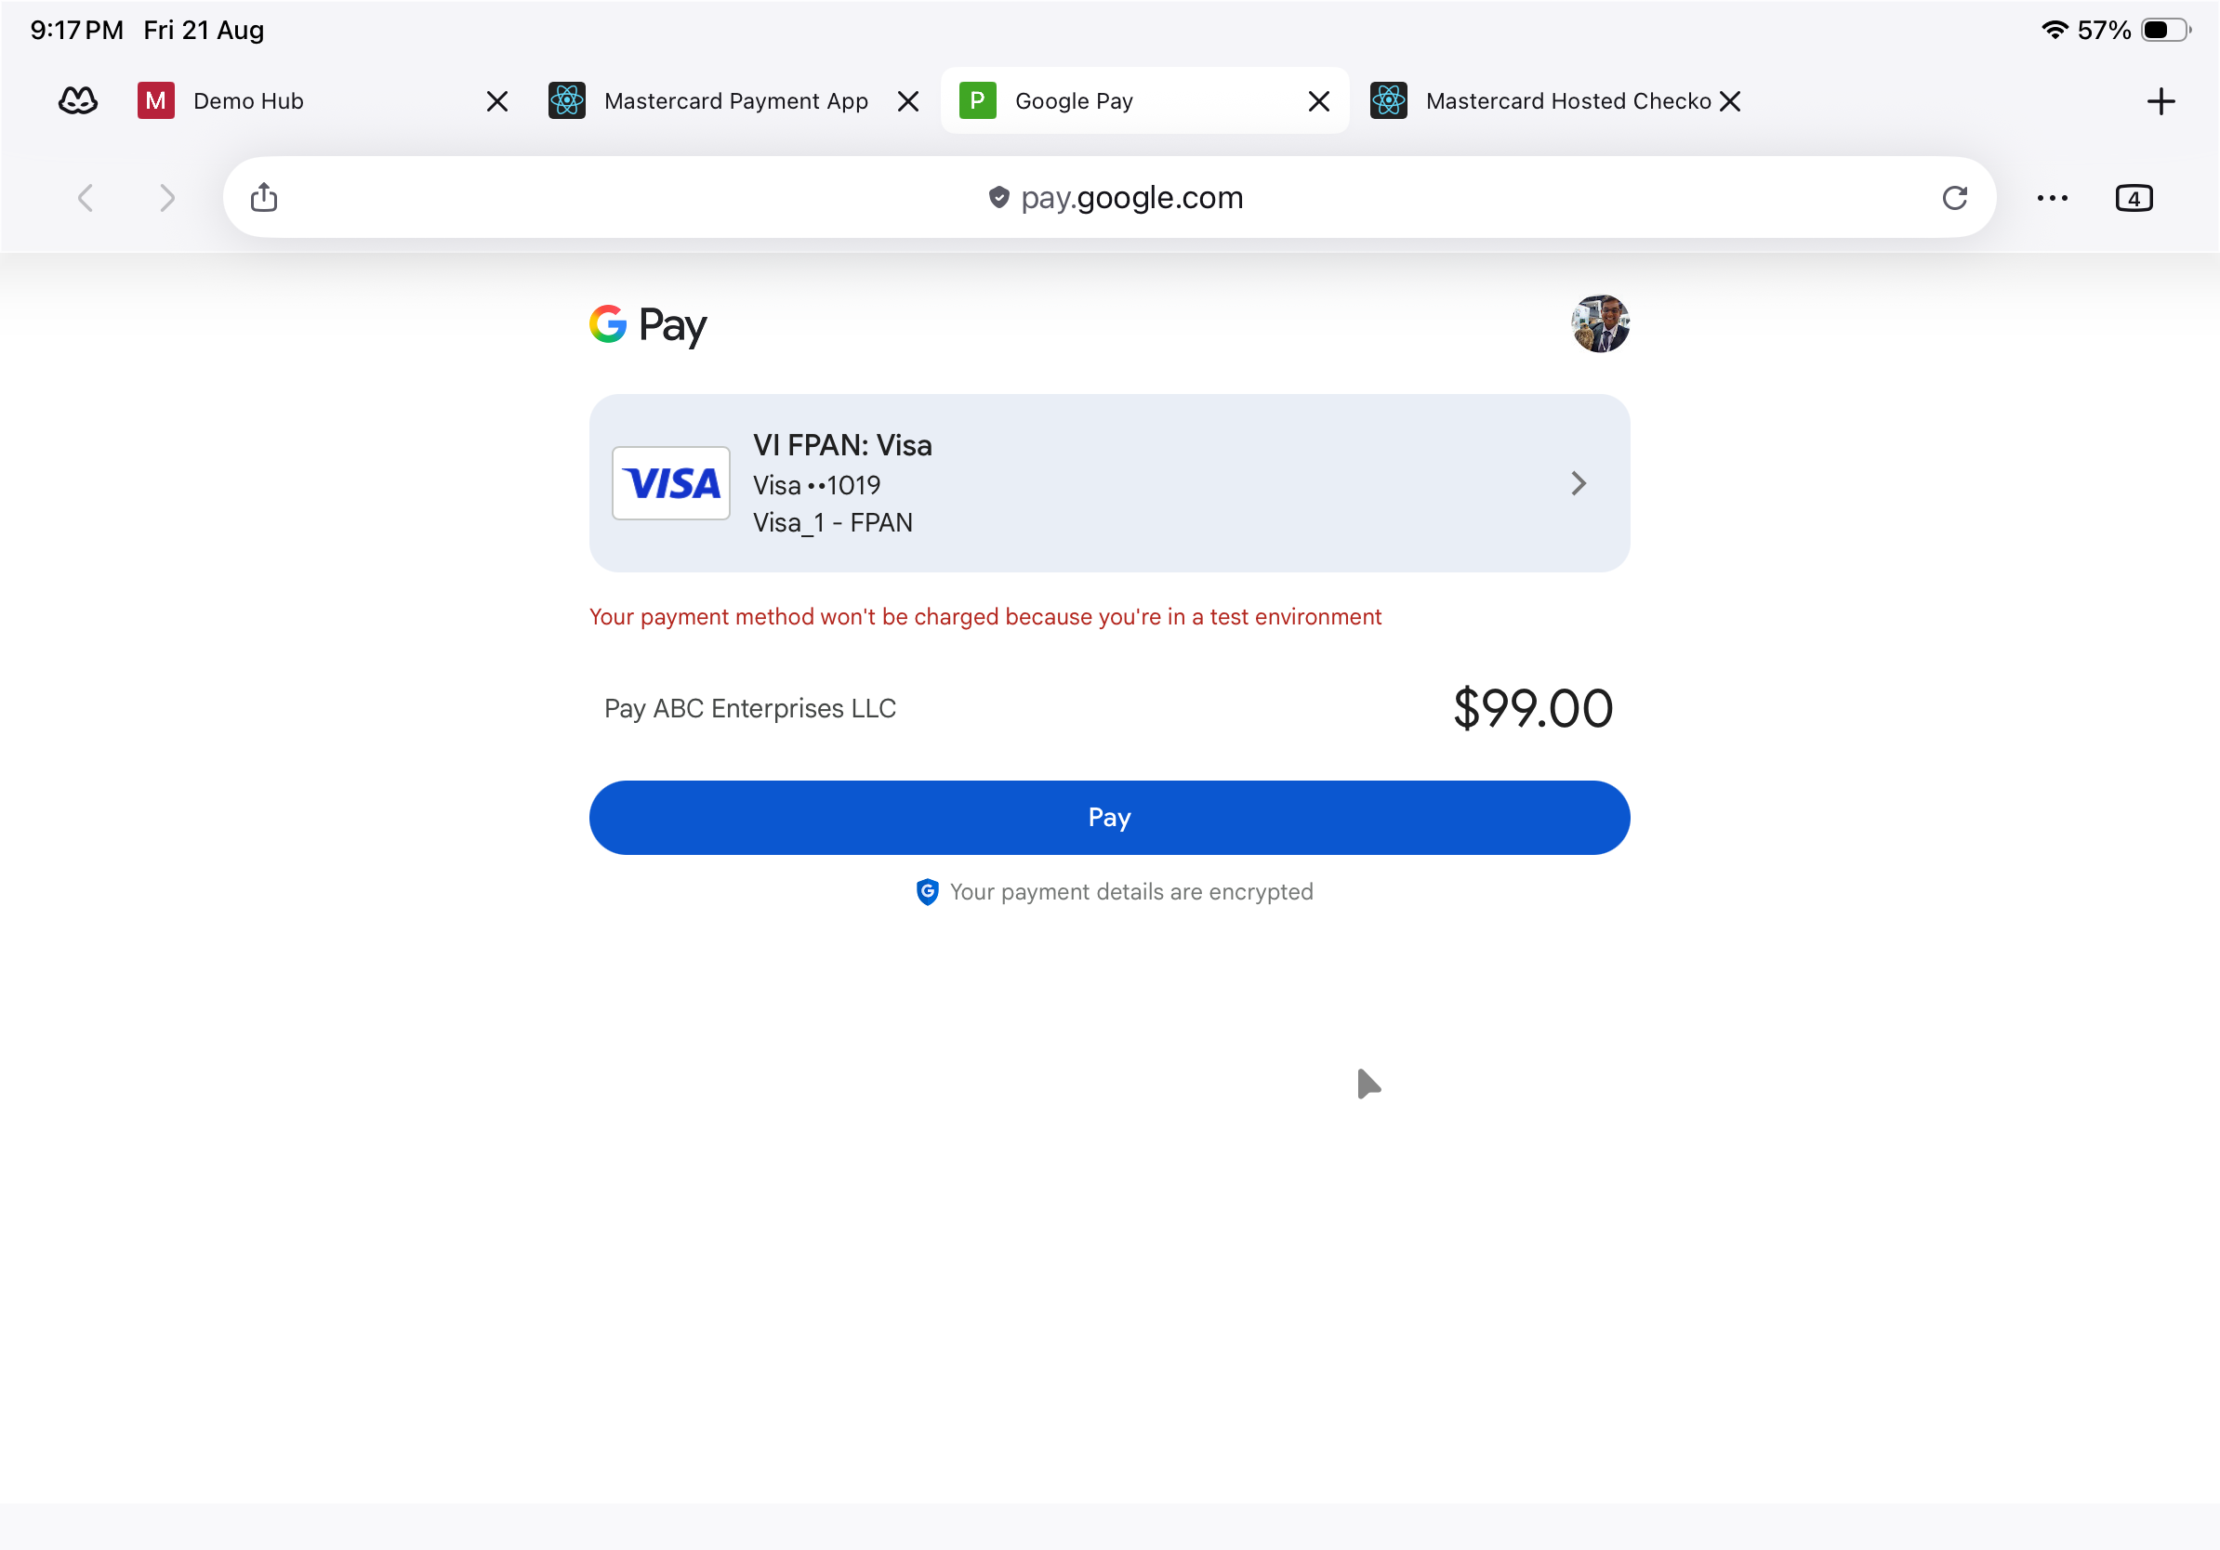
Google Pay sheet (pay.google.com) — selected card and test-environment notice.
Step 4: Complete 3-D Secure authentication
Complete the ACS Emulator for 3DS V2 step and select Submit.
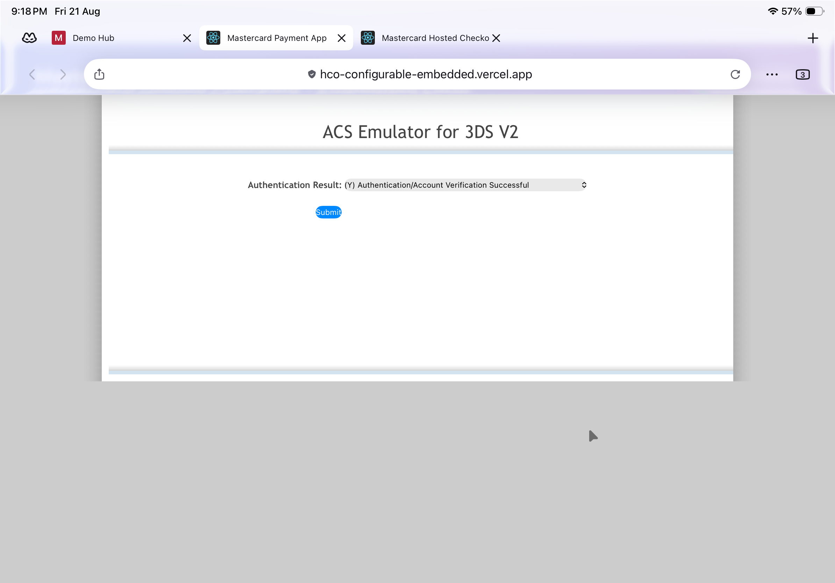
3-D Secure V2 — ACS Emulator authentication result, then Submit.
Step 5: Confirmation
The embedded receipt confirms the order with the amount, Order ID, Transaction ID, status and technical details (session and checkout versions).
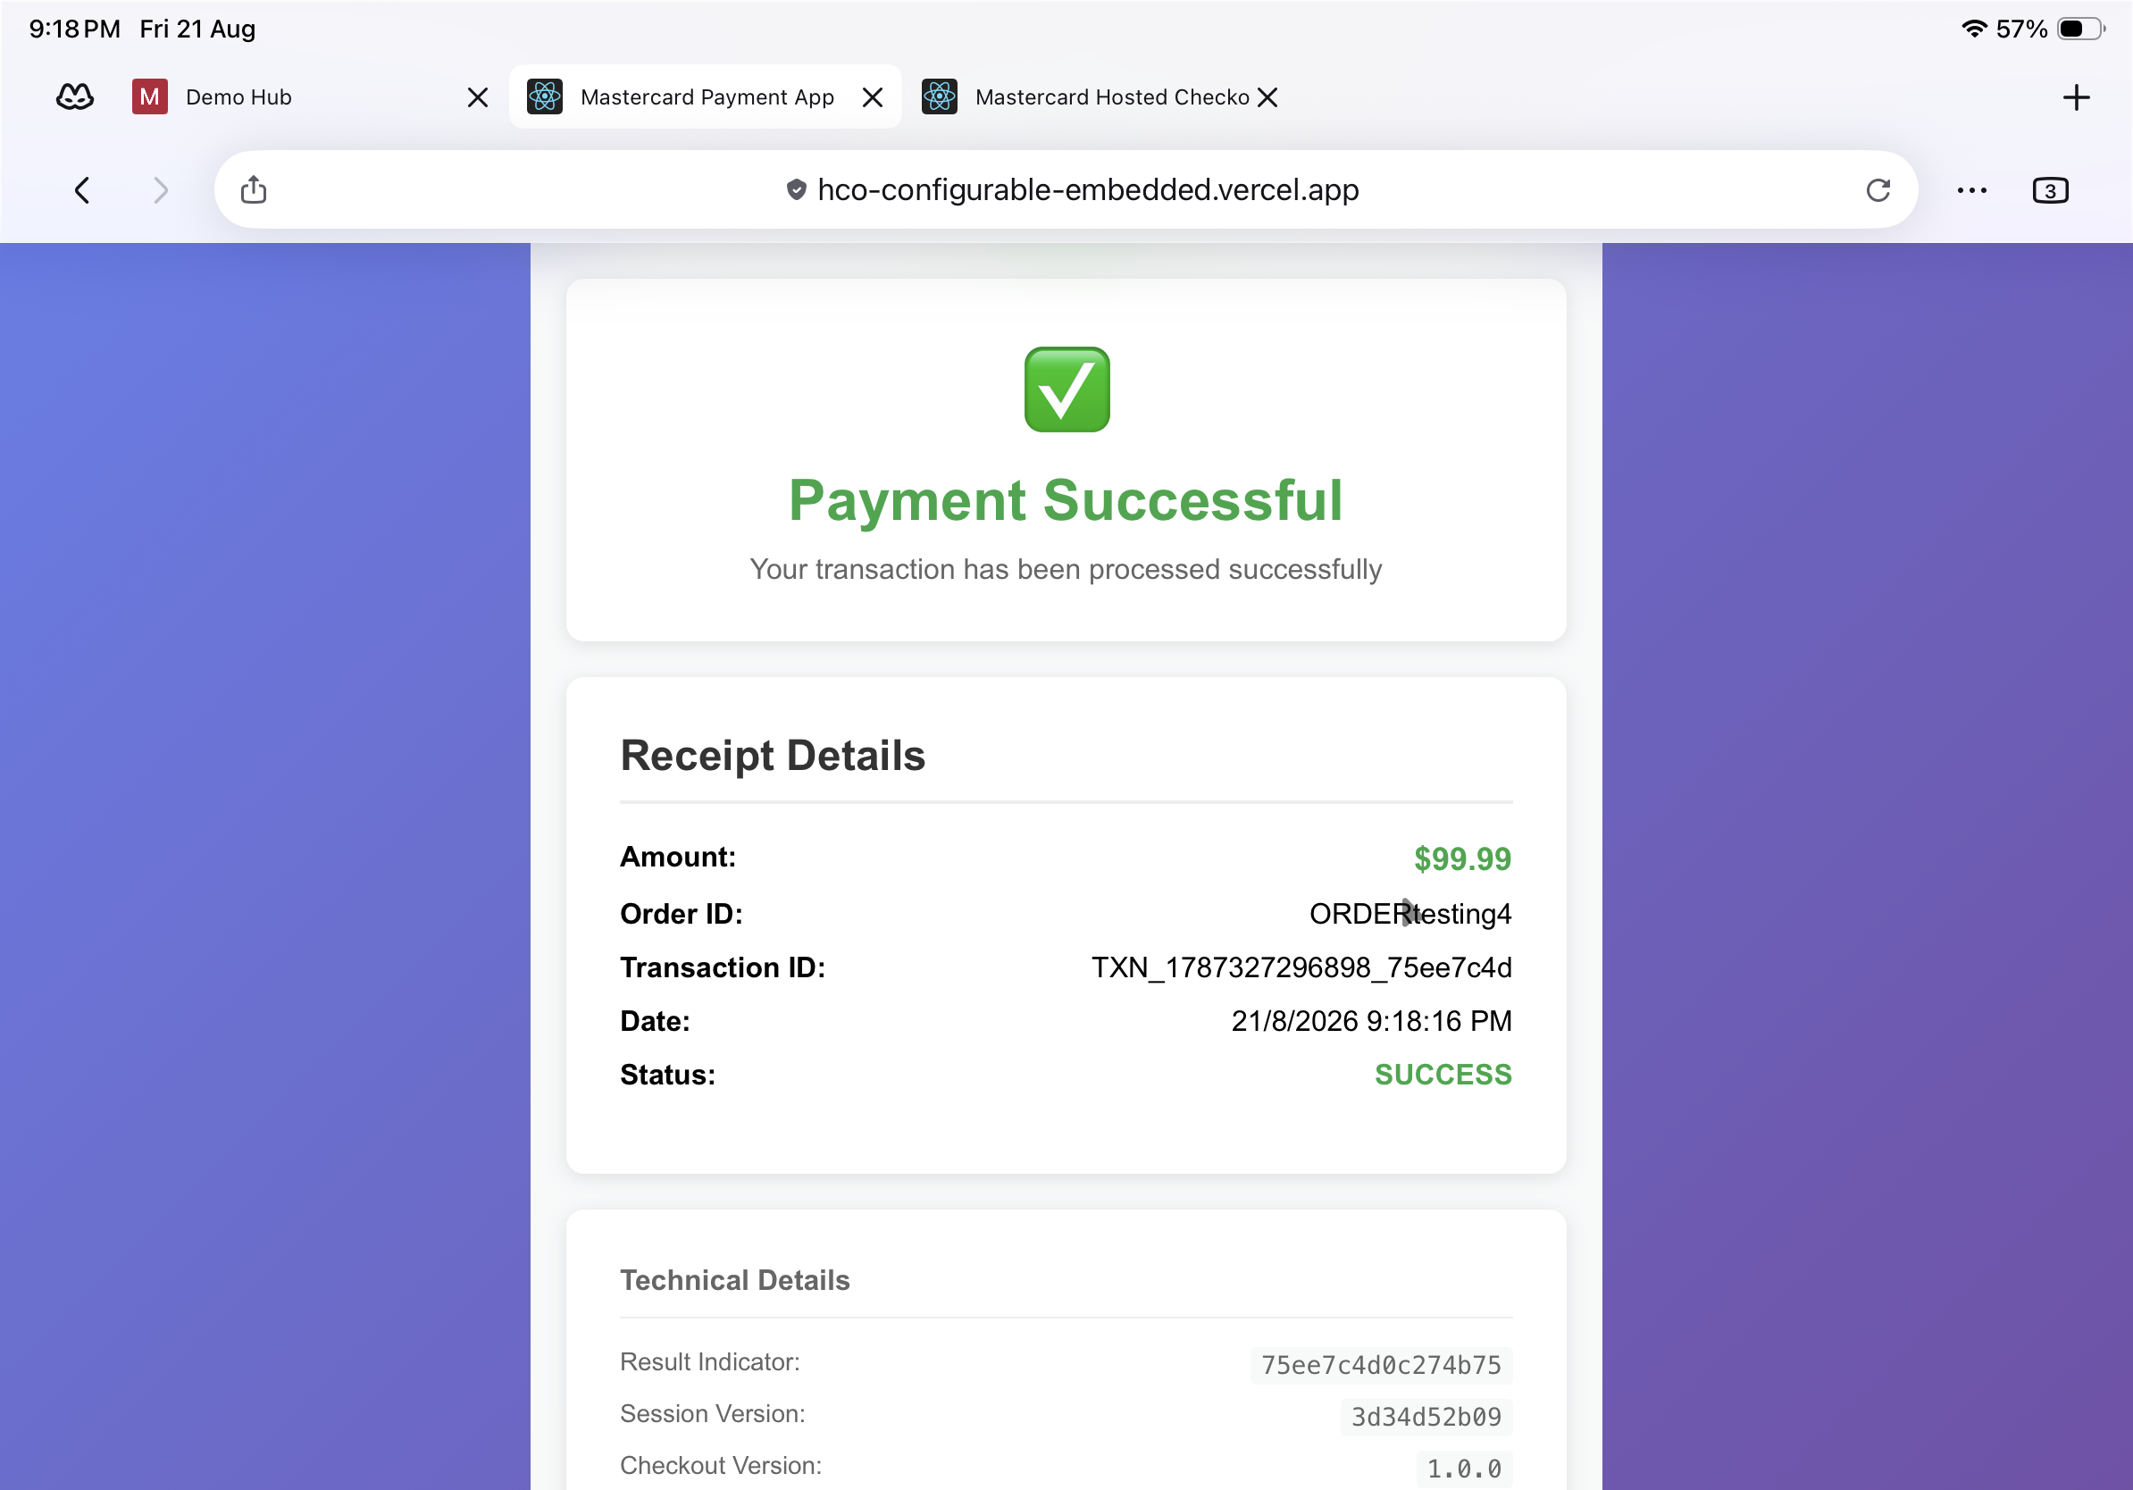
Embedded receipt — Payment Successful with transaction and technical details.
Questions & Feedback
For any queries or improvements, reach out to Gaurav.joshi@mastercard.com

