Mastercard Gateway Test App
Hosted Checkout — Google Pay — Application User Guide
Version 1.0.0

Executive Summary
This document is a step-by-step guide for Sales and CTS (Customer Technical Support) teams to validate this payment scenario in the Mastercard Gateway MTF (Merchant Test Facility) environment.
This flow demonstrates a Google Pay payment on the gateway-hosted Payment Page, including 3-D Secure V2 authentication. The shopper authorises in the Google Pay wallet and is returned to the merchant on completion.
Step-by-Step Flow
Step 1: Choose Google Pay
From the payment options, select Google Pay. The demo indicates the shopper will be redirected to their Google Pay wallet and presents the Buy with G Pay button.
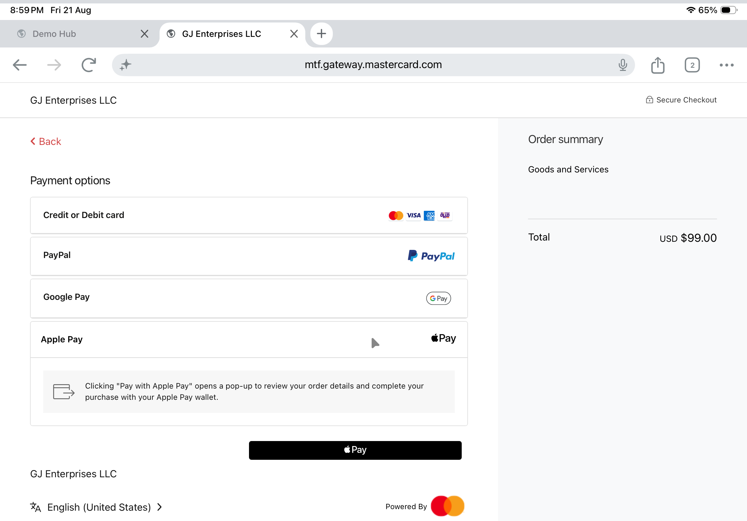
Payment options on the hosted page.
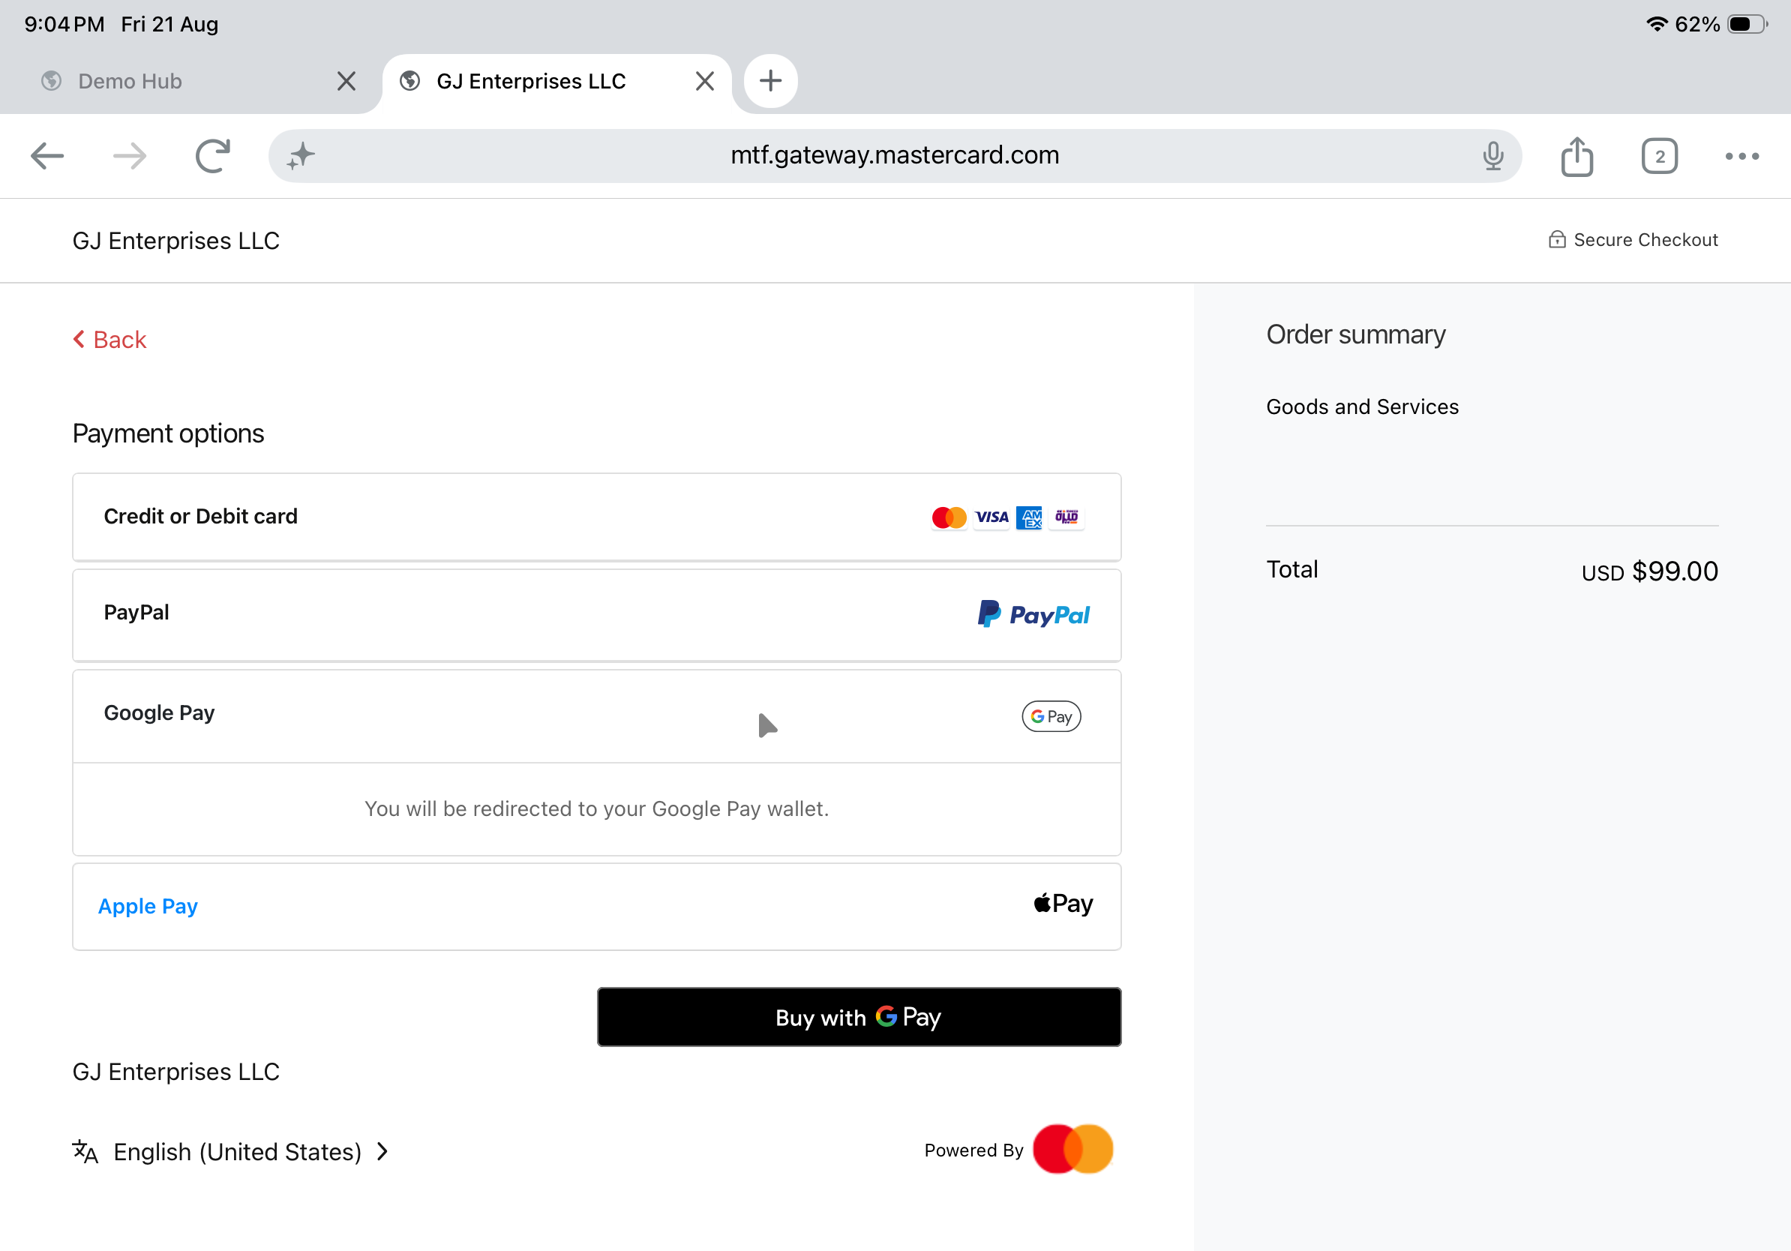
Google Pay selected — “redirected to your Google Pay wallet” and the Buy with G Pay button.
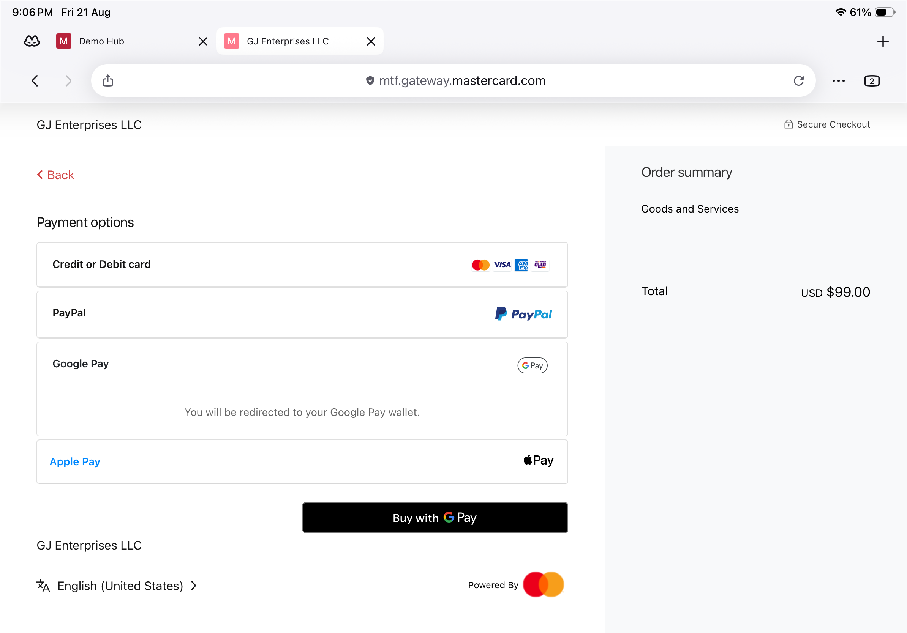
Google Pay option ready to launch the wallet.
Step 2: Confirm in the Google Pay sheet
The Google Pay sheet (pay.google.com) shows the selected card and a test-environment notice (“won’t be charged”). Select Pay to proceed.
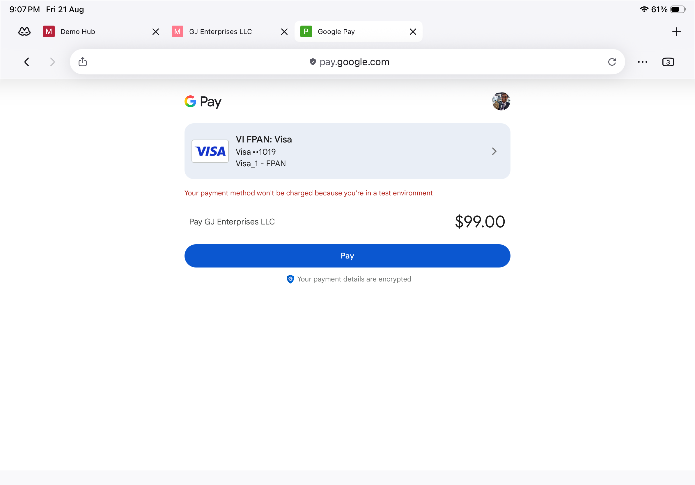
Google Pay sheet (pay.google.com) — selected card and test-environment notice.
Step 3: Complete 3-D Secure authentication
Complete the ACS Emulator for 3DS V2 step and select Submit.
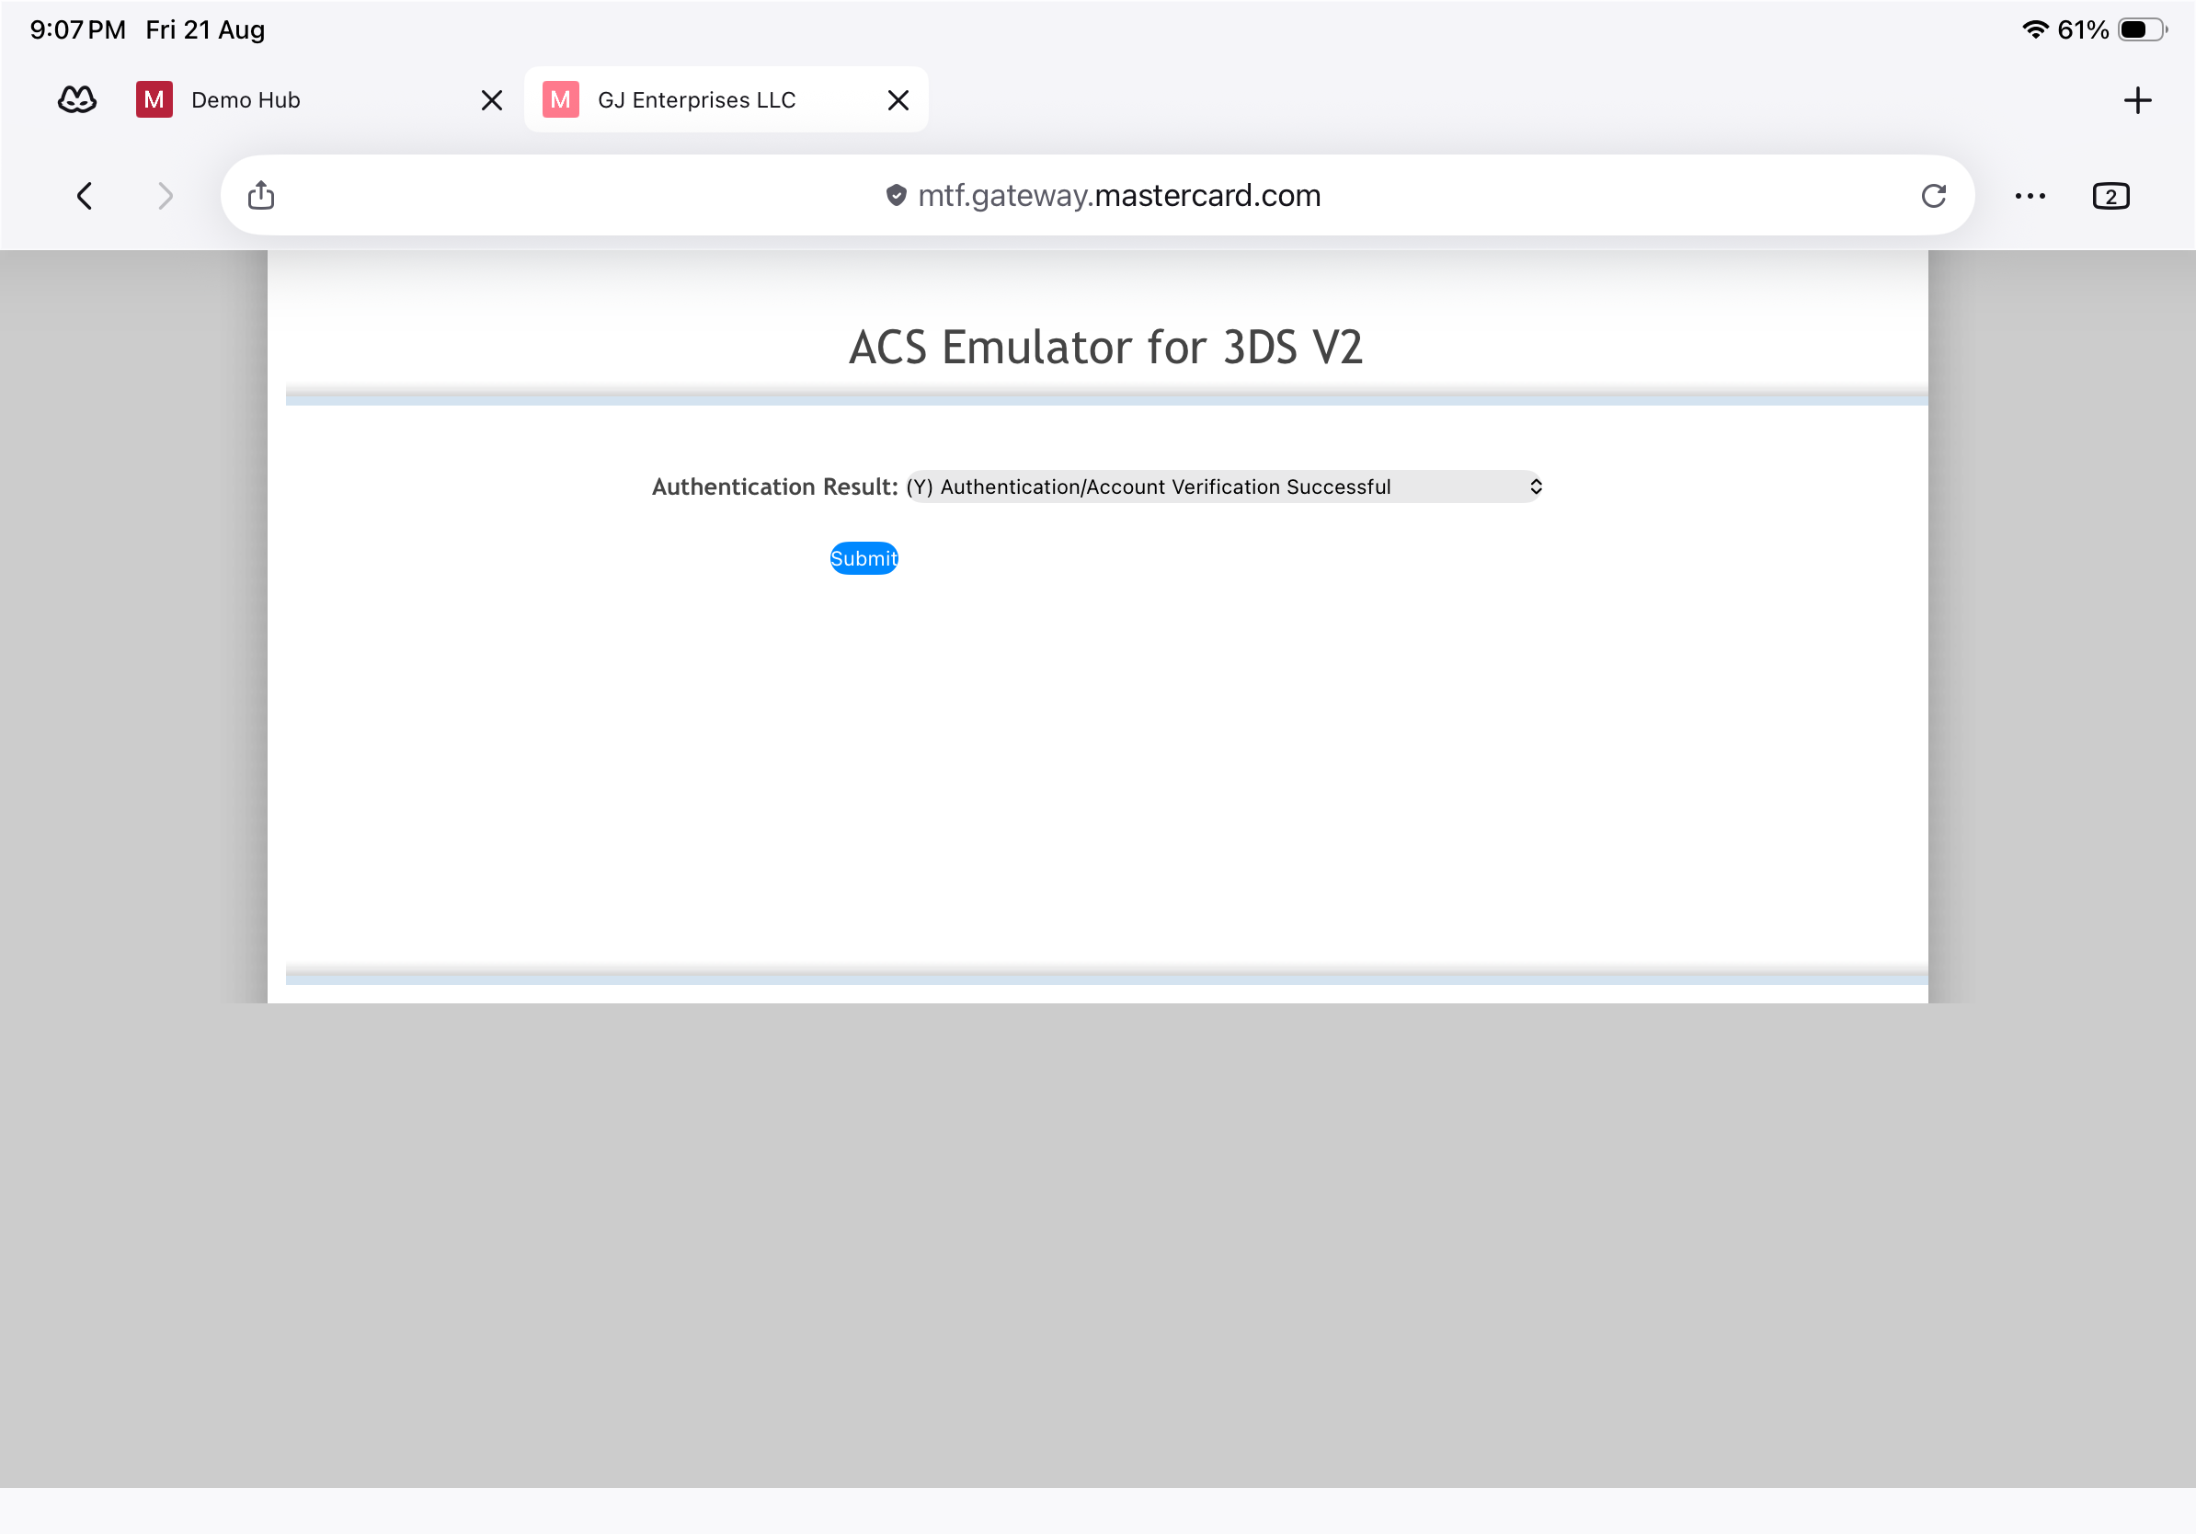
3-D Secure V2 — ACS Emulator authentication result, then Submit.
Step 4: Confirmation
On success the merchant receipt page confirms the order with the payment summary and order id.
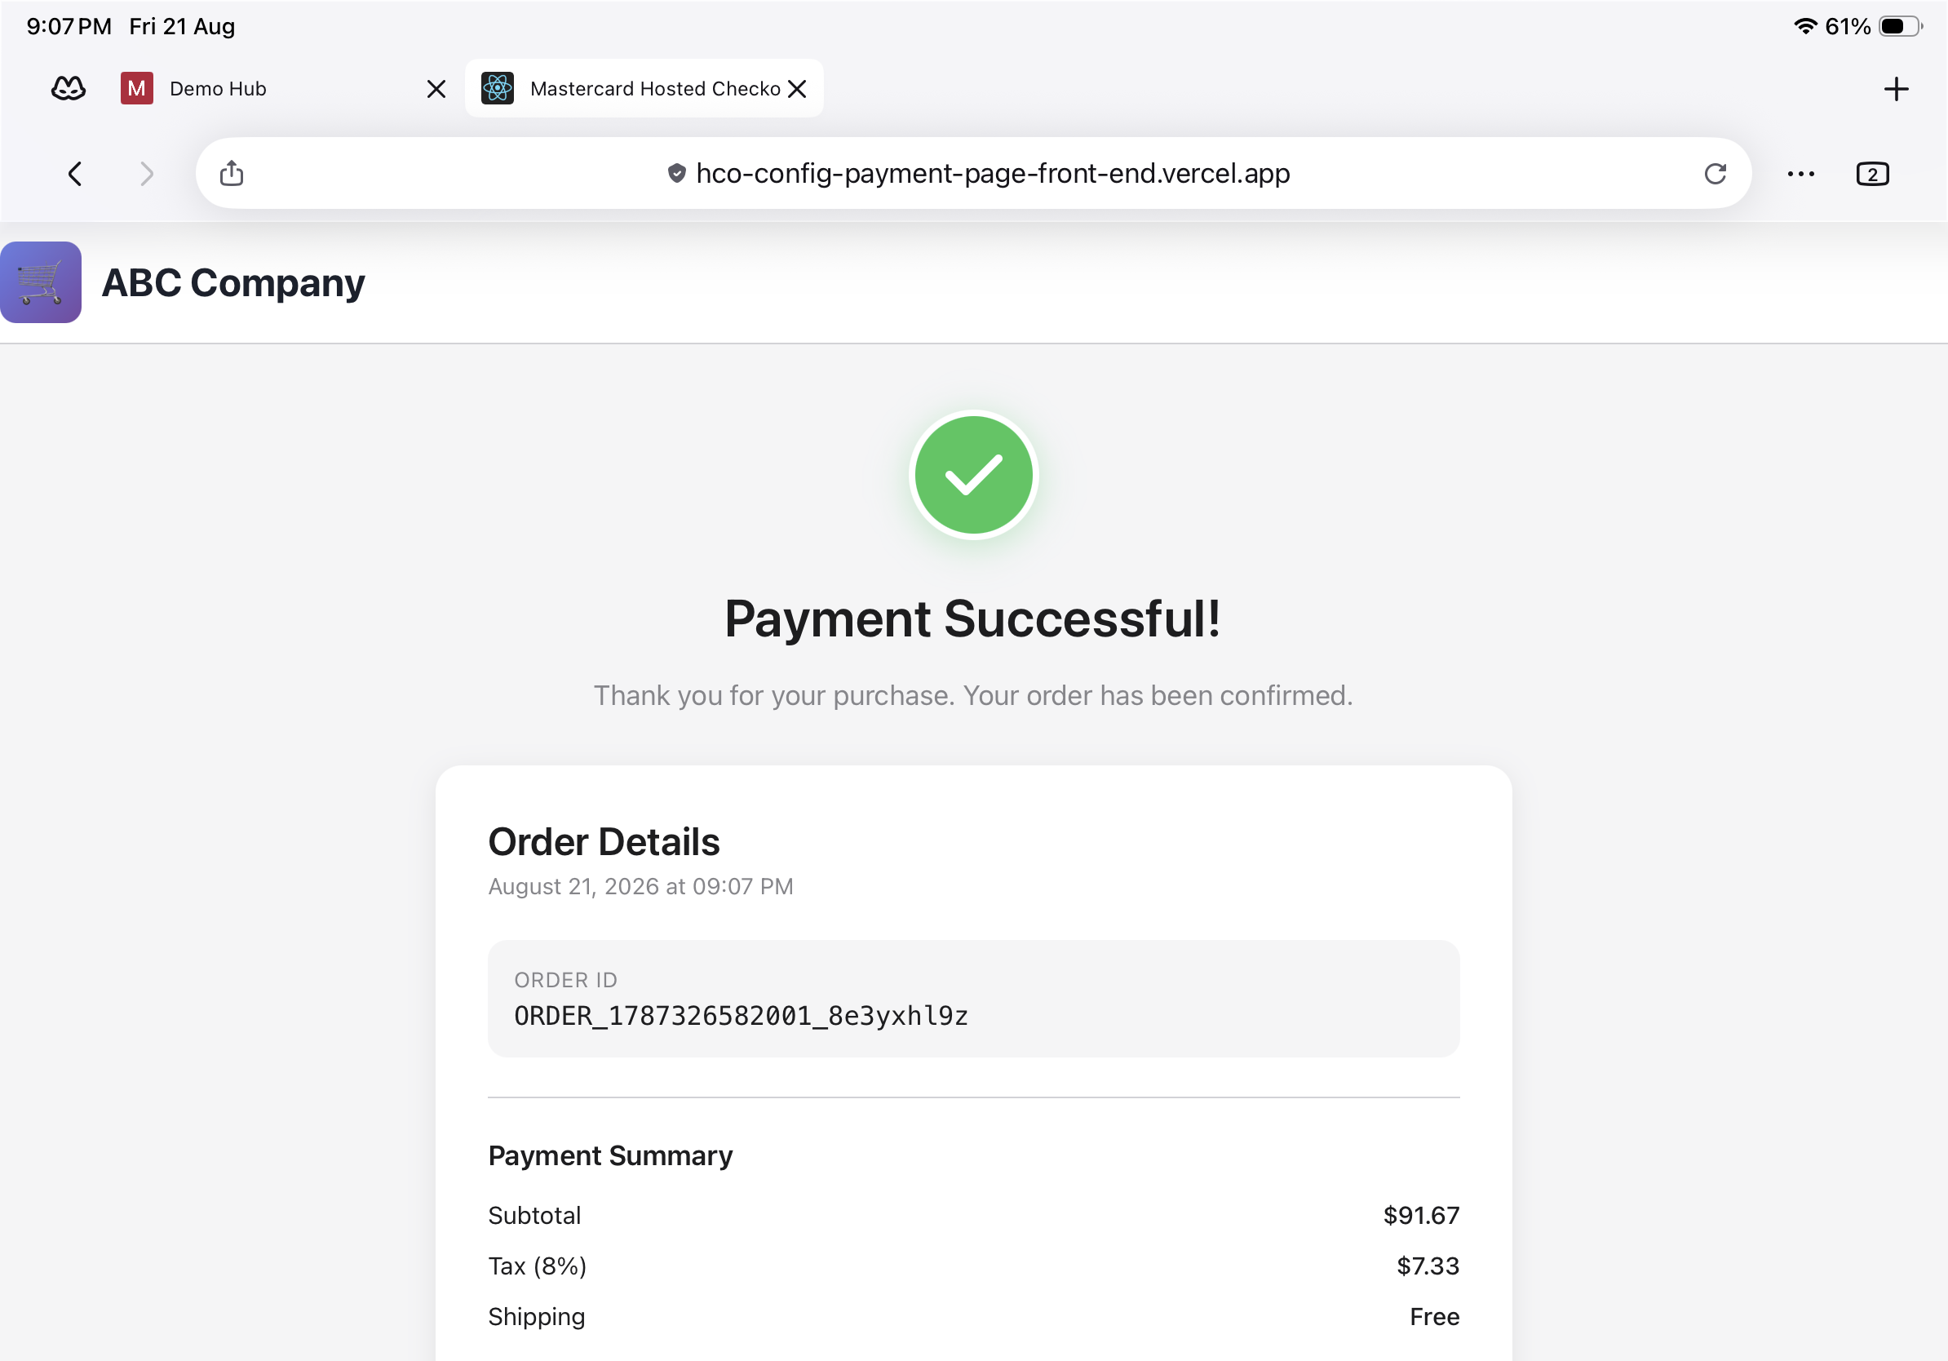
Merchant receipt — Payment Successful with order details.
Questions & Feedback
For any queries or improvements, reach out to Gaurav.joshi@mastercard.com

