Mastercard Gateway Test App
Hosted Checkout — PayPal — Application User Guide
Version 1.0.0

Executive Summary
This document is a step-by-step guide for Sales and CTS (Customer Technical Support) teams to validate this payment scenario in the Mastercard Gateway MTF (Merchant Test Facility) environment.
This flow demonstrates a PayPal payment via Hosted Checkout. The shopper is redirected to PayPal to authorise, then returned to the merchant receipt page.
Step-by-Step Flow
Step 1: Choose PayPal
From the payment options on the hosted page, select PayPal. The demo indicates the shopper will be redirected to PayPal; select Pay to continue.
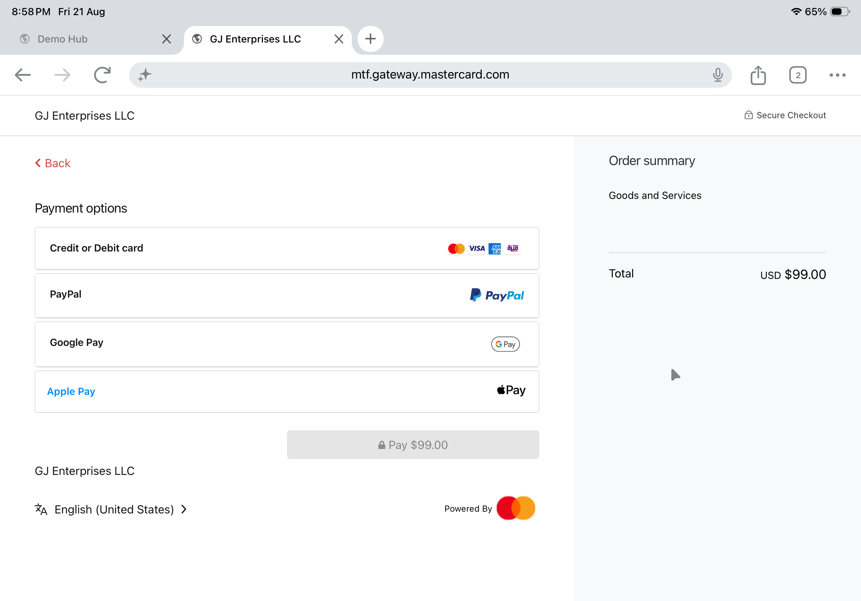
Payment options on the hosted page.
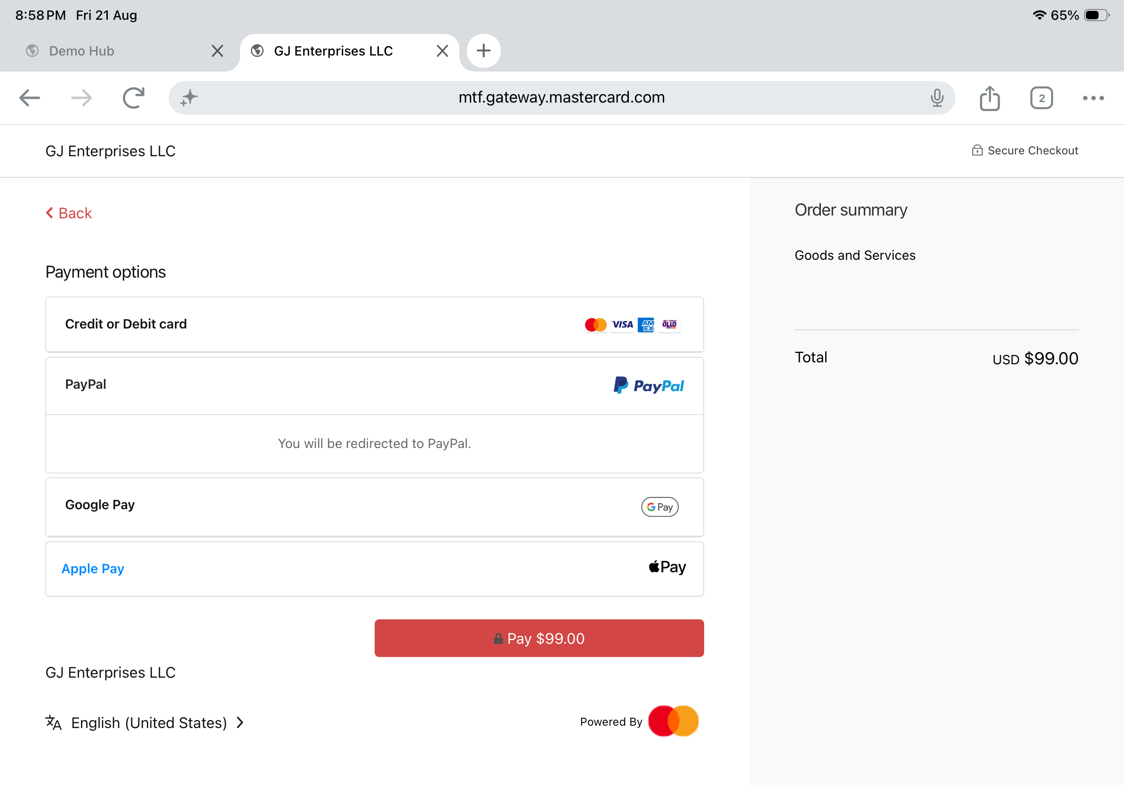
PayPal selected — redirect notice and the active Pay button.
Step 2: Approve on the PayPal test page
On the PayPal (test system) page, set the CAPTURE Status (e.g. COMPLETED) and, if needed, the refund test flags, then select Pay Now.
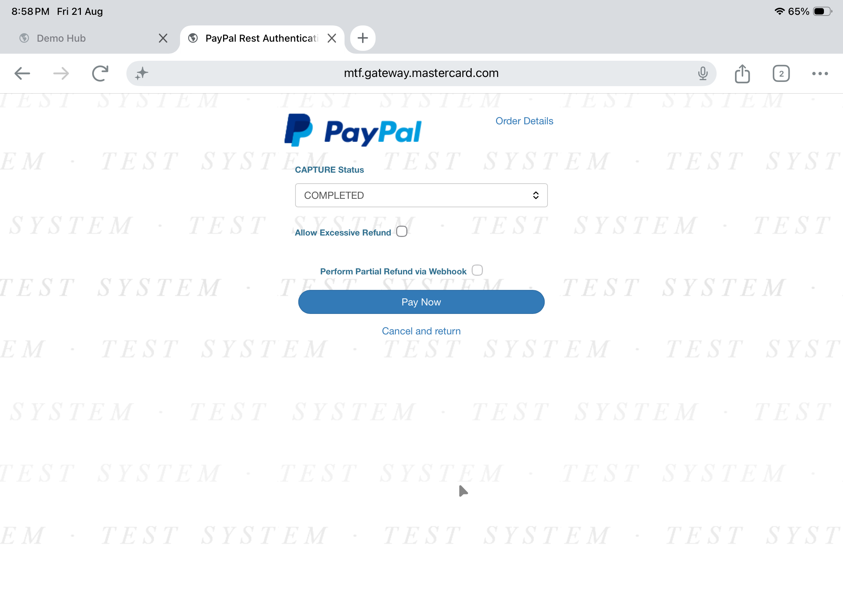
PayPal test page — set CAPTURE status and select Pay Now.
Step 3: Confirmation
The shopper is returned to the merchant receipt page, which confirms the order.
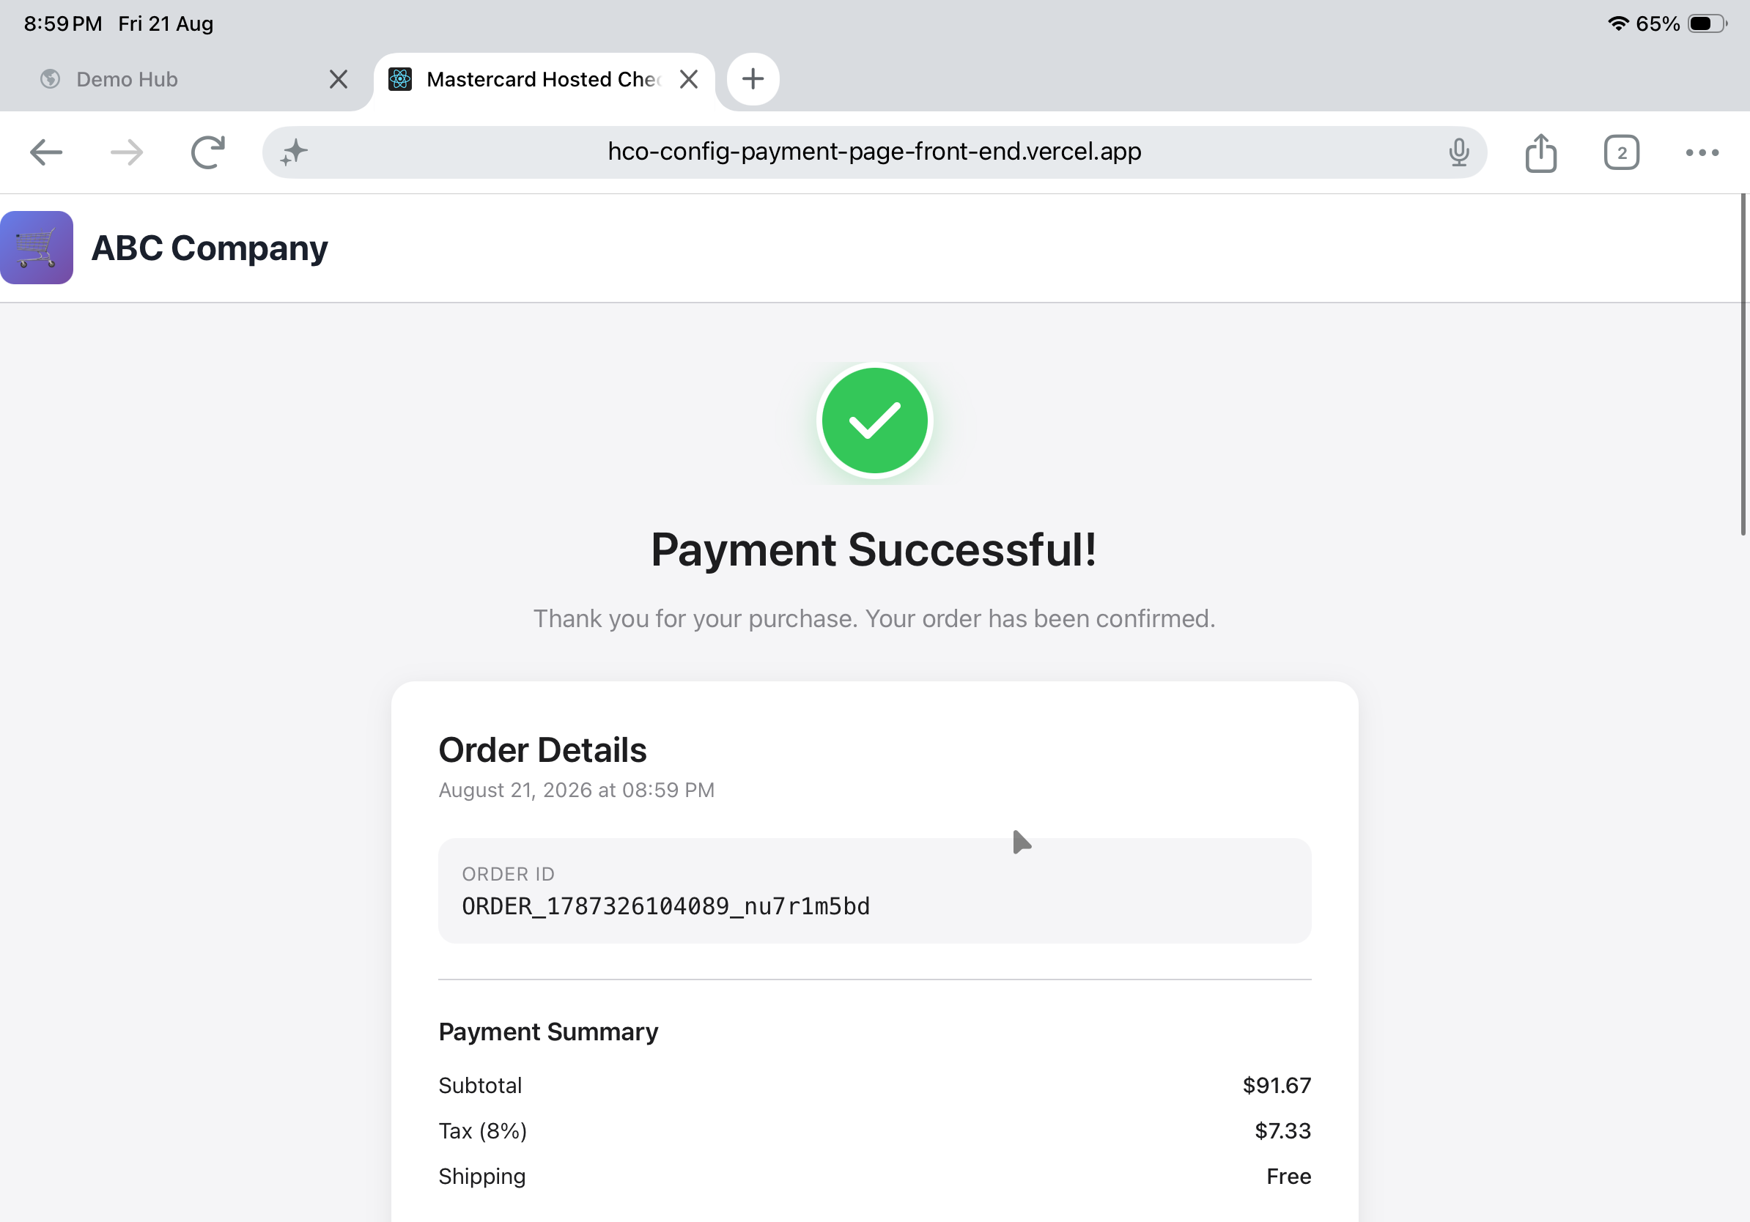
Merchant receipt — Payment Successful with order details.
Questions & Feedback
For any queries or improvements, reach out to Gaurav.joshi@mastercard.com

