Mastercard Gateway Test App
Hosted Checkout — Payment Page — Application User Guide
Version 1.1.0

Executive Summary
This document is a step-by-step guide for Sales and CTS (Customer Technical Support) teams to validate this payment scenario in the Mastercard Gateway MTF (Merchant Test Facility) environment.
The Payment Page is the standard Hosted Checkout redirect flow with no configuration UI. The demo is set in TechGear, a sample hardware store: the shopper fills a cart and checks out, is redirected to the gateway-hosted Payment Page to pay, and returns to a TechGear receipt. The amount charged is the cart total. This walkthrough illustrates a card payment with 3-D Secure V2; PayPal, Google Pay and Apple Pay may also be offered on the same page, depending on the merchant's configuration.
Step-by-Step Flow
Step 1: Browse the store
Open the demo. A thin Demo strip under the header lists the steps and shows the MTF test card. Select Browse Collection or a category, open a product and select Add to Cart.
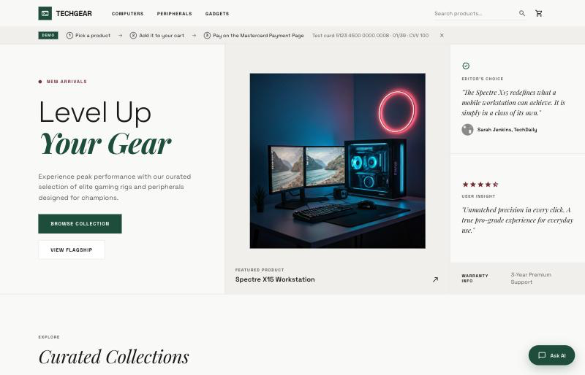
TechGear home page — the Demo strip lists the steps and the MTF test card.
Step 2: Review the cart
Open the cart (top right). Change quantities or add the suggested accessory, then select Proceed to Checkout. The total shown is the amount that will be charged.
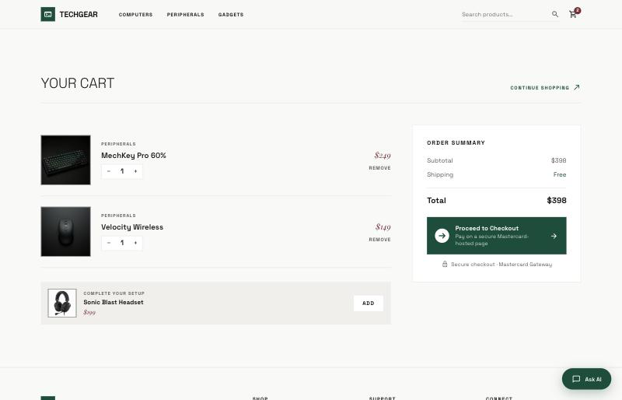
Cart with two items ($398); select Proceed to Checkout.
Step 3: Start the secure payment
The TechGear checkout page shows the order summary and a Payment step for Mastercard Hosted Checkout. Select Continue to secure payment. The demo's backend creates a checkout session (INITIATE_CHECKOUT) for the cart, and the browser redirects to the Payment Page.
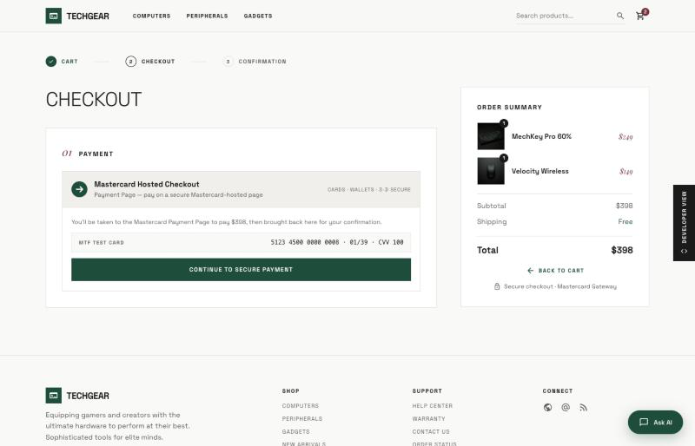
TechGear checkout — select Continue to secure payment.
Step 4: Pay on the Payment Page
The gateway-hosted Payment Page lists the cart's items and total in its Order summary. If several payment options are shown, choose Credit or Debit card.
Complete the fields (cardholder name, card number, expiry date, security code), then select Pay. Example MTF test card: 5123 4500 0000 0008, expiry 01/39, security code 100.
Notice: “The next screen you see may be payment card verification through your card issuer.”
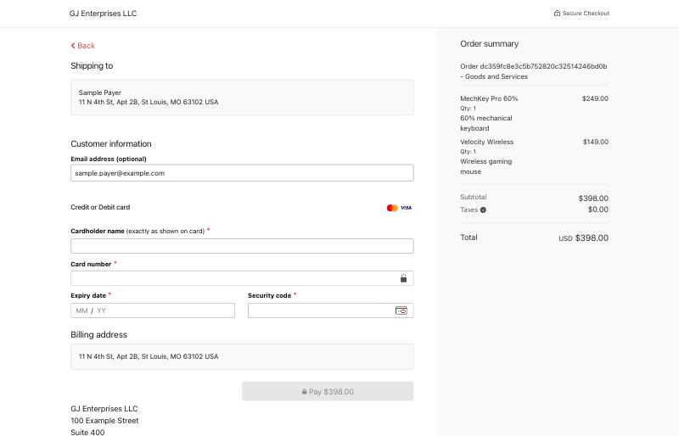
Mastercard-hosted Payment Page — the order summary lists the TechGear items.
Step 5: Complete 3-D Secure authentication
In MTF the ACS Emulator for 3DS V2 appears. Select the authentication result — for a successful flow choose “(Y) Authentication/Account Verification Successful” — then Submit.
Important: This emulator screen appears only in test environments. In production the shopper completes real issuer authentication.
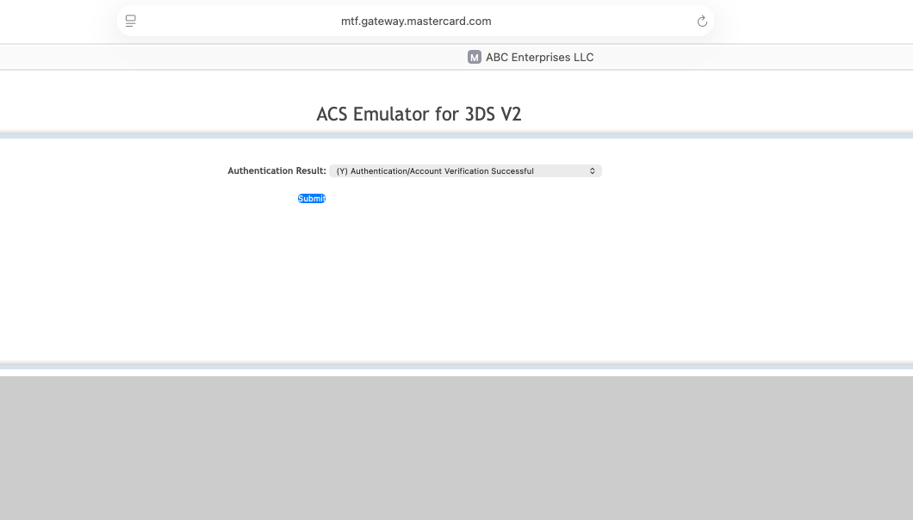
3-D Secure V2 — ACS Emulator authentication result, then Submit.
Step 6: Confirmation
The shopper returns to the TechGear receipt. The demo confirms the payment by checking that the resultIndicator sent back by the gateway matches the successIndicator issued when the session was created. Only then is the order shown as confirmed and the cart emptied.
The receipt lists the order number, items, total and result indicator. If the indicators don't match, the page says the payment didn't go through and offers Back to cart.
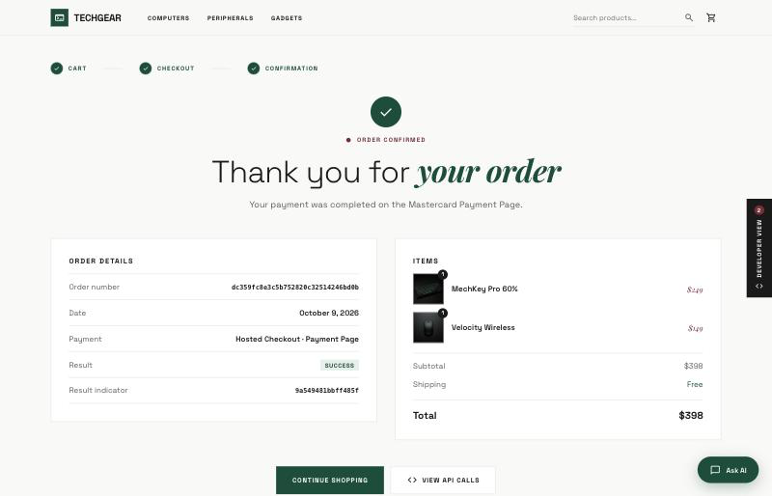
TechGear receipt — order confirmed after the result indicator is verified.
Behind the scenes: Developer view
On the checkout and receipt pages, the Developer view tab on the right edge opens a drawer. Network calls lists the API calls behind the checkout (Create checkout session, then Checkout.configure and showPaymentPage) with their request and response bodies. How it works explains the four stages of the flow.
Note: Open the Developer view when presenting to technical audiences; keep it closed for a shopper's-eye demo.
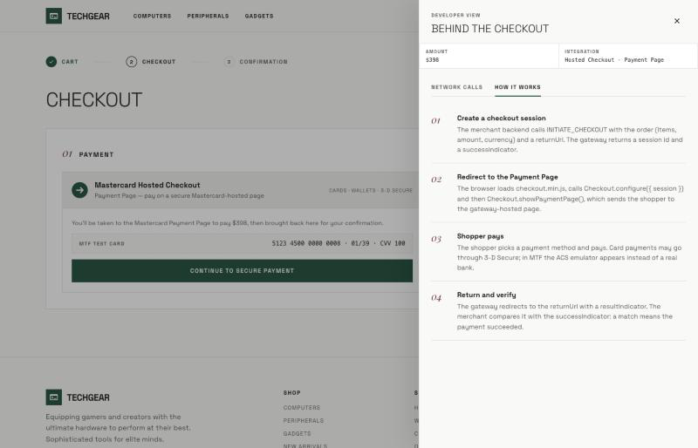
Developer view — How it works.
Questions & Feedback
For any queries or improvements, reach out to Gaurav.joshi@mastercard.com

