Mastercard Gateway Test App
Hosted Checkout — Embedded Page — Application User Guide
Version 1.0.0

Executive Summary
This document is a step-by-step guide for Sales and CTS (Customer Technical Support) teams to validate this payment scenario in the Mastercard Gateway MTF (Merchant Test Facility) environment.
The Embedded Page is a merchant-embedded Hosted Checkout flow with fixed configuration (no configuration UI). The gateway payment interface is embedded directly in the merchant page (in an in-page frame) rather than via a full-page redirect, so the shopper stays on the merchant site while the gateway handles the sensitive data. This walkthrough illustrates a card payment with 3-D Secure V2; PayPal, Google Pay and Apple Pay are also available.
Step-by-Step Flow
Step 1: Start the checkout
On the merchant page, review the order and select Proceed to Checkout.
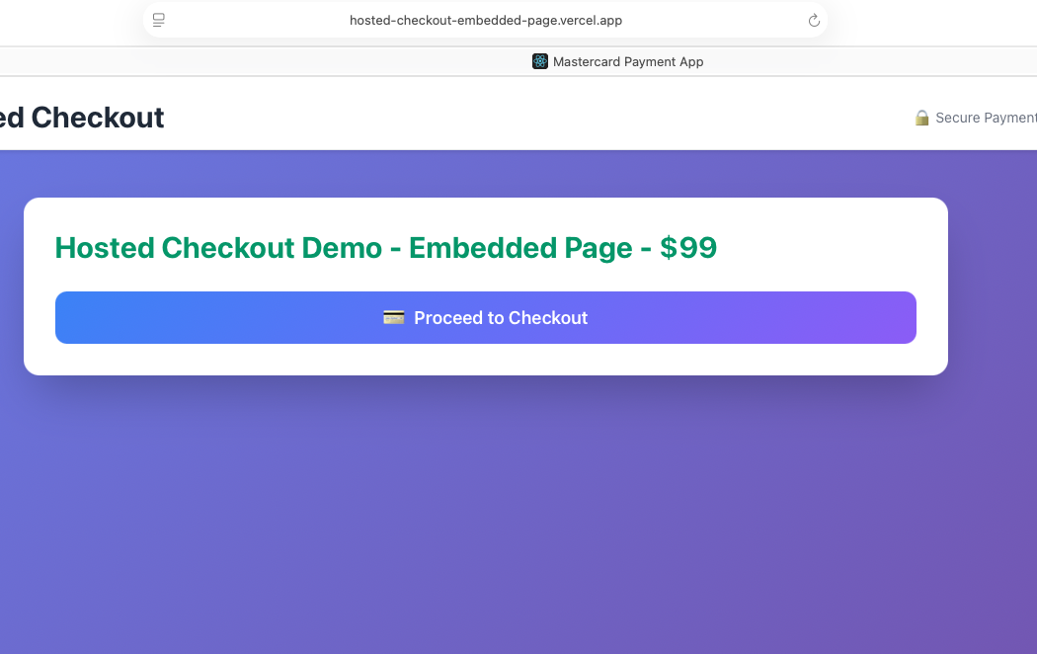
Merchant page — Hosted Checkout Demo (Embedded Page); select Proceed to Checkout.
Step 2: Choose a payment method in the embedded form
The gateway payment options render inside the merchant page (labelled “Payment Page embedded in frame”). Select Credit or Debit card to reveal the card entry fields.
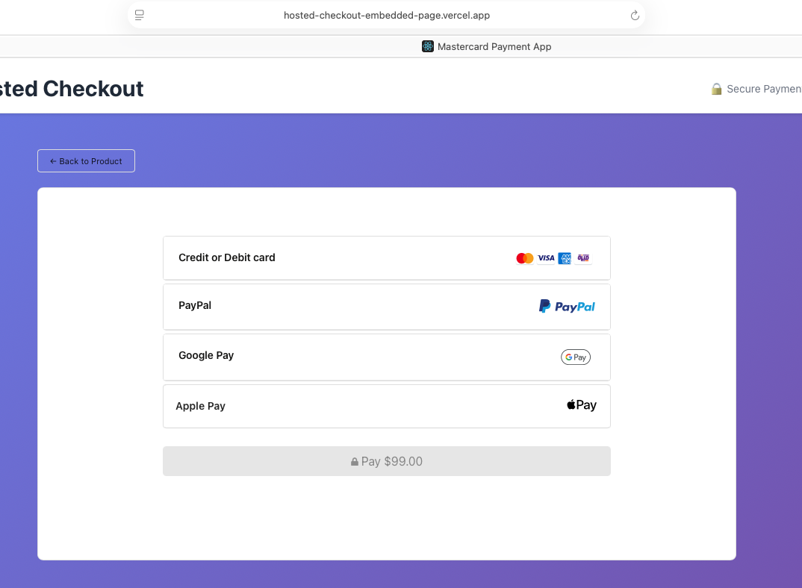
Payment options embedded directly in the merchant page (Payment Page embedded in frame).
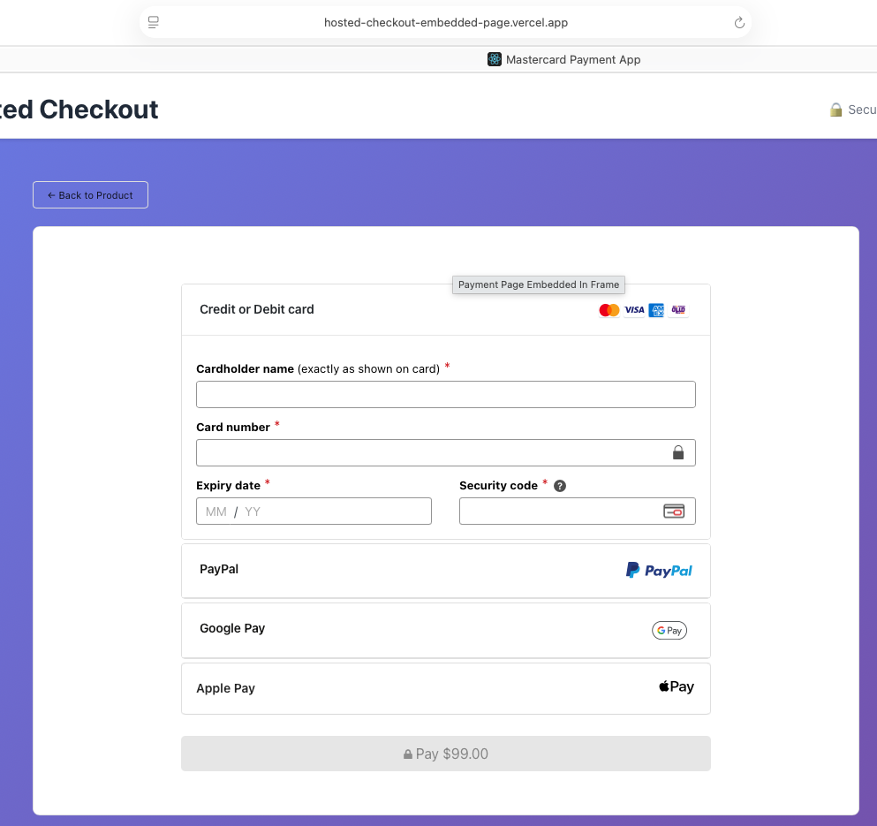
Credit or Debit card selected — card entry fields shown in the embedded frame.
Step 3: Enter card details and pay
Complete the fields (cardholder name, card number, expiry date, security code), then select Pay. Example MTF test card: 5123 4500 0000 0008, expiry 01/39, security code 100.
Notice: “The next screen you see may be payment card verification through your card issuer.”
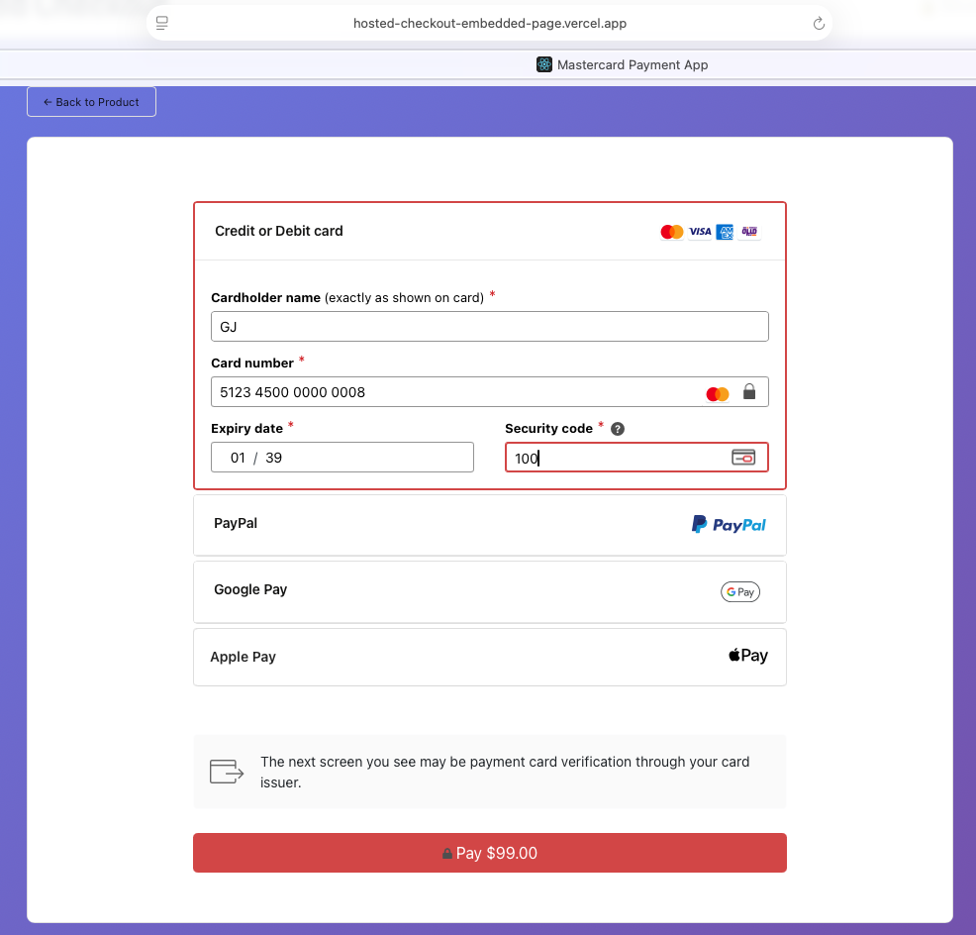
Card details entered; select Pay.
Step 4: Complete 3-D Secure authentication
In MTF the ACS Emulator for 3DS V2 appears. Select the authentication result — for a successful flow choose “(Y) Authentication/Account Verification Successful” — then Submit.
Important: This emulator screen appears only in test environments. In production the shopper completes real issuer authentication.
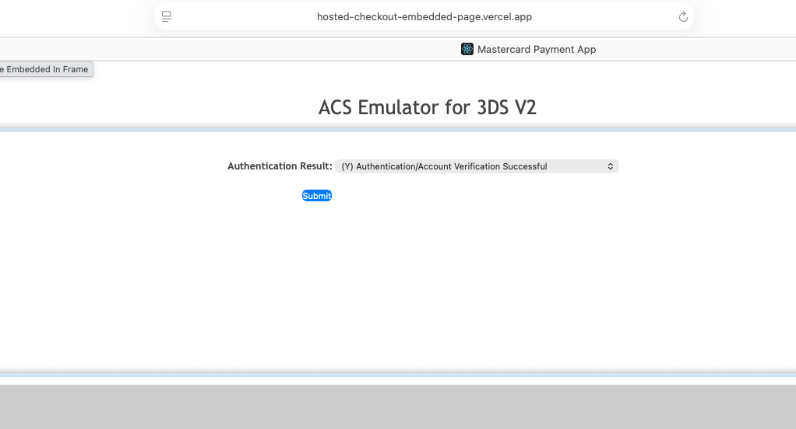
3-D Secure V2 — ACS Emulator authentication result, then Submit.
Step 5: Confirmation
The merchant receipt page confirms the order with the amount, Order ID, Transaction ID, status and technical details (session and checkout versions).
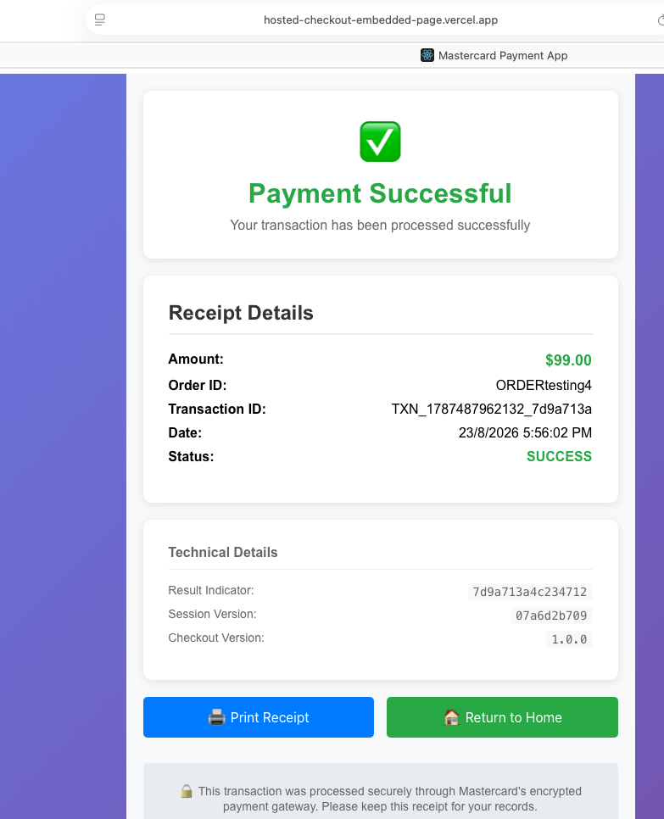
Merchant receipt — Payment Successful with transaction and technical details.
Questions & Feedback
For any queries or improvements, reach out to Gaurav.joshi@mastercard.com

