Flow 2 — Pay with the token
Mastercard Hosted Checkout · Credential on File · hco-flows.vercel.app
What this flow shows
A returning cardholder buys something and never types a card. The merchant sends the token it stored in flow 1 to the hosted page, which opens with that card already listed. One tap and the order is placed.
The cardholder is present and approves the payment, so this is still cardholder-initiated — but it is a credential-on-file payment rather than a fresh card entry. Contrast it with flow 3, where later charges happen with nobody watching.
Before you start
- Run flow 1 first. This flow spends the token that flow 1 produced.
- On the hub, choose Flow 2, “Pay with the token”.
- Test card (MTF): 5123 4500 0000 0008 · expiry 01/39 · security code 100.
- The 3-D Secure screen is the MTF ACS emulator, not a real bank. Leave the result on “(Y) Authentication/Account Verification Successful” and press Submit.
- Everything runs against the Mastercard test environment (mtf.gateway.mastercard.com). No real money moves.
Step by step
1. The hub now holds a saved card
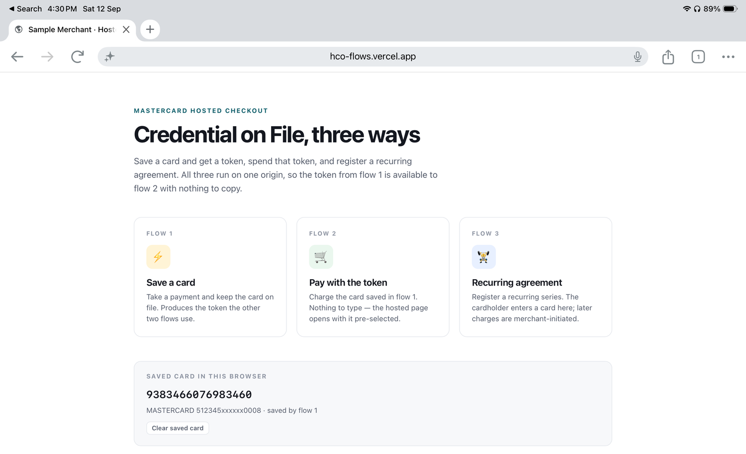
“Saved card in this browser” shows the token from flow 1 and the masked card it represents. The demo hands it to flow 2 automatically; “Clear saved card” resets the demo to a first-time shopper.
2. Review the basket
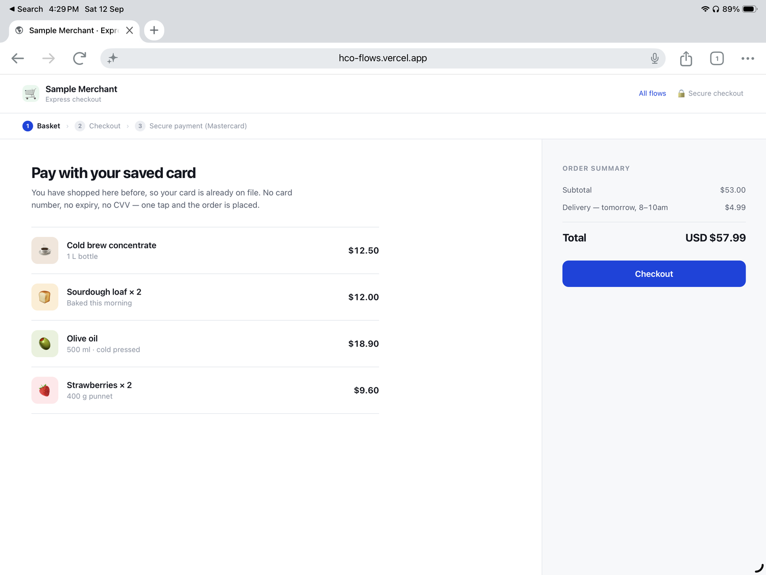
An ordinary express-checkout basket — $57.99 including delivery. Nothing payment-specific has happened yet.
3. Confirm the order
There is no card form. The merchant shows the card it has on file and asks only for approval of the amount.
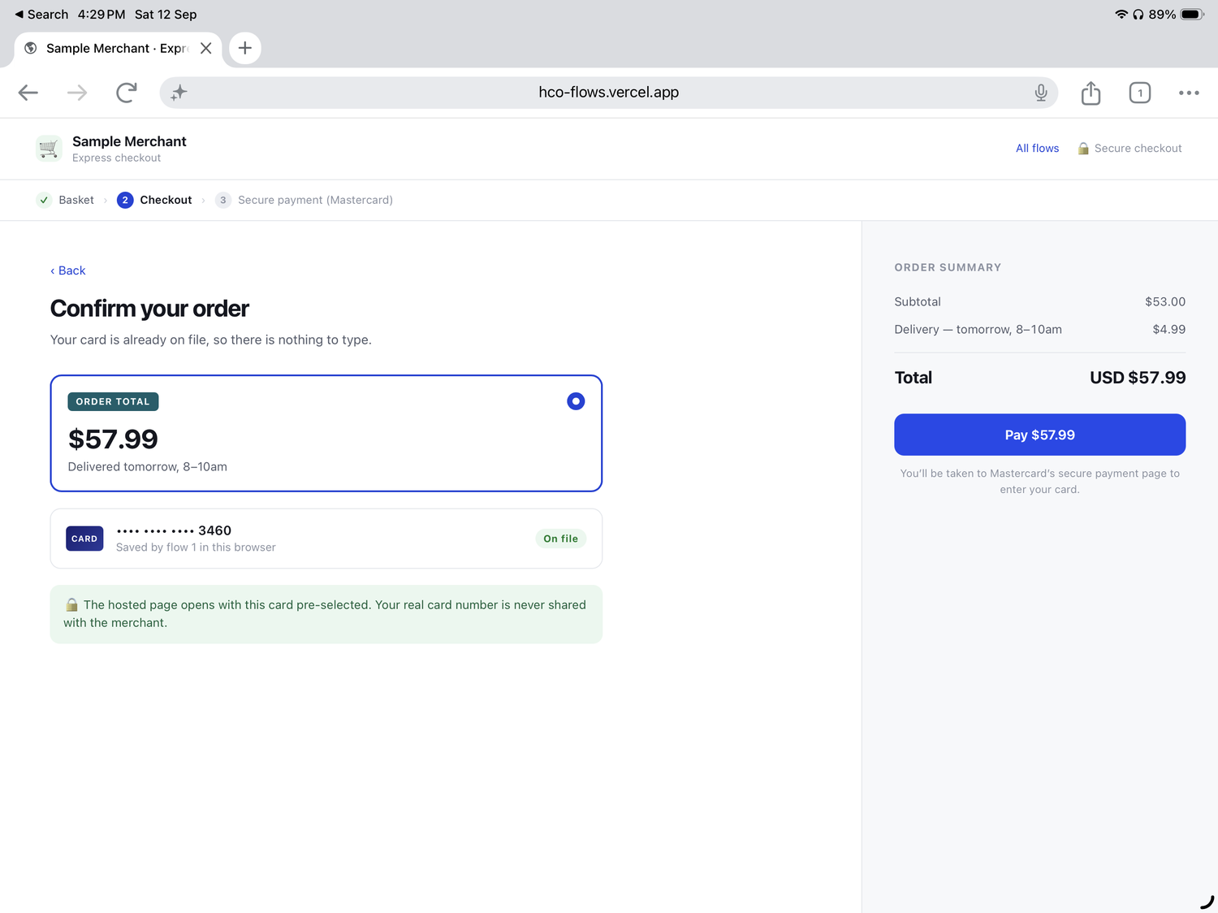
The card is labelled “Saved by flow 1 in this browser” and shows the last four digits — which is all the merchant has. The real card number is never shared with it.
4. The hosted page opens with the card pre-selected
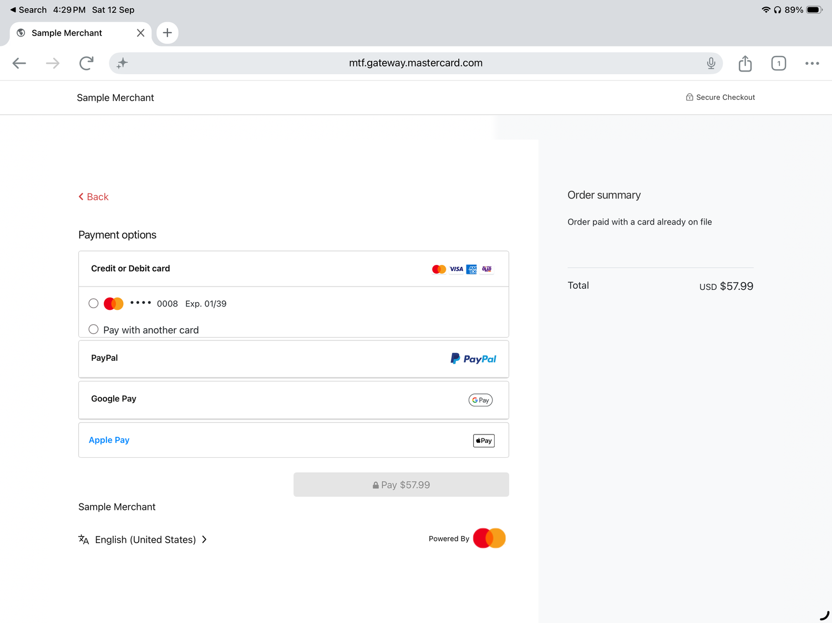
On mtf.gateway.mastercard.com the saved card is already listed (•••• 0008, Exp. 01/39) alongside “Pay with another card”. That list is produced by the tokens the merchant put in the session.
5. Complete 3-D Secure
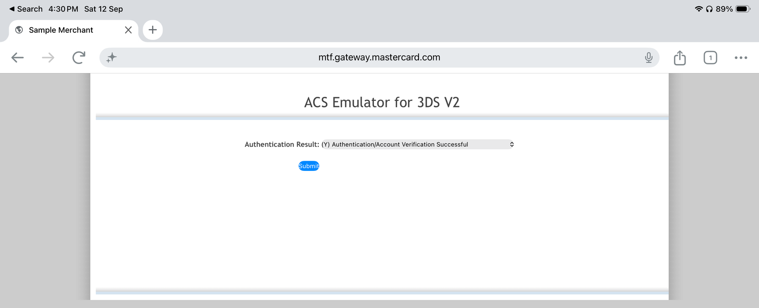
The MTF emulator again. A returning-customer token payment is a common candidate for exemptions or frictionless authentication in production.
6. The order is placed
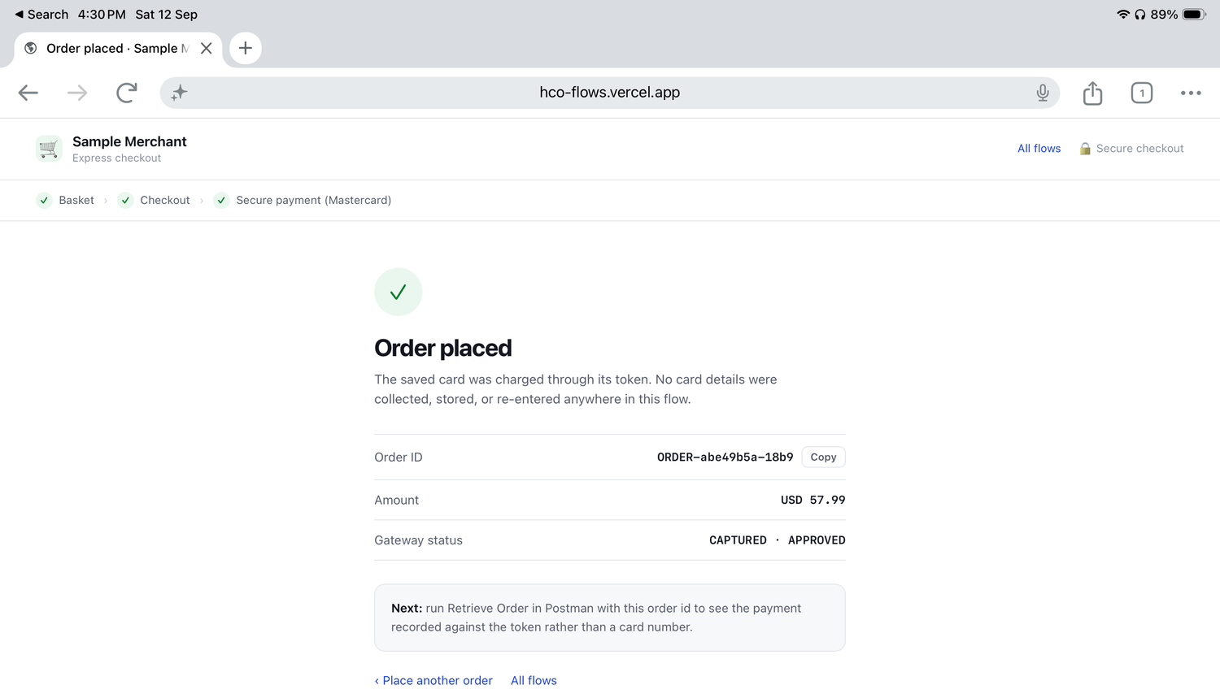
Gateway status reads CAPTURED · APPROVED — funds were authorised and captured in one step. The screen also suggests running Retrieve Order in Postman with this order id, where the payment shows against the token rather than a card number.
What happens on the gateway
One call creates the session; the token does the rest.
POST https://{{host}}/api/rest/version/{{version}}/merchant/{{merchantId}}/session
{
"apiOperation": "INITIATE_CHECKOUT",
"interaction": {
"operation": "PURCHASE",
"tokens": ["9383466076983460"],
"merchant": { "name": "Sample Merchant", "url": "https://..." },
"returnUrl": "https://..."
},
"order": {
"id": "ORDER-abe49b5a-18b9",
"amount": "57.99",
"currency": "USD"
}
}
Field | Why it is there
interaction.tokens | The saved card tokens to offer on the hosted page. This is the whole trick of the flow — the merchant sends a token, and the page renders it as a selectable card.
interaction.operation | PURCHASE authorises and captures in one step, which is why the result reads CAPTURED. Use AUTHORIZE instead when you capture later at dispatch.
saveCardForCredentialOnFile | Not needed here — the card is already stored. Include it only if you want to store an additional card the shopper enters through “Pay with another card”.

Cardholder-initiated: the shopper is in the session and approves the amount, so the transaction is a CIT even though the credential was stored earlier. Flow 3 shows the merchant-initiated counterpart.
Reproduce it in Postman
The CIT / MIT card on the demo hub carries a Postman collection and the Gateway Environment. Import both, select the environment, and set merchantId and apiPassword to your own MTF credentials — order, agreement and transaction ids are generated for you, and the card token is captured automatically.
Folder “2. CIT — Checkout with the saved token”:
- Initiate Checkout with token — sends {{cardToken}}, which folder 1 captured for you.
- Retrieve Order — confirms the payment is recorded against the token, not a card number.
Worth pointing out in a demo
- No card number, expiry or security code is typed anywhere in this flow.
- The merchant’s checkout stays simple: it holds a token and a last-four, nothing sensitive.
- The shopper can still pay with a different card — the hosted page offers that without the merchant building a second form.
- This is the express-checkout pattern behind “buy again” and one-tap reorder.

