Flow 3 — Recurring agreement (CIT → MIT)
Mastercard Hosted Checkout · Credential on File · hco-flows.vercel.app
What this flow shows
A subscription. The first payment is made by the cardholder and registers a recurring agreement. Every payment after that is made by the merchant on its own schedule — no shopper, no hosted page — quoting the agreement id and the stored token.
Term | What it means
CIT | Cardholder-initiated. The cardholder is in the session and approves the payment. Flows 1 and 2, and the first payment of this flow.
MIT | Merchant-initiated. The merchant charges a stored credential later, under an agreement the cardholder set up earlier. The monthly charges in this flow.

Before you start
- On the hub, choose Flow 3, “Recurring agreement”. It does not depend on the other two flows — the cardholder enters a card here.
- Open https://hco-flows.vercel.app in a browser.
- Test card (MTF): 5123 4500 0000 0008 · expiry 01/39 · security code 100.
- The 3-D Secure screen is the MTF ACS emulator, not a real bank. Leave the result on “(Y) Authentication/Account Verification Successful” and press Submit.
- Everything runs against the Mastercard test environment (mtf.gateway.mastercard.com). No real money moves.
Step by step
1. Choose the plan
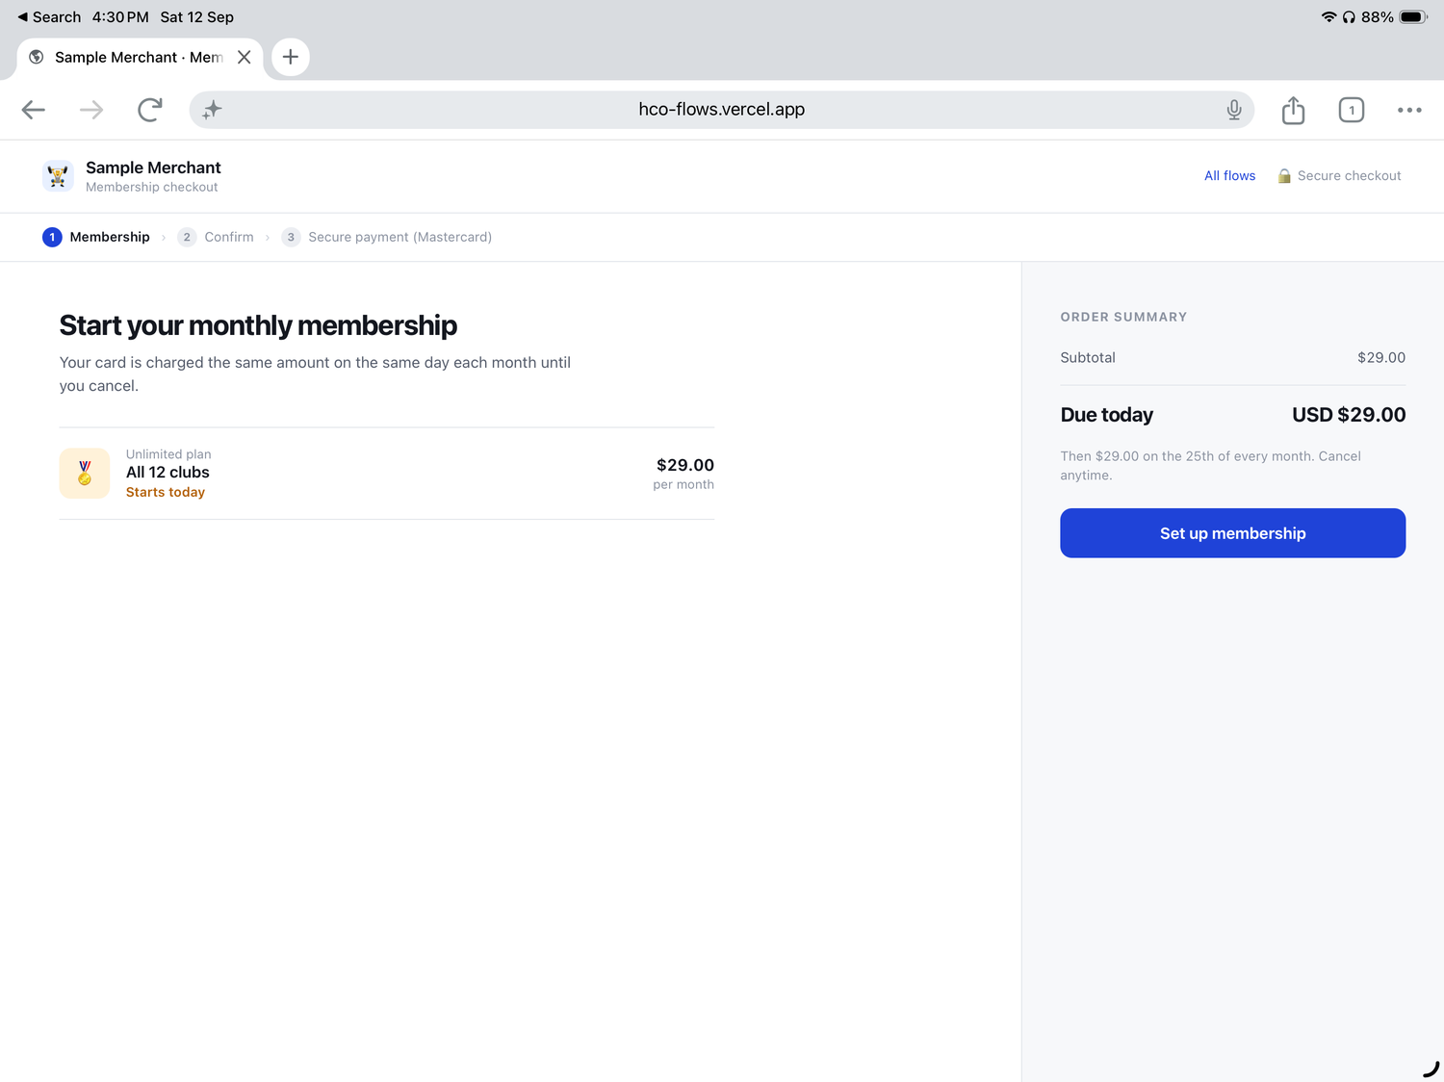
$29.00 per month, billed on the same day each month until cancelled. The order summary states both the amount due today and what happens afterwards.
2. Confirm the plan and authorise the series
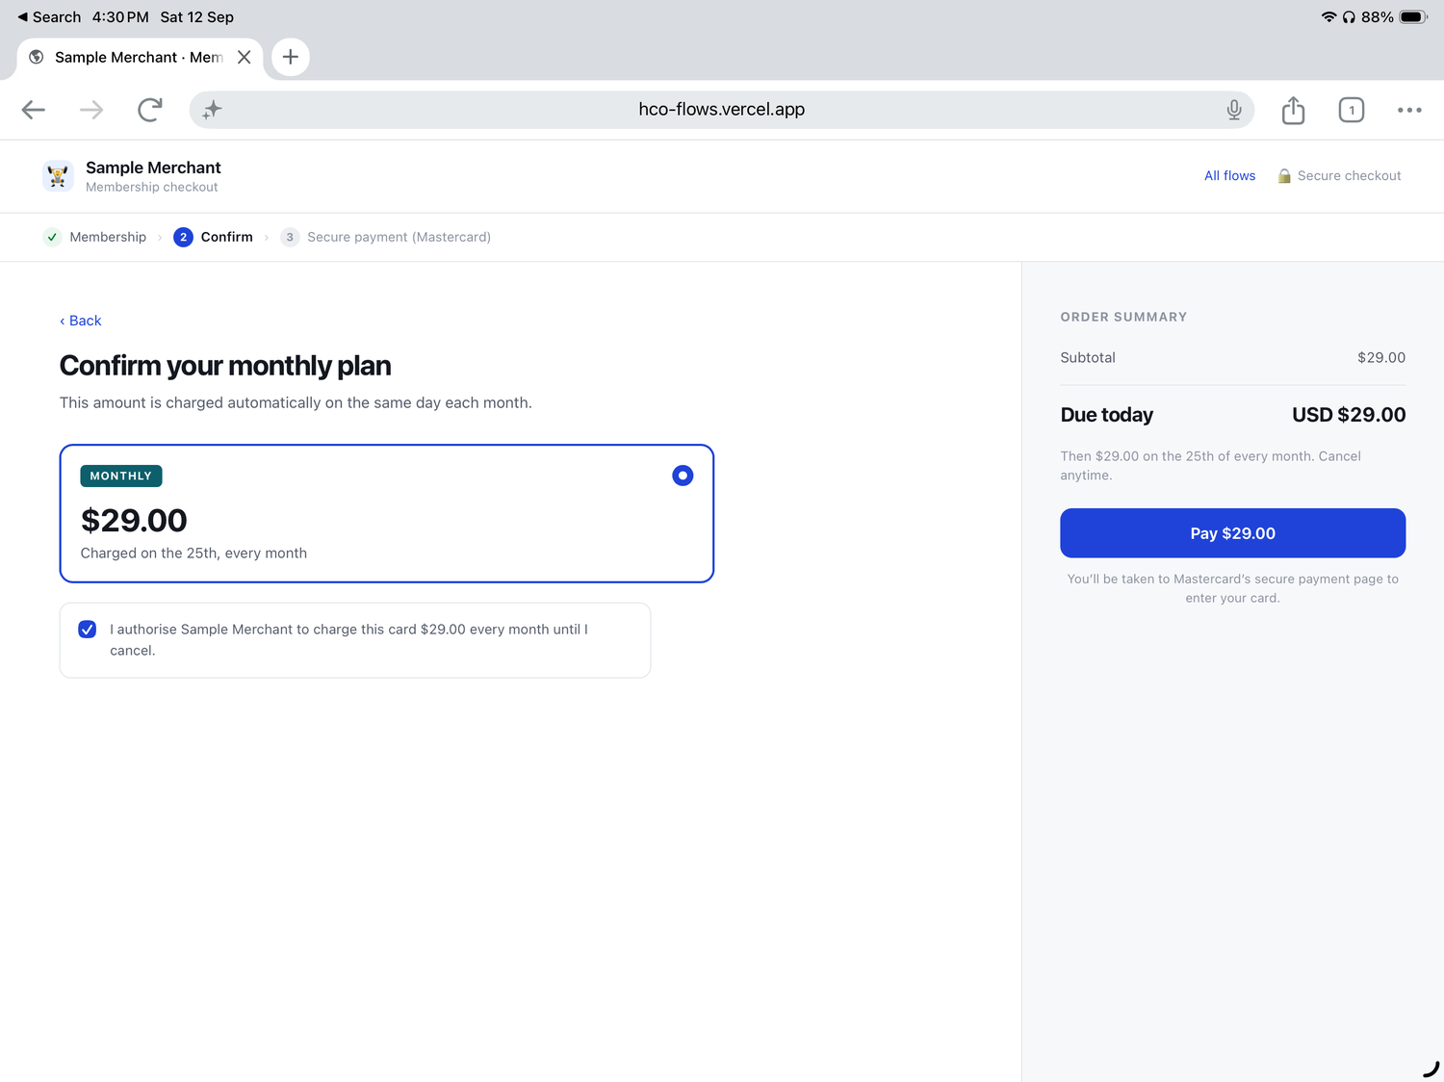
The amount, the billing day and an explicit authorisation to charge that amount every month until cancellation. For a recurring series this consent is the basis every later merchant-initiated charge rests on — capture it and keep it.
3. The hosted page opens for the first payment
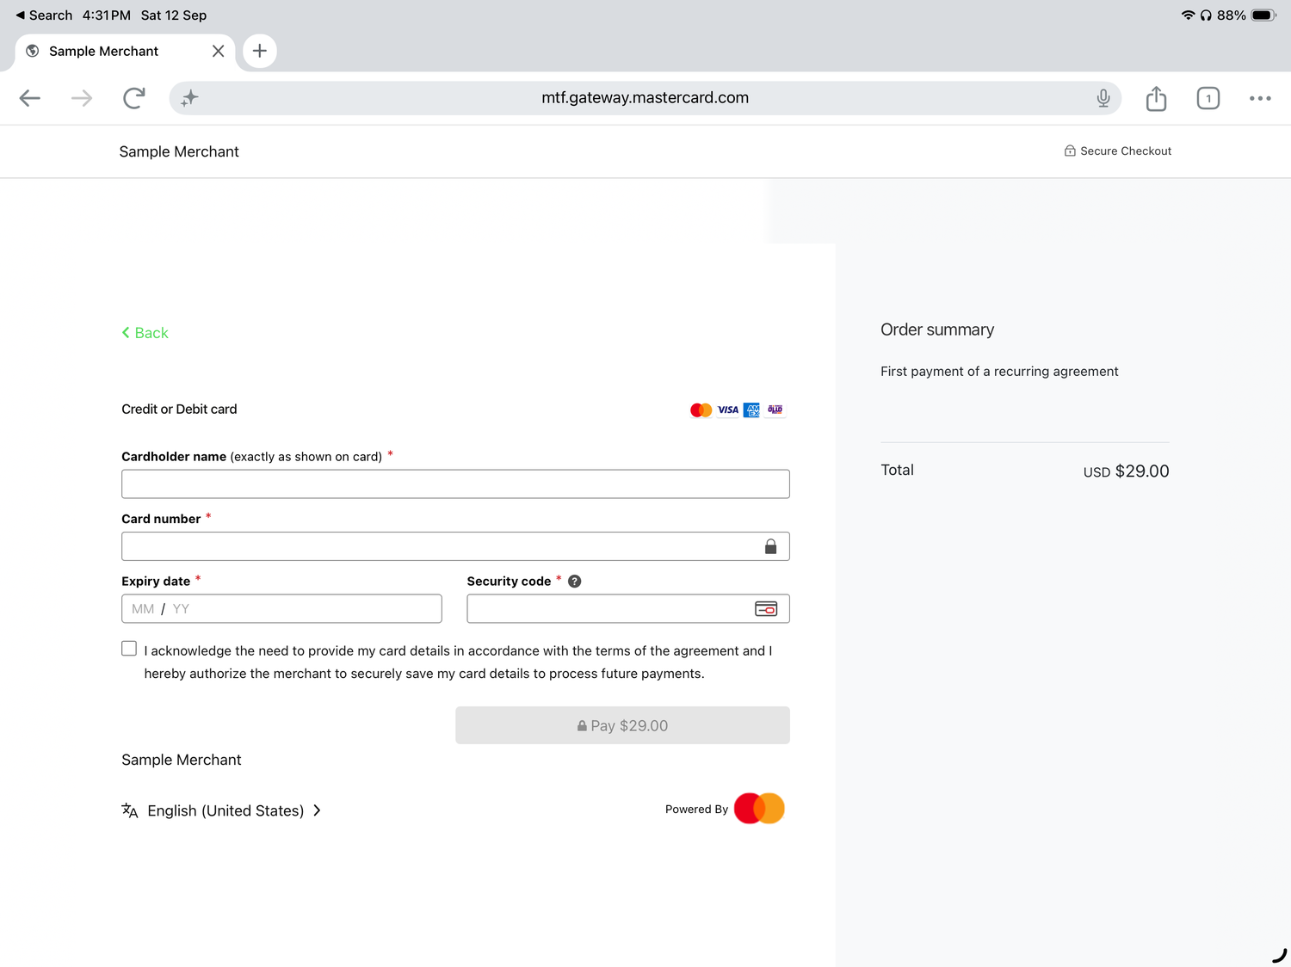
Two things differ from flow 1. The order summary reads “First payment of a recurring agreement”, and the consent line is agreement-specific: the cardholder acknowledges the terms of the agreement and authorises the merchant to save the card for future payments. The gateway renders that wording because the session carried an agreement block.
4. Enter the card and accept the agreement terms
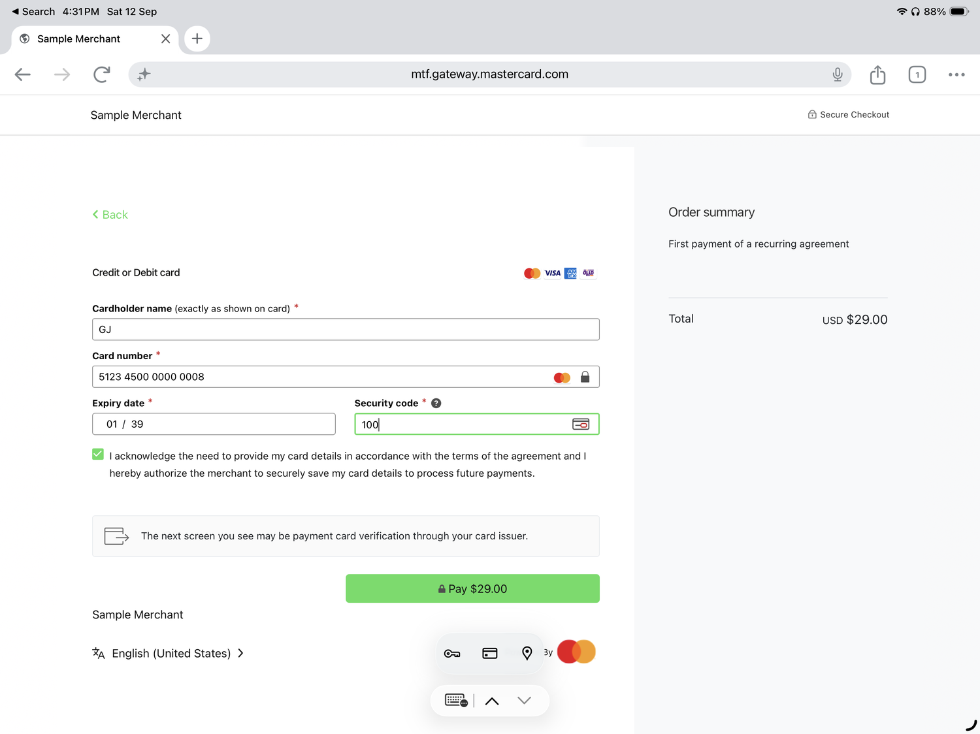
The Pay button only enables once the acknowledgement is ticked. (The green accent is the merchant’s own styling, set through the session’s style options.)
5. Complete 3-D Secure
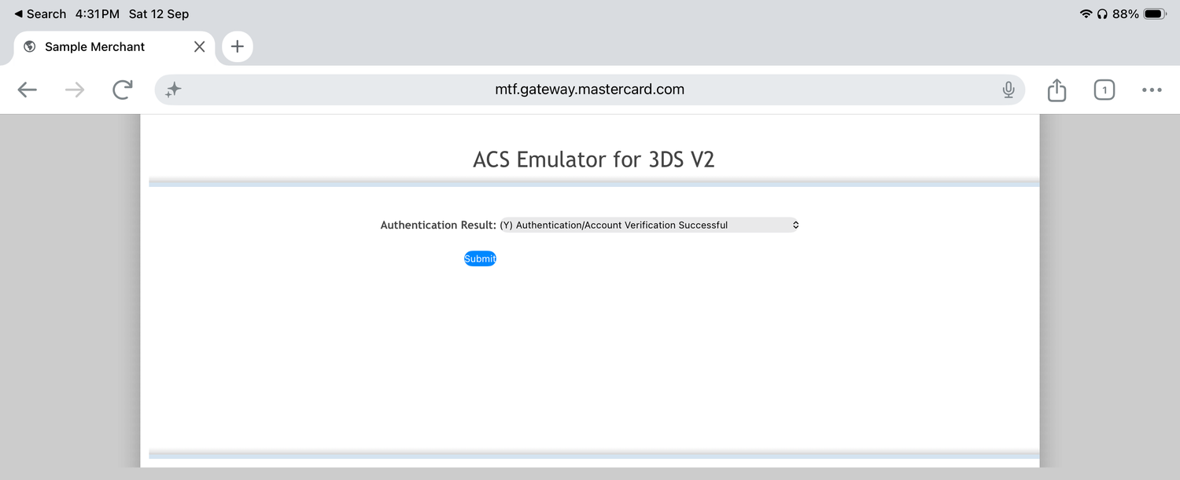
Authenticating the cardholder on this first, cardholder-present payment is what lets the later merchant-initiated charges run without a challenge.
6. The agreement is registered
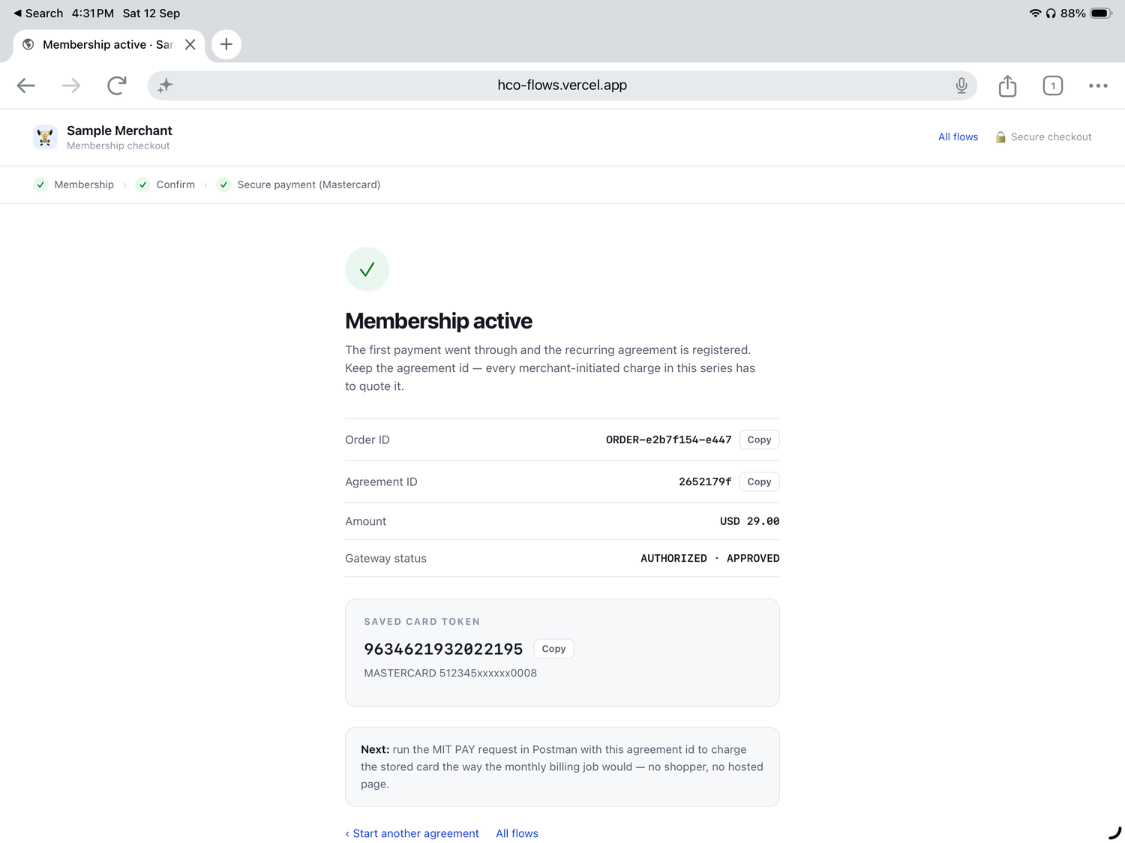
Two identifiers to keep: the Agreement ID (2652179f in this run) and the saved card token (9634621932022195). Every later charge in the series quotes both. Gateway status is AUTHORIZED · APPROVED for the first payment.
What happens on the gateway
1. First payment — cardholder-initiated, registers the agreement
POST https://{{host}}/api/rest/version/{{version}}/merchant/{{merchantId}}/session
{
"apiOperation": "INITIATE_CHECKOUT",
"interaction": { "operation": "AUTHORIZE", "merchant": { ... } },
"agreement": {
"id": "2652179f",
"type": "RECURRING",
"expiryDate": "2029-08-25",
"amountVariability": "FIXED",
"minimumDaysBetweenPayments": 29
},
"order": {
"id": "ORDER-e2b7f154-e447",
"amount": "29.00",
"currency": "USD",
"description": "First payment of a recurring agreement"
}
}
Field | Why it is there
agreement.id | Your identifier for the series. Generate it, store it, and quote it on every later charge. The result screen shows it so you can copy it into Postman.
agreement.type | RECURRING — a fixed series such as a subscription. Other agreement types cover instalments and unscheduled top-ups.
agreement.expiryDate | When the agreement lapses. The Postman collection computes three years out so it never goes stale.
agreement.amountVariability | FIXED, because every instalment is the same $29.00. Use VARIABLE where the amount changes, as it would for metered billing.
agreement.minimumDaysBetweenPayments | The shortest gap the scheme should expect between charges — 29 for monthly billing.

2. Later payments — merchant-initiated
No session and no hosted page. The merchant’s billing job calls the gateway directly, once per instalment, against a new order id.
PUT https://{{host}}/api/rest/version/{{version}}/merchant/{{merchantId}}/order/{{orderId}}/transaction/{{transactionID}}
{
"apiOperation": "PAY",
"agreement": { "id": "2652179f", "type": "RECURRING" },
"order": { "amount": "29.00", "currency": "USD" },
"sourceOfFunds": { "token": "9634621932022195" },
"transaction": { "source": "MERCHANT" }
}
Field | Why it is there
transaction.source | MERCHANT is what marks the payment as merchant-initiated. Without it the gateway treats the request as cardholder-present and the issuer may decline it or expect authentication.
agreement.id | Ties this charge to the series the cardholder authorised. The issuer uses it to recognise the payment as part of an agreed sequence.
sourceOfFunds.token | The stored credential from the first payment. No card number anywhere in the request.
order.id | A new order id for each instalment — one order per monthly charge, not a repeat of the first.

Reproduce it in Postman
The CIT / MIT card on the demo hub carries a Postman collection and the Gateway Environment. Import both, select the environment, and set merchantId and apiPassword to your own MTF credentials — order, agreement and transaction ids are generated for you, and the card token is captured automatically.
Folder “3. CIT → MIT — recurring agreement”:
- Initiate Checkout CIT (create agreement) — generates an agreement id and order id, then creates the session.
- Retrieve Order (capture token) — run after the first payment; stores the token in {{cardToken}}.
- PAY — merchant-initiated (MIT) — charges the stored card the way the monthly billing job would. Run it again to simulate the following month; each run takes a fresh order id and keeps the same agreement id.
- Retrieve Order (MIT) — confirms the merchant-initiated payment.
Tip: run the MIT PAY request two or three times in front of an audience. It is the clearest way to show that no cardholder, browser or hosted page is involved once the agreement exists.
Worth pointing out in a demo
- The cardholder consents once, in language they can read, and that consent carries the whole series.
- The agreement id is the thread connecting the first payment to every charge that follows.
- Authentication happens on the first, cardholder-present payment — later charges run unattended.
- Nothing sensitive is stored by the merchant: an agreement id, a token, and a masked card for display.

