Flow 1 — Save a card
Mastercard Hosted Checkout · Credential on File · hco-flows.vercel.app
What this flow shows
The cardholder makes a small verification payment and agrees that the card may be kept on file. The gateway stores the card and hands back a token — a number that stands in for the card. The merchant keeps the token and never holds the card number.
Run this flow first. Flows 2 and 3 both spend the credential it produces.
Before you start
- On the hub, choose Flow 1, “Save a card”.
- Open https://hco-flows.vercel.app in a browser.
- Test card (MTF): 5123 4500 0000 0008 · expiry 01/39 · security code 100.
- The 3-D Secure screen is the MTF ACS emulator, not a real bank. Leave the result on “(Y) Authentication/Account Verification Successful” and press Submit.
- Everything runs against the Mastercard test environment (mtf.gateway.mastercard.com). No real money moves.
Step by step
1. Start at the demo hub
All three flows are served from one origin, which is how the token saved here becomes available to flow 2 without anything being copied by hand.
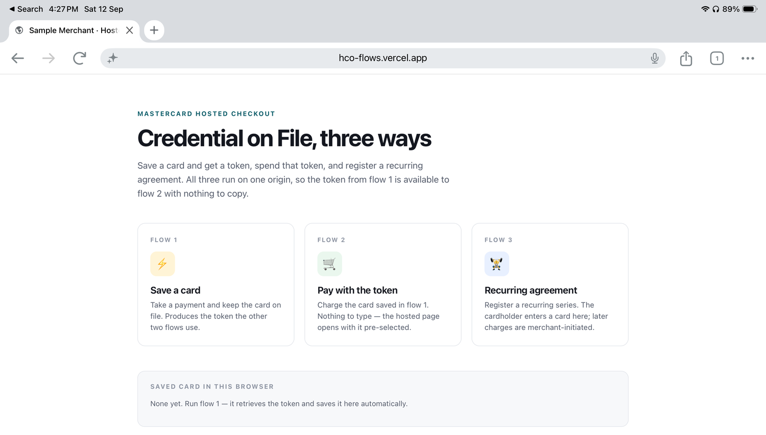
On a first run the “Saved card in this browser” panel is empty — nothing has been stored yet.
2. Begin the account setup
The merchant states plainly why it wants the card: $1.00 is charged now to verify it, and the card is then kept for later sessions.
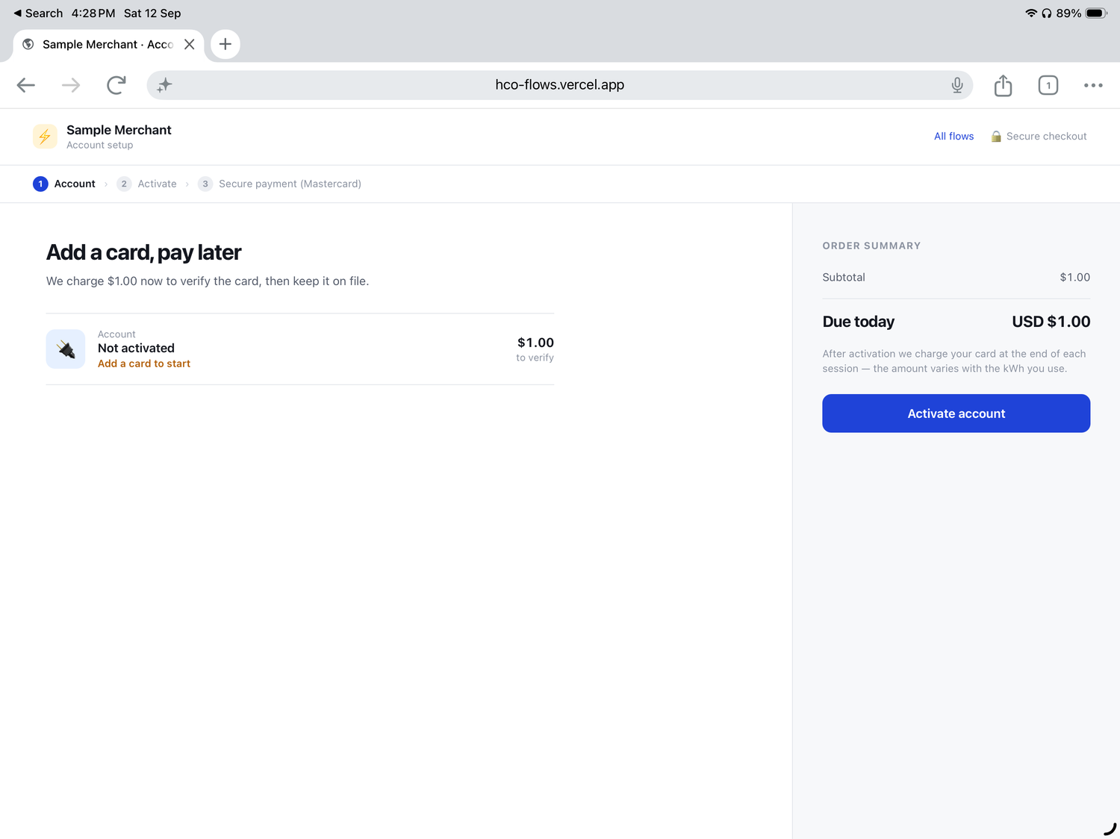
This is the merchant’s own page (hco-flows.vercel.app). There are no card fields on it — the merchant never collects card data itself.
3. Show the amount and take consent
The cardholder sees the verification amount and ticks an explicit authorisation.
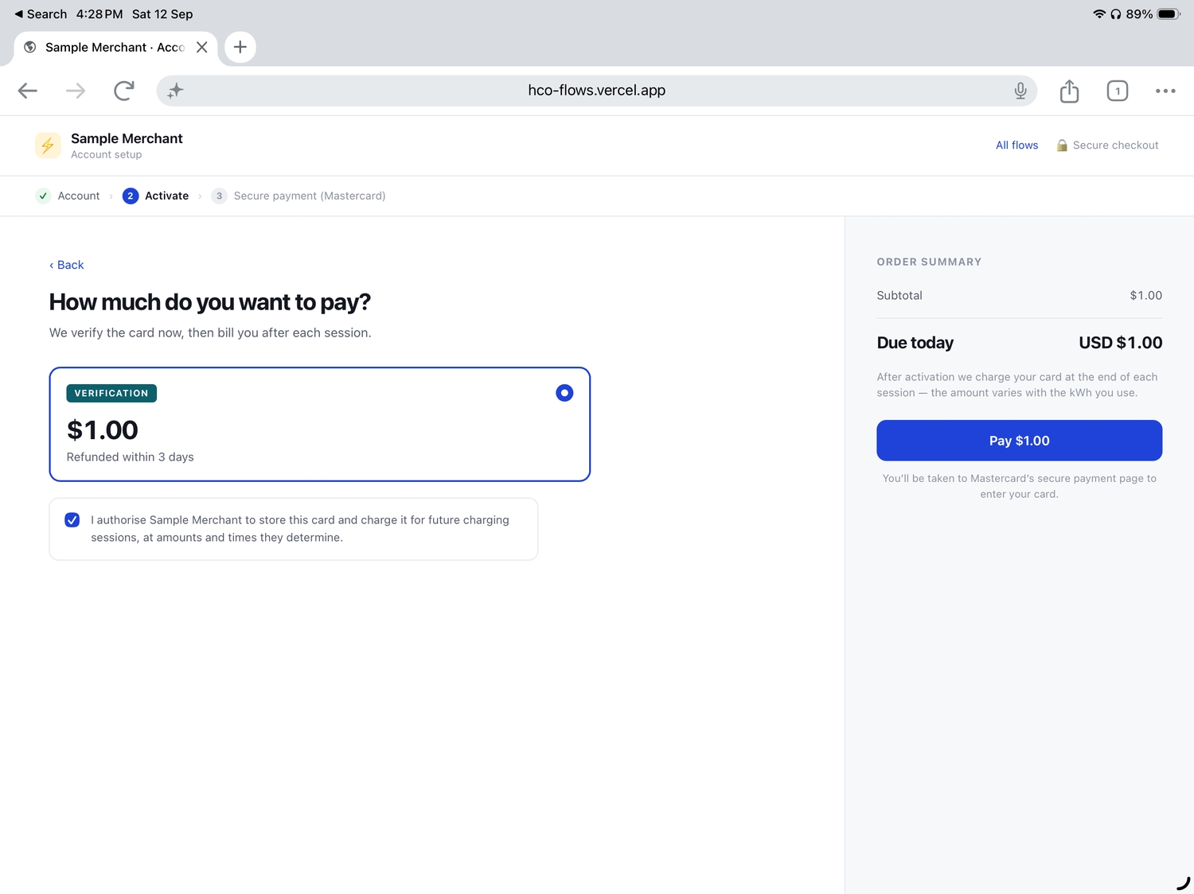
The authorisation checkbox is the part that matters commercially: the cardholder is told, in plain language, that the merchant will store the card and charge it later. Card scheme rules for credential-on-file require that consent to be captured and retained.
4. The hosted payment page opens
The merchant creates a checkout session on the gateway and redirects the browser to Mastercard’s hosted page using the session id it gets back.
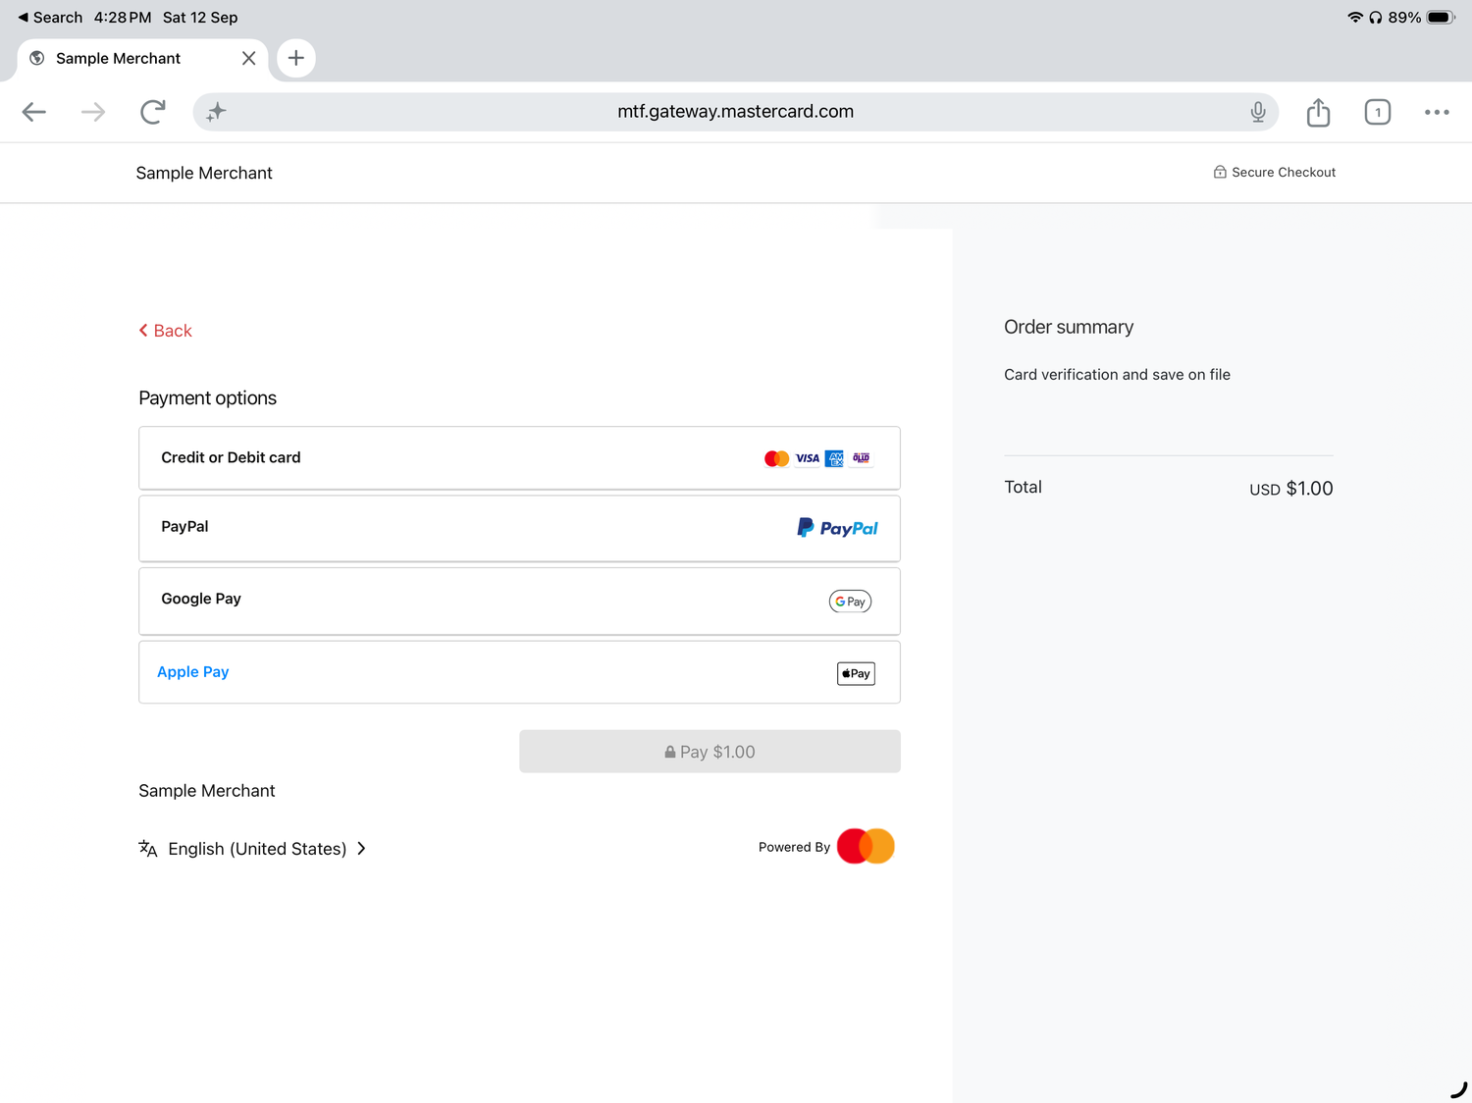
Check the address bar — the browser is now on mtf.gateway.mastercard.com, not on the merchant’s site. The order summary reads “Card verification and save on file”.
5. Enter the card
Card details are typed into Mastercard’s page. They never reach the merchant’s servers, which is what keeps the merchant’s PCI scope small.
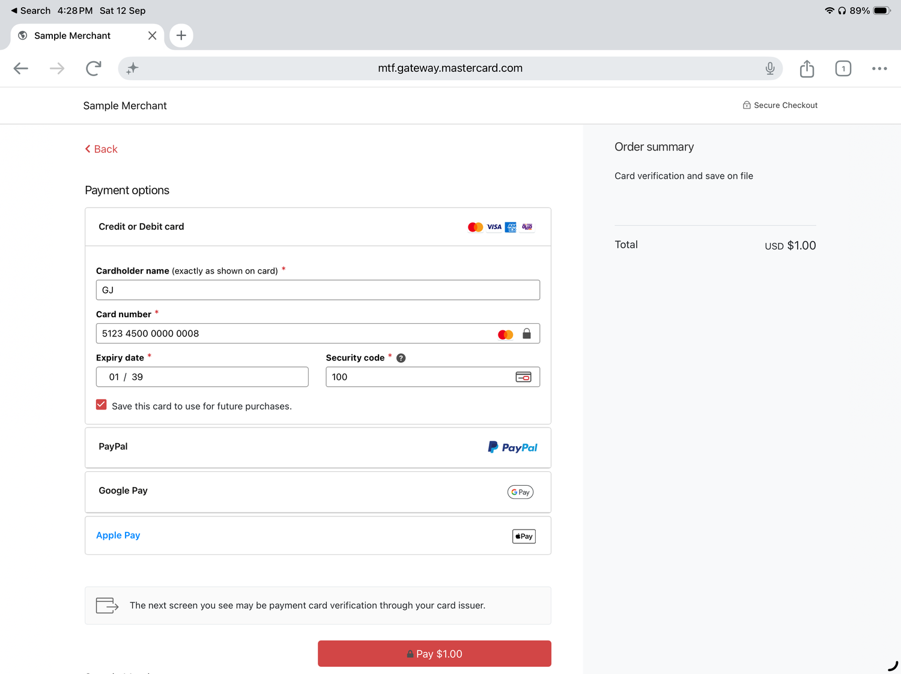
“Save this card to use for future purchases” appears because the session asked for the credential to be stored. Test card 5123 4500 0000 0008, expiry 01/39, security code 100.
6. Complete 3-D Secure
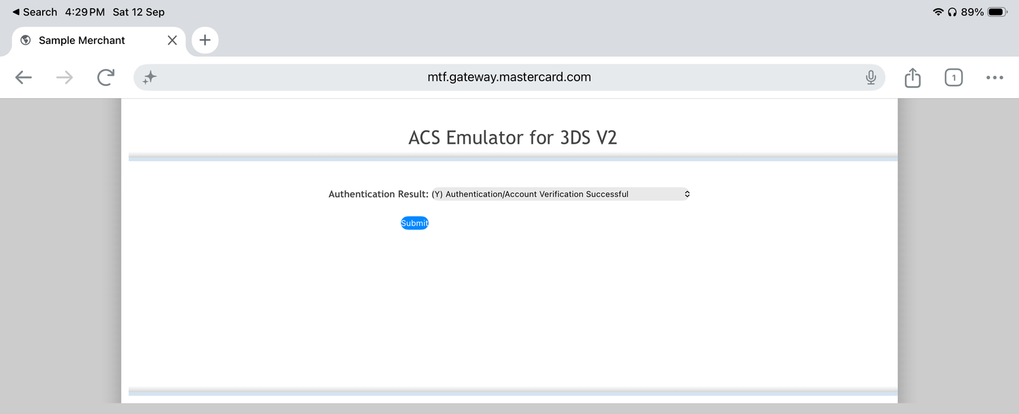
In MTF the issuer step is emulated. Choose “(Y) Authentication/Account Verification Successful” and Submit. In production this is the real issuer challenge — setting up a credential on file is a sensible moment to authenticate the cardholder.
7. The card is on file
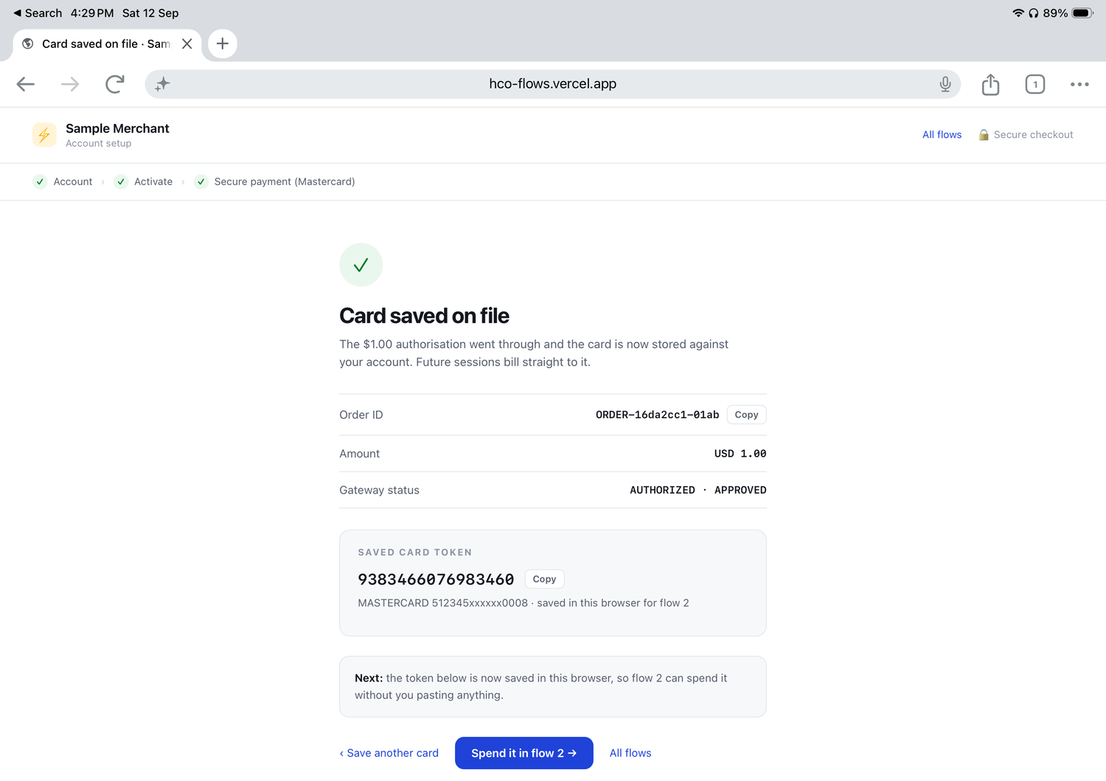
The result screen reports the order and, most importantly, the saved card token (9383466076983460 in this run) against a masked card number. The token is what the merchant stores, and what the other two flows use.
What happens on the gateway
Two API calls do the work.
1. Create the checkout session
POST https://{{host}}/api/rest/version/{{version}}/merchant/{{merchantId}}/session
{
"apiOperation": "INITIATE_CHECKOUT",
"interaction": {
"operation": "AUTHORIZE",
"saveCardForCredentialOnFile": "PAYER_INITIATED_PAYMENTS",
"merchant": { "name": "Sample Merchant", "url": "https://..." },
"returnUrl": "https://..."
},
"order": {
"id": "ORDER-16da2cc1-01ab",
"amount": "1.00",
"currency": "USD"
}
}
Field | Why it is there
interaction.operation | AUTHORIZE reserves the amount rather than taking it. That is why the result screen reads AUTHORIZED · APPROVED — a separate capture (or a void) would follow.
interaction.saveCardForCredentialOnFile | Tells the gateway to store the card and show the “save this card” option on the hosted page. PAYER_INITIATED_PAYMENTS records that the payer will initiate the later payments — which is exactly what flow 2 does.
order.amount | The verification amount. $1.00 here; many merchants save the card during a real purchase instead.
session.id (response) | Returned by the gateway and handed to Checkout so the hosted page can be opened for this order.

2. Read the token back
GET https://{{host}}/api/rest/version/{{version}}/merchant/{{merchantId}}/order/{{orderId}}
"sourceOfFunds": {
"token": "9383466076983460",
"provided": { "card": { "number": "512345xxxxxx0008", "brand": "MASTERCARD" } }
}
The merchant stores that token against its customer record. The card number it sees is masked and is only ever for display.
Reproduce it in Postman
The CIT / MIT card on the demo hub carries a Postman collection and the Gateway Environment. Import both, select the environment, and set merchantId and apiPassword to your own MTF credentials — order, agreement and transaction ids are generated for you, and the card token is captured automatically.
Folder “1. CIT — Checkout & save the card”:
- Initiate Checkout (save card) — creates the session; the test script saves the session id.
- Retrieve Order (capture token) — run it after the payment completes; it stores the token in {{cardToken}}.
- Retrieve Token — shows what the gateway holds against that token: masked card, expiry, status.
Worth pointing out in a demo
- The merchant never sees or stores a card number — only a token.
- Consent is explicit, on screen, and recorded before the card is stored.
- The token is stable: the merchant reuses the same value for every later payment.
- Verifying with a small amount is one pattern; saving the card during an ordinary purchase works the same way.

