Mastercard Gateway Test App
Hosted Session + 3DS — Application User Guide
Version 1.0.0

Executive Summary
This document is a step-by-step guide for Sales and CTS (Customer Technical Support) teams to validate this payment scenario in the Mastercard Gateway MTF (Merchant Test Facility) environment.
In a Hosted Session integration, the merchant renders its own payment form but the card data is captured directly into a gateway-hosted session, so the merchant never handles raw card data on its server. The session is then used to complete the payment with 3-D Secure authentication. This demo uses a fixed configuration (no configuration UI).
Step-by-Step Flow
Step 1: Start from the cart
Review the shopping cart and order summary (subtotal, tax, shipping and total), then select Proceed to Payment.
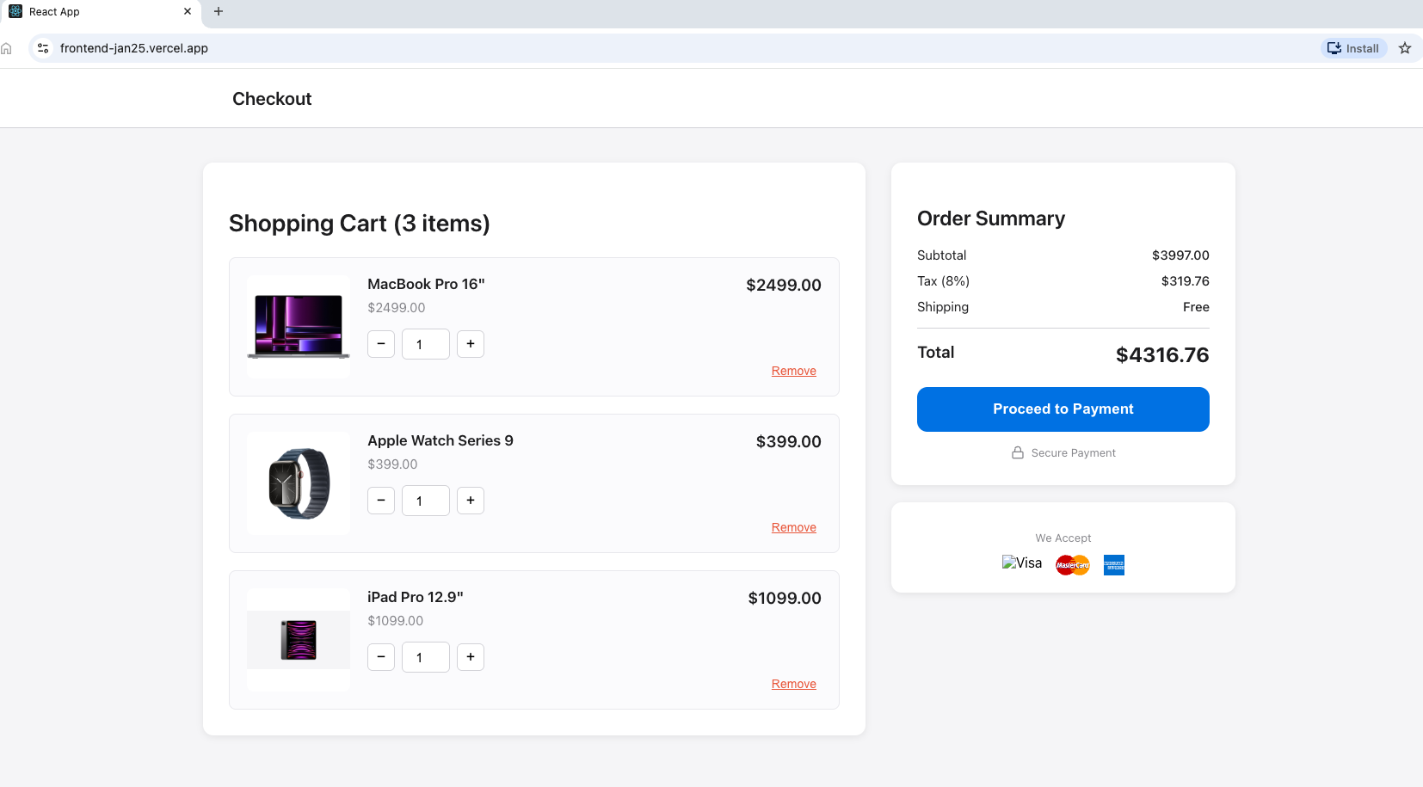
Checkout — shopping cart and order summary; select Proceed to Payment.
Step 2: Enter card details on the Secure Checkout page
The Secure Checkout page shows the Order Summary and the Payment Method options. With Credit or Debit Card selected, the Card Details form displays the Session ID, Order ID and Transaction ID. Enter the card number, expiry month/year, CVV and cardholder name, then select Pay. Example MTF test card: 5123 4500 0000 0008, expiry 01/39, security code 100.
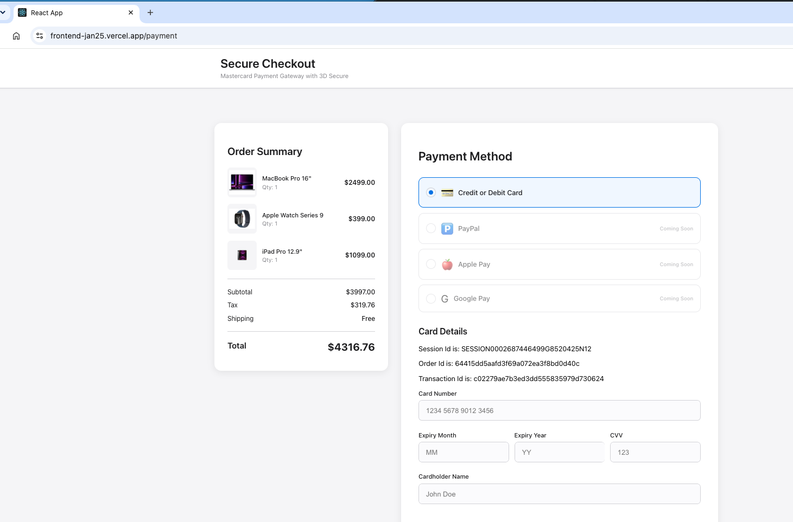
Secure Checkout — Hosted Session payment form with session details.
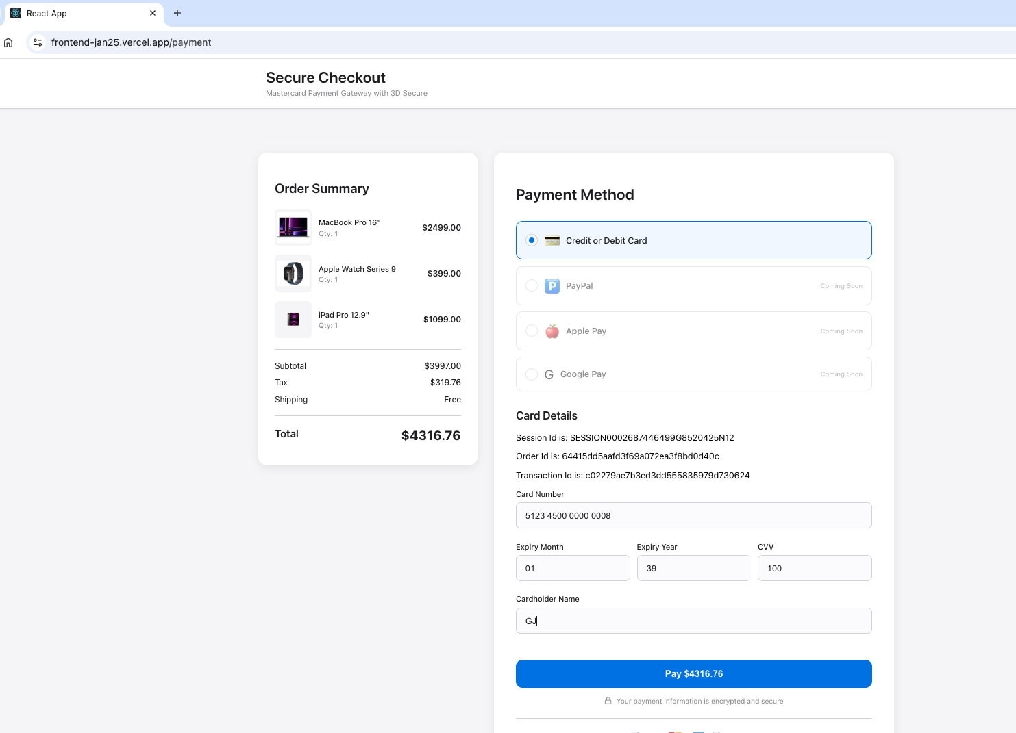
Card details entered directly on the merchant page; select Pay.
Step 3: Complete 3-D Secure authentication
The 3-D Secure challenge appears (ACS Emulator for 3DS V2). Select the authentication result and Submit to complete authentication.
Important: This emulator screen appears only in test environments. In production the shopper completes real issuer authentication.
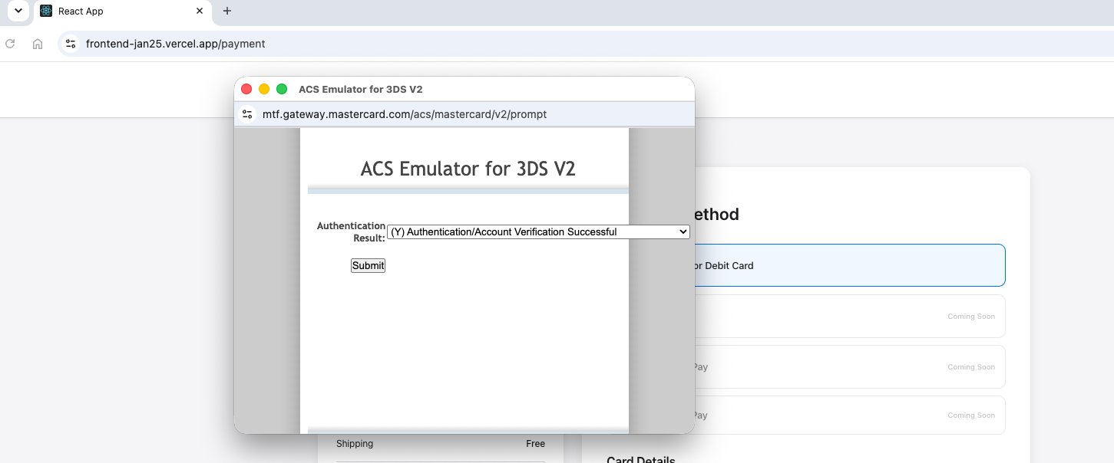
3-D Secure V2 — ACS Emulator authentication result, then Submit.
Step 4: Confirmation
The Payment Successful screen confirms the order with the Order Details, Items Purchased, Payment Summary and Transaction Details — Status (e.g. CAPTURED), Gateway Code (e.g. APPROVED) and Recommendation (e.g. PROCEED).
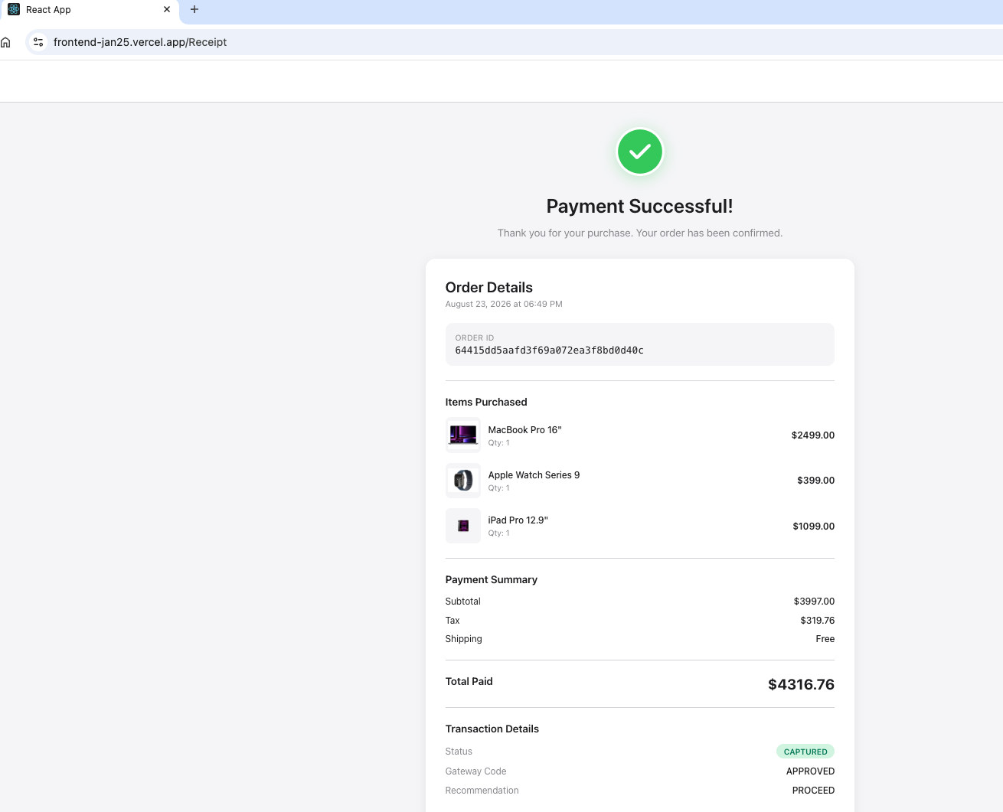
Payment Successful — order details, payment summary and transaction details (CAPTURED).
Questions & Feedback
For any queries or improvements, reach out to Gaurav.joshi@mastercard.com

