YOSIA IMMANUEL BASTIAN
JC DATA ENGINEER BATCH 008
PURWADHIKA DIGITAL TECHOLOGY SCHOOL

Create table products dan insert data products
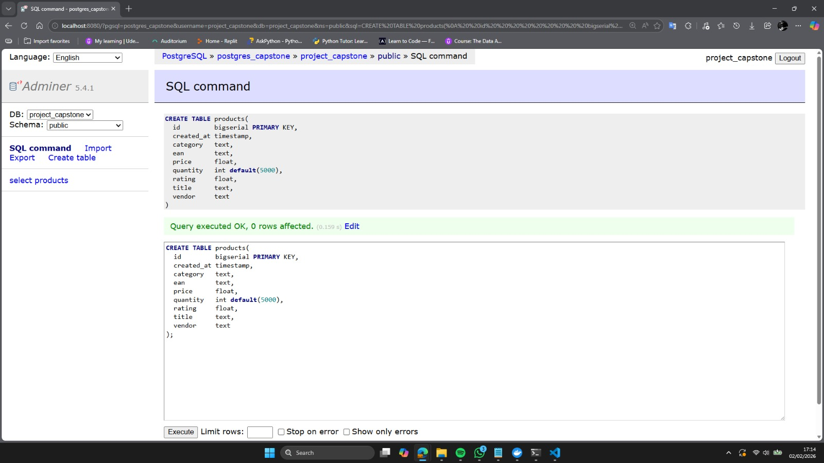

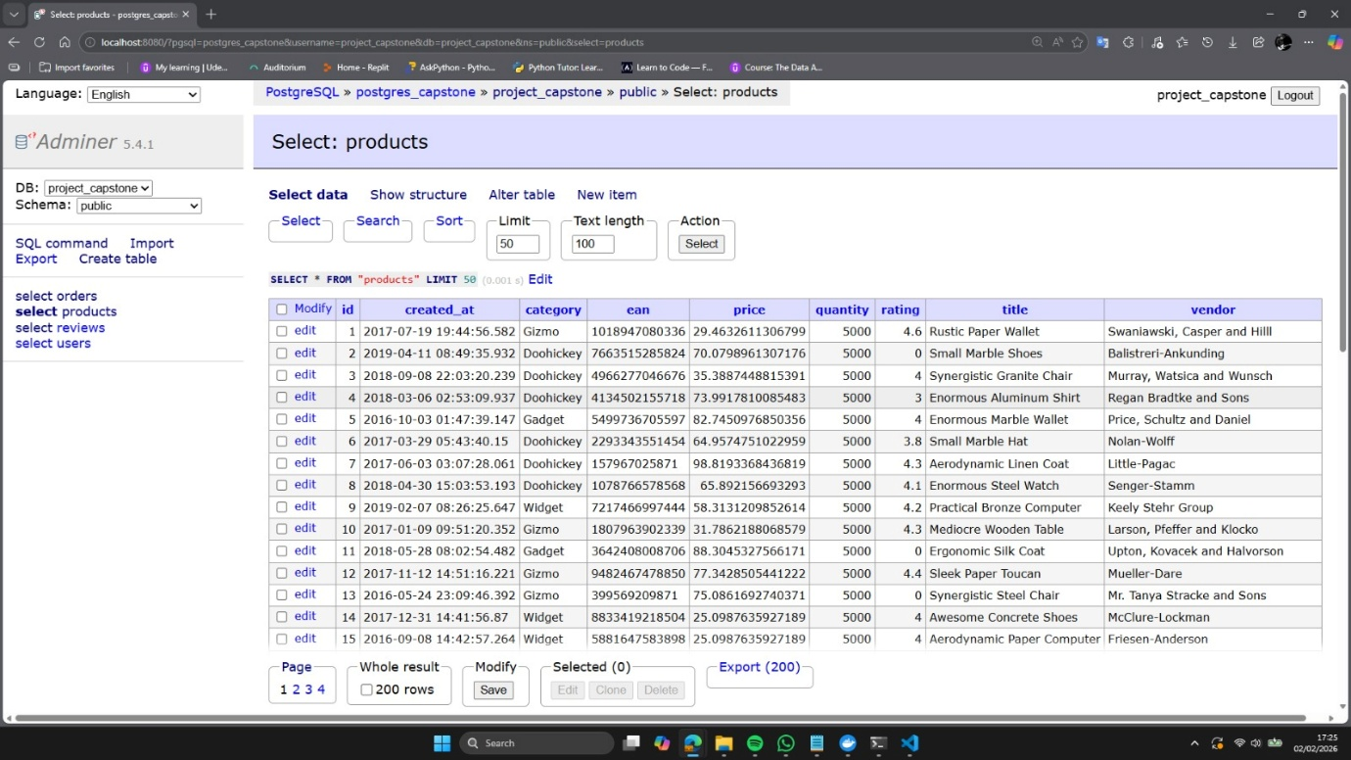

Create table users dan insert data users
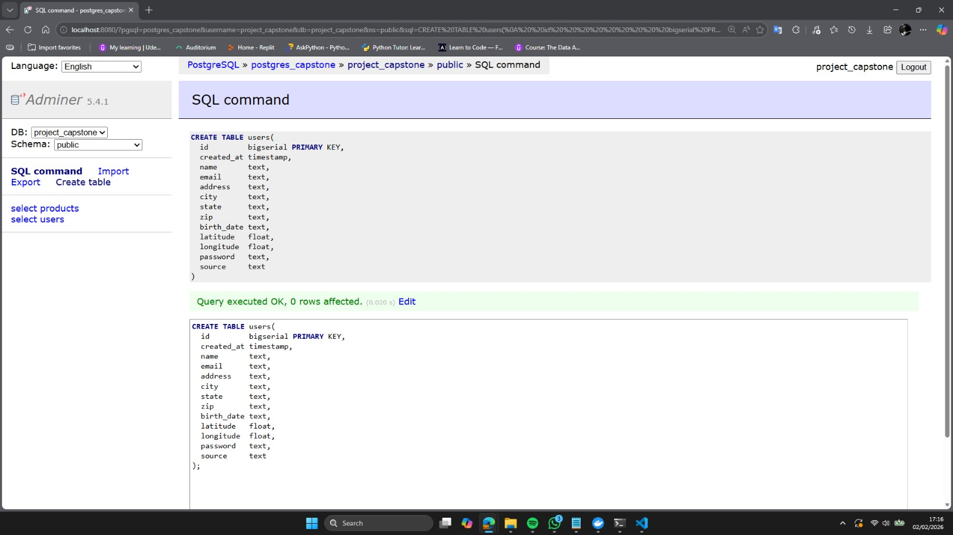

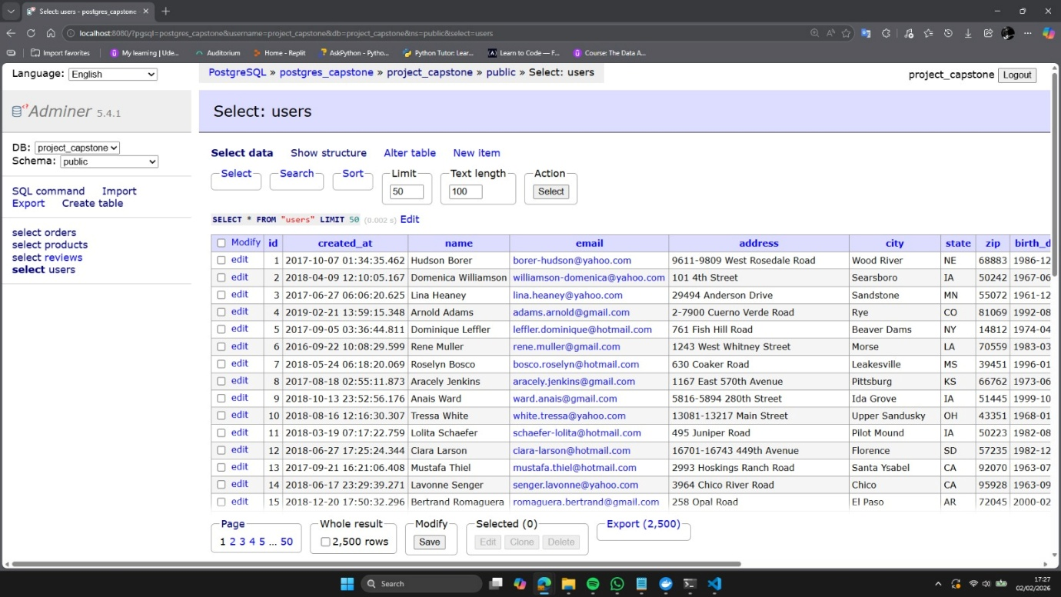

Create table orders dan insert data orders
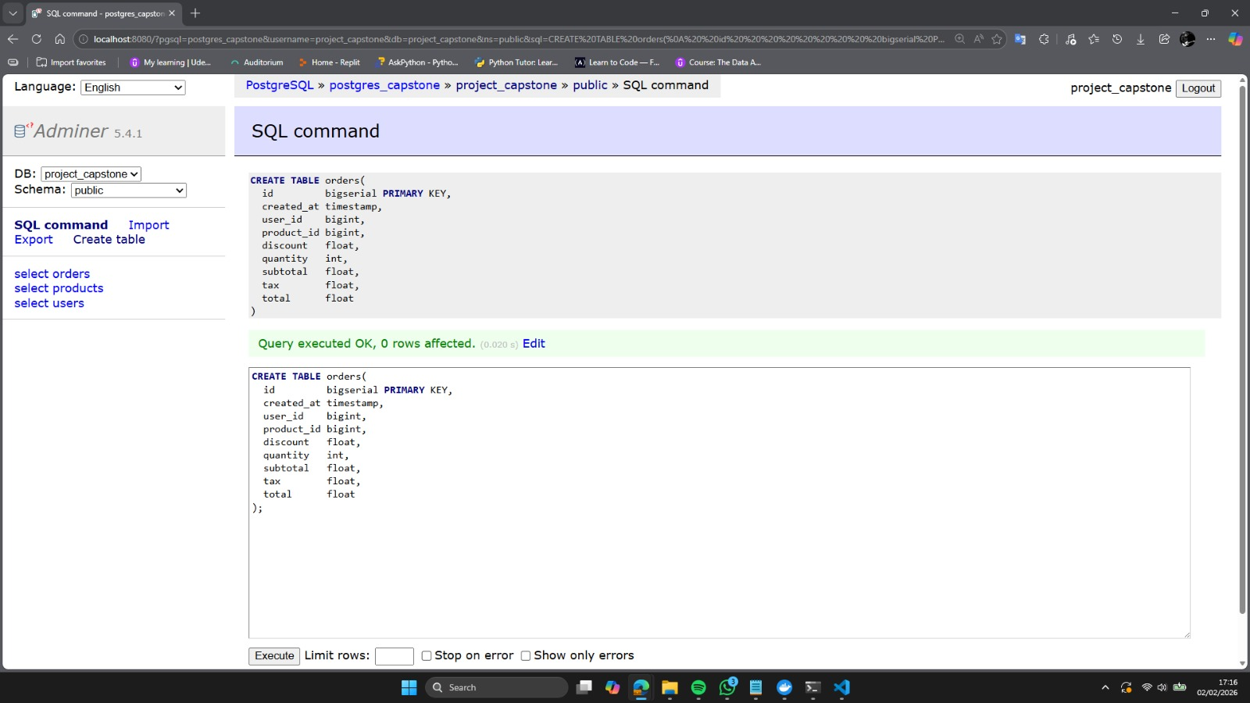

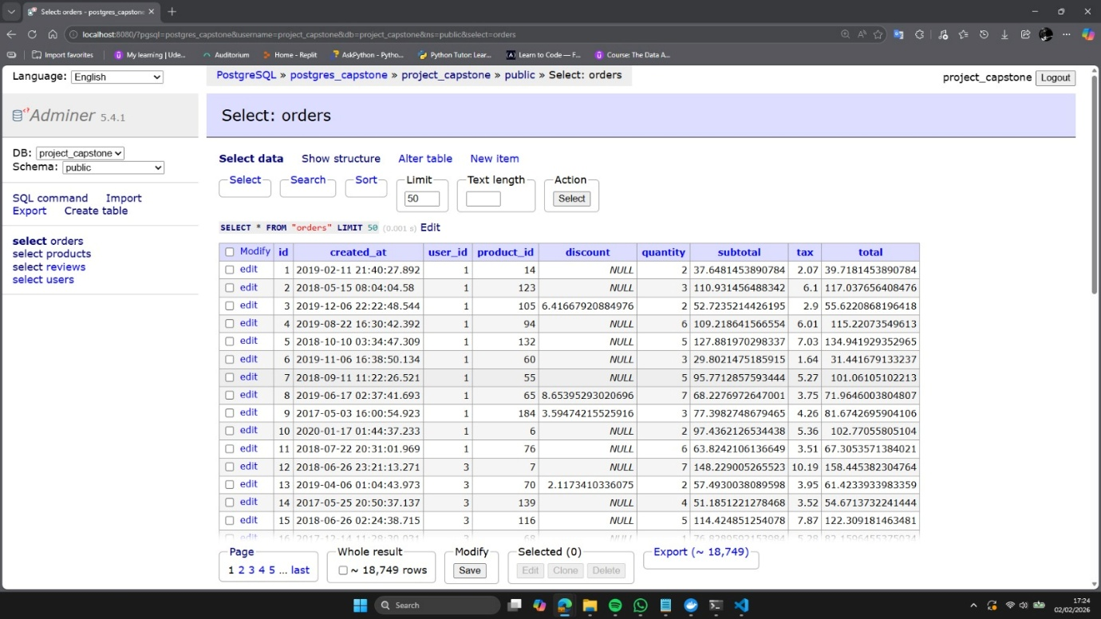

Create table reviews dan insert data reviews
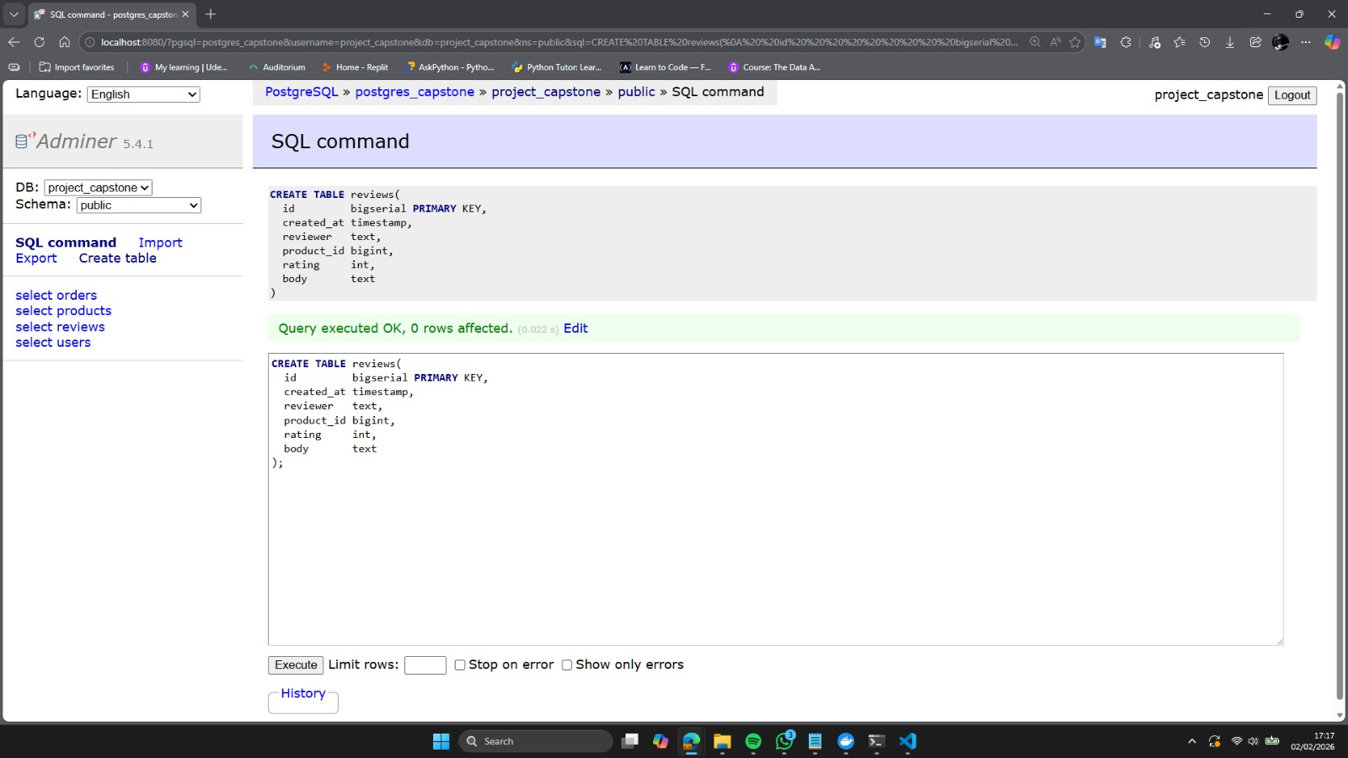

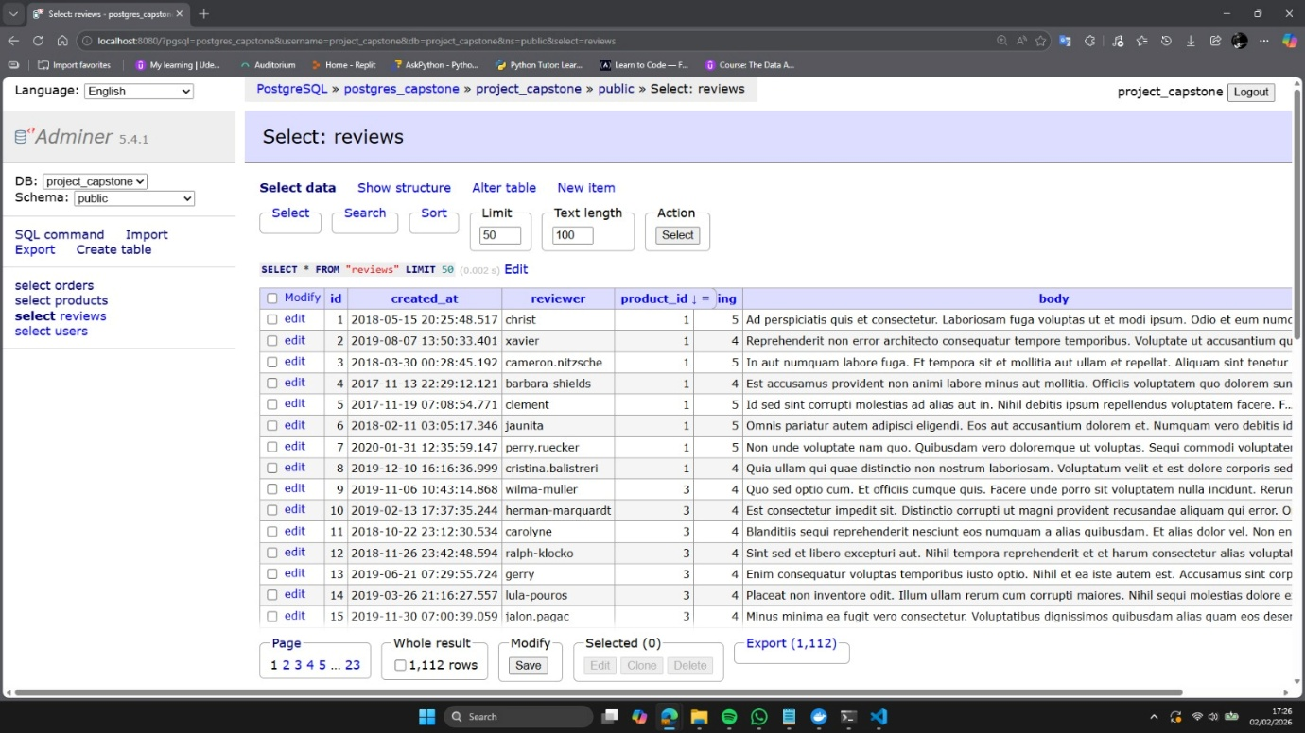

Pertanyaan | : | Hitunglah ada berapa banyak transaksi di table Order?  Aggregate COUNT pada kolom Id.
Jawaban | : | SELECT COUNT(id) AS total_transaksi  FROM orders;

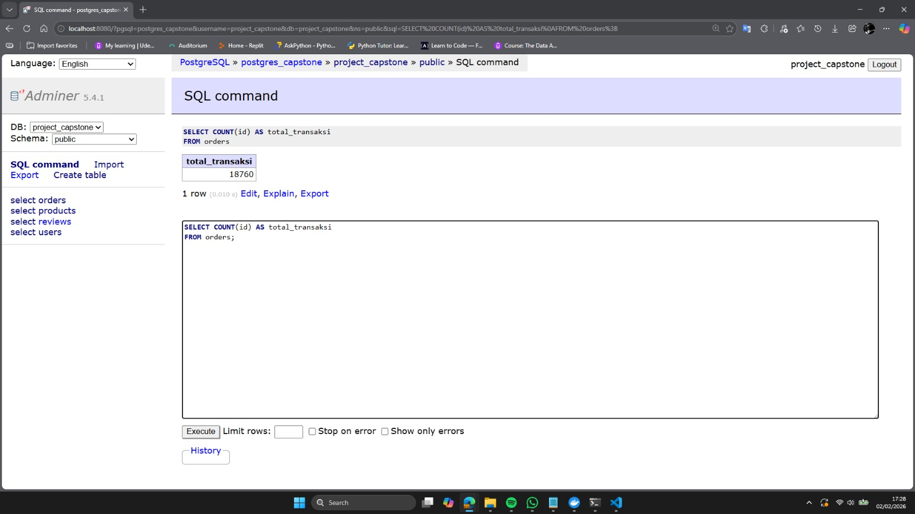

Pertanyaan | : | Hitunglah berapa jumlah Order dari seluruh transaksi di Table Order?  Aggragate SUM pada kolom Total.
Jawaban | : | SELECT SUM(total) AS jumlah_order  FROM orders;

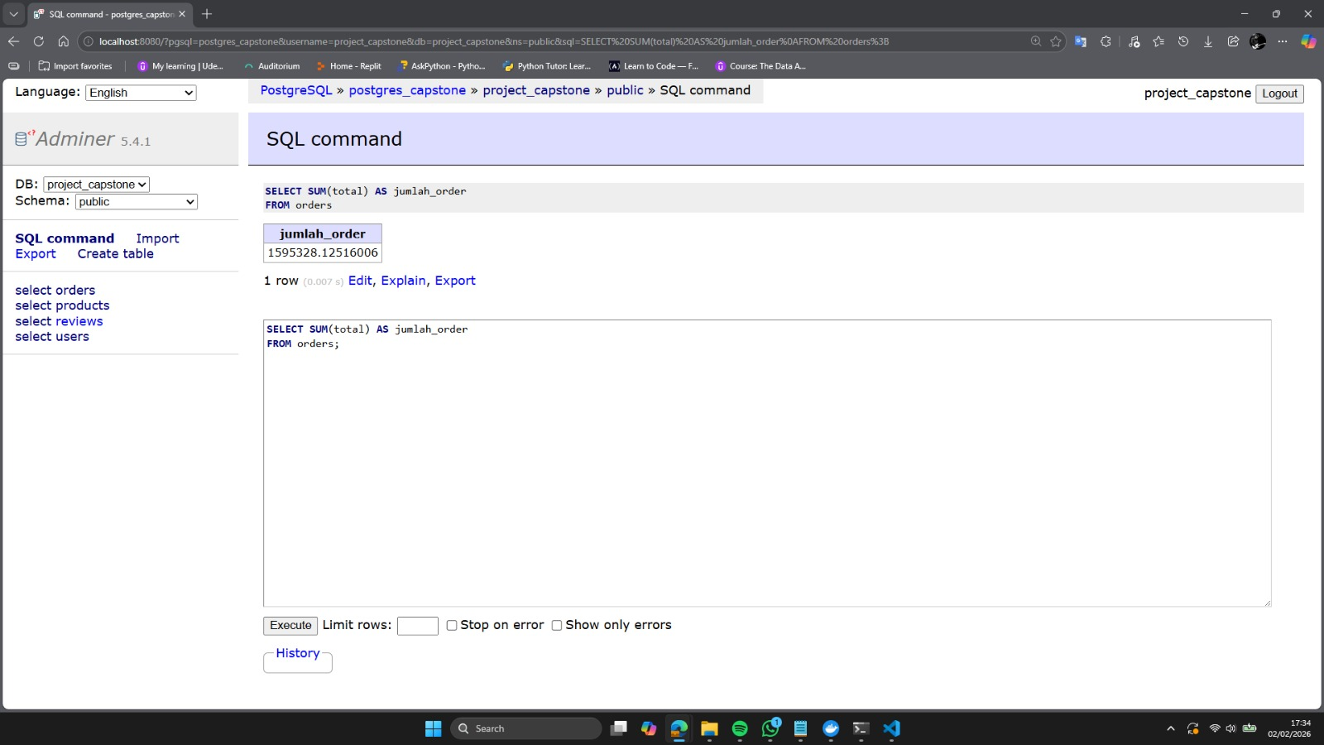

Pertanyaan | : | Hitung 10 product yang sering memberikan discount di tabel Order berdasarkan produk Title dari table Products?
Jawaban | : | SELECT  p.title,  COUNT(o.id) AS total_transaksi  FROM orders o  JOIN products p ON o.product_id = p.id  WHERE o.discount IS NOT NULL  GROUP BY p.title  ORDER BY total_transaksi DESC  LIMIT 10;

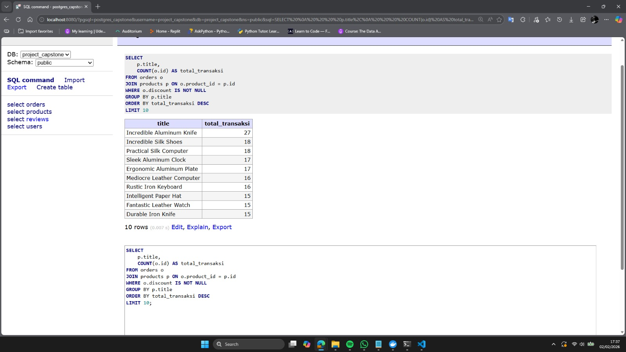

Pertanyaan | : | Hitung berapa jumlah Order dari transaksi di Table Order, berdasarkan kolom  category dari tabel produk?
Jawaban | : | WITH order_category AS (  SELECT  p.category,  o.total  FROM orders o  JOIN products p ON o.product_id = p.id  )  SELECT  category,  SUM(total) AS total_order  FROM order_category  GROUP BY category  ORDER BY total_order DESC;

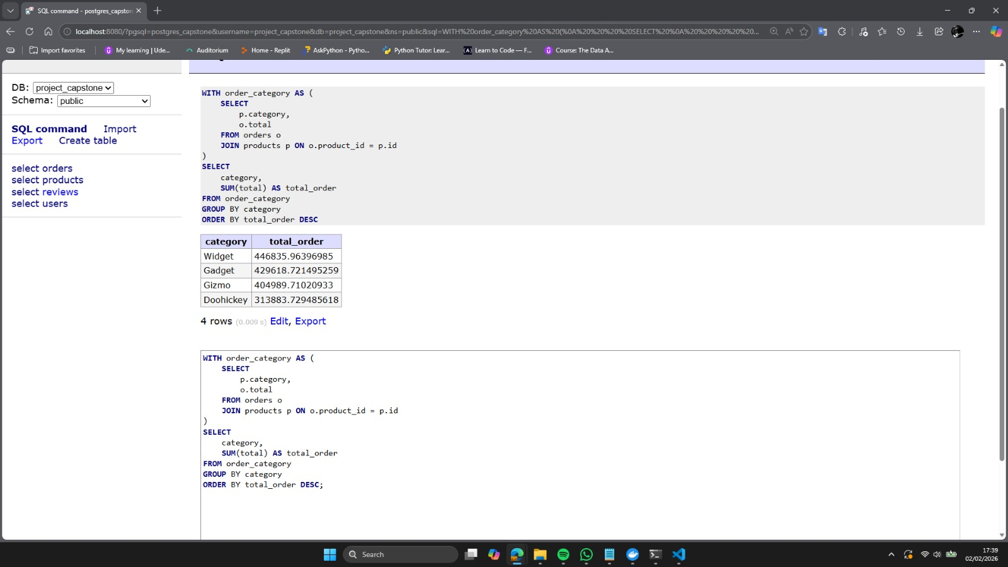

Pertanyaan | : | Hitung berapa jumlah total Order di table Order, dari setiap title di table Product  yang memiliki rating >=4?
Jawaban | : | WITH product_rating AS (  SELECT  p.title,  p.rating,  o.total  FROM orders o  JOIN products p ON o.product_id = p.id  WHERE p.rating >= 4  )  SELECT  title,  SUM(total) AS total_order  FROM product_rating  GROUP BY title  ORDER BY total_order DESC;

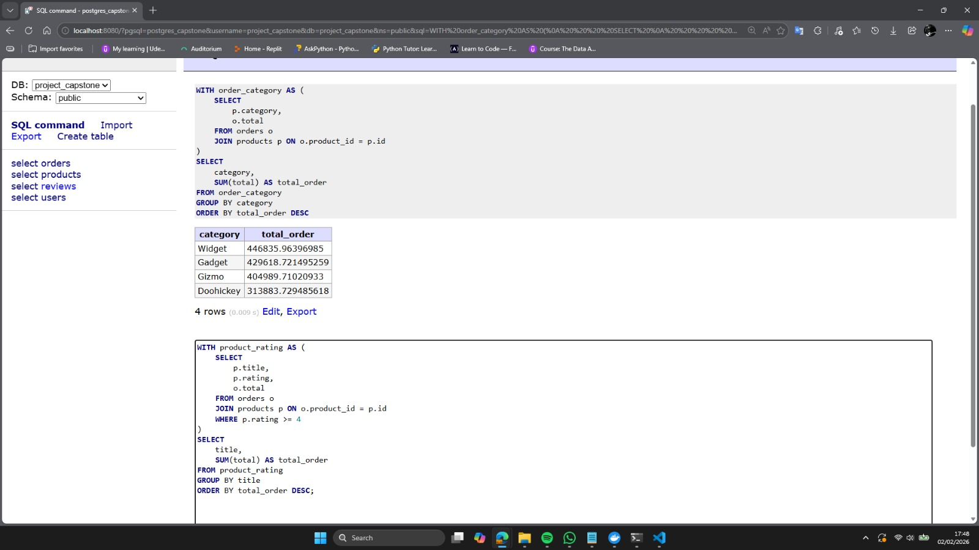

Pertanyaan | : | Dapatkan list reviews berdasarkan ketagori produk = ‘Doohickey’, dimana rating dari table reviews <= 3? Dan urutkan berdasarkan table created_at di table reviews.
Jawaban | : | WITH doohickey_reviews AS (  SELECT  r.created_at,  r.body,  r.rating,  p.category  FROM reviews r  JOIN products p ON r.product_id = p.id  WHERE p.category = 'Doohickey'  AND r.rating <= 3  )  SELECT  created_at,  body,  rating  FROM doohickey_reviews  ORDER BY created_at DESC;

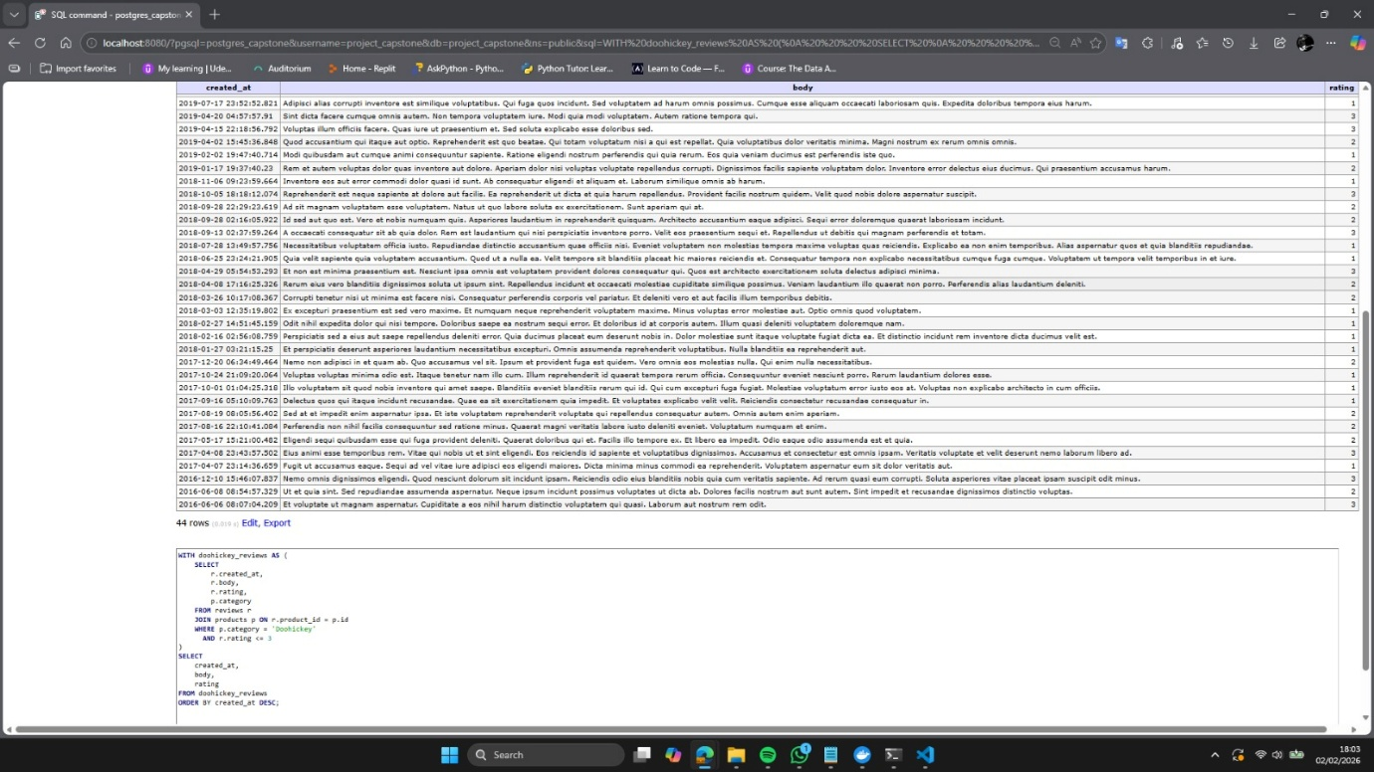

Pertanyaan | : | Ada berapa source di table Users?
Jawaban | : | SELECT DISTINCT source  FROM users;

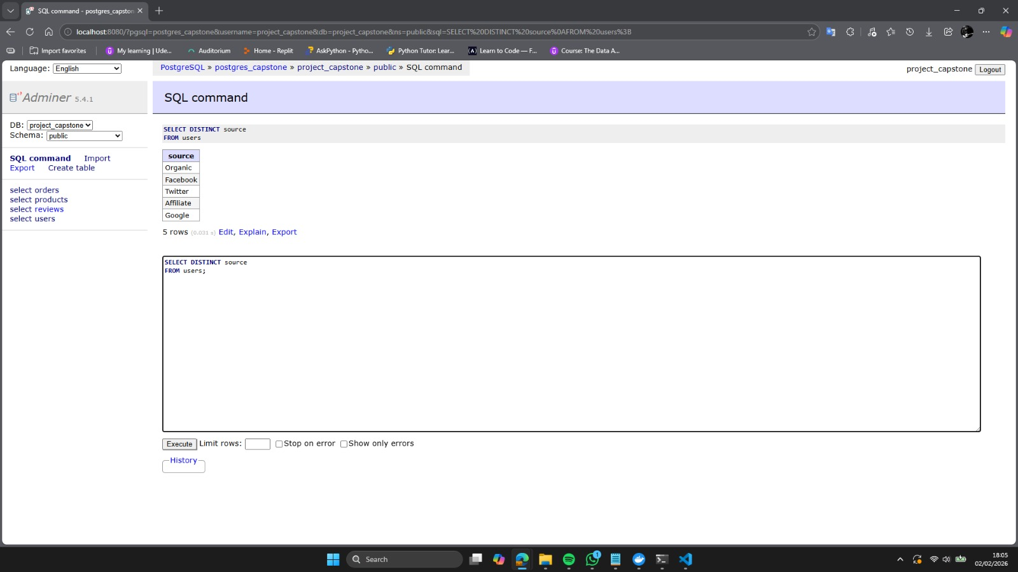

Pertanyaan | : | Hitung total user di table Users yang memiliki email dari gmail.com.  Rename kolom alias total_user_gmail.
Jawaban | : | SELECT COUNT(id) AS total_user_gmail  FROM users  WHERE email LIKE '%@gmail.com';

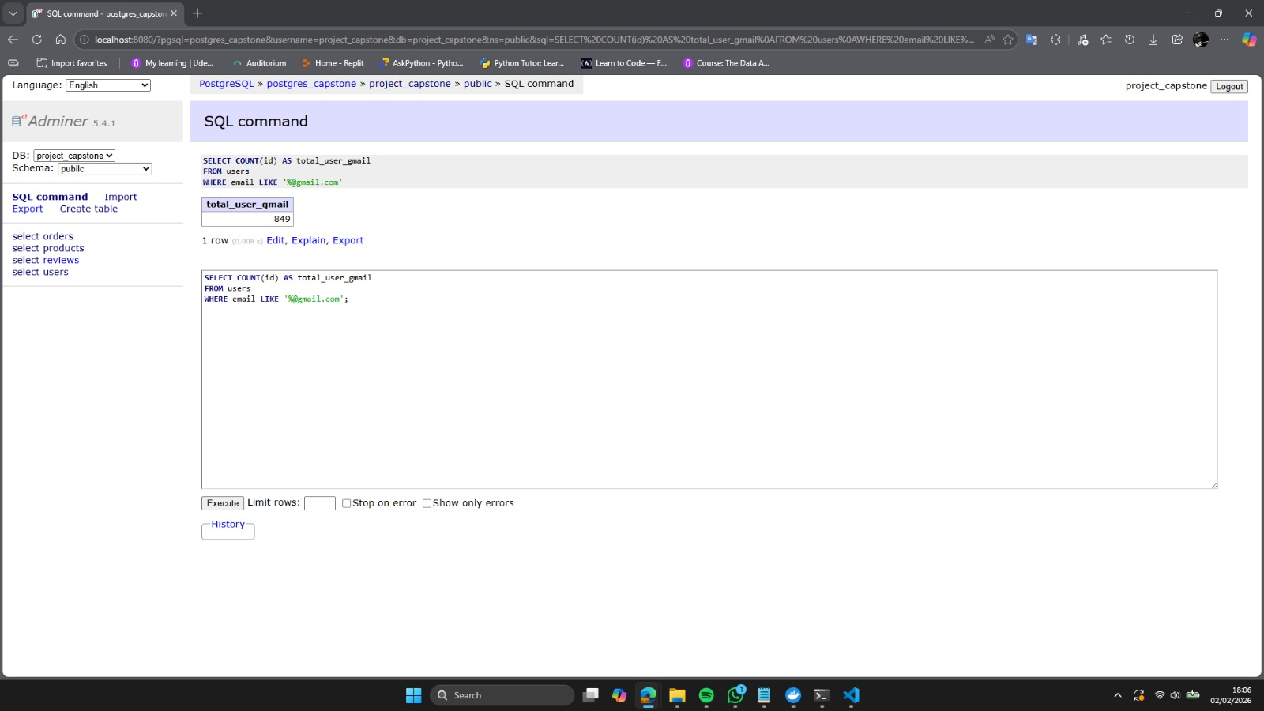

Pertanyaan | : | Dapatkan list id, title, price, and created at dari table Products, dengan kriteria  price antara 30 - 50, dan urutkan dari transaksi terbaru - terlama?
Jawaban | : | SELECT  id,  title,  price,  created_at  FROM products  WHERE price BETWEEN 30 AND 50  ORDER BY created_at DESC;

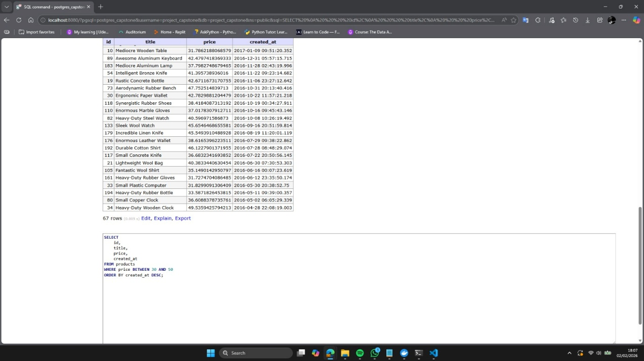

Pertanyaan | : | Dapatkan list Name, Email, Address, Birtdate dari table Users yang lahir diatas  tahun 1997? Buatlah dalam format database views.
Jawaban | : | CREATE VIEW users_after_1997 AS  SELECT  name,  email,  address,  birth_date  FROM users  WHERE EXTRACT(YEAR FROM TO_DATE(birth_date, 'YYYY-MM-DD')) > 1997;  -- output:  SELECT * FROM users_after_1997;

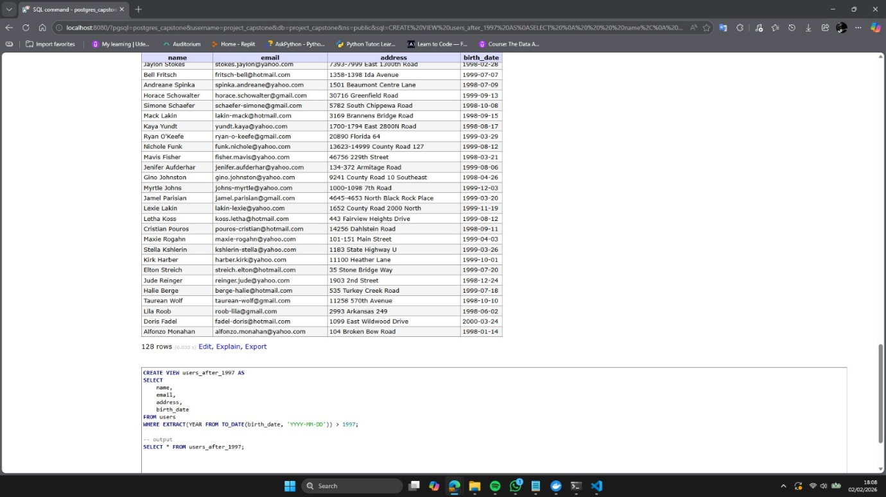

Pertanyaan | : | Dapatkan list id, created_at, title, category, dan vendor dari table products, yang memiliki title yang sama / title muncul dengan value yang sama sebanyak lebih dari 1 kali.
Jawaban | : | WITH product_duplicates AS (  SELECT  id,  created_at,  title,  category,  vendor,  ROW_NUMBER() OVER (PARTITION BY title ORDER BY created_at) AS row_num  FROM products  )  SELECT  id,  created_at,  title,  category,  vendor  FROM product_duplicates  WHERE title IN (  SELECT title  FROM products  GROUP BY title  HAVING COUNT(*) > 1  )  ORDER BY title, created_at;

