**Langchain**

Langchain is a framework which allows you to build applications on the top of LLMs.

When we are making call to ChatGPT, it is internally making call to OpenAI api which internally using LLM such as GPT-4, GPT-3.5

In this case ChatGPT is not an LLM, it is an application, where as GPT-3.5, GPT-4 are LLMs.

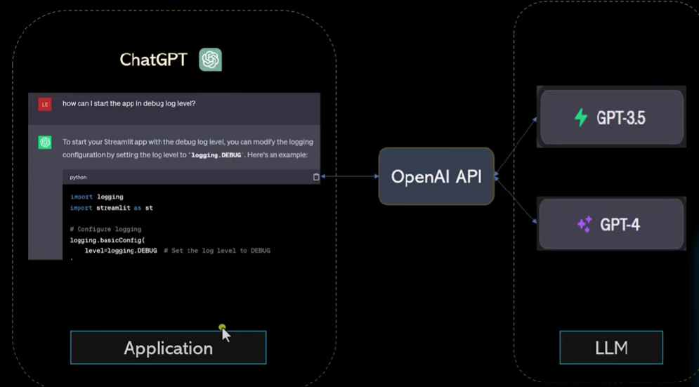

We can build an application similar kind of ChatGPT, where we can give the cuisine name and it will provide restaurant name and menu for the same.

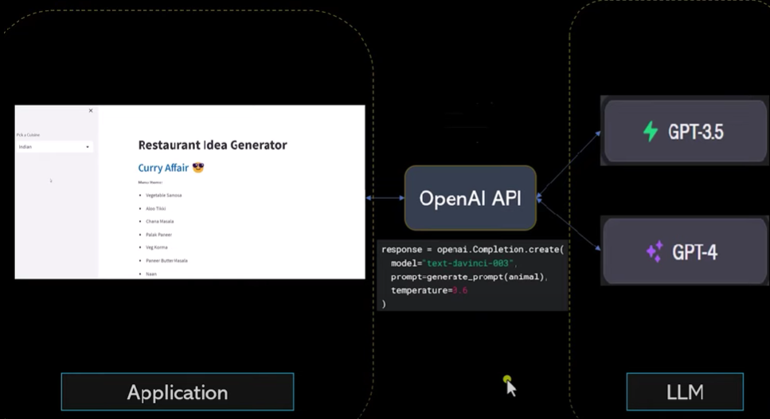

Now every business wants to build their own LLMs. Such as chatgpt because chatgpt don’t have access to their internal organization data so people want to build an application based on their llms.

Also, business not use above architecture, because calling OpenAI API has cost associated with it. Also ChatGPT doesn’t answer latest questions. As its knowledge is limited to Sept 2021. Also chatgpt doest have access to your personal organization data. 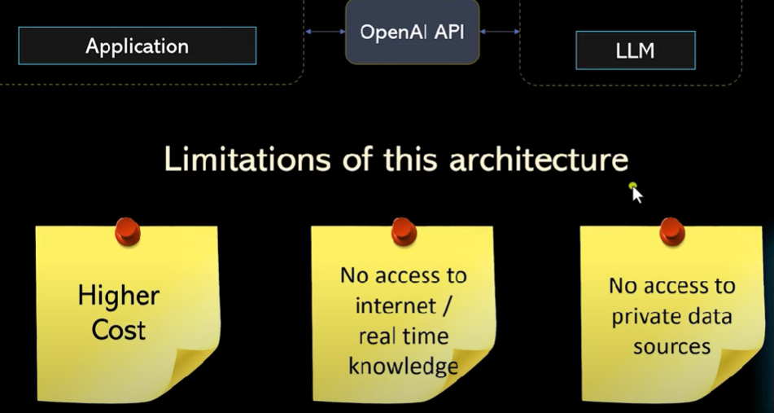

So we can build a framework where we can use any LLM API such as OpenAI, Huggingface, Google Palm and the framework should also provide integration with google search, Wikipedia, or integration with your own organization data so that the application can pull info from the various sources. So the framework is langchain.

**Create a basic llm object**

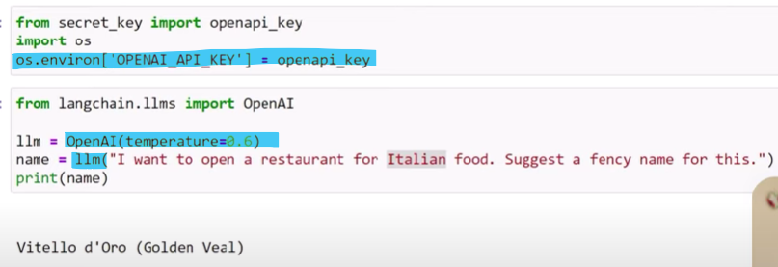

We can import any llm model from langchain.llms library such as huggingface, anthropic etc.

Temperature = 0 it means that it wont take any risk while providing output and give safe output. Where as 1 means it will try to be more creative and take risk and give the output.

**Prompt Templates in Langchain :**

Prompt templates help to translate user input and parameters into instructions for a language model.

* With no input variables

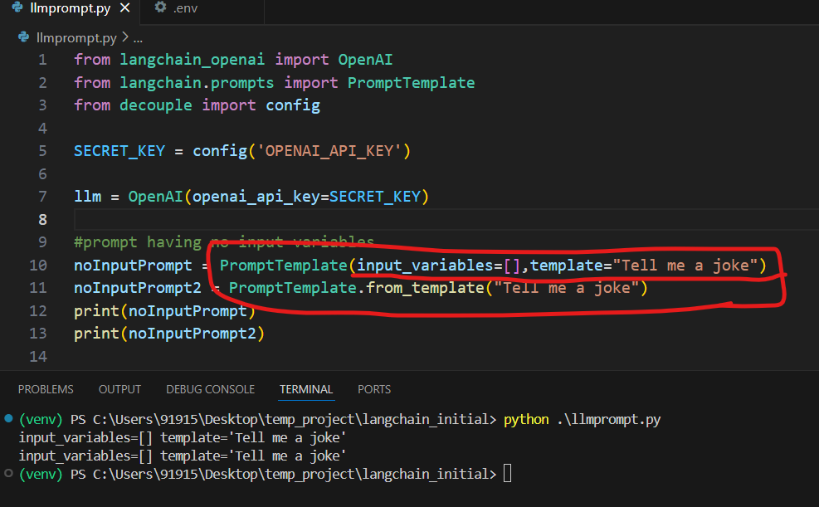

* With one input variable.

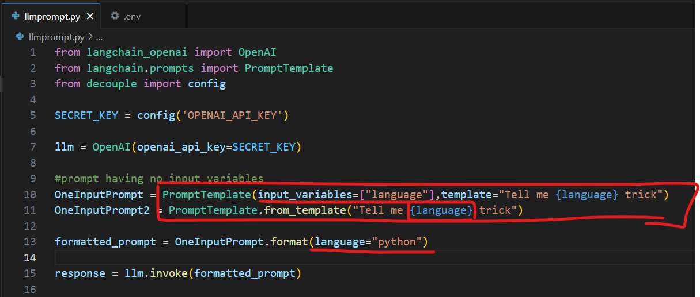

* With multiple input variables

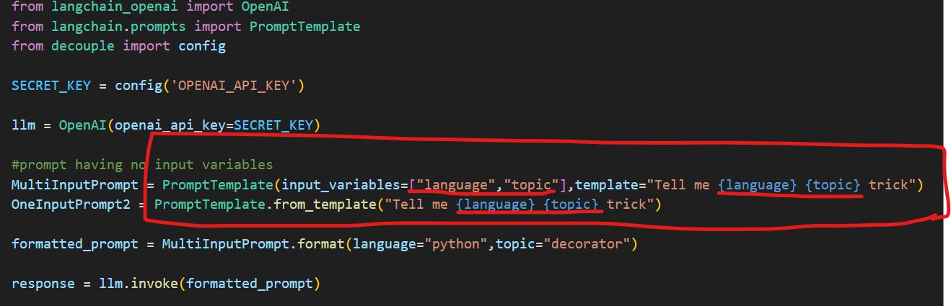

**ChatModelPrompt template**

* Message prompt template as tuple

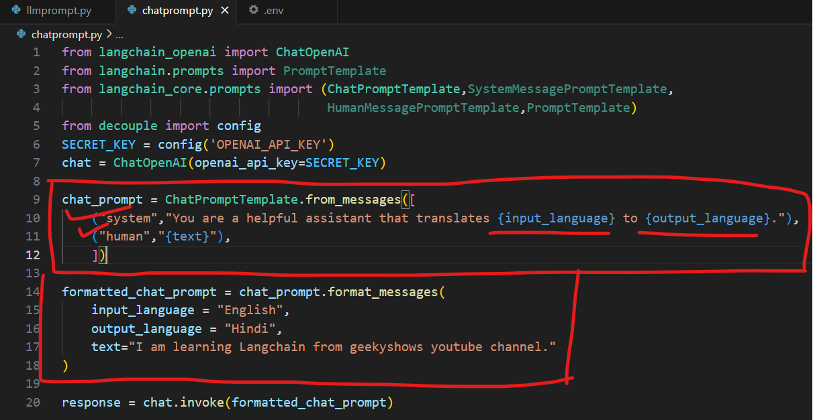

* Using message class

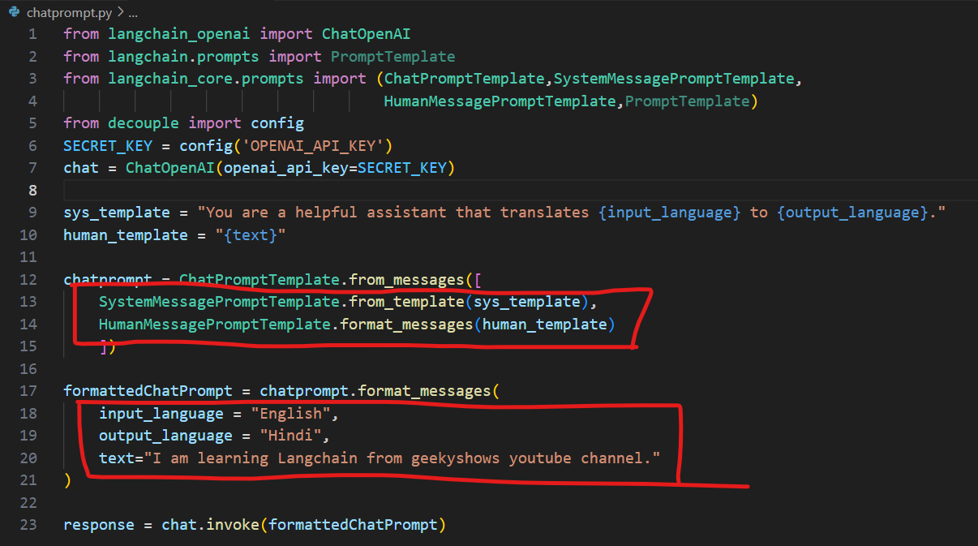

* Using PromptTemplate

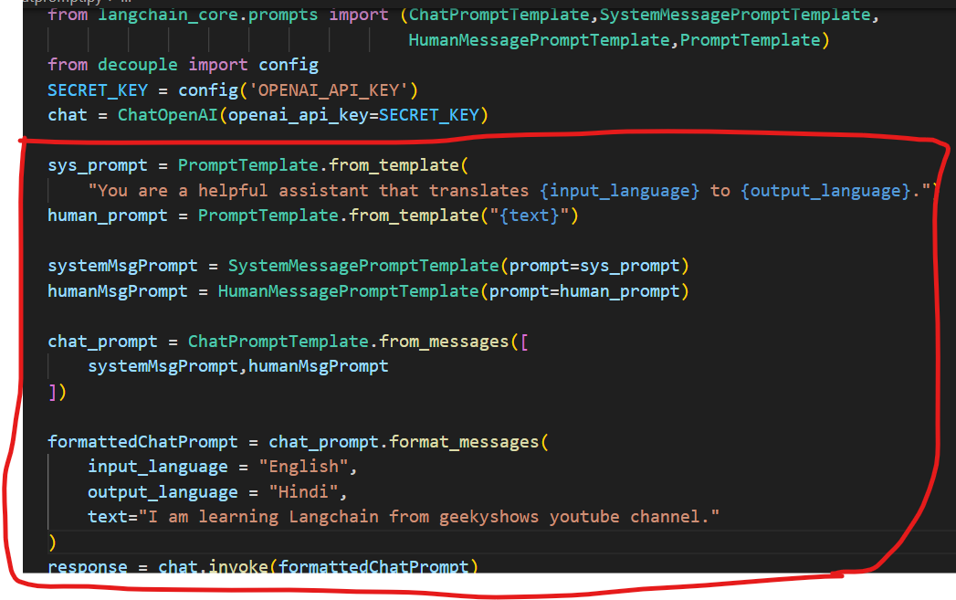

Few shot prompt template

Few shot prompting is a prompting technique which provides the Large Language Model (LLM) with a list of examples, and then asks the LLM to generate some text following the lead of the examples provided.

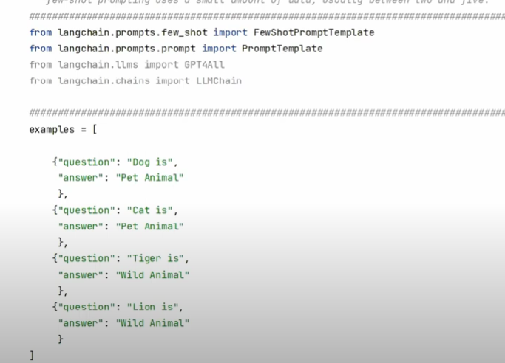

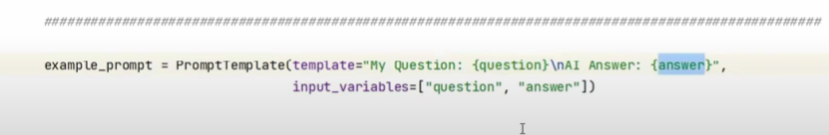

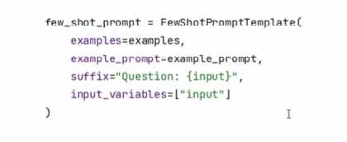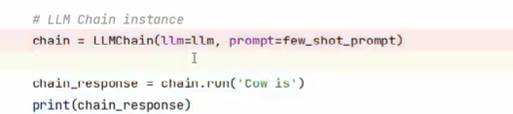

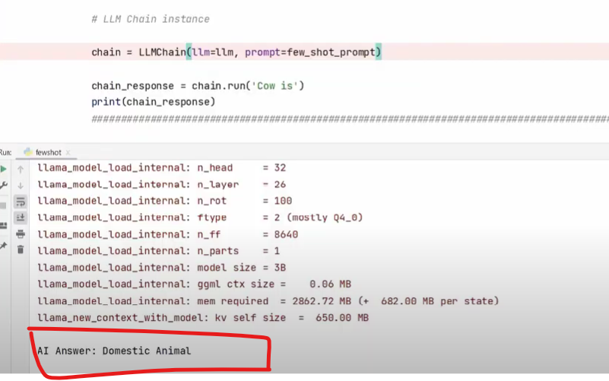

**Few-shot examples for chat models**

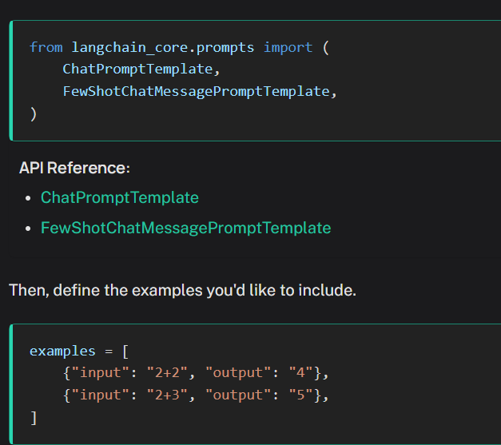

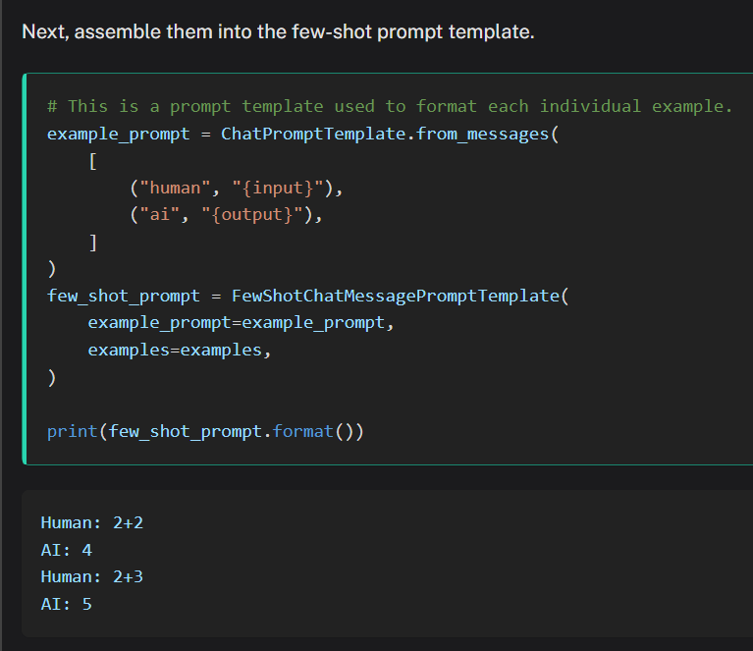

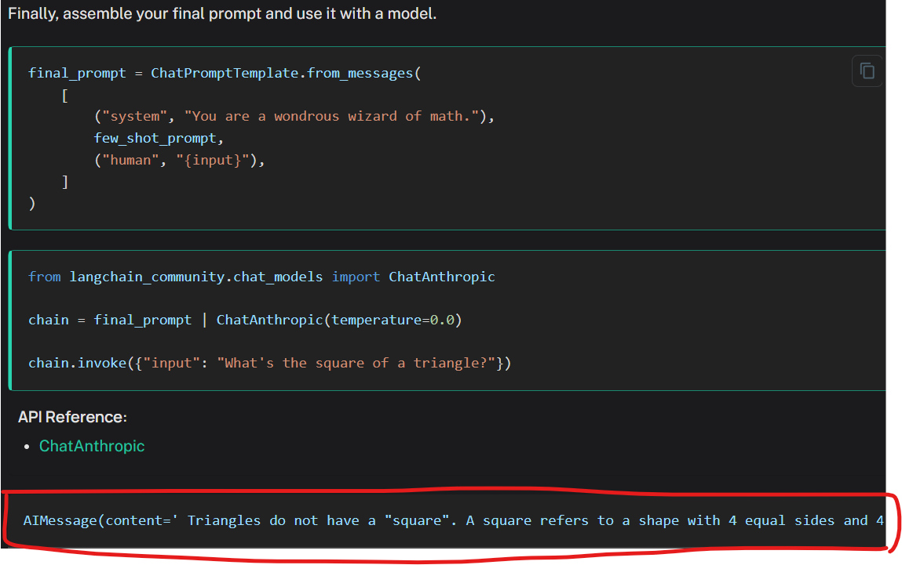

Chains: Chains refer to sequences of calls - whether to an LLM, a tool, or a data preprocessing step.