**Chains:**

"""

Chains are nothing more than tieing together a series of tasks.

Earlier we are using invoke function to create prompts also

we are using it to chat model to respond to us.

Instead of this what we can do is prompt output we chain to as a input to the model and

output of model is chained to input to someother item like this.

"""

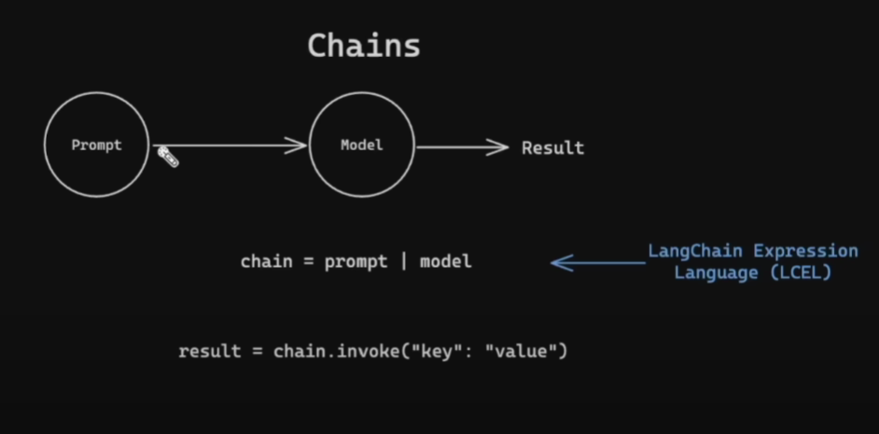

**Chain possibilities:**



