Mobile Web Development
Lab 03
2 Oct 2012
Richard Rodger
richard@nearform.com

Objectives
- Understanding the basic structure of a Backbone app
- Using Backbone views to create HTML interfaces
- Using Underscore templates to generate HTML
- Providing a native feel to scrolling interfaces
- Understanding and using Backbone events
- Understanding and using Backbone models and collections
- Using the Backbone storage interface
- Using the HTML application cache protocols

Table of Contents

Objectives 1
Directions For Lab Work 3
Using the Backbone framework 4
Using Underscore Templates 9
Supporting Scrolling, and Android 11
Handling the Add button 13
Using Models and Collections 15
Using Backbone to store data 17
Using Custom Event Bindings 19
Fine-grained Views 21
Using the HTML5 Application Cache 22

Directions For Lab Work
The approach introduced in the previous lab will be used throughout the course:
- Choose a top level folder to contain all your work
- The work for each lab should be placed within a subfolder called labXX
  - For example, the folder for this lab should be lab03
- Use the desktop Safari browser and the Safari Web Inspector as your primary development environment
- Serve your apps from your local machine for testing using the nginx web server, as per the instructions in lab01. Use nginx even when testing from desktop Safari. This ensures that AJAX requests will function correctly as you will avoid cross-domain browser restrictions.
- Proxy AJAX requests via nginx to a local Node.js server that you run from the command line.

Ensure that you have completed all the tasks in lab01 before proceeding, as this and future labs will assume a correctly configured and working environment.
All labs assume a basic level of experience with the command line.
This lab assumes you have completed the jQuery Mobile tasks in Lab 02. The basic framework of the To Do list app is rebuilt using the Backbone framework.

Using the Backbone framework
Create a simple boilerplate jQuery Mobile app using the Backbone framework. You will need jQuery and jQuery Mobile from Lab 02.
Download the backbone framework from
http://documentcloud.github.com/backbone/
For learning purposes, you should use the full source (Development) version. This means you have review the Backbone source code if you need check how something is implemented. This also allows you to step the debugger into the Backbone framework.
You will also need the underscore library:
http://documentcloud.github.com/underscore/
Again, go with the source (Development) version.

This lab exercises validates that your configuration is working with all dependencies loaded.

1. Create a file called bb-a.html in your lab03 folder.
2. Insert the following HTML code and save:
<!DOCTYPE html>
<html>
<head>
<title>Title</title>
<meta name="viewport"
content="user-scalable=no,initial-scale=1.0,maximum-scale=1.0" />
<meta name="apple-mobile-web-app-capable" content="yes" />

<link rel="stylesheet" href="jquery.mobile.css" />
<link rel="stylesheet" href="bb.css" />

<script src="jquery.js"></script>
<script src="jquery.mobile.js"></script>
<script src="underscore.js"></script>
<script src="backbone.js"></script>

<script src="bb-a.js"></script>
</head>
<body>

<div id="main" data-role="page">

<div data-role="header" data-position="fixed">
<h1>Title</h1>
</div>

<div data-role="content">
<ul id="list" data-role="listview">
<li class="tm">
<span class="text"></span>
</li>
</ul>

</div>

</div>

</body>
</html>

3. Create a file called bb.css in your lab03 folder
4. Insert the following CSS code and save:
.tm {
display: none;
}

div[data-role='content'] {
overflow: hidden;
position: fixed;
top: 40px;
bottom: -60px;
left: 0px;
right: 0px;
}

5. Create a file called bb-a.js in your lab03 folder
6. Insert the following JavaScript code and save:

function pd( func ) {
return function( event ) {
event.preventDefault()
func && func(event)
}
}

document.ontouchmove = pd()

var app = {
view: {}
}

var bb = {
view: {}
}

bb.init = function() {

bb.view.List = Backbone.View.extend({

initialize: function() {
var self = this
_.bindAll(self);

self.setElement('#list')

self.elem = {
item_tm: $('li.tm').remove()
}
},

render: function() {
var self = this

self.$el.empty()

for( var i = 0; i < 3; i++ ) {
var item = self.elem.item_tm.clone()
item.find('span.text').text('item '+i)
self.$el.append(item)
}
}
})
}

app.init = function() {
console.log('start init')

bb.init()

app.view.list = new bb.view.List()
app.view.list.render()

console.log('end init')
}

$(app.init)

This app uses the same boilerplate code as in previous labs.
The bb.view.List object defines a list of items, and inserts three items into the list when it's render method is called. A separate top level object, bb, is used to store the Backbone definitions. The app object stores the instances of the views (and later models) in app.view.

7. In the Safari browser, open http://127.0.0.1/lab03/bb-a.html. You should see a jQuery Mobile interface containing a list with three items, as shown below:
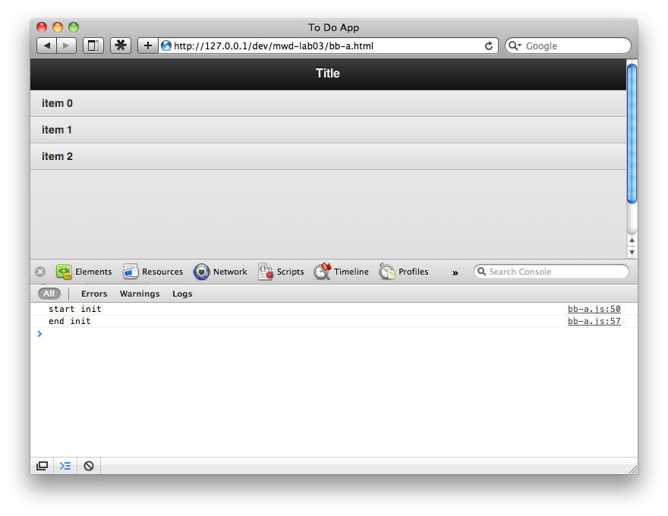
8. Open the Web Inspector, and click on the Console tab.
You should see the output of the two logging lines:
start init
end init

9. Open the app on your mobile device: http://192.168.100.111/lab03/bb-a.html. As always, insert your own IP address. You should see the same interface:
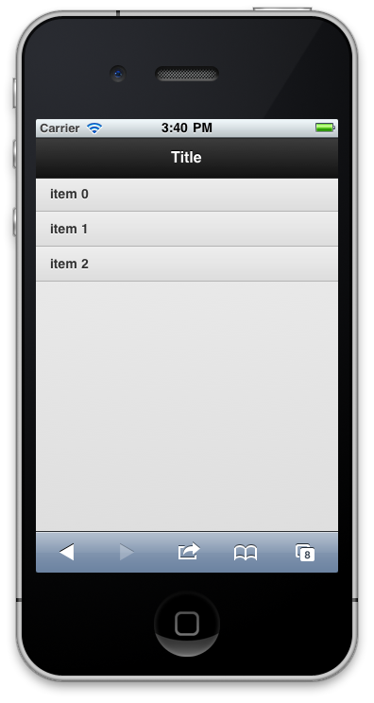

Using Underscore Templates
The previous example used direct DOM manipulation to construct a view. This was also the technique used in Lab 02.
With underscore, you use source code templates instead for HTML construction. The underscore template syntax is similar to JSP or ASP.NET. However, due to escaping of HTML content by jQuery, the traditional <% %> syntax is problematic to use. In this example, the syntax {{ }} is used instead.
To insert the string value of a variable verbatim, use: {{=varname}}
To insert a HTML escaped string value, use: {{-varname}}

1. Copy the bb-a.js and bb-a.html in your lab03 folder to bb-b.js and bb-b.html. Update the reference to bb-a.js in the HTML script tag in bb-a.html.
2. In bb-b.html, use underscore template syntax for the text of each item:
...
<li>
<span class="text">{{-text}}</span>
</li>
...

3. In bb-b.js, set up the {{}} syntax for underscore templates:

_.templateSettings = {
interpolate: /\{\{(.+?)\}\}/g,
escape: /\{\{-(.+?)\}\}/g,
evaluate: /\{\{=(.+?)\}\}/g
};

The templateSettings property is part of the underscore API.

4. Replace the list view definition with:

bb.view.List = Backbone.View.extend({

initialize: function() {
var self = this
_.bindAll(self)

self.setElement('#list')

self.tm = {
item: _.template( self.$el.html() )
}
},

render: function() {
var self = this

self.$el.empty()

for( var i = 0; i < 3; i++ ) {
var html = self.tm.item({text:'item '+i})
self.$el.append( html )
}
}
})

The HTML string template is extracted using the .html() jQuery method. Backbone provides the $el variable as a reference to the root level element for each view (as set by setElement).

This code grabs the content of the ul tag, converts it to HTML source code, and uses the _.template method to create a template object. This object is then called to create the HTML source code for each item. Underscore templates are parameterized by passing in an object literal, in this case: {text:...}

5. Open the app in desktop Safari and on your mobile device, and confirm that it still works.

Supporting Scrolling, and Android
The jQuery Mobile scrolling solution is more suited to mobile web sites. You can use the iScroll library to provide a more native scrolling style.
The app should work equally well on Android and iPhone. Some infrastructure code is required to support this.
1. Copy the bb-b.* files to bb-c.* – as per step 1 in the previous exercise. Update the script tag to reference bb-c.js.
2. Add a reference to the iScroll library to bb-c.html:
<script src="iscroll.js"></script>
3. Add some simplistic browser detection code to bb-c.js:
var browser = {
android: /Android/.test(navigator.userAgent)
}
browser.iphone = !browser.android

4. The existing CSS expands the app to full screen:
div[data-role='content'] {
overflow: hidden;
position: fixed;
top: 40px;
bottom: -60px;
left: 0px;
right: 0px;
}

The bottom: -60px setting is needed because jQueryMobile hides the URL address bar, adding 60 pixels to the page height. This happens after page load, so the true bottom ends up 60 pixels below the CSS dimensions understood by the CSS file.
5. Handle Android as a special case:

app.init_browser = function() {
if( browser.android ) {
$("#main div[data-role='content']").css({
bottom: 0
})
}
}

...

app.init = function() {
console.log('start init')

bb.init()

app.init_browser()

...

...but this fix is not needed on Android.

6. Define a mixin object to handle scrolling. You can then use composition-based inheritance to provide scrolling to Backbone views:
bb.init = function() {

var scrollContent = {
scroll: function() {
var self = this
setTimeout( function() {
if( self.scroller ) {
self.scroller.refresh()
}
else {
self.scroller = new iScroll( $("div[data-role='content']")[0] )
}
},1)
}
}

This code uses the iScroll API to create a new iScroll object if one does not already exist for the view. If an iScroll object does exist, then it is refreshed. This handles the case where the height of the content has changed. A setTimeout is used to ensure that the DOM has fully updated before iScroll performs any height calculations.
7. To inherit from the mixin, use the underscore extend method:

bb.view.List = Backbone.View.extend(_.extend({
...

render: function() {
...

self.scroll()
}
},scrollContent))
}

Call the inherited self.scroll method to activate the scrolling.

Handling the Add button
This exercise shows how Backbone is used to respond to user events.
1. Copy the bb-c.* files to bb-d.* – as per step 1 in the previous exercise. Update the script tag to reference bb-d.js.
2. Add the jQuery Mobile code for the Add button to bb-d.html:
<div data-role="header" data-position="fixed">
<h1>Title</h1>
<a id="add" data-icon="plus" class="ui-btn-right">Add</a>
</div>

3. In bb-d.js, Create a new head view for the title bar:
bb.init = function() {
...

bb.view.Head = Backbone.View.extend(_.extend({
events: {
'tap #add': function(){ app.view.list.additem() }
},

initialize: function() {
var self = this
_.bindAll(self)
self.setElement("div[data-role='header']")
}
}))

This view uses the events property of Backbone view objects to handle a tap event on the app button. The additem method is called on the list view in response. The jQuery Mobile event handling ensures that click events will work as well so you can test in desktop Safari.

The property names of the view events property are in the format:
“<event> <selector>” // tap := event, #add := selector

The value of the property can be a method name on the same view, given as a string, or a function, as above.

4. Refactor the list view so that items are constructed in a separate additem method:

bb.view.List = Backbone.View.extend(_.extend({
...

render: function() {
var self = this

self.$el.empty()

for( var i = 0; i < 3; i++ ) {
self.additem()
}

self.scroll()
},

additem: function() {
var self = this

var html = self.tm.item({text:'item '+self.count})
self.$el.append( html )
self.count++
}

},scrollContent))

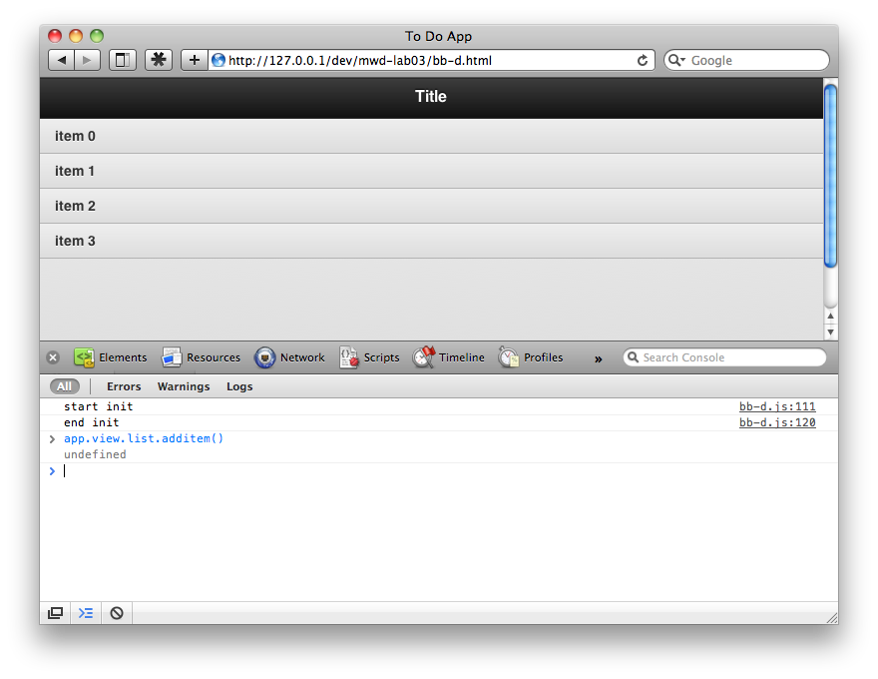
You can test this method from the console by running app.view.list.additem() - a new item should appear:

Using Models and Collections
The business data and state of your app are stored using Backbone Models. Some kinds of models are naturally lists, such as To Do items. These can be further managed using Backbone Collections.

1. Copy the bb-d.* files to bb-e.* – as per step 1 in the previous exercise. Update the script tag to reference bb-e.js.
2. Add a Model for each item:

bb.model.Item = Backbone.Model.extend(_.extend({
defaults: {
text: ''
},

initialize: function() {
var self = this
_.bindAll(self)
}

}))

This is mostly boilerplate. The text property will contain the textual description of the item.
3. Add a Collection for the Model items:

bb.model.Items = Backbone.Collection.extend(_.extend({
model: bb.model.Item,

initialize: function() {
var self = this
_.bindAll(self)
self.count = 0
},

additem: function() {
var self = this
var item = new bb.model.Item({
text:'item '+self.count
})
self.add(item)
self.count++
}

}))

The additem method create a new numbered item in the collection each time it is called.
4. Update the head View so that it calls the additem method. A reference to the items collection is needed.
bb.view.Head = Backbone.View.extend(_.extend({
events: {'tap #add': function(){ var self = this; self.items.additem() } },
initialize: function( items ) {
...
self.items = items
}
5. Update the list View so that appends items to the HTML based on the model.
bb.view.List = Backbone.View.extend(_.extend({

initialize: function( items ) {
...

self.items = items
self.items.on('add',self.appenditem)
},

render: function() {
var self = this

self.$el.empty()

self.items.each(function(item){
self.appenditem(item)
})
},

appenditem: function(item) {
var self = this
var html = self.tm.item( item.toJSON() )
self.$el.append( html )
self.scroll()
}
}))

The View listens for add events on the Collection:
self.items.on('add',self.appenditem)

The appenditem method is called whenever a new item is added to the collection.

6. Update the app.init method to provide the items collection to the views:

app.init = function() {
...

app.model.items = new bb.model.Items()

app.view.head = new bb.view.Head(app.model.items)
app.view.list = new bb.view.List(app.model.items)

...
}

Using Backbone to store data
Backbone provides an abstraction layer to persist data in Models. This abstraction layer can cover AJAX and other methods, and also localStorage, which is used in this example.
Download the localStorage plugin for Backbone from:
https://github.com/jeromegn/Backbone.localStorage

1. Copy the bb-e.* files to bb-f.* – as per step 1 in the previous exercise. Update the script tag to reference bb-f.js.
2. Add a reference to the localStorage plugin to bb-f.html:
<script src="backbone.localStorage.js"></script>

3. Update the Collection to support storage:

bb.model.Items = Backbone.Collection.extend(_.extend({
model: bb.model.Item,
localStorage: new Store("items"),

initialize: function() {
...
self.count = 0

self.on('reset',function() {
self.count = self.length
})
},

additem: function() {
...
item.save()
}

}))

The localStorage property is required by the plugin. The Collection now listens for the reset event, which indicates that the list of items has been replaced (i.e. loaded), and sets it's item count appropriately. Finally the item.save() method is called to save any items added.

4. Modify the app.init method to load the stored items on app startup:

app.init = function() {
...

app.model.items.fetch( {
success: function() {
app.view.list.render()
}
})

console.log('end init')
}

The fetch method of the collection will load all the items found in localStorage. The list View is rendered once the items are loaded.

Using Custom Event Bindings
Backbone allows you to trigger and respond to arbitrary events. You can also listen for changes in Model properties using the change:propname syntax for event names. This exercise demonstrates a custom event binding that updates the title bar with the number of items in the collection, handling the special case where the items are still loading.
1. Copy the bb-f.* files to bb-g.* – as per step 1 in the previous exercise. Update the script tag to reference bb-g.js.
2. Turn the title into a template using underscore:
<div data-role="header" data-position="fixed">
<h1>{{-title}}</h1>
<a id="add" data-icon="plus" class="ui-btn-right">Add</a>
</div>

3. Add a new state Model to store global application state:

bb.init = function() {
...

bb.model.State = Backbone.Model.extend(_.extend({
defaults: {
items: 'loading'
},
}))

The items property will hold the state of the items: “loading”, or “loaded”

4. Update the head View to handle the change events:

bb.view.Head = Backbone.View.extend(_.extend({
...
initialize: function( items ) {
...
self.elem.add.hide()

app.model.state.on('change:items',self.render)
self.items.on('add',self.render)
},

render: function() {
...
var loaded = 'loaded' == app.model.state.get('items')

self.elem.title.html( self.tm.title({
title: loaded ? self.items.length+' Items' : 'Loading...'
}) )

if( loaded ) {
self.elem.add.show()
}
}

The add button is hidden initially – you can't add items while data is loading. The head View then listens for changes to the items property of the state Model:
app.model.state.on('change:items',self.render)
and renders itself again if there is a change.
The render method is updated to have the loading versus loaded conditions, and to display the number of items.

5. The app.init method updates the state once the items have loaded, triggering the render of the head View, as per 4.
app.model.items.fetch( {
success: function() {

// simulate network delay
setTimeout( function() {
app.model.state.set({items:'loaded'})
app.view.list.render()
}, 2000)
}
})

Fine-grained Views
For the full To Do List app, the items will need to be able to control their appearance in a fine-grained manner. Each item can show a checkbox, and a delete button. Each item should thus have it's own view.
1. Copy the bb-g.* files to bb-h.* – as per step 1 in the previous exercise. Update the script tag to reference bb-h.js.
2. Define a new item View:

bb.view.Item = Backbone.View.extend(_.extend({
initialize: function() {
var self = this
_.bindAll(self)
self.render()
},

render: function() {
var self = this
var html = self.tm.item( self.model.toJSON() )
self.$el.append( html )
}

},{
tm: {
item: _.template( $('#list').html() )
}
}))

This view extracts the contents of the list element to create a template for each list item. The template is common to all the items, and so is defined as an inherited property, using the _.extend composition inheritance pattern.
Backbone models provide a toJSON method that returns a data object containing the attributes of the item. This can be passed directly to the underscore template for use in constructing the HTML
3. Update the list View appenditem method to work with the new item View:
appenditem: function(item) {
var self = this

var itemview = new bb.view.Item({
model: item
})

self.$el.append( itemview.$el.html() )
self.scroll()

Using the HTML5 Application Cache
HTML5 defined a protocol for offline applications. This enables your application to run without an internet connection. The assets used by the app: images, javascript files, css, are downloaded and stored locally. In the case of the To Do List app, this can be combined with localStorage to create a web app that becomes nearly native once installed on the device home screen (as per lab 02).
The protocol requires the use of a special manifest file identified in the HTML tag of your main page. The manifest file lists all the offline assets. When the app starts, the browsers attempts to load the manifest file. If this is not possible (no connection), then the cached assets are used.
If the manifest file can be loaded, it is compared with the previous version. If unchanged, the cached assets are still used. If changed, then all the assets are downloaded again.
WARNING: it is possible for your app to become “stuck” in a cached state. Ensure that your web server always serves the manifest file with a no-cache headers – luckily nginx does this by default.

1. Copy the bb-h.* files to offline.* – as per step 1 in the previous exercise, including bb.css. Update the script tag to reference offline.js.
2. Update the offline.html file to reference the manifest file:
<!DOCTYPE html>
<html manifest="offline.appcache">
<head>

3. Create the offline.appcache file, and list all the app assets:
CACHE MANIFEST
# version 1

offline.html
offline.js
offline.css

jquery.js
jquery.mobile.js
jquery.mobile.css

underscore.js
backbone.js
backbone.localStorage.js
iscroll.js

images/icons-18-white.png
images/ajax-loader.png

4. Modify your nginx configuration so that the correct MIME type is served for the offline.appcache file. Without this setting the caching will no work. In your nginx configuration folder, edit themime.types file, and add the line:
types {
...
text/cache-manifest appcache;

...
}
Reload the nginx configuration for the setting to take effect:
nginx -s reload

5. Test the app caching using Firefox – use the File/Work Offline option to confirm that your app can work offline – hit reload when offline to do this. Also test using Safari and observe the console to ensure there are no errors. All files needed must be listed in the manifest file, and they must all exist.
6. Install the app on your device home screen, and then place the device into “Airplane” mode, so that it has no connectivity. Re-open your app. It should still function.

