**Classification -** The Classification algorithm is a Supervised Learning technique that is used to identify the category of new observations on the basis of training data. In Classification, a program learns from the given dataset or observations and then classifies new observation into a number of classes or groups. Such as, **Yes or No, 0 or 1, Spam or Not Spam, cat or dog,** etc. Classes can be called as targets/labels or categories.

The algorithm which implements the classification on a dataset is known as a classifier. There are two types of Classifications:

* **Binary Classifier:** If the classification problem has only two possible outcomes, then it is called as Binary Classifier.  
  **Examples:** YES or NO, MALE or FEMALE, SPAM or NOT SPAM, CAT or DOG, etc.
* **Multi-class Classifier:** If a classification problem has more than two outcomes, then it is called as Multi-class Classifier.  
  **Example:** Classifications of types of crops, Classification of types of music.

Classification Algorithms can be further divided into the Mainly two category:

* **Linear Models**
  + Logistic Regression
  + Support Vector Machines
* **Non-linear Models**
  + K-Nearest Neighbours
  + Kernel SVM
  + Naïve Bayes
  + Decision Tree Classification
  + Random Forest Classification

**Experiment** - In this experiment we have trained using Logistic Regression algorithm , K-nearest neighbours algorithm and Naïve Bayes algorithm on a single dataset and compared its results.

**Dataset** - The dataset we have used is Social Network Ads. In this dataset on the basis of one’s age, gender and estimated salary we have predicted how much the person is likely to buy the ads.

**Results** - Accuracy of each model -

1. **Logistic Regression** –

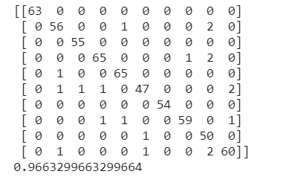

1. **Naïve Bayes –**

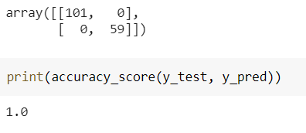

1. **KNN** **N neighbours (2)** -

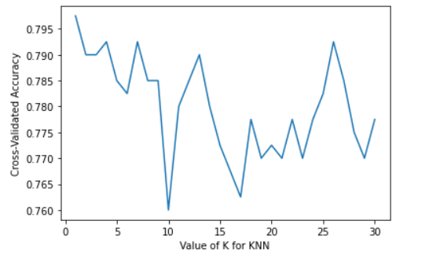



**Conclusion** – Here we can see that the naïve bayes classifier has given the highest accuracy.Therefore we can conclude that for this dataset using naive bayes classification algorithm is ideal.