Supplementary Material for: Grain Size-Inclusion Size Interaction in Metal Matrix Composites Using Mechanism-Based Gradient Crystal Plasticity
R. Aghababaei and S.P. Joshi

Computational Implementation of MSGCP
For completeness, we give a brief outline of the computational implementation of MSGCP within UMAT.

Plastic slip constitutive law
The kinematics and kinetics of MSGCP approach implemented in this work closely follows the conventional continuum crystal plasticity framework of Asaro and co-workers (Asaro, 1983; Peirce, et al., 1983), except that a length-scale effect is introduced in the slip system hardening. The constitutive law for plastic slip rate is assumed as
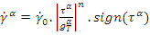 (S1)
where and are the reference plastic slip rate and resolved shear stress on slip system and is the overall hardening of lattice due to both SSD and GND densities. The evolution law for the SSD induced hardening for multiple slip deformation is given by
(S2)

where is a matrix representing self and latent hardening coefficients given by (Asaro, 1983a,b),
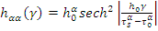 (no sum on) (S3)
(S4)
In Eq. (S3), is initial hardening modulus, is the saturation value for the resolved shear stress, is the critical resolved shear stress, is the total cumulative shear strain on all slip systems and (~ 1-2) is a accounts for the interaction between different slip systems.
In the MSGCP approach, the GND densityon slip system is assumed to contribute to its overall hardening via Taylor hardening model. Consequently, is given by (Han, et. al. 2005)
 | 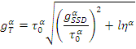 | (S5)
where the internal material length-scale , with as the magnitude of Burgers vector, as the overall shear modulus and as an empirical material constant ranging between 0.1-0.5. In Eq. (S5), is an effective scalar measure of the GND density tensor on the slip system
 | 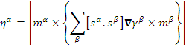 | (S6)
where are respectively, the slip direction and slip-plane normal for slip system. The effective slip gradient is related to the GND density in each slip system via.
Slip gradient calculation
In implementing this length-scale feature within a UMAT, one needs to calculate the slip gradients at each Gauss point (GP). We exploit the concept of shape functions that is at the core of a typical finite element (FE) formulation for evaluating the slip gradients corresponding to each slip systems. For illustration purposes, we present the formulation applicable for an 8-node plane strain finite element, but the approach can be extended to different types of FE’s. As is widely known, the number of GP’s in a FE determines the order of integration. The 8-node plane strain element that we adopt here (CPE8R) uses a reduced integration procedure in order to minimize the effects due to shear locking. Therefore, for each FE all the state variables (i.e. individual and total slip, slip gradients, etc.) and stresses are calculated at these GP’s. To calculate the plastic slip gradients within an FE, we apply the approach similar to the one is used in calculating strains from displacements in a conventional FE formulation (Cook, et al., 2002). Within a FE, we consider a 4-node pseudo-element (Fig. S1) constructed by joining the GP’s describable by linear shape functions. The local isoparametric coordinatesof the pseudo-element are related to the global coordinatesvia the determinantof the Jacobian matrix (Cook, et al., 2002)
 | 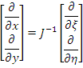 | (S7)

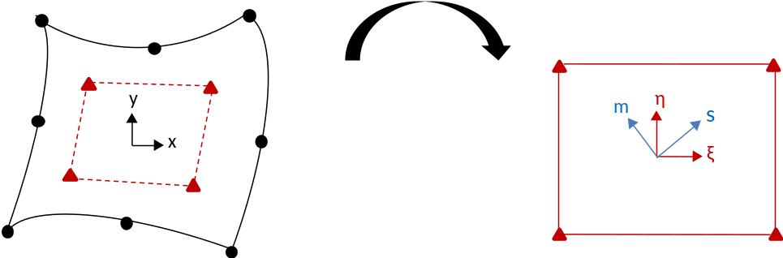
(a) (b)
Figure S1. (a) An Eight-node plane strain FE with four GPs and (b) a linear pseudo-element constructed from the GPs of the actual FE where are the local isoparametric coordinates. The slip and normal directions of a typical slip system are also shown (b).

The slip gradient vectorin the slip direction within each element is obtained using the chain rule of partial differentiation
 | 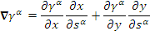 | (S8)
and the Cartesian slip gradients are related to the pseudo-element shape functions by
 | 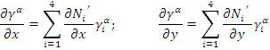 | (S9)
where is the plastic slip at pseudo-node (i.e. GP of the actual FE) and on slip system. The Cartesian derivatives of (Eq. S9) are calculated using Eq. (S7).

Time integration scheme
The time integration used in the UMAT is based on the implementation by Huang (1991), but contains augmented information about the GND effects. For completeness, we summarize the method here. The incremental slip on slip system is
(S10)
where the parameter is introduces a linear interpolation between value of slip rate at the beginning and end of the time increment (Peirce et al, 1984). The degenerates to Euler forward time integration scheme, but the recommended value is 0.5. Eq. (S10) can be solved using Newton-Raphson technique
(S11)
Then, the plastic slip rate is computed as
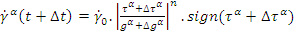 (S12)
Here, the values of stress and solution dependent state variables are evaluated at the end of each time increment and this allows using larger time increment. Further details on the basic implementation of the user subroutine UMAT and incremental formulations can be found in the report by Huang (1991).
Additional References
Asaro, R. J. 1983. Micromechanics of crystals and polycrystals. Adv. Appl. Mech. (23):1
Cook, R.D., Malkus, D.S., Plesha, M.E., Witt, R. J. 2002. Concepts and Applications of Finite Element Analysis, Fourth Ed., John Wiley and Sons, Inc.
Han, C.S., Gao, H., Huang, Y., Nix, W.D. 2005. Mechanism-based strain gradient crystal plasticity - I. Theory. J. Mech Phys Solids 53 (5), 1188-1203.

Huang, Y. 1991. A user-material subroutine incorporating single crystal plasticity in the ABAQUS finite element program. Mech Report 178, Division of Engineering and Applied Sciences, Harvard University, Cambridge, Massachusetts.
Peirce, D., Asaro, R. J., Needleman, A. 1983. Material rate dependence and localized deformation in crystalline solids. Acta Metall. 31(12), 1951-1976.

This is similar to the one adopted in ABAQUS to calculate strain from nodal displacements, e.g.,

