**Supplementary Material for**

**Phenomenological Crystal Plasticity Modeling and Detailed Micromechanical Investigations of Pure Magnesium**

Jing Zhang and Shailendra P. Joshi

1. **Hardening rate versus stress for single crystals and polycrystals**

Figures A-1 and A-2 show the hardening rate-stress $(θ-σ)$ curves for the single crystal and polycrystal simulations together with those derived from the scatter and smooth fit data of Kelley and Hosford (1967, 1968).

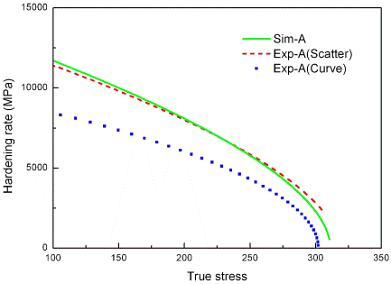 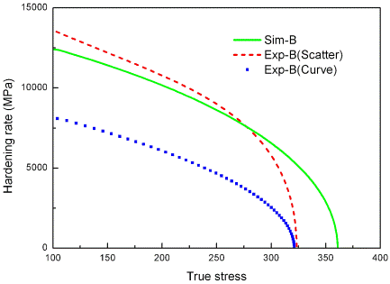

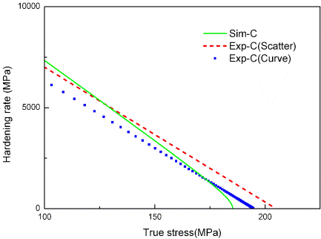 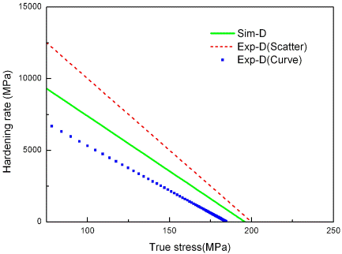

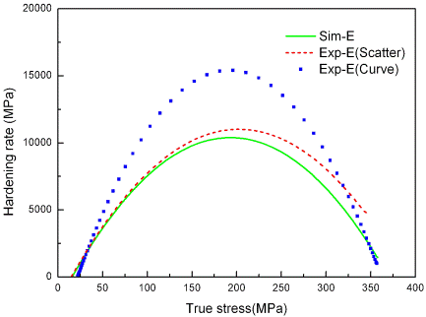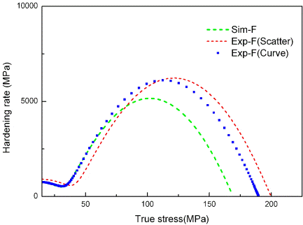

Figure A-1 Comparison of predicted and experimentally reported (K-H) hardening rates as a function of stress for different single-crystal Mg orientations (Fig. 5 in the main paper).

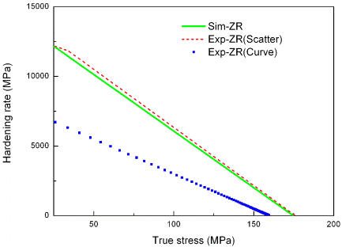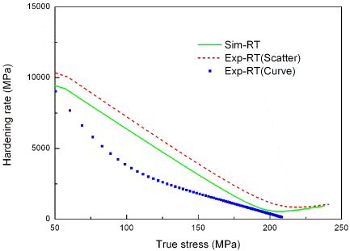

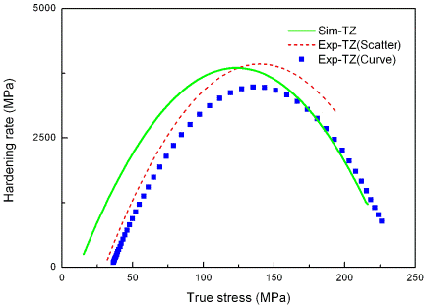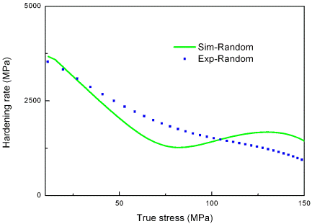

Figure A-2 Comparison of predicted and experimentally reported (K-H) hardening rates as a function of stress for different polycrystalline Mg textures (Fig. 13 in the main paper).

1. **3D simulation for Orientation C with initial heterogeneities and elastic constraint**

Following up from the discussion for slip and twin activities for orientation C (and D, Figs. 6c and d), the results for C-orientation in 3D with initial heterogeneities (5% tensile twins distributed randomly) are included. The channel walls providing the constraint to the $x_{1}$ end faces (not shown in Fig. B-1) are assumed to be made of steel. Figures B-1a and b respectively show the distribution of CT v.f. and relative activities for this orientation, which are qualitatively similar, but quantitatively somewhat different than the strict plane strain simulations (fig. 6c and d). Specifically, the role of TT and CT is increased at the expense of the prismatic and pyramidal <a> activities.



$$x_{1}$$

$$x_{2}$$

$$x_{3}$$

Figure B-1 CT v.f distribution at 10% strain for orientation C with initial heterogeneities and elastic constraint.



Figure B-2 Relative activities for C-orientation with initial heterogeneities.