Strategic Management and Operational Dynamics in High-Profile IPL Franchises: A Structural Analysis

Project Documentation Report

1. Introduction

The Indian Premier League (IPL) is one of the most popular and commercially successful cricket leagues in the world, bringing together sports, entertainment, and business on a single platform. Since its launch in 2008, it has attracted global audiences, top international players, and major corporate sponsors, making it a multi-billion-dollar ecosystem. Managing an IPL franchise is not limited to playing matches; it involves strategic planning in areas such as player selection, financial management, branding, and performance optimization. One of the key challenges faced by franchises is balancing commercial success with consistent on-field performance. Teams often generate huge revenue and brand value, but this does not always guarantee winning championships. Factors like player auctions, salary caps, injuries, and high-pressure environments add complexity to franchise operations. This project focuses on analyzing these challenges and understanding how franchises operate within such constraints. It also highlights the role of data analytics and strategic decision-making in improving team performance. The proposed website provides a structured platform to explore these concepts in an easy and informative way. Overall, the project emphasizes the importance of combining business strategies with sports management to achieve long-term success in IPL franchises.

1.1 Objectives

- To develop a web-based system for analyzing IPL franchise management.
- To understand the working of the Indian Premier League and its business model.
- To study the gap between financial success and on-field performance of teams.
- To identify the advantages and disadvantages of IPL franchises.
- To analyze the major challenges faced by teams such as auctions, injuries, and team balance.
- To explore strategies like data analytics and smart planning used by franchises.
- To provide a clear and structured platform for users to understand IPL concepts.
- To display data insights using charts and statistics for better understanding.
- To improve knowledge of web development and real-world system design

2. Project Description

This project presents a web-based system that analyzes the strategic management and operational dynamics of IPL franchises. The platform is designed to visually and conceptually represent how franchises function by dividing the system into seven structured modules, as shown in the figure. Each module corresponds to a specific aspect such as introduction, problem analysis, advantages and disadvantages, challenges, strategic solutions, data insights, and conclusion. The system combines theoretical concepts with visual elements like charts, comparisons, and structured layouts to improve understanding. It helps users clearly visualize the relationship between commercial success and on-field performance in IPL franchises.

2.2 Modules

Each module is designed to focus on a specific aspect of IPL franchise management, providing clear and structured information for better understanding.

2.2.1 Home Module
As shown in the image, the Home Module displays the main title “Strategic Management and Operational Dynamics in IPL Franchises” along with a visual representation (trophy and stadium). It provides a quick overview of the project and key statistics such as number of teams, players, matches, and revenue. This module acts as the dashboard and entry point for users.

2.2.2 Problem Statement Module

This module visually represents the Valuation vs Performance Paradox using a comparison format. It shows how franchises achieve high commercial success (revenue, brand value, sponsorships) but may experience inconsistent on-field performance (wins, playoffs, trophies). The “VS” structure in the image clearly highlights the gap between business success and match results.
2.2.3 Pros & Cons Module
In this module, the system divides information into two sections: Pros and Cons.
- The Pros section highlights benefits like revenue sharing, global exposure, talent development, and entertainment value.
- The Cons section explains challenges such as injuries, high pressure, salary cap limitations, and unpredictable performance.

2.2.4 Challenges Module
This module outlines the key operational challenges faced by franchises using categorized blocks. It includes issues such as mega auctions, team balance, managing star players, pitch variations, and player injuries. The visual icons and structured layout make it easy to understand complex problems in a simplified way.

2.2.5 Solutions / Strategies Module
This module presents strategies used by franchises to overcome challenges. It includes data analytics, talent scouting, sports psychology, fitness management, and smart team building. The image representation of players and icons reflects real-world implementation of these strategies in IPL teams.

2.2.6 Analytics / Insights Module
This module provides data-driven insights using charts and graphs. It includes metrics like total matches, average runs, wickets taken, match results, and top-performing teams. These visualizations help users analyze performance trends and understand decision-making based on data.

2.2.7 Conclusion Module
The final module summarizes the entire system. It highlights key factors such as strategic planning, effective management, data-driven decisions, and sustainable success. The visual icons reinforce the idea that a balance of business and sports strategies leads to long-term success.
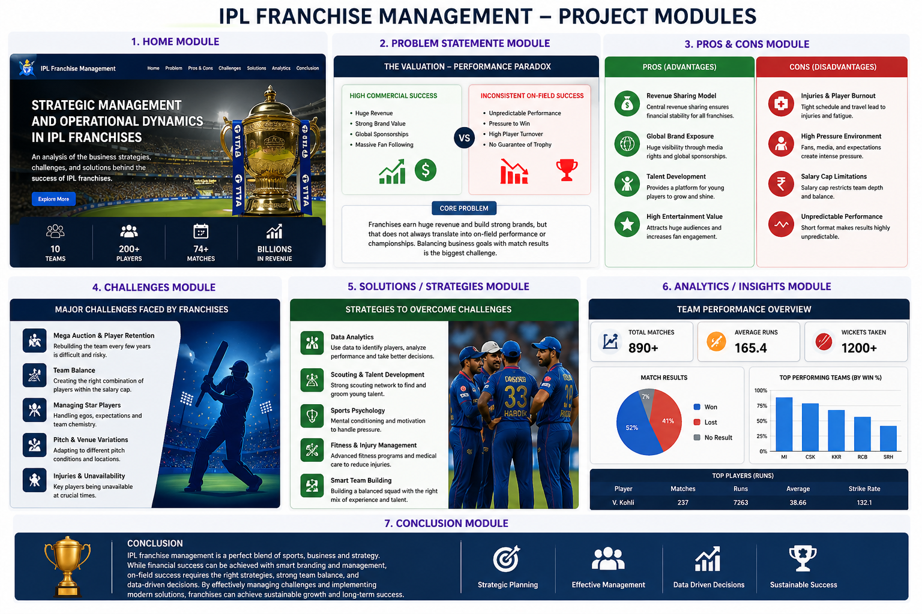

3. Implementation Process

The implementation of the IPL Franchise Management website is carried out in a systematic and step-by-step manner to ensure proper development, integration, and deployment of all modules.

3.1 Requirement Analysis and System Design
In this phase, the objectives of the project are identified. The system requirements such as modules (Home, Problem Statement, Pros & Cons, Challenges, Solutions, Analytics, Conclusion) are defined based on the analysis of the Indian Premier League ecosystem. Functional requirements like displaying data, visualizing analytics, and user navigation are finalized.
In this stage, the overall architecture and user interface of the website are designed. Wireframes and layouts are created for each module as shown in the project image. The navigation structure, color themes, icons, and placement of charts and content are planned to ensure a user-friendly experience

3.2 Frontend Development
- Framework: HTML, CSS, JavaScript , React.js for advanced UI
- UI Design: CSS used for responsive and clean design
- Structure: Component-based sections for each module (Home, Problem, Pros & Cons, etc.)
- Routing: Navigation between modules using React Router
- Visualization: Charts and graphs used in Analytics module for better understanding
This layer handles all user interactions and displays content in a structured way.

3.3 Backend Development

Technology: Node.js with Express.js

API Handling: REST APIs used to fetch and manage data

Authentication: Basic login system for admin (if implemented)

Data Processing: Handles requests like adding teams, players, and match data

This layer manages logic and communication between frontend and database.

3.4 Database Implementation
- Database: MongoDB
- Structure: Stores data in tables/collections like:
  - Teams
  - Players
  - Matches
  - Performance
Data is stored and retrieved efficiently for analytics and display.
3.5 Integration
- Frontend is connected to backend using APIs
- Backend connects to database for data storage and retrieval
- All modules are linked through navigation
Ensures smooth communication between all components.

3.6 Security
- Basic authentication for admin access
- Input validation to avoid incorrect data entry
- Secure API handling (if backend is used)
Protects system data and ensures safe usage.

3.7 Testing
The system is tested to ensure it works correctly. This includes:
- Functional testing (all modules working properly)
- UI testing (layout and responsiveness)
- Performance testing (loading speed)

3.8 Deployment and Maintenance
Finally, the project is deployed to a live server. The frontend can be hosted using platforms like Netlify or Vercel, and the backend can be deployed on Render or similar services. The website becomes accessible to users online.
After deployment, the system is monitored and updated regularly. New features, improved UI, and updated data can be added to enhance the system.

3.9 Database Structure
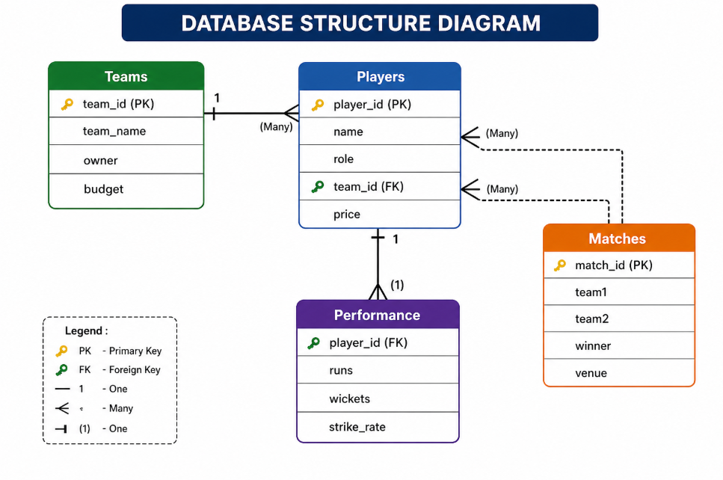
4. Technologies Used
The IPL Franchise Management system is developed using the following technologies:

4.1 Frontend Technologies
- HTML – Used to create the structure of web pages
- CSS – Used for styling and designing the user interface
- JavaScript – Used to add interactivity and dynamic behavior
- React – Used for building a responsive and modern UI

4.2 Backend Technologies
- Node.js – Used for server-side development
- Express.js – Used to handle APIs and server requests

4.3 Database
- MongoDB – Used to store data such as teams, players, matches, and performance

4.4 Tools & Platforms
- GitHub – Used for version control and code management
- Netlify – Used for deploying the frontend application

5. Project Deployment Process

The deployment process involves making the IPL Franchise Management website available for users on the internet. It ensures that the developed system is properly hosted, accessible, and functional in a real-time environment.

5.1 Code Preparation
Before deployment, the entire project code is reviewed and finalized. All modules such as Home, Problem Statement, Pros & Cons, Challenges, Solutions, Analytics, and Conclusion are checked for errors. Unnecessary files are removed, and the project is organized properly.
5.2 Version Control using GitHub
The project code is uploaded to a GitHub repository. This helps in maintaining version control, tracking changes, and storing the project securely. It also allows easy integration with deployment platforms.
5.3 Frontend Deployment

The frontend of the website (HTML, CSS, JavaScript / React) is deployed using platforms like Netlify.
Steps:
- Connect GitHub repository
- Select project folder
- Build and deploy
- Generate live website URL
5.4 Backend Deployment
If the project includes backend functionality (Node.js, Express), it is deployed using platforms like Render.
Steps:
- Upload backend code to GitHub
- Connect to hosting platform
- Configure environment variables
- Deploy server

5.5 Database Deployment
The database (MongoDB/MySQL) is hosted online using services like:
- MongoDB Atlas (for MongoDB)
- Cloud database services
The backend is connected to the database using a connection string to fetch and store data.
5.6 Integration of Frontend and Backend
After deploying both frontend and backend:
- API URLs are updated in frontend code
- Data fetching is tested
- All modules are connected properly
5.7 Testing After Deployment
The live website is tested to ensure:
- All pages load correctly
- Navigation works properly
- Data is displayed accurately
- No runtime errors occur
5.8 Domain Setup
A custom domain name can be added to make the website more professional.
- Example: www.webiste.com
5.9 Maintenance and Monitoring
After deployment, the website is regularly monitored for performance and errors. Updates and improvements are made when required to keep the system efficient.

6. Use Cases

The IPL Franchise Management system provides features for both users and admin to use the system easily and effectively.
6.1 User Functionalities
- View homepage with overview of the Indian Premier League
- Understand problem statement (valuation vs performance)
- View pros and cons of franchises
- Learn challenges faced by teams
- Explore strategies and solutions
- View analytics like team and player performance
- Read conclusion and summary

6.2 Admin Functionalities

Login to the system
- Add, update, and delete team details
- Manage player information
- Add and update match details
- Update player performance (runs, wickets, etc.)
- Generate reports and analytics
- Logout securely

6.3 Key Use Cases Summary
- Users explore IPL concepts
- Users analyze performance and strategies
- Admin manages all data
- System provides useful insights

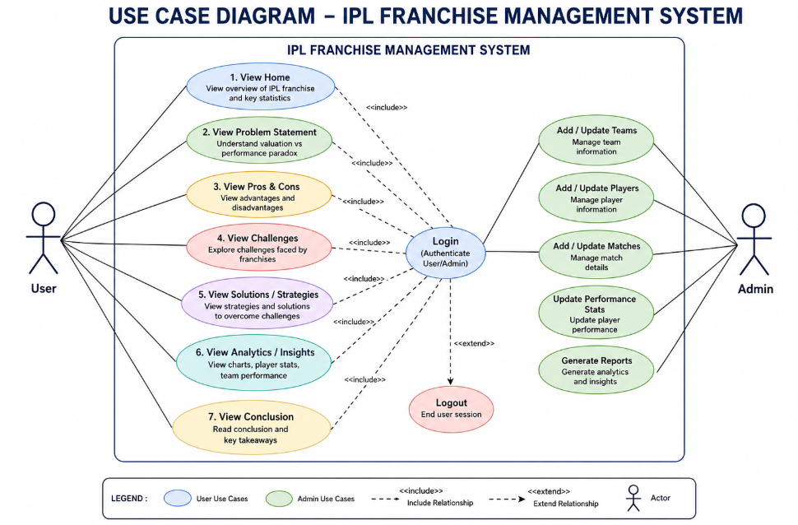

7. Conclusion

The Indian Premier League is a unique platform where sports and business come together, creating both opportunities and challenges for franchise management. This project successfully explains how IPL teams operate by balancing financial growth and on-field performance. Through different modules, it covers key areas such as problem analysis, pros and cons, challenges, and strategies.
The system helps users understand complex concepts in a simple and structured way. It also shows the importance of data analysis, planning, and decision-making in improving team performance. Overall, this project provides a clear view of how effective management can lead to long-term success. In future, the system can be enhanced with real-time data and advanced features for better analysis.

