Kunal Joshi  Cloud Security Architect and Engineer, Developer, Identity and Cryptography Subject Matter Expert | 📞 (+91) 9602201321  joshikunal16@gmail.com  linkedin.com/in/joshikunal16
SKILLS  Development  Java, Python, C/C++  Identity and Access Management  OAuth, SAML, AWS Identity And Access Management.  Cryptography  AWS Key Management Service, Hardware Security Modules (HSM), PKCS#11, JCE, OpenSSL Dyn. Encryption SDK.  Others  Penetration Testing, Privilege Escalation, Application Layer network design, Protection against DDoS, Protection against Owasp top 10 Web Application security risks, CloudFormation, AWS CDK, AWS SDKs, Terraform.  CERTIFICATIONS AND BADGES  AWS certified Security Specialty, AWS IAM Subject Matter Expert, AWS CloudHSM Subject Matter Expert, AWS KMS Subject Matter Expert.  EXPERIENCE  Amazon Web Services, Mumbai — Cloud Security Architect  May 2024 – Present  - Designed and implemented comprehensive security solutions for AWS customers to align with cloud security principles and regulatory compliance, focusing on Indian standards and regulations regulatory bodies in financial sector.  - Developed security architectures and action plans to adhere to security pillars including Identity and Access Management, Logging and Monitoring, Incident Response, Data Protection, and Infrastructure Security.  - Developed and deployed scalable security solutions, including automated least privilege policy creation, automated patch management systems, Infrastructure as Code (IaC) pipelines, and security scanners, enhancing the security posture for multiple customer environments.  - Worked closely with customers to translate complex security requirements into actionable cloud-based architectures, ensuring seamless integration with AWS services such as IAM, KMS, CloudTrail, and GuardDuty.  Amazon Web Services, Bangalore — Cloud Engineer II - Security  May 2024 – Present  Cloud Security  - Managed escalations and issues with Security Domain AWS services such as IAM, KMS, CloudTrail, CloudHSM, Shield/DDoS, Cognito, Single-Sign On, GuardDuty, Inspector, AWS Organizations, Certificate Manager, etc.  - Developed internal training materials for services including Identity and Access Management, CloudHSM, Single Sign-On, and Secrets Manager  Subject Matter Expert - Identity and Access Management  - Served as a subject matter expert in AWS IAM services, specializing in concepts such as Federation, SAML, and Single Sign-On.  - Published public knowledge center articles such as - https://aws.amazon.com/premiumsupport/knowledge-center/iam-tag-based-restriction-policies/  AWS Single Sign On - Application Catalog team  - Contributed to onboarding 60+ applications to production for AWS Single Sign On - Cloud Application catalog and authored public documentation for onboarded applications.  AWS SDK Operations  - Part of the AWS SDK Operations team, responsible for troubleshooting and debugging issues related to all AWS SDKs. Worked on AWS SDKs in multiple languages, including Python, Java, C++, C#, JavaScript, Ruby, Go, and PHP. Also managed other AWS tools such as AWS CLI, AWS CDK, and AWS Encryption SDK  Subject Matter Expert – Cryptography  - Subject Matter Expert in Cryptography services, specializing in AWS KMS and AWS CloudHSM.  - Handled escalations related to AWS KMS and CloudHSM issues.  - Worked on CloudHSM client using interfaces such as Java JCE, PKCS#11, and OpenSSL dynamic engine for backend cryptography operations. | 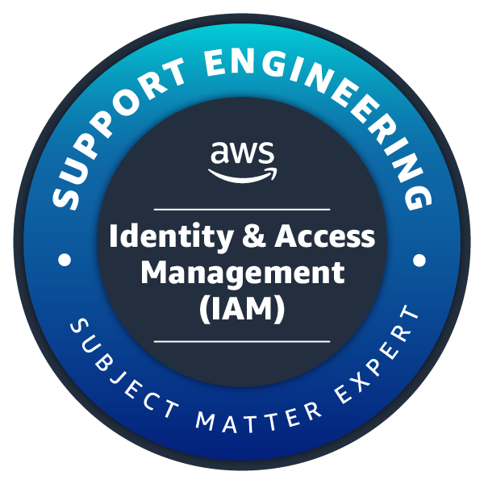  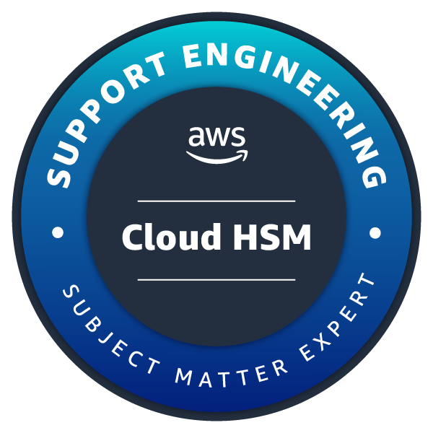  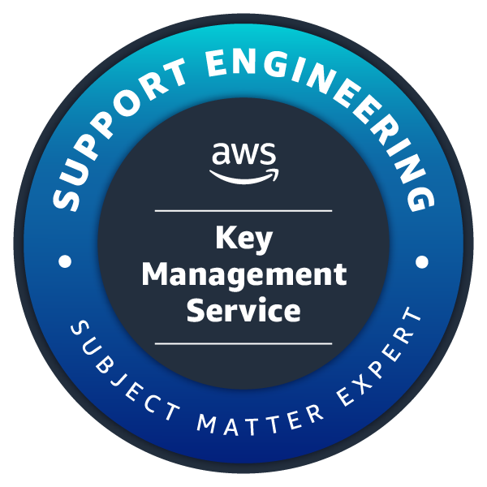  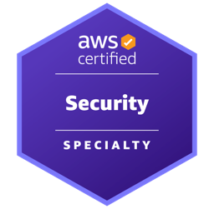  ACHIEVEMENTS  - ACM ICPC 2016-Kolkata finals Rank 58.  - Qualified - Google code jam 2017-2018  - #2223 - Round 1 Code Jam 2017  - AIR 98 - Tata Codevita 2016  OPEN-SOURCE PROJECTS  SpotLightPy - PyPI  - An Open Source Python Package (MIT License) published at Python Packaging Index (PyPI) to extract resource images from the Microsoft Spotlight Project for Windows X.  - Developed using Python 3.5  - Uses Python Imaging Library (PIL) to decrypt cached Images.  - 600+ downloads by the global python community.  - Git:https://github.com/joshikunal94/spotlightpy  - Python Packaging Index: https://pypi.python.org/pypi/spotlightpy  EDUCATION  College Of Technology And Engineering, Udaipur — B.Tech Computer Science  2013 - 2017  Completed B.Tech from College Of Technology And Engineering, Udaipur with O.G.P.A (Overall Grade Point)7.98 with S.G.P.A of 8.49 in final semester.  Maharana Mewar Public School, Udaipur — Class XII  2012  Completed class XII examination of Central Board Of Secondary Education (CBSE) with 92.0%.

