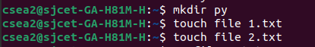
ls is used to list files and directories in a folder.

mkdir is used to create one or more directories.

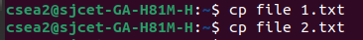
.

cp is used to copy files or directories.

