**CAPSTONE PROJECT SUMMARY**

1. **Project Vision**

|  |  |
| --- | --- |
|  | |
|  |
|  | |
| **Version 0.1** | |
|  | |

Table of Contents

1 Introduction 3

1.1 Purpose 3

1.2 Scope 3

1.2.1 In Scope 3

1.2.2 Out of Scope 3

1.3 Definitions, Acronyms, and Abbreviations 3

1.4 References 3

2 Positioning 3

2.1 Business Opportunity 3

2.2 Problem Statement 3

2.3 Product Position Statement 3

3 Stakeholder and User Descriptions 3

3.1 Stakeholder Summary 3

3.2 User Summary 3

4 Stakeholder Requirements 3

5 System Features 3

6 Assumptions 3

7 Constraints 3

# Introduction

## Purpose

The purpose of this document is to collect, define and analyze High Level Requirements of “Intelligent Language Translator Mobile Application (ILT)”. These details will be focusing on how ILT mobile application will fulfills the needs and specifications.

## Scope

<A brief description of scope>

### In Scope

* Android Mobile Application
* Hindi-English Translation
* User Friendly

### Out of Scope

* **iOS and Windows Mobile Application-** ILTMA will be available in multiple mobile operating systems including iOS and Windows.
* **Multi Language Translation-** In future ILTMA will be also focusing on dealing with multi language translation and real time speech translation.
* **Solving Mathematical and Scientific Problems based on OCR-** Based on user response ILTMA will be also dealing with solving mathematical and scientific problems based on the OCR.

## Definitions, Acronyms, and Abbreviations

* **ILT** – Intelligent Language Translator
* **ILTMA** – Intelligent Language Translator Mobile Application
* **Android** – One of the leading mobile operating system by Google. It is targeted mobile OS for use in subsequent development efforts.
* **ANN** – Artificial Neural Network inspired by biological neural networks, which are used to estimate or approximate functions that can depend on a large number of inputs that are generally unknown.
* **OCR** – Optical Character Recognition

## References

<This subsection provides a complete list of all documents referenced elsewhere in the Project Vision**.** Identify each document by title, report number if applicable, date, and publishing organization. Specify the sources from which the references can be obtained. This information may be provided by reference to an appendix or to another document>

| Reference File Name | Version | Description |
| --- | --- | --- |
|  |  |  |
|  |  |  |

# Positioning

## Business Opportunity

Imagine you someone who loves to travel to places. It’s not mandatory that the place you are traveling will use English as their primary language or the language which you understands. How you are going to read the street signs or any other important information. Probably you are someone shy and don’t like to ask people for help. What you can do is take out your phone capture the signs/ text using ILTMA you want to translate in your language. The real time translation will be done right on your mobile screen.

Many software vendors are already offering such a system. In particular, we aim to take ILT to a whole different level. The ILAMA expands from initial definition of OCR. It would provide users with the mean of understanding foreign languages. Future functionality could involve real time speech language translation, solving mathematical and scientific problems based on the principle of OCR. ILTMA would provide all these features in future based on initial user response. This Intelligent system can be installed on any Android based phone.

## Problem Statement

|  |  |
| --- | --- |
| The Problem of | People not being able to understand foreign language without any human translator. |
| Affects | People of all age groups who love to travel to different places and faces problem in understanding foreign languages. |
| the impact of which is | Difficulty community with people using different languages. |
| a successful solution would be | a simple, mobile application with a low learning curve that can be easily used by users of different age groups. The product will provide users will the real time mean of translating foreign languages to know language. The application would also support efficient mean of deep learning and self-learning. |

Table 1 Problem Statement

## Product Position Statement

|  |  |
| --- | --- |
| For | User of all age groups facing difficulties in understanding foreign languages. |
| Who | Wants to translate |
| ILT mobile application | is a smart software application |
| That | Provides ability to translate foreign languages to known language on the principle of optical character recognition. |
| Unlike | Current translation system which only provide text-text translation and do not provide real time speech translation. |
| Our product | Provide user with real time mean of translating foreign language to a more understanding language. This is accomplished by developing a strong artificial neural network with least error rate. |

Table 2 Product Position Statement

# Stakeholder and User Descriptions

## Stakeholder Summary

| Stakeholder Name | Represents | Role |
| --- | --- | --- |
| Requirement Engineers | This stakeholder works with other stakeholders to translate needs into requirements. | Specifies domain, non-functional and functional requirements. Refines project requirements as needed. |
| Software Architects | This stakeholder is the primary lead in the development of ILTMA. | Responsible for overall architecture of the system, and guides overall design and implementation of system. |
| Project Manager | This stakeholder leads development of the ILTMA. | Plans, allocates and manages resources and decides priorities and keep the project team focused. |

Table 3 Stakeholder Summary

## User Summary

| User Name | Description | Responsibilities | Stakeholder |
| --- | --- | --- | --- |
| User | Primary end user of the system | Uses application to translate foreign languages to known language. | self |

Table 4 User Summary

# Stakeholder Requirements

| ID | Requirement | Stakeholder |
| --- | --- | --- |
| 1 | Easy to Use | User |
|  |  |  |
|  |  |  |

Table 5 Stakeholder Requirements

# System Features

| ID | Feature | Stakeholder Requirement ID |
| --- | --- | --- |
| 1 | Easy to Use | 1 |
|  |  |  |

Table 6 System Features

# Assumptions

N/a

# Constraints

Clear and intuitive vocabulary organization

Less error rate

Efficient OCR Neural Network

1. **Project Requirement**

**Project Identification**

|  |  |
| --- | --- |
| **Project:** | Intelligent Language Translator |
| **Prepared By:** | Parth Rai Sharma, Navaraj, Robindra, Chinmaya |
| **Document Version:** | 0.1 |
| **Published Date:** | 14/09/2016 |

**Contributors**

The following individuals contributed to this document.

| **Name** | **Title** |
| --- | --- |
| Parth Rai Sharma | *Team Lead ,Developer* |
| Nava Raj Joshi | *Researcher , Developer* |
| Robindra Paul | *Business Analyst, Developer* |
| Chinmaya Railkar | *Business Analyst, Developer* |

**Distribution**

This document is distributed to all the following people.

| **Name** | **Title** |
| --- | --- |
| Anjana Shah | Professor |

**Referenced Documents**

This document refers to the following materials

|  |  |  |  |  |
| --- | --- | --- | --- | --- |
| **Version number** | **Title** | **Author** | **Date** | **Source / Location** |
| 0.1 | *Project Vision Document* | Team |  |  |
|  |  |  |  |  |
|  |  |  |  |  |

**Revision History**

|  |  |  |  |
| --- | --- | --- | --- |
| **Version Number** | **Revision Date** | **Summary of Changes** | **Modified by** |
| 0.1 | 2016-09-15 | Created Initial draft | Nava Raj, Robindra |
| 0.2 | 2016-09-28 | Added Context Diagram | Parth Rai |
| 0.3 | 2016-09-28 | Vision Template draft | Chinmaya |

[Note: It is recommended that drafts be numbered 0.1 to 0.9, and that the first approved version be numbered 1.0. Thereafter, new version numbers will depend upon changes: 1.01, 1.1, etc for minor updates, 2.0, 3.0 etc for major changes.]

TABLE OF CONTENTS

1. Business Context Diagram 3

2. REquirements Scope Statements 4

1. Business Context Diagram

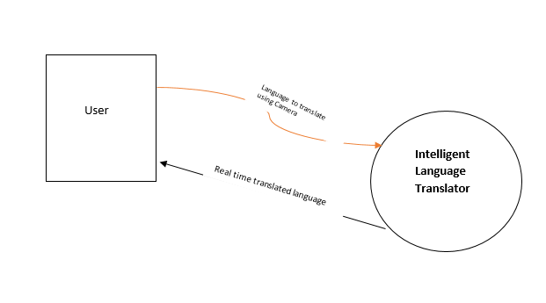

|  |  |
| --- | --- |
| **Requirement Scope Area** | **Description** |
| Intelligent Language Translator |  |

|  |  |
| --- | --- |
| **External Entity** | **Description** |
| User | Anybody who use the application. |
|  |  |
|  |  |

| **Information Flows** | **Description** |
| --- | --- |
| Language to Translate | Provided by application users based on user input or visual input taken by camera. |
| Translated Language | Provided by application users based on user input or visual input taken by camera |
|  |  |
|  |  |

2.Requirements Scope Statements

|  |  |  |
| --- | --- | --- |
| **HLR#** | **Description** | **Priority**  **(H, M, L)** |
|  | User Sends language to translate using camera | H |
|  | System do real time translation | H |
|  | System differentiates between languages |  |
| HLR04 | Easy to use | H |
|  |  |  |

1. **PROJECT PLAN**

The purpose of this mobile application is to translate eventually any given language (English at the moment) to any desired language (Hindi at the moment) irrespective of any surface the language is written on. It could from a wall, book, pipes, toys, language written on fabric etc.

1. Requirements Analysis and Design

## ILT is an intelligent language translator used to translate foreign language in to desired(Hindi) language based on the principal of Optical Character Recognition(OCR) which will be working on the Highly Efficient Artificial Neural Network.

## Purpose

The purpose of this mobile application is to translate eventually any given language (English at the moment) to any desired language (Hindi at the moment) irrespective of any surface the language is written on. It could from a wall, book, pipes, toys, language written on fabric etc.

## Scope

This app will be running on android which will translate language from English to Hindi and will be extremely User friendly which even a 4-year-old kid can use it without any complications and with just 2 clicks. However, this app will not be available on IOS and windows Mobile Application. It won’t be a multi Language Translation App resulting in less usage of the problem-solving algorithms however the concept remains the same for working of other languages on the app.

# System Overview

There is one user and one system and when user clicks on the app to capture the desired language to be translated, the system processes the information and returns the output in more then 2 second or less.

## Project Perspective

It is a new self-contained system which not only translates word by word but does translate literal context of one language to another.

## System Context

Once the picture is taken to be translated then the system fetches the alphabets and tries to change the word from one language to another and once the words are ready then it puts them into sentences.

## General Constraints

* Clear and intuitive vocabulary organization

We need to build an intelligent neural network. It’s like teaching the computer two languages and getting an output in which computer not only changes the language but also translates the exact meaning with possibly less errors as possible.

* Less error rate

For less error rate, we need to put good number of alphabets with different type of writing styles and show the accurate context of the translation of a sentence.

* Efficient OCR Neural Network

.

## Assumptions and Dependencies

The app needs to be extremely user friendly getting the result in no more then 2 seconds. The app will be using already present libraries in java supporting the app.

## 3.0 Functional Requirements

### 3.1 Functional Requirement

* It should not take more then 2 seconds for the system to translate any number of words that could be fetched from the photo to be translated.
* System can distinguish picture and words.

## 3.2 Use Cases

### 3.2.1 User Use Case #1

**Diagram:**

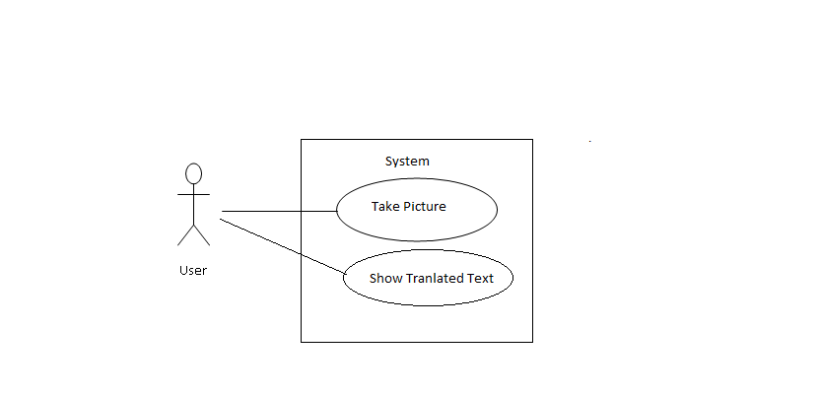

**3.3 Data Modelling and Analysis**

* Activity Diagrams

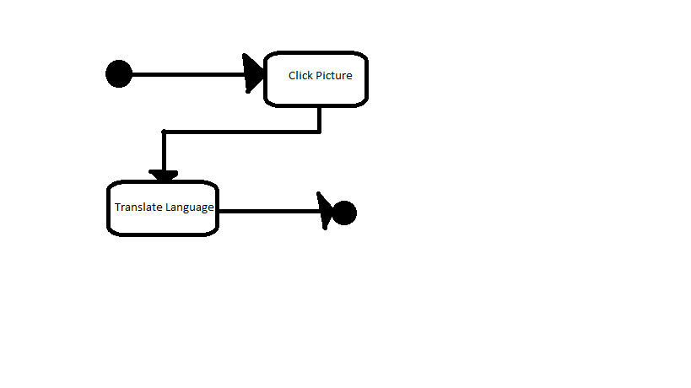

* Sequence Diagrams

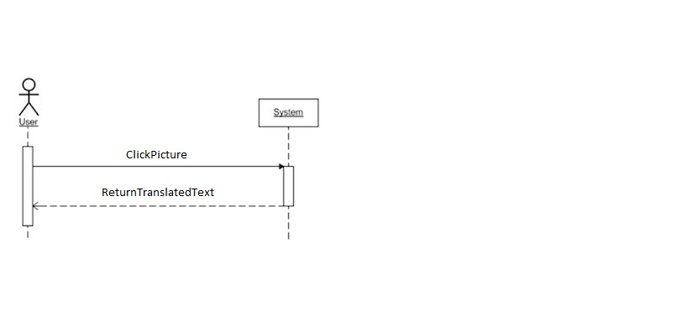

Note:

Activity diagram and uml Class diagram has been made as there is no data stored in the app.

**3.4 Process Modelling**

The application does not have any data collection.

## 4.0 Non-Functional Requirements

* Application support all type of android devices having camera.
* Easy to use
* Easy to maintain
* Outcome should be reliable.
* There is no concern over portability, availability and Security as the app does not store any data in it and can be downloaded from the app store in the future. But we need to make sure the app does not crash on any device and does the translation in less then 2 seconds.

## 5.0 Logical Database Requirements

There is no database required in this application

1. **WIREFRAME/MOCK UPS**

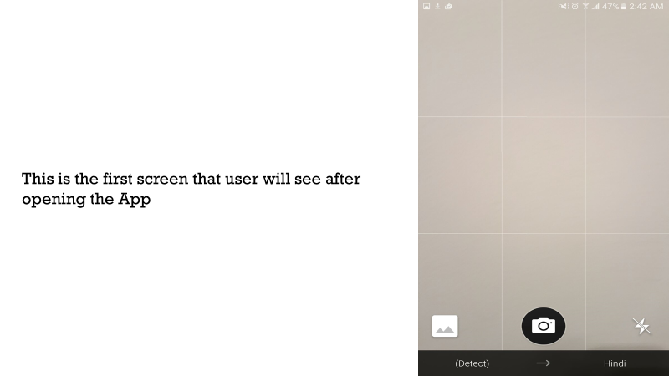

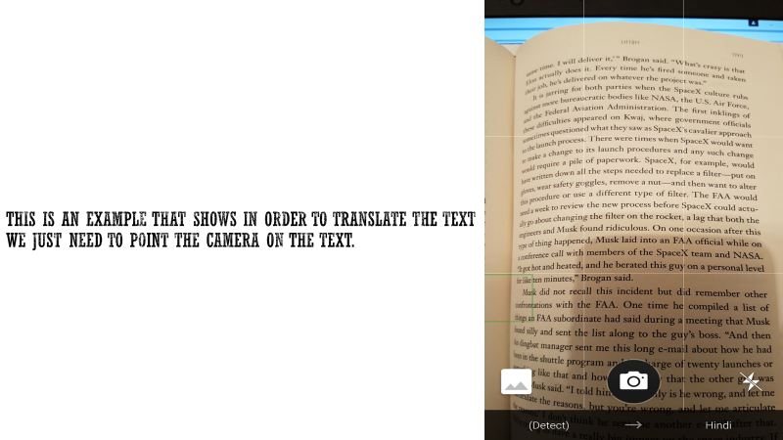

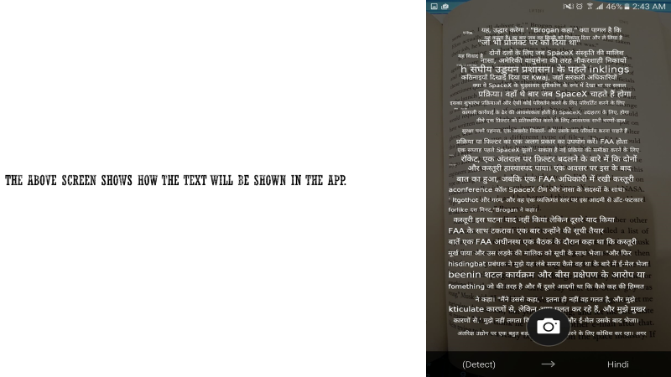

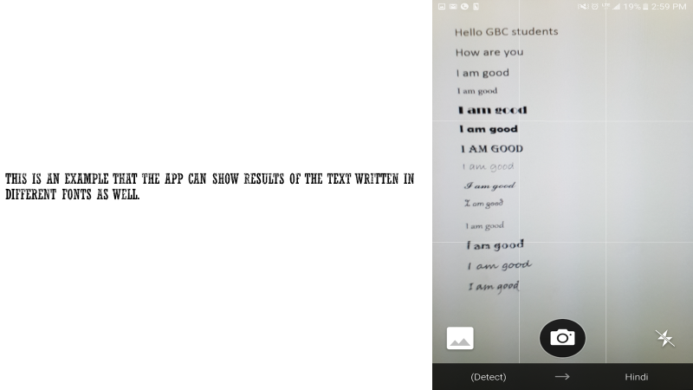

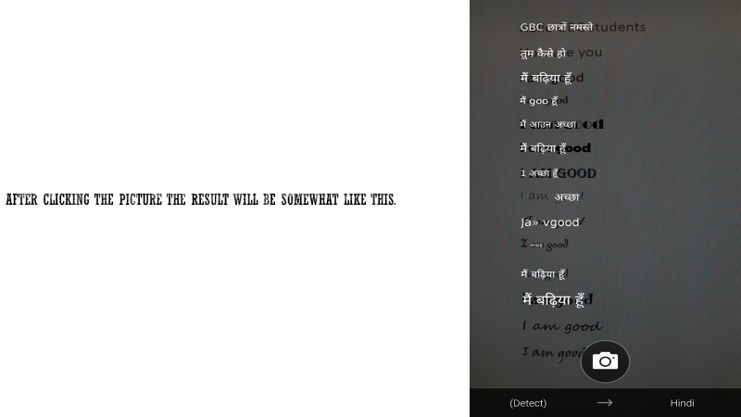

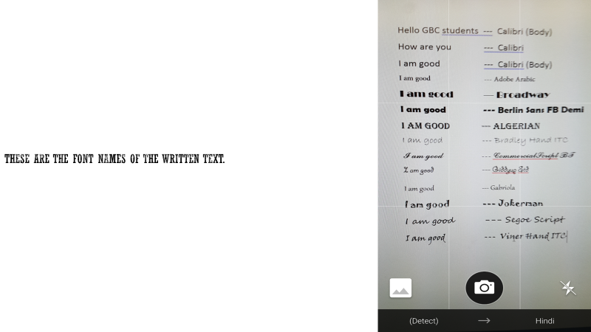

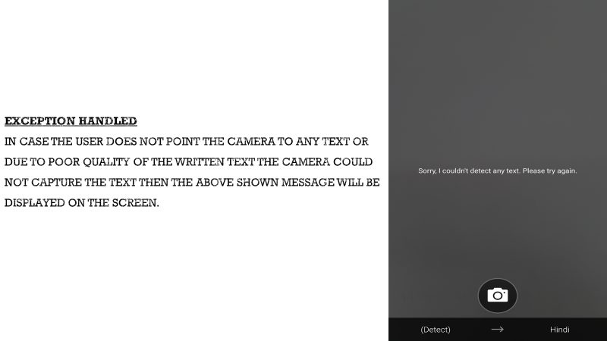

1. **STATUS REPORT**

**Project Status Report**

|  |
| --- |
| Date of Report Issue/Prepared: 26/03/2017 |

Report Prepared By: Robinder Paul

Employer/Organization:

|  |  |  |
| --- | --- | --- |
| Project Name:  Project Team:  Period Reporting:  Overall Project Health | Intelligent Language Translator | |
| Robinder Paul, Parth R shrma, Navaraj Joshi, Chinmaya Railkar | |
| Start Date: **Jan 19, 2017** | End Date: **Mar 27, 2017** |
| Green (Good) | |

**Summary**

*[Notes:* ***Key accomplishments last period:***

*List brief 1- or 2- sentence descriptions of what was accomplished in this last period:*

* *Include important schedule milestones if any occurred in this last period.*
* *Include any events that significantly reduced risk in the project.*
* *Include key tasks that closed an issue that was marked “open” on the previous report, if any.]*

|  |  |
| --- | --- |
| **Accomplishments As Planned** | **Planned but not Accomplished** |
| Design Finalization | Final product |
| Platform Approach |  |
| Design Efficient Neural Network |  |
| Software Design |  |
| Testing Software |  |
| Prototype Testing |  |
| Advance development of neural network |  |
| Testing Software |  |
| Prototype Testing |  |
| Software completion and testing |  |
| Changes to software according to required changes |  |

**Gant Chart**

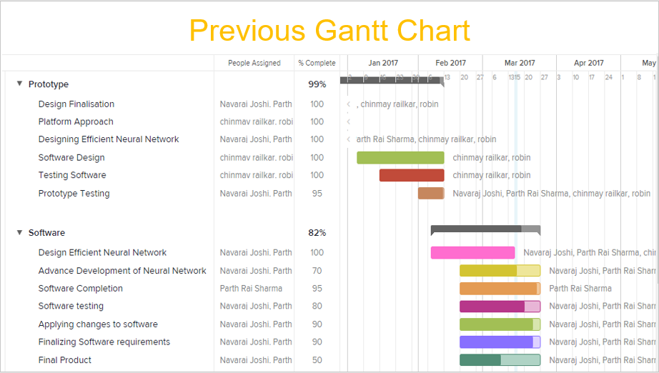

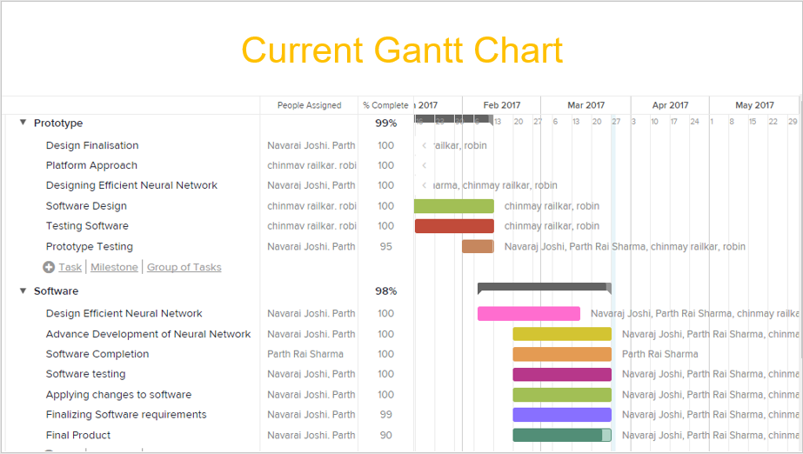

**Upcoming Objectives**

[ Notes: **Upcoming tasks for the next period: ( 2 weeks)**

List brief 1- or 2-sentence descriptions of what you plan to accomplished this next period.

* Include important schedule milestones if any that will occur in this period.
* Include any upcoming events that will significantly reduce risk in the project.
* Include key tasks that will move an open issue toward closure.

|  |  |  |
| --- | --- | --- |
| Planned Activities/Tasks for Next Period | |  |
| Activity/Task | Date/Duration | Assigned To |
| Final product Presentation | 2/04/2017 | Robinder, Parth, Navaraj, Chinmaya |

|  |  |  |
| --- | --- | --- |
| Milestones for Next Period | |  |
| Milestone (Objective) | Delivery Date | Assigned To |
| Final Product Presentation | 2/04/2017 | Robinder, Parth, Navaraj, Chinmaya |

**Managing Issues and Risk**

**[ Notes: Issues:** List principal open issues.

* Include any item that specifically needs attention.
* Include a task in the “Upcoming tasks for this period” that will move this issue toward closure.
* Don’t try to track all project issues in this report. Just list the principal ones along with any progress toward closing them.]

|  |  |  |  |
| --- | --- | --- | --- |
| Issues/Problems | Resolution Strategy | Due Date | Assigned To |
| ---------- | --------- | -------- | -------- |

|  |  |  |  |  |
| --- | --- | --- | --- | --- |
| Upcoming Risks | Risk Ranking  (Hi, Med, Low) | Risk Impact  (Hi, Med, Low) | Mitigation Strategy | Assigned To |
| Not meeting the deadline. | med | med | Divide more task and Complete them | Robin, Parth, Navraj, Chinmaya |

**NOTE: Attach additional sheets if insufficient space available**

**Minutes of meeting in march**

16th March, 2017 at 11 A.M

* Software testing
* Software completion

23rd March, 2017 at 11 A.M

* Completing the final product

30th March 15, 2017 at 11 A.M

To be attended