**Online Retail Store Application Details**

**HLD**

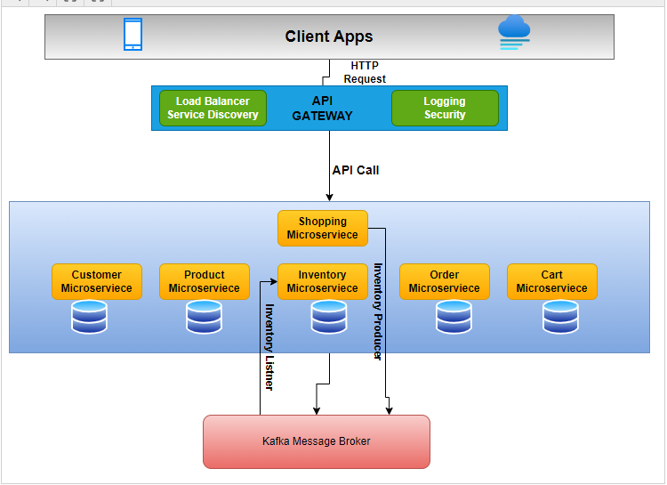

**Application Configuration details**

**Customer - 7080**

**Product - 7081**

**cart - 7082**

**inventory - 7083**

**order - 7084**

**shopping-service - 7085**

**Eureka Naming server-8761**

**Api Gateway – 8765**

**All the Application are registered with Eureka Naming Server**

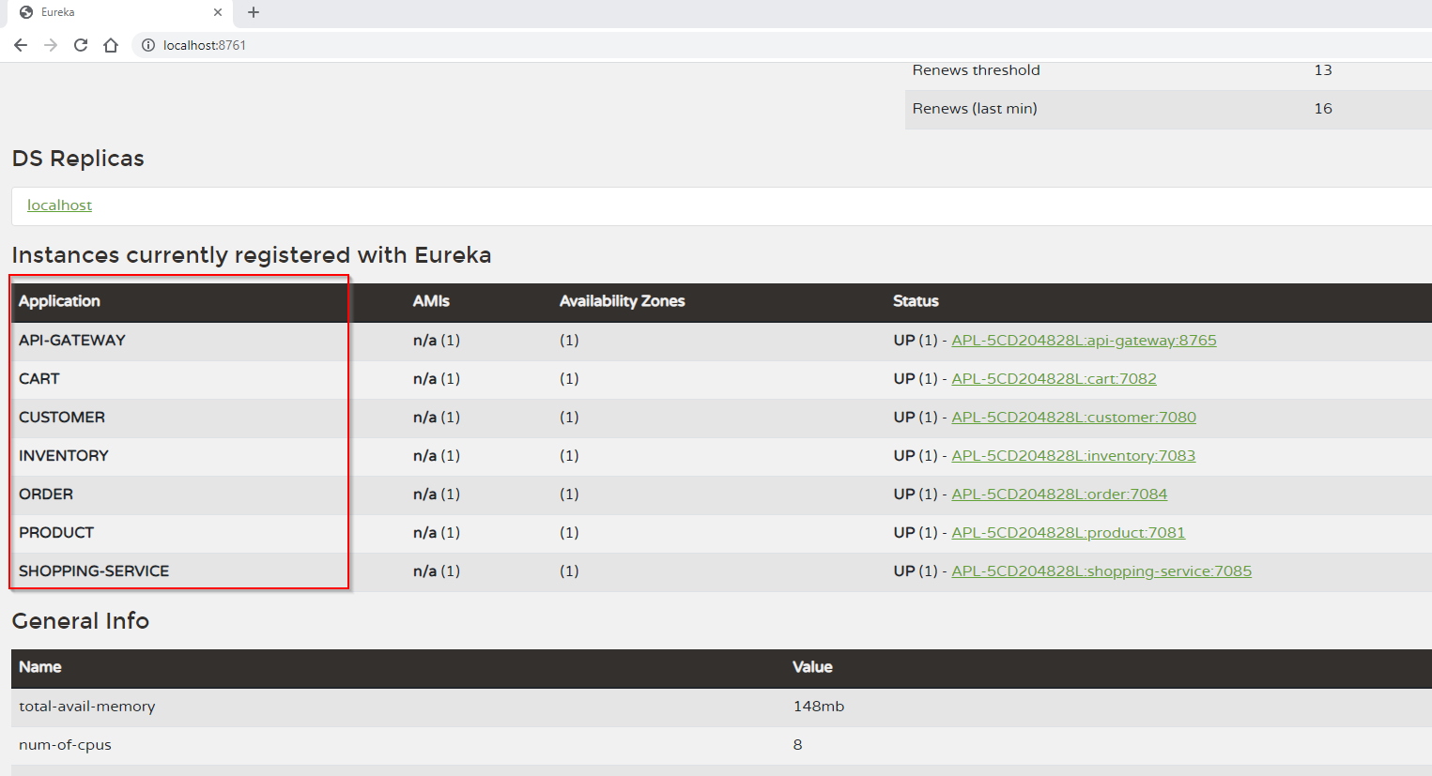

**(1) Create Product using ShoppingService**

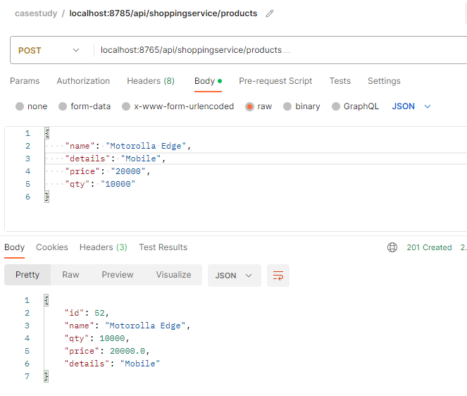

**Product in DB**

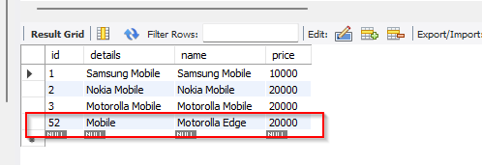

**Created Logging Filter in API Gateway to capture all the request called as part of cross cutting concern**



**(2) Create Customer using ShoppingService and return cartId and customerId**

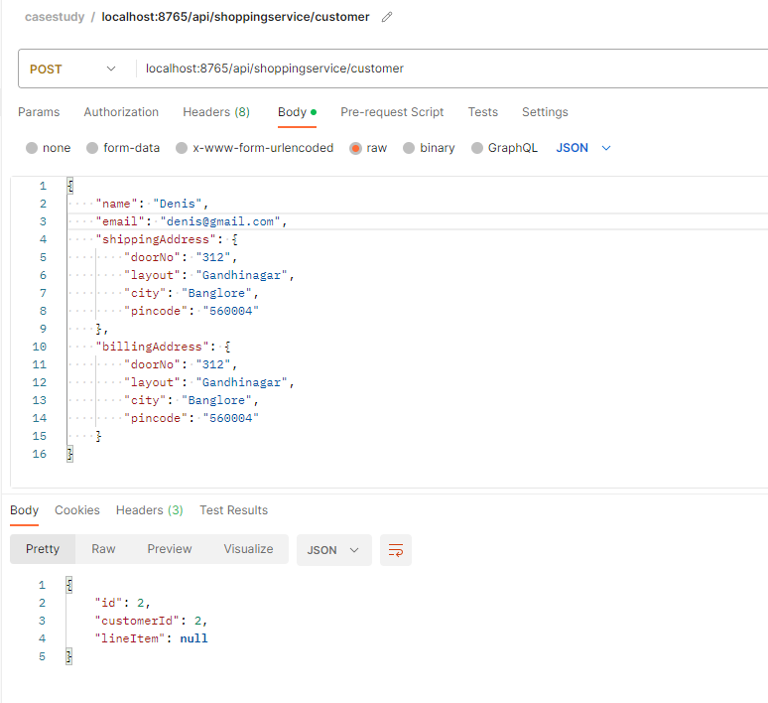

**3)Updating cart items for customer 2**

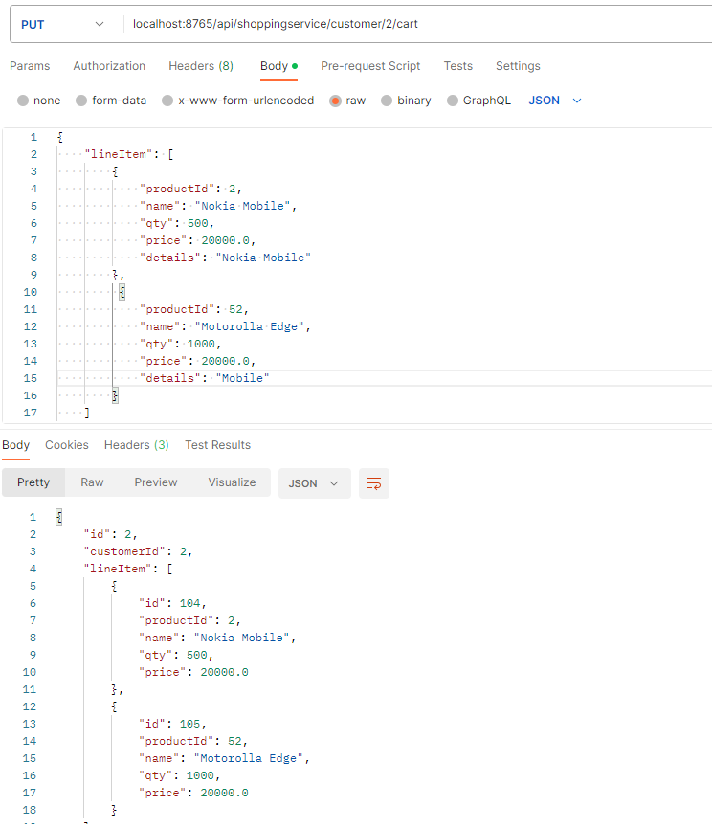

**DB Entry in Cart Line Item**

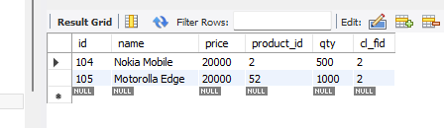

**4)Placing an Order for customerId – 2**

**Inventory count in DB before placing an order**

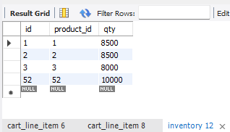

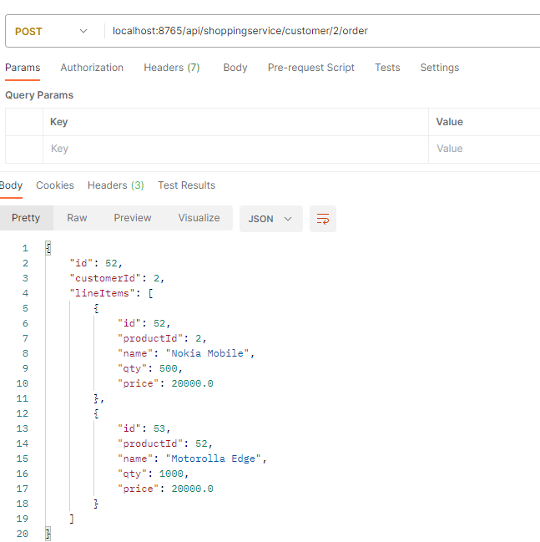

**Inventory count after placing an Order and its updated using Asynchronous listener created which is getting messages from Kafka message broker**

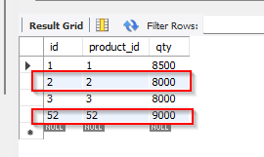

**5)Fetch order list for customer Id – 2**

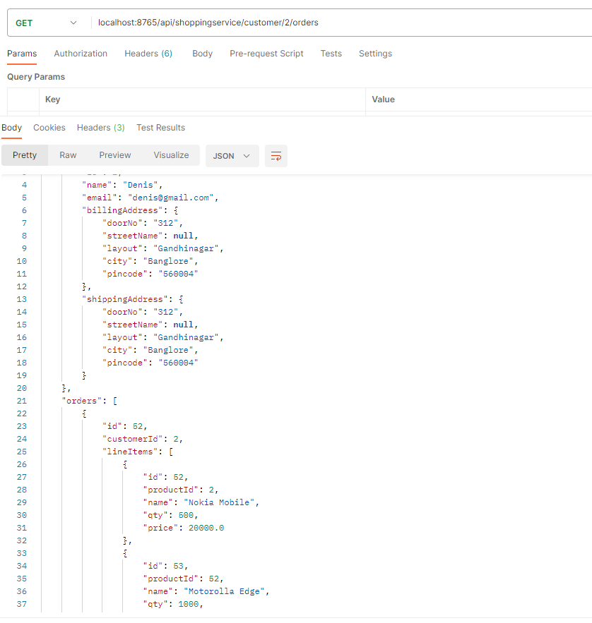

**Oder Line Items for Customer Id -2 in DB**

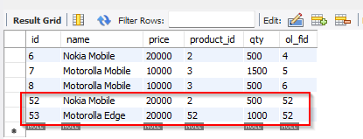

**Data deleted in Cart Line Item**

