Proposal on

**SpareRoom**

Submitted to



**Department of Computer Science and Engineering** **Nepal Engineering College**

In partial Fulfillment of the

Requirement for Degree of B.E. in computer

By

Milan Malla (017-350)

Shuveccha Silwal (017-381)

Sijan Joshi (017-382)

Submission date: 24-02-2020

**Abstract**

Today’s world mostly relies on internet for most of the information collection. The purpose of this mobile application is to provide a platform for the user to search for spare room that he/she can share with the room owner on certain terms and conditions and also find vacant rooms. It is an online space where one can search spare rooms and fully vacant room based on the specified location. Its design is going to be made simple and easy to use so that user with less knowledge about new technologies can also use it with ease. It is based on search and contact where user can directly contact the room’s owner. It is going to have the feature of watchlist with which user can save some of his/her ’s favorite rooms for future reference. SpareRoom app can be a platform that helps user who is in search for a room along with a roommate.

**Keywords:** SpareRoom, web application

**Acknowledgement**

First of all, we would like to show our utmost gratitude to the Department of Computer Engineering for granting us permission to commence with our project and encouraging us to be a part of such innovative curriculum. We would like to express our deep sense of gratitude and sincere thanks to our project supervisor Menuka Maharjan for constant gratitude and support in starting the project.

**Table of Contents**

**Chapter 1. Introduction** 1

**1.1** **Problem Statement** 1

**1.2 Objective** 1

**1.2** **Feasibility Study** 2

**1.3.1 Technical Feasibility** 2

**1.3.2 Operational Feasibility** 2

**1.3.3 Economic Feasibility** 2

**1.3.4** **Legal Feasibility** 2

**1.4** **Scope** 3

**Chapter 2. Literature Review** 4

**Chapter 3. System Design** 5

**3.1** **Flow Chart** 6

**3.3 Modules** 7

**3.3.1 Admin Module** 7

**3.3.2 Registration Module** 7

**3.3.3 User Management Module** 7

**3.3.4 Ad Module** 7

**3.3.5 Contact Module** 8

**3.4** **System Requirement** 8

**3.4.1** **Software Requirements** 8

**Chapter 4. Expected Output** 9

**Chapter 5. Conclusion** 10

**References** 11

# Chapter 1. Introduction

SpareRoom is a mobile application that allows visitors to search for rooms based on specified location. The purpose of this mobile application is to provide a platform for users both post ad for room and search for room. It is an ad-based application which relies on a user posting add and another user searching for posted ads and selecting the room suitable for the user. It will help the user to eliminate hazardous process of visiting house to house in search for room and also helps user to save some money by sharing of the room with multiple room partners.

User will be able to download the app from different websites and can search for rooms there. The application will be on fully customized material design.

## 1.1 Problem Statement

On today’s digital age we mostly rely on Internet for most of our day to day work. People are busy most of the time and they do not have time to search door to door for vacant room. And people are compelled to live in unfacilitated room due to low budget. And some people are even compelled to pay rent of the room that is not spare.

## 1.2 Objective

* To provide people a platform to post ad for their spare room.
* The main function of this mobile application is to help user search for suitable room.
* To provide users with an opportunity to help others people by sharing their spare room.
* To help user to get spare and vacant room without going house to house.

## 1.2 Feasibility Study

### 1.3.1 Technical Feasibility

Technical Feasibility means whether the project is working in a perfect manner. It means the project must support or perform all the technical functions for which it is implemented. The project ‘SpareRoom’ is technically feasible. This website is capable of providing user good interface thus this project is able to work in effective and efficient manner.

### 1.3.2 Operational Feasibility

Operational Feasibility means the project must perform its operation perfectly. If the project is working properly then we can say that the project is operationally feasible which is applicable for this project.

### 1.3.3 Economic Feasibility

Economic Feasibility is a term which is related to estimation of cost required for the project. The project is feasible under the economic condition.

### 1.3.4 Legal Feasibility

Legal Feasibility means the developing project must be legal. The way by which the product is going to be implemented must be legal also the project must perform a legal task. It must be acceptable worldwide. The project is not going to perform any tasks which do not lie under the condition of law. Thus, the project must be legal to use and can be acceptable by the user.

## 1.4 Scope

The scope of this mobile application is to facilitate user to search for spare and vacant room and also post ad for spare and vacant room, as well as to provide user with easy and functional interface so that users of any age group can use this mobile application with ease. The outcomes of the mobile application will contribute to the user by providing a platform that will eliminate a hazardous process of traditional room finding.

# Chapter 2. Literature Review

During research of this project several articles, journals, have been reviewed most of which are taken from the internet. The mobile application is an ad based mobile application that allows people to interact with each other, share their ads for room and search for spare and vacant room. There is no loss of data as the user ads and messages are stored in database and can be retrieved and reviewed anytime. It also provides users the flexibility of time and place to reflect on the previous postings to the discussion thread and thus actively engages them in a meaningful and intellectual experience. [1]

Rooms that are located in same location are grouped together. The messages are private and the users involved in the chat can only view them.

However, one of the web-article points out that “Having multiple rooms on the same location can create laggy interface on initial load.” But it also points out that “Location based room map helps users to get clear view about the location where there are more rooms available.” [2]

# Chapter 3. System Design

System Design is the process of defining the elements of the system such as the architecture, modules and components, the different interfaces of those components and the data that goes through the system. It is meant to give us clear idea, what our system is going to look like just with a single glance.

## 3.1 Flow Chart

*Figure 1. Flow chart for SpareRoom*

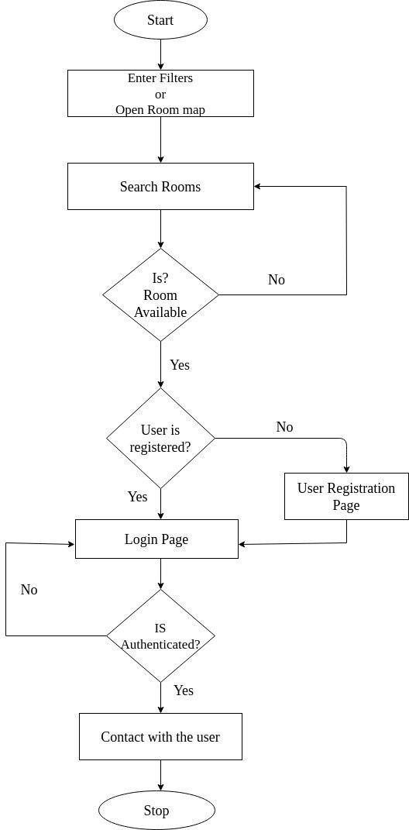

From the above flow chart, it is clear that user has option to enter filters like location, pricing and terms to search for rooms or user can view them directly from room map. After user gets the room list, the process of checking whether the room is available or not takes place. Only registered user can contact the ad poster so user is sent to register/login page. And after the authentication process the user can contact to the ad poster.

## 3.3 Modules

### 3.3.1 Admin Module

This is a master account creation module. It is not accessible to normal users. It will look after all the other module and have authority to control it.

### 3.3.2 Registration Module

This module is responsible for the registration of new user. It requires information of the new user for the registration. This module also verifies the data entered by the user.

### 3.3.3 User Management Module

The module is responsible for the management of the registered user. User can edit and modify some of their information through this module.

### 3.3.4 Ad Module

This module manages the ad posted by the corresponding users. It helps the user to post the ad for room. It is also responsible for selecting, updating and deleting ad for room.

### 3.3.5 Contact Module

This module manages the messages between user about the room. It helps the user to contact other users that has posted the ads.

## 3.4 System Requirement

### 3.4.1 Software Requirements

* Flutter
* Firebase
* Dart

# Chapter 4. Implementation and Discussion

# Chapter 5. Conclusion

Our “SpareRoom” mobile application is going to be designed in such a way that the user can post ad for spare and vacant room and search for spare and vacant room. This project will mainly focus on facilitating user to freely post ad and eliminate the traditional way of room finding where user has to visit house to house. Flutter is going to be used to make this project as productive as possible. Our main focus will lie on making the user interface as simple as possible. Hence this mobile application will be beneficial for user of any age group.

# References

1. R. Joon, "UX Planet," [Online]. Available: https://uxplanet.org/roommates-ux-uicase-study-assignment-in-48-hours-bfeddd09e3b. [Accessed 24 02 2020].
2. "atomengine," [Online]. Available: https://atomengine.co.uk/projects/room-finderweb-app/. [Accessed 24 02 2020].
3. K. Ferrell, "RoomFinderPro," [Online]. Available: https://github.com/kferrell/RoomFinderPro. [Accessed 24 02 2020].