eWatchman

Mobile Security Solution Application

12/1/2014

Cloud Computing

Prepared By,

Priyam Bakliwal

Nausheen Fatma

Joshita Mishra

Jui Chandwaskar

Table of Contents

1. **Abstract3**
2. **Overview3**

2.1. Intended audience3

2.2. Benefit of users3

1. **Use case diagram**3
2. **Technical Stack**4

4.1. Components used4

4.2. Communication flow4

4.3 Technologies used5

1. **Future enhancement5**

#### Abstract

This application can be used through any android device that supports camera, take a photo every minute upload it on cloud. This mobile security solution would help the user to enhance the security of a location by capturing the photograph every minute. Web based album can be used to view the captured pictures. User can use the search option to search the stored pictures by time and device.

#### Overview

##### 2.1. Intended audience:

This application can be used by security personals for any public or private surveillance systems.

##### Benefits for Users:

* **Financial :** Low cost security solution (Costs for video surveillance is reduced)
* **Storage :** Storage requirements of storing a video is more than the storage requirement of storing an image. Thus this solution will help save a lot of storage space, hence money saving.

#### Use case diagram

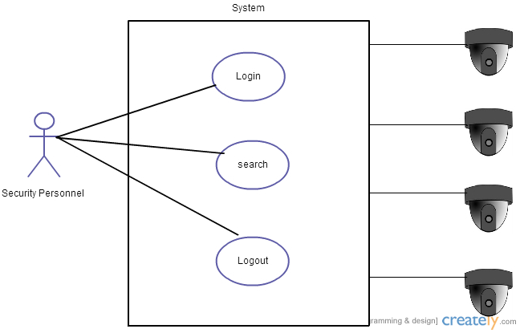

Fig.1 Use case diagram

System is divided into three modules from user perspective:

1. Login: As a user, I want to login to the system.
2. Search: As a user, I want to search the picture according to date and time.
3. Logout: As a user, I want to logout of the system.

#### Technical Stack:

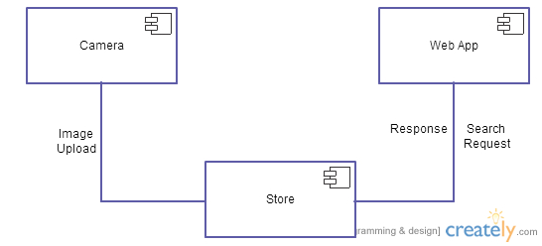

Fig. 2 UML Component Diagram

##### 4.1 Components used:

* ANDROID APP : Dumb app(Just used to click picture every minute)
* GOOGLE BUCKETS : Google Buckets (Used for storage of Images)
* WEB APPLICATION : GUI for users to view the uploaded images

##### 4.2 Communication flow:

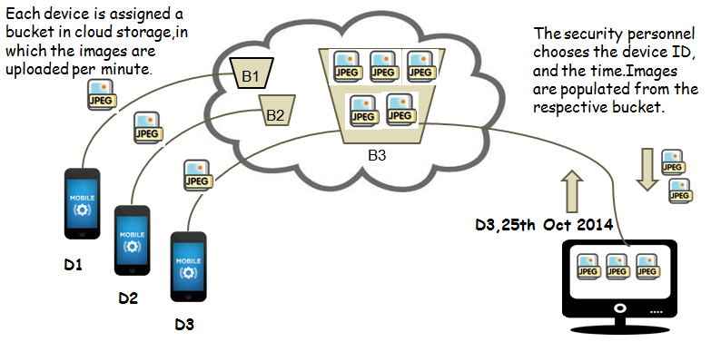

Fig. 3 Flow diagram

Android camera device is installed with this application. During first installation of this application, new bucket will be created for the particular device with its corresponding device ID(uuid). After first installation, it will capture images after an interval of one minute and upload it on cloud every minute.

Using the Web application, user can monitor the images being captured. User can select filter with date and time for displaying the set of images in the selected time span.

##### 4.3 Technologies used:

* Android 4.4 SDK
* CSS, HTML5, JavaScript
* Java
* Google Cloud Storage

#### Future enhancements

* Multiple User Support
* Better Search Options
* Configurable Time Settings
* Role Based Implementation
* Use of Compression while storing images in camera