Practical - 14
Practical Title : Admin Dashboard with Role-Based Access Control, Dynamic Menu, and Audit Log
Problem Definition: Develop an admin dashboard that displays user statistics, student count, event count and latest registrations. Restrict access to admin users only and show dynamic menu options based on role.
Theory
- Are dashboard values loaded dynamically from the database?
Answer: Dashboard values are loaded dynamically from the MySQL database.

- Is access restricted to admin users?
Answer: Access to the admin dashboard is restricted to authenticated admin users.

- Are role-based menus working?
Answer: Role-based menus display appropriate options for admin and student users.

- Are important admin actions recorded in audit_logs?
Answer: Important admin actions, such as adding, updating, and deleting student records, are recorded in the audit_logs table.

Implementation :
- Loaded dashboard values dynamically from the MySQL database.
- Restricted admin dashboard access to authenticated admin users.
- Implemented role-based menus for admin and student users.
- Recorded important admin actions, such as adding, updating, and deleting student records, in the audit_logs table.
- Displayed dashboard information and management options according to user roles.

Evidence of Work (Screenshots)
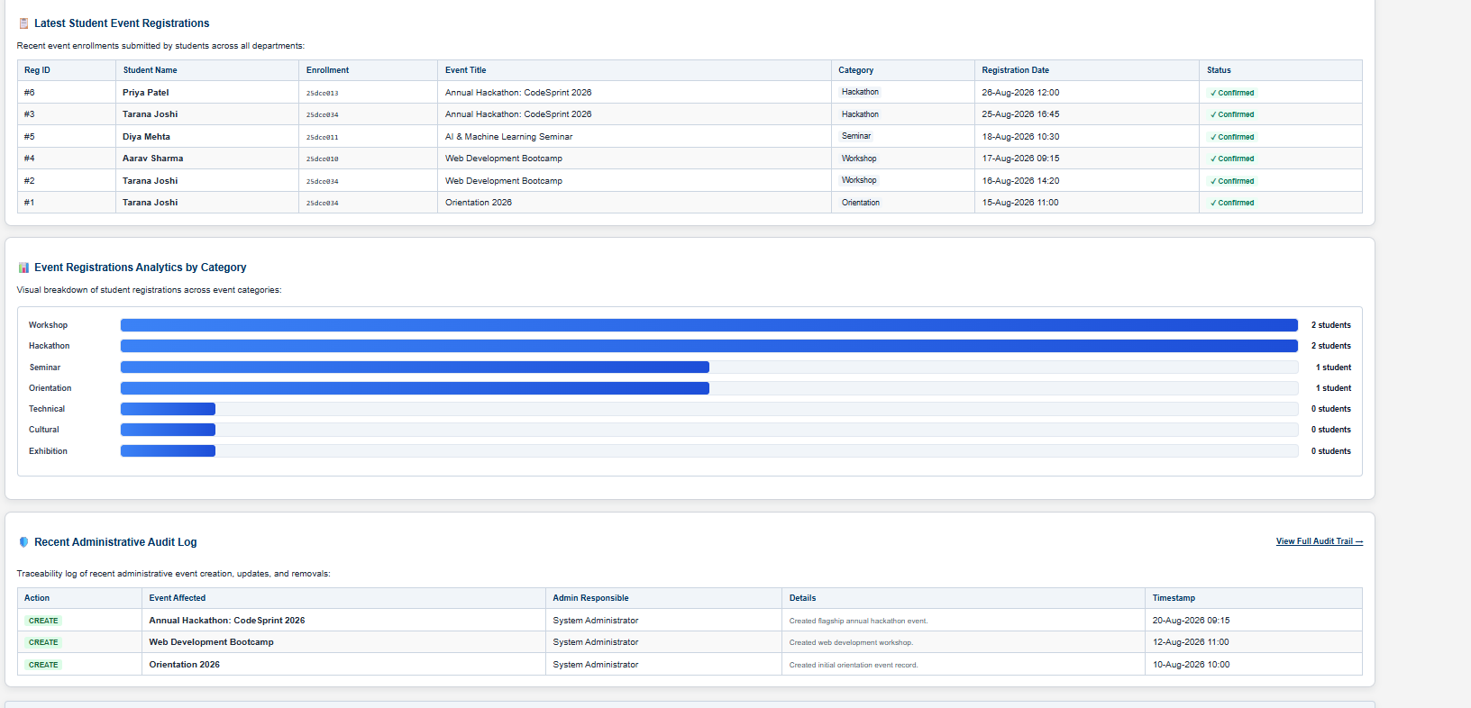

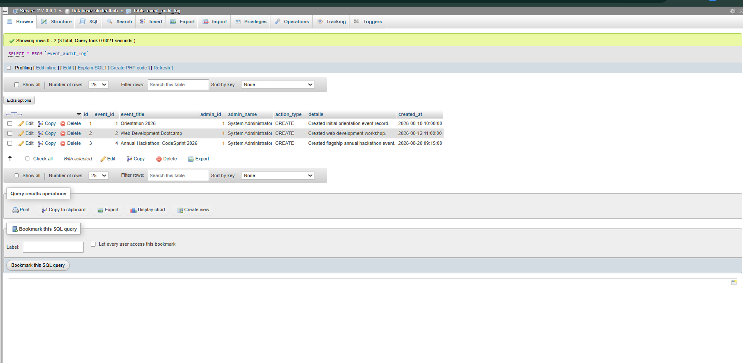

GitHub Repository Link:

https://github.com/joshitarana2621/studenthub-portal/tree/main/practical14

Challenges Faced:
- Fetching and displaying dashboard statistics dynamically from the database.
- Restricting dashboard access based on user roles.
- Implementing role-based menus correctly.
- Recording admin activities in the audit_logs table.
- Maintaining consistency between database records and audit logs.

Learning Outcomes:
- Learned to create dynamic admin dashboards using PHP and MySQL.
- Understood role-based access control and dashboard security.
- Learned to display menus according to user roles.
- Gained knowledge of audit logging to track admin activities.
- Improved understanding of database integration, security, and activity monitoring.

