SUBJECT: WEB DEVELOPMENT FRAMEWORKS (ITUE203)
SEMESTER: 3RD | ACADEMIC YEAR: 2026–2027

PRACTICAL – 12
Event Management CRUD with Poster Upload and File Validation
Student Name: tarana joshi
Enrollment Number: 25DCE034

Key Questions and Answers
- What is CRUD?
Answer: Create, Read, Update and Delete operations on records.
- Why use prepared statements?
Answer: They separate SQL commands from values and reduce SQL injection risk.
- Why validate uploads on the server?
Answer: Client-side checks can be bypassed.
- Why use a random filename?
Answer: It reduces filename collisions and avoids trusting the original name.
- Does MIME validation prove a file is safe?
Answer: No. It is one check only; uploads should be restricted and never executed.
- What is htmlspecialchars() used for?
Answer: It escapes special characters before displaying user-controlled text in HTML.
- What is a foreign key?
Answer: A constraint linking a column to a record in another table.
- Why restrict admin pages on the server?
Answer: Users can type a URL directly even if a menu link is hidden.
- What does enctype multipart/form-data do?
Answer: It enables a form to send uploaded file data.
- What should happen if no new poster is selected during edit?
Answer: The existing poster should remain unchanged.

Output:
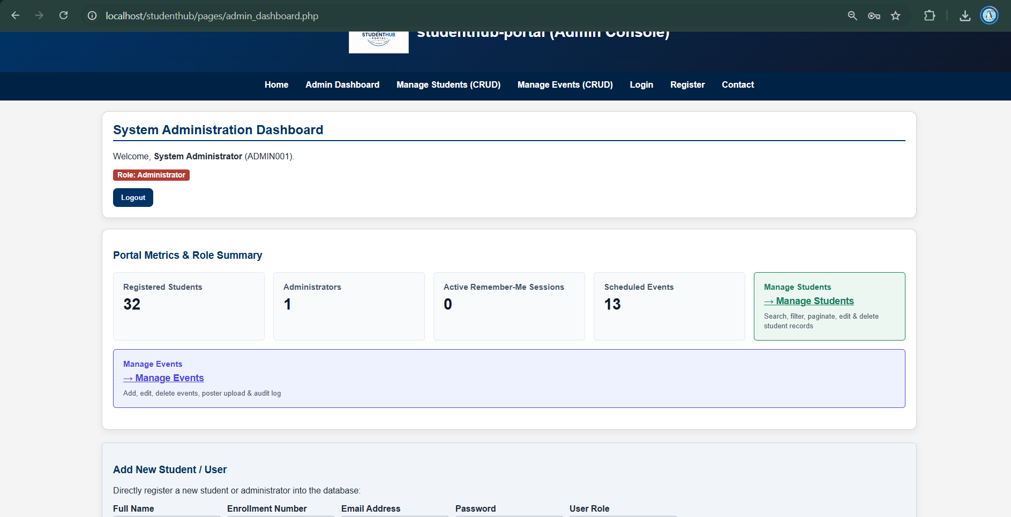

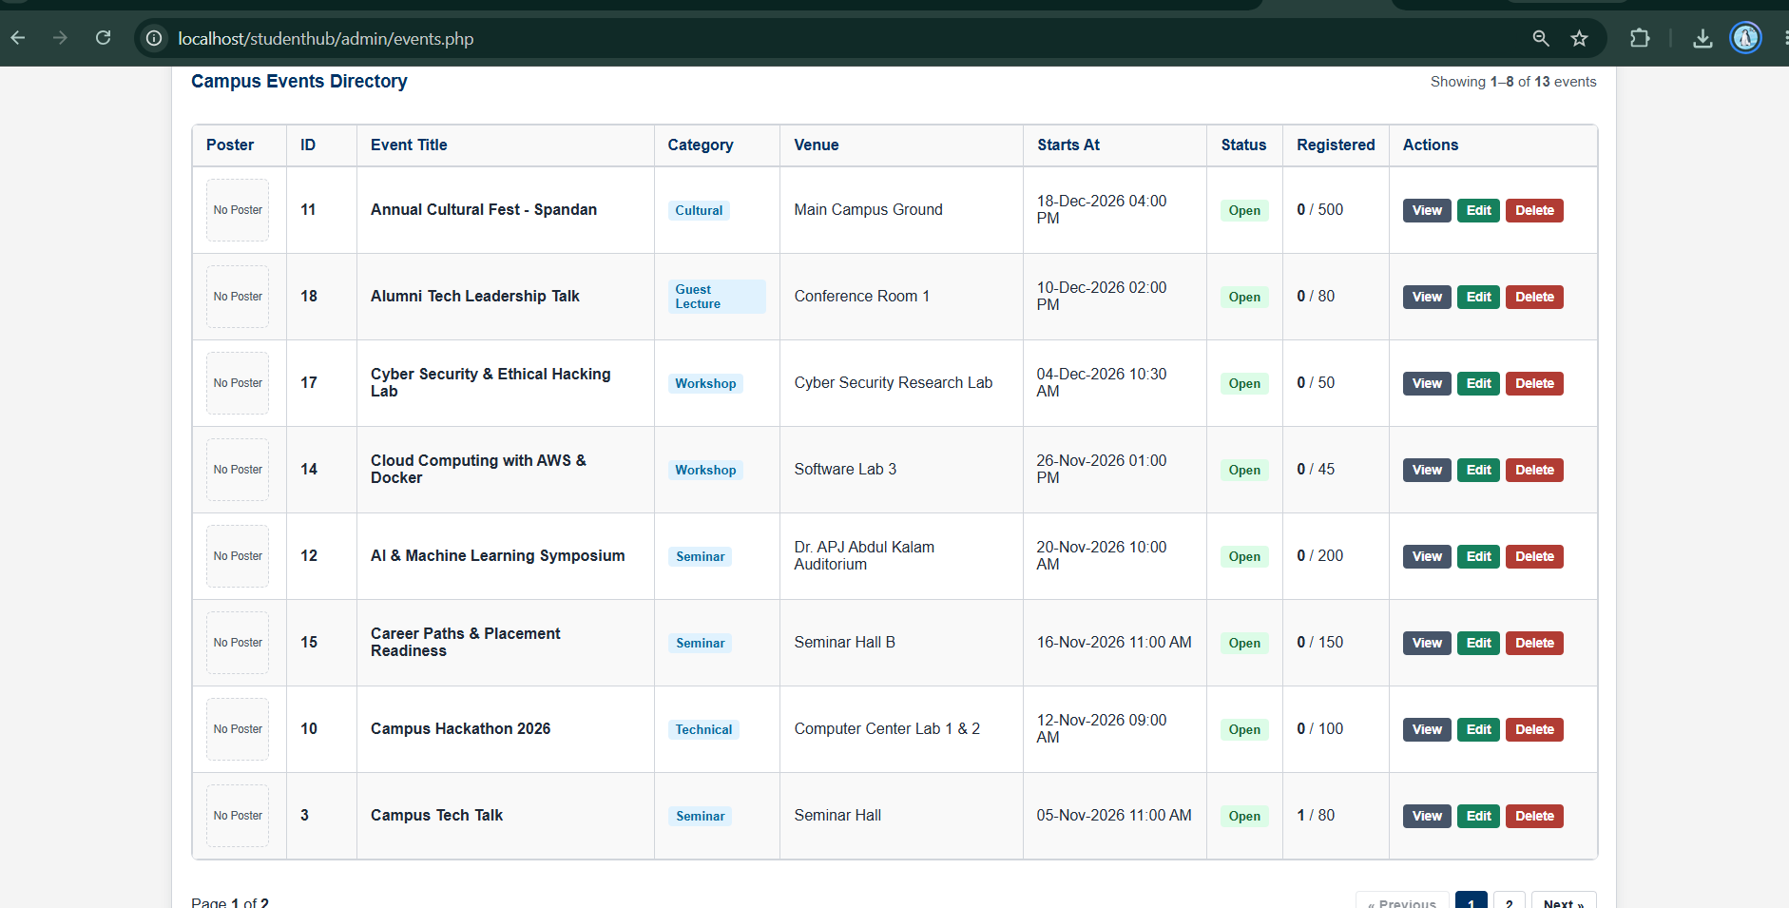

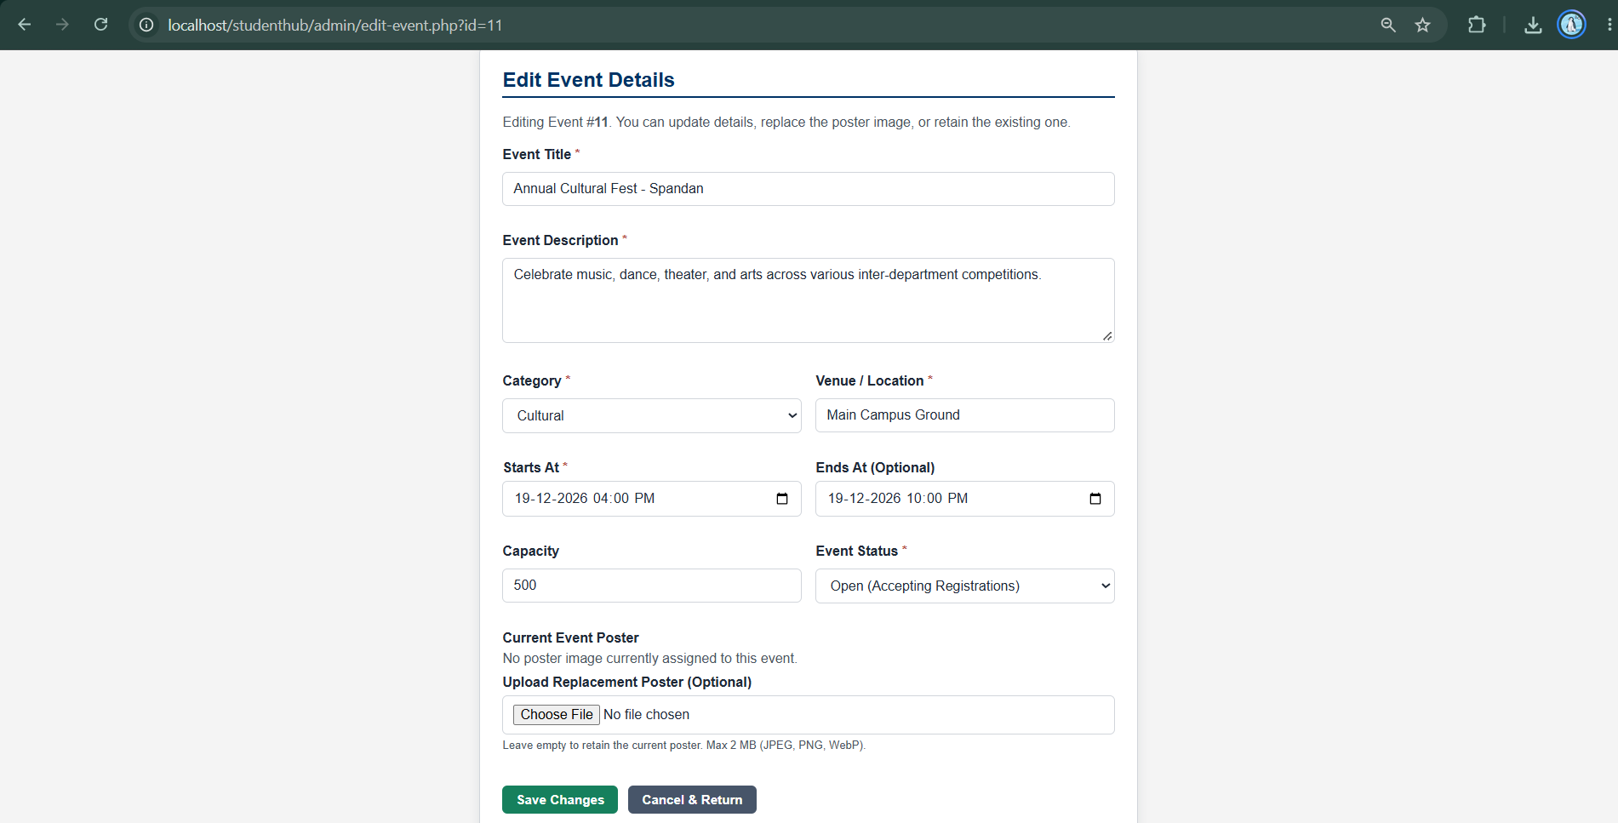

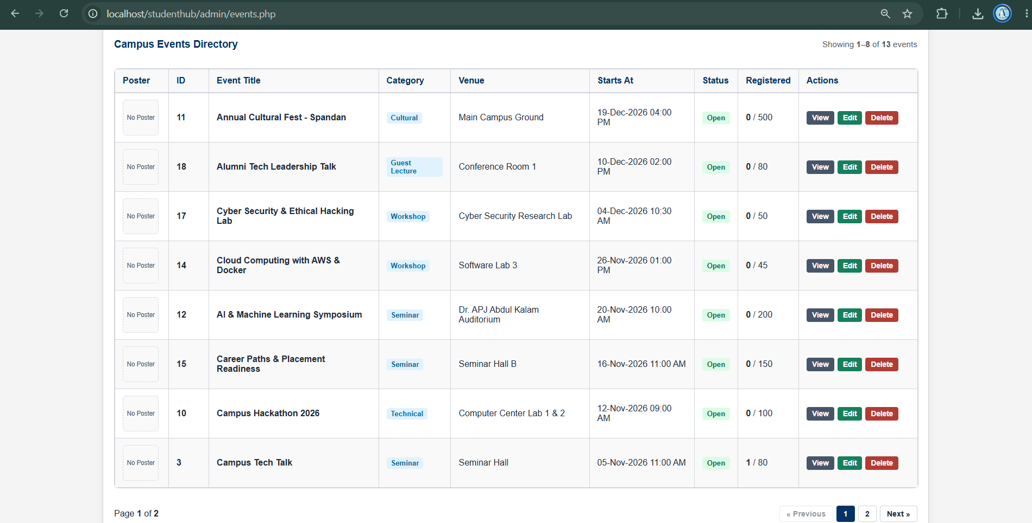

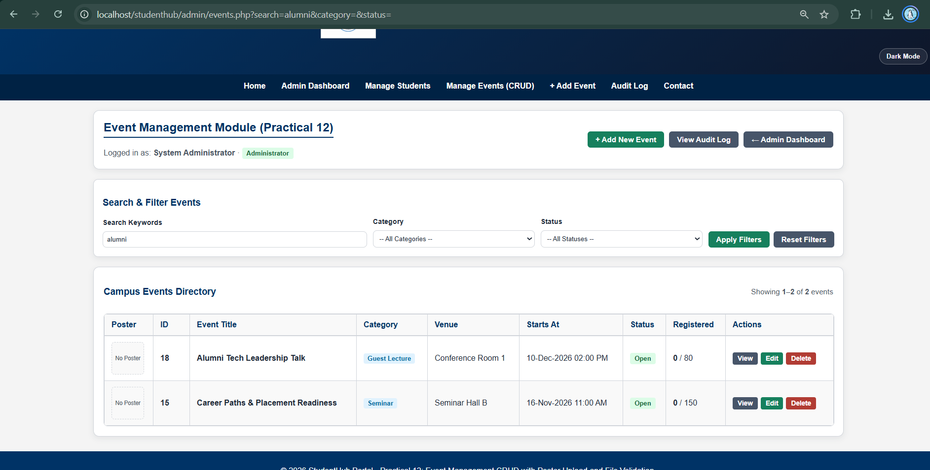

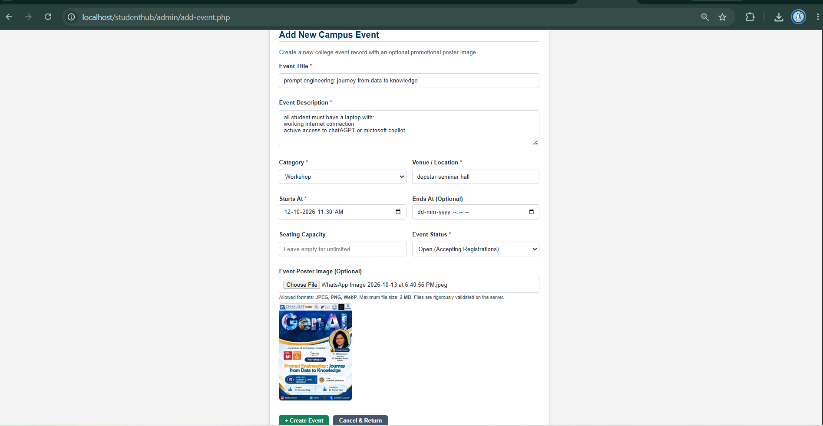

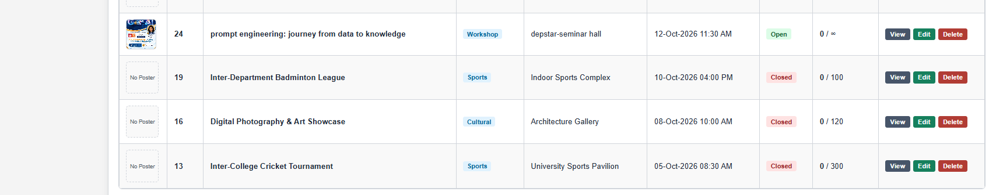

GitHub-Link:
https://github.com/joshitarana2621/studenthub-portal/tree/main/practical12

Conclusion
The practical demonstrates PHP-MySQL event CRUD and server-side poster validation. Actual execution and test outcomes must be recorded by the student.

