CHAROTAR UNIVERSITY OF SCIENCE AND TECHNOLOGY
SUBJECT: WEB DEVELOPMENT FRAMEWORKS (ITUE203)
SEMESTER: 3RD | ACADEMIC YEAR: 2026–2027

PRACTICAL – 13
PHP JSON API and AJAX/Fetch-Based CRUD without Page Reload
Student Name: tarana joshi
Enrollment Number: 25DCE034

Key Questions and Answers
1. What is an API? A defined way for one program to request data or operations from another.
2. Why use JSON? It is a lightweight text format for structured data.
3. What does fetch() return? A Promise that resolves to a Response object.
4. Why check response.ok? fetch does not reject just because the server returned an HTTP error status.
5. What is HTTP 201? It indicates that a resource was created successfully.
6. Why use PUT? It is commonly used to update or replace a resource.
7. What is HTTP 422 used for here? The request format is readable, but the submitted fields fail validation.
8. Why set Content-Type to application/json? It tells the server/client that the body is JSON.
9. Why keep API errors in JSON? The frontend can parse and display errors consistently.
10. How do you verify a request? Use Developer Tools > Network to inspect method, status, payload and response.

Output:
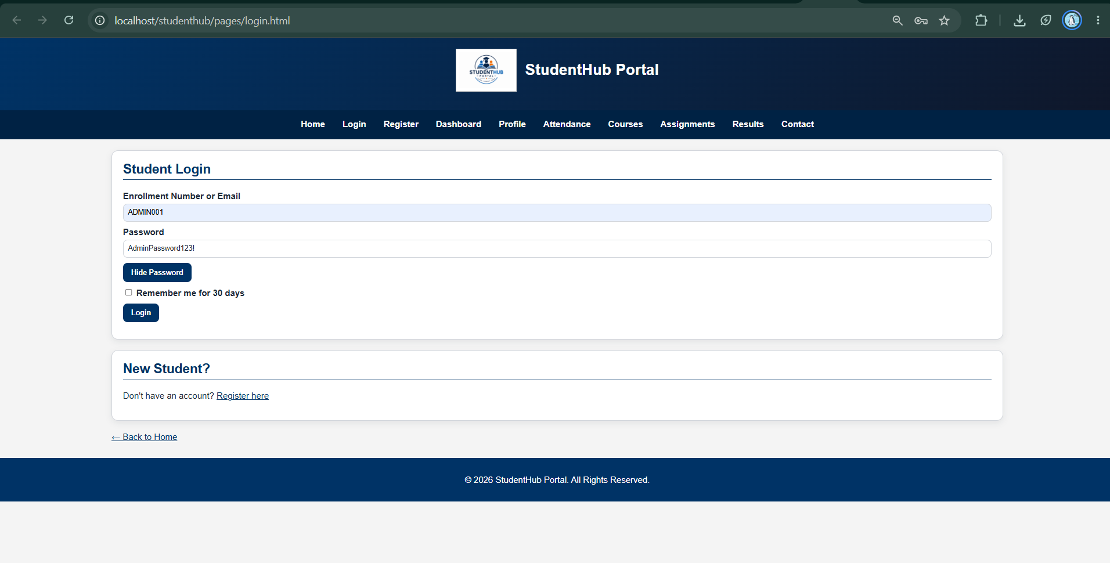

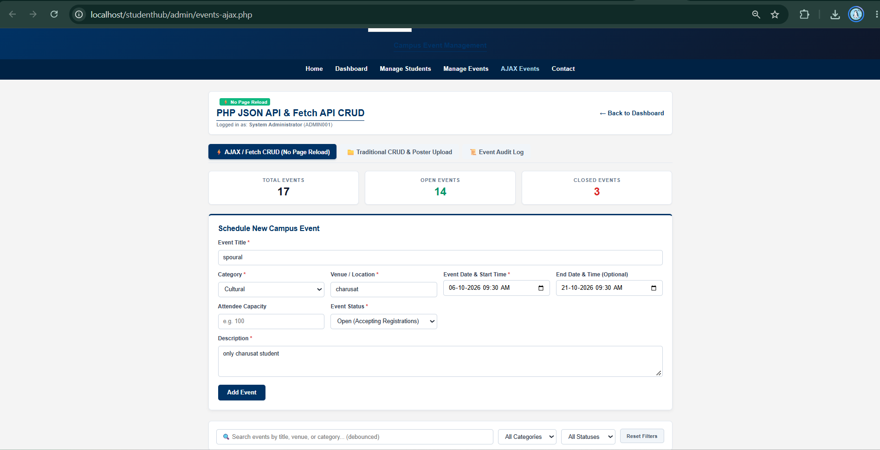

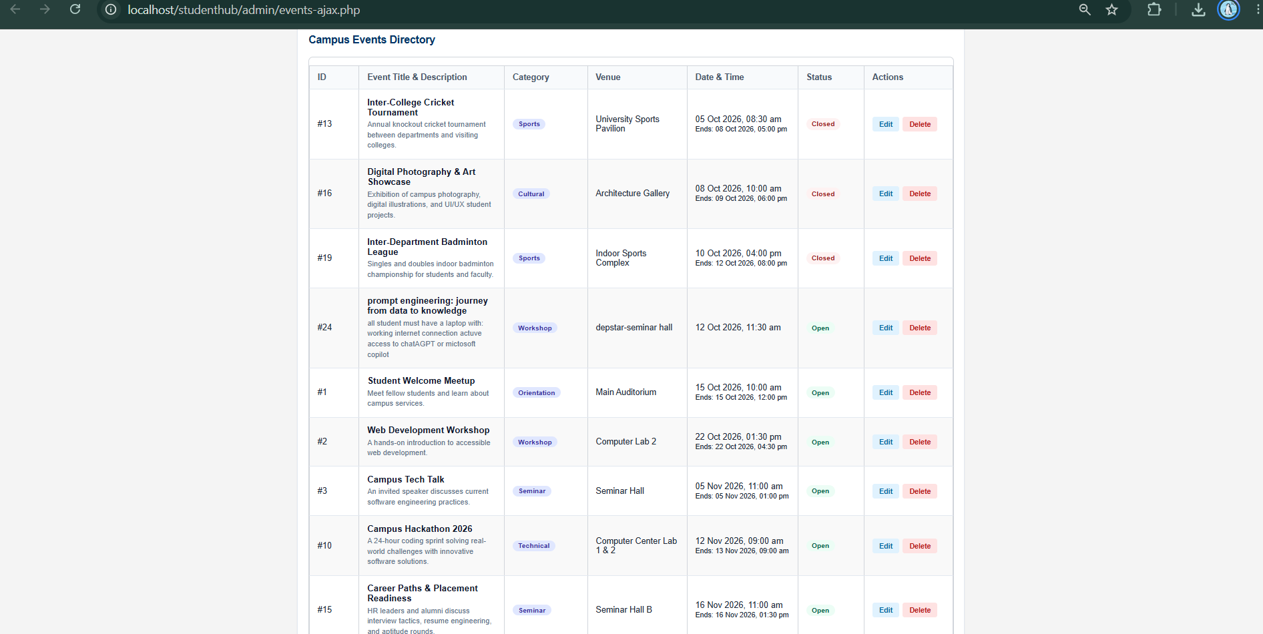

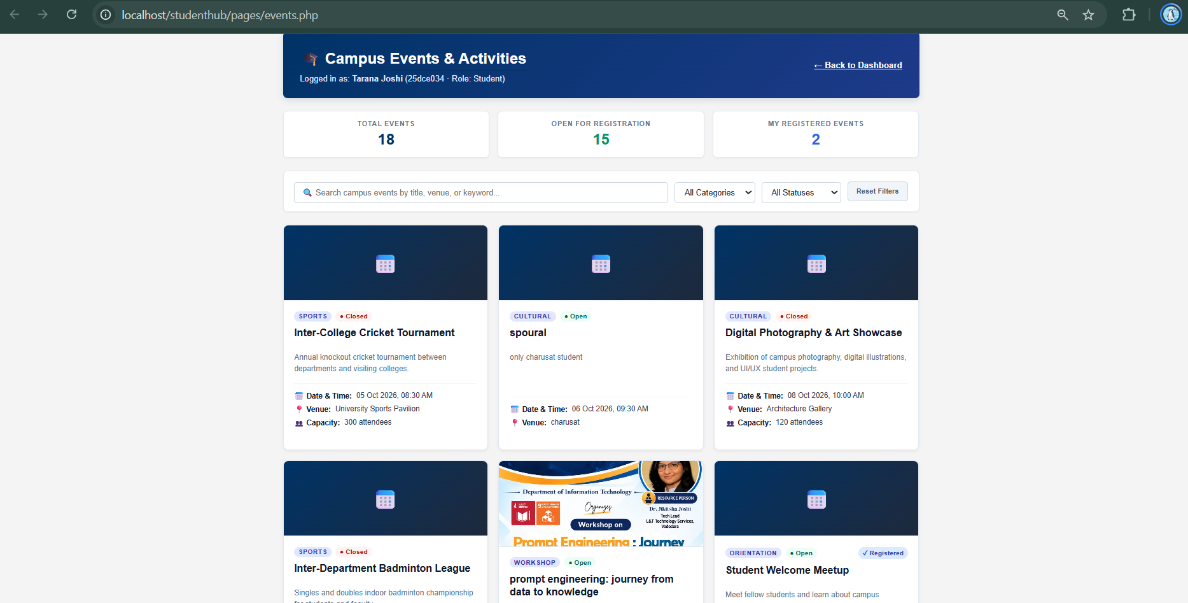

Conclusion
The practical demonstrates asynchronous PHP-MySQL CRUD through a JSON API and Fetch API. Complete the test report after running the requests in XAMPP.

