Practical - 1
Practical Title: Project Initiation, Requirement Analysis, Sitemap, Wireframe, and GitHub Setup

Problem Definition: Initiate the semester-long StudentHub portal by identifying the problem scope, user roles, key modules, navigation flow, and minimum 10 pages. Create a sitemap, low-fidelity wireframe, project folder structure, README file, and GitHub repository.

Theory

What is URL and parts of URL?
Answer: A URL (Uniform Resource Locator) is the complete address of a webpage or any resource available on the internet. When we enter a URL in a web browser, it helps the browser locate the required webpage on the web server.
For example:
https://www.studenthub.com/dashboard/profile.html?id=101
Parts of a URL:
- Protocol (https://) – Specifies how the browser communicates with the server.
- Domain Name (www.student.com)– The unique name of the website.
- Path (/dashboard/profile.html) – Shows the location of the webpage or file.
- Query String (?id=101) – Sends additional information to the webpage.
- Fragment (#section) (optional) – Opens a specific section of the webpage.
A URL makes it easy for users and browsers to access the correct web page quickly and accurately.
References
- https://developer.mozilla.org/en-US/docs/Learn_web_development/Howto/Web_mechanics/What_is_a_URL
- https://www.w3schools.com/html/html_urlencode.asp

How does HTML file process in web browser?
AnswerWhen a user opens an HTML file, the browser first reads the HTML document from the local computer or web server. The browser then starts parsing the HTML from top to bottom and creates a Document Object Model (DOM).
After that, if the HTML file contains CSS, the browser loads and applies the styles to the webpage. If JavaScript files are present, the browser executes them to add interactivity.
Finally, the browser combines the HTML structure, CSS styling, and JavaScript functionality to display the complete webpage on the screen. Whenever changes occur through JavaScript, the browser updates the page without reloading the entire website.
References
- https://developer.mozilla.org/en-US/docs/Learn
- https://www.geeksforgeeks.org/how-browser-renders-html/

3. How will page navigation flow managed among all HTML pages?
Answer: In the StudentHub Portal, page navigation will be managed using HTML navigation links (<nav> and <a> tags). Every webpage will contain the same navigation menu so that users can move easily between different pages.
The homepage will act as the main entry point. From there, users can access pages like About, Login, Dashboard, Courses, Assignments, Events, Profile, Contact, and FAQ.
Using a common header and footer on every page keeps navigation consistent and improves the user experience. Relative file paths will be used so that all pages remain connected within the project folder.
References
- https://developer.mozilla.org/en-US/docs/Web/HTML/Element/nav
- https://www.w3schools.com/html/html_links.asp

4. How will GitHub commits be maintained after each practical?
Answer
After completing every practical, I will save all project changes and create a Git commit with a meaningful commit message. Each commit will describe the work completed in that practical, making it easy to track project progress.
For example:
- Initial project setup
- Added Home page
- Designed Login page
- Created Dashboard
- Added CSS styling
After committing the changes, I will push the updated project to my GitHub repository. This process keeps a complete history of the project and allows me to restore previous versions whenever required.
References
- https://docs.github.com/en/get-started
- https://git-scm.com/docs/git-commit

Implementation/ Output/Result (Keep only one option which is suitable to practical)
Output
Sitemap
StudentHub Portal - Sitemap

This document outlines the site structure and navigation hierarchy of the StudentHub Portal project.

[ Home ]
|
+----------------+------------+-----+-------------+--------------+--------------+
| | | | | |
[ About College ] [ Login ] [ Register ] [ Dashboard ] [ Courses ] [ Attendance ] [ Contact ]
| | | | | | |
|-- College Info |-- Student Login |-- New Stud |-- Profile |-- Subject |-- View |-- Email
|-- Campus Photos | Register |-- Course Det | List | Attendance |-- Phone
|-- Placement Data |-- Attendance |-- Study |-- Attendance |-- Location
|-- College Events |-- Notices | Material | Report

[ Footer ]
|
+------------------+------------------+
| | |
[ Privacy Policy ] [ Terms & Conditions ] [ Social Media ]
- Evidence of Work (Screenshots):

Fig 1.1 :Wireframe of index page: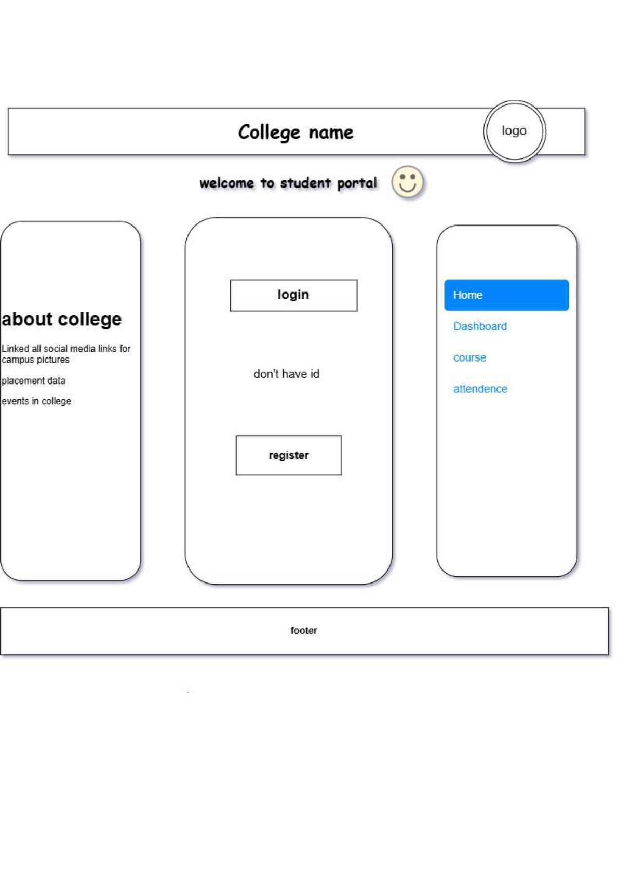
Fig 1.2 Wireframe of login page: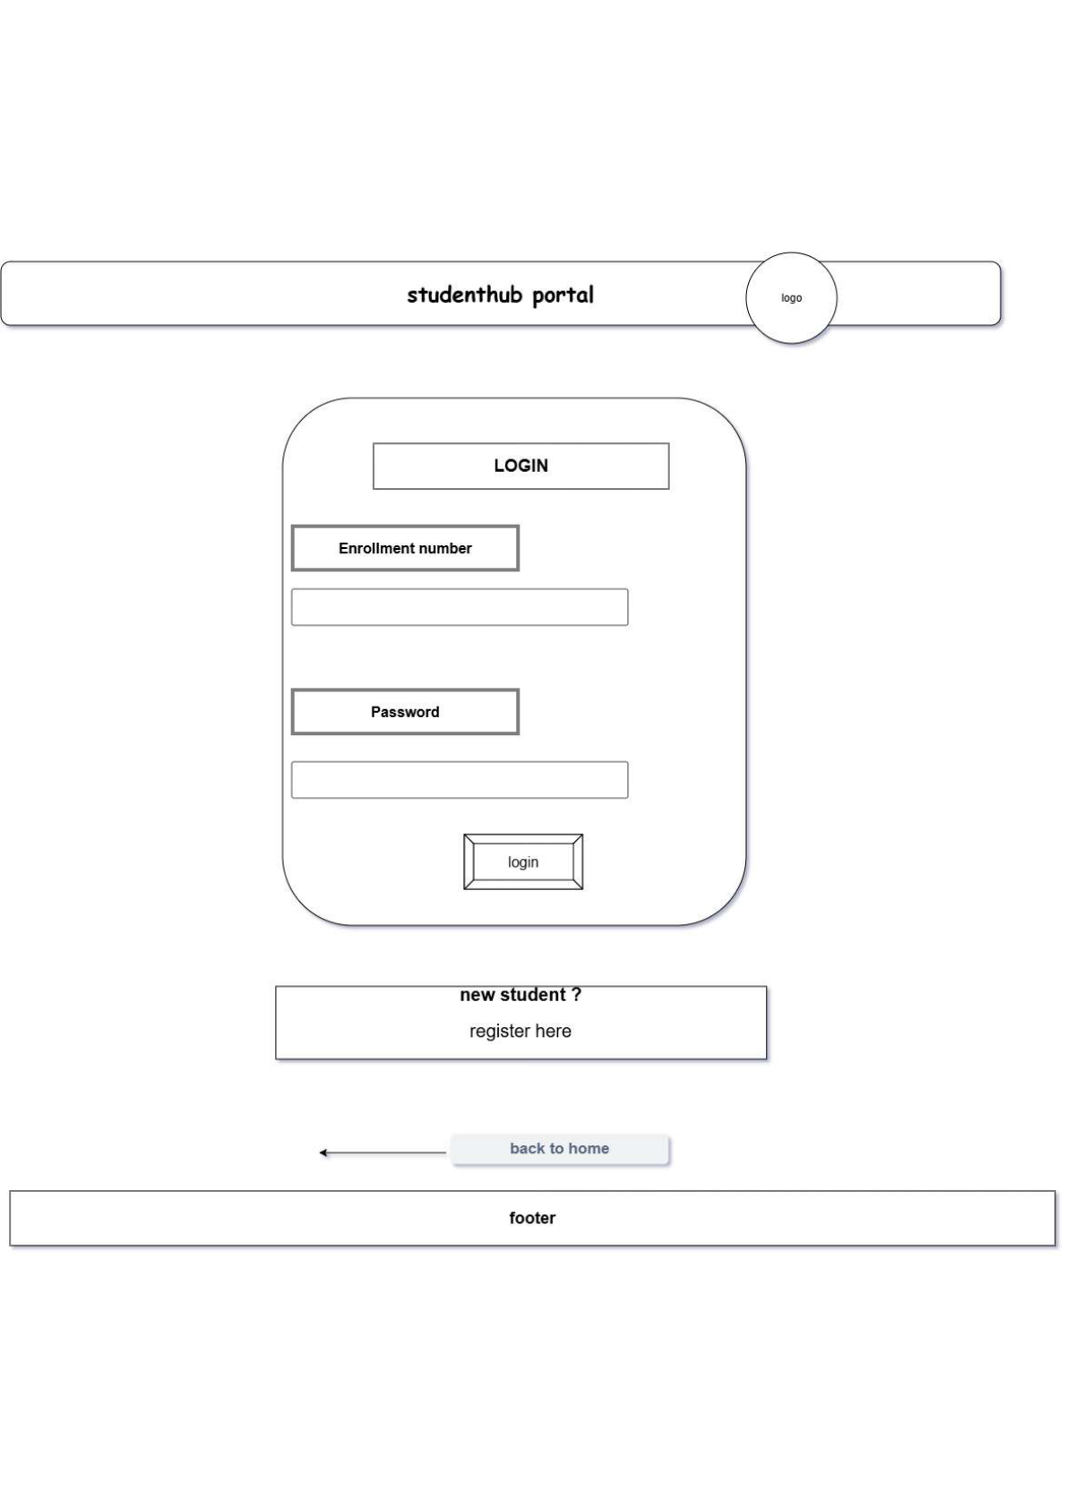
Fig 1.3 Wireframe of register page: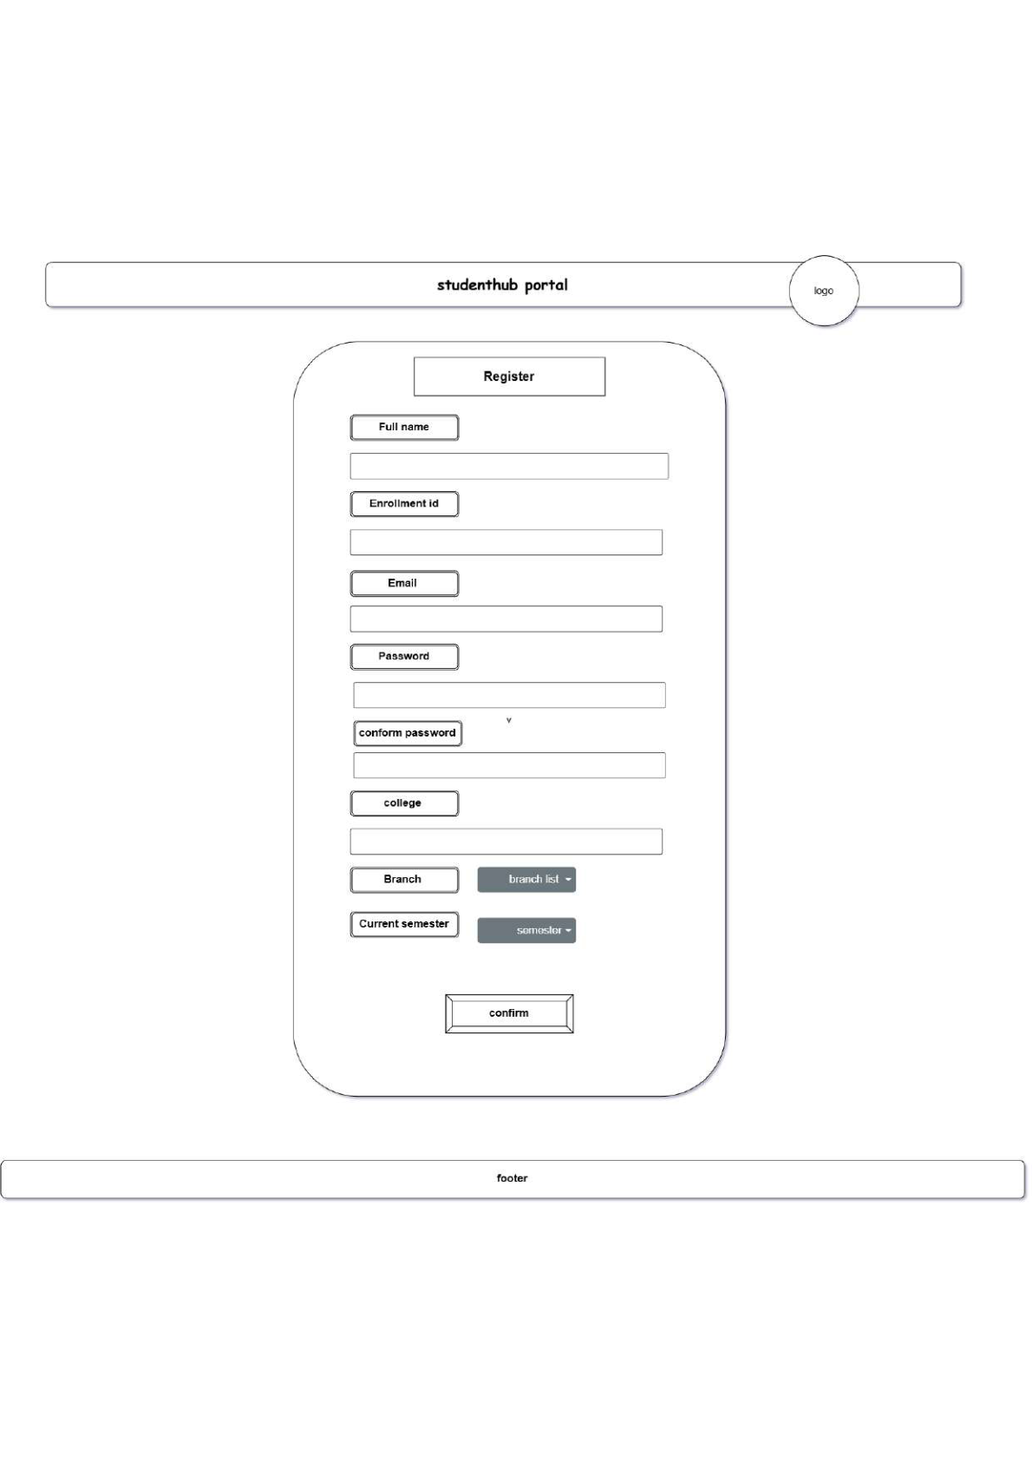
Fig 1.4 Wireframe of dashboard: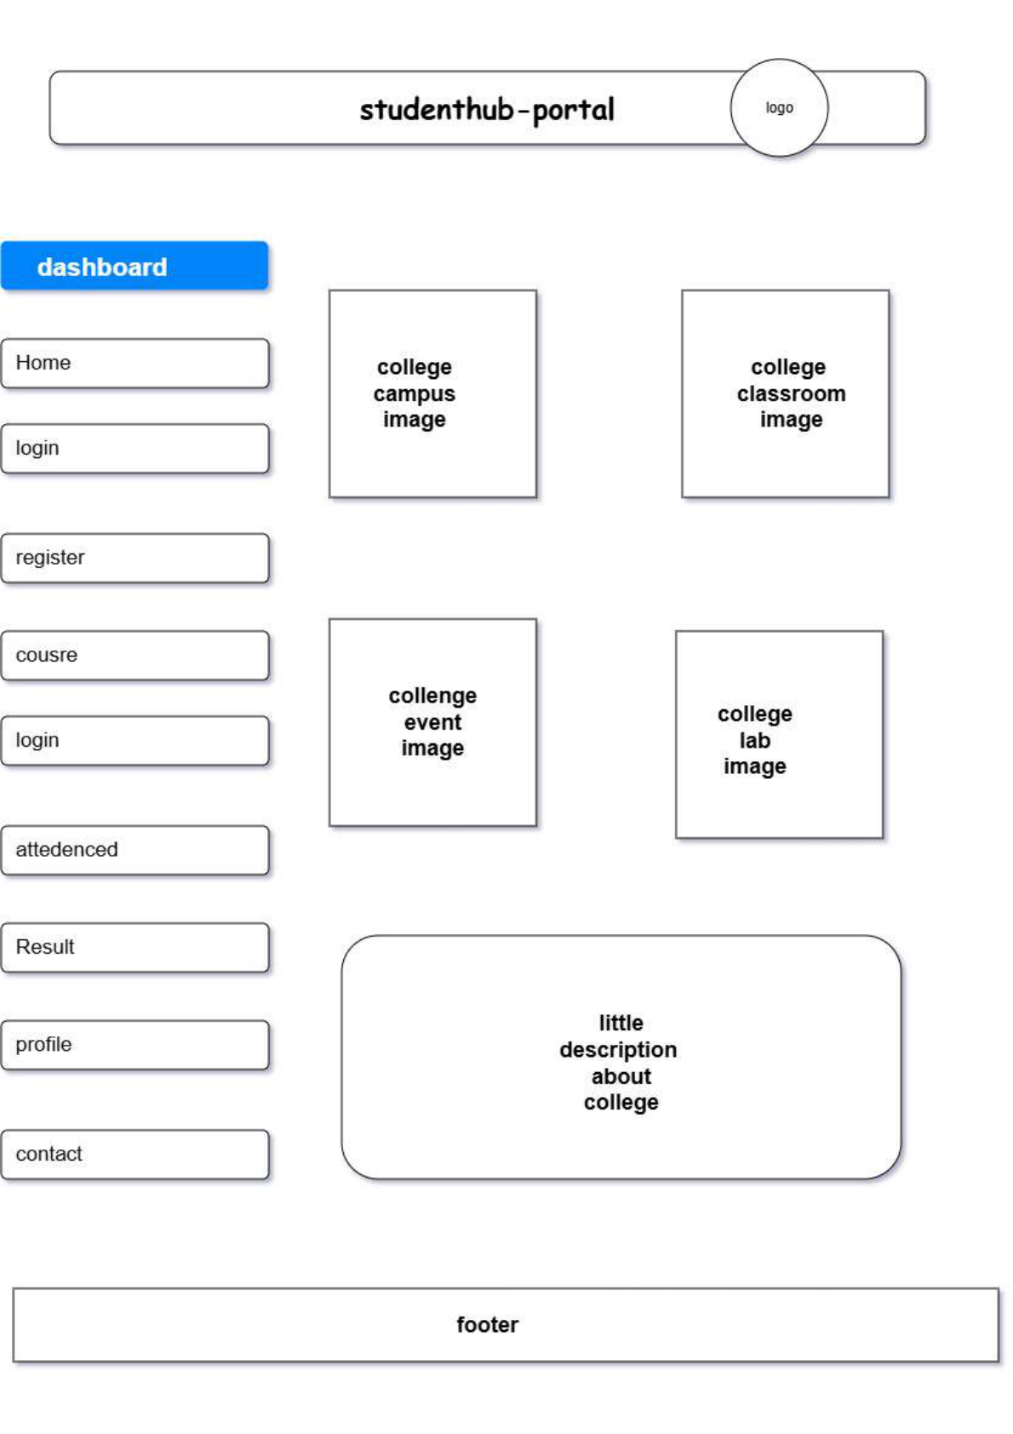
Fig 1.5 Wireframe of course page: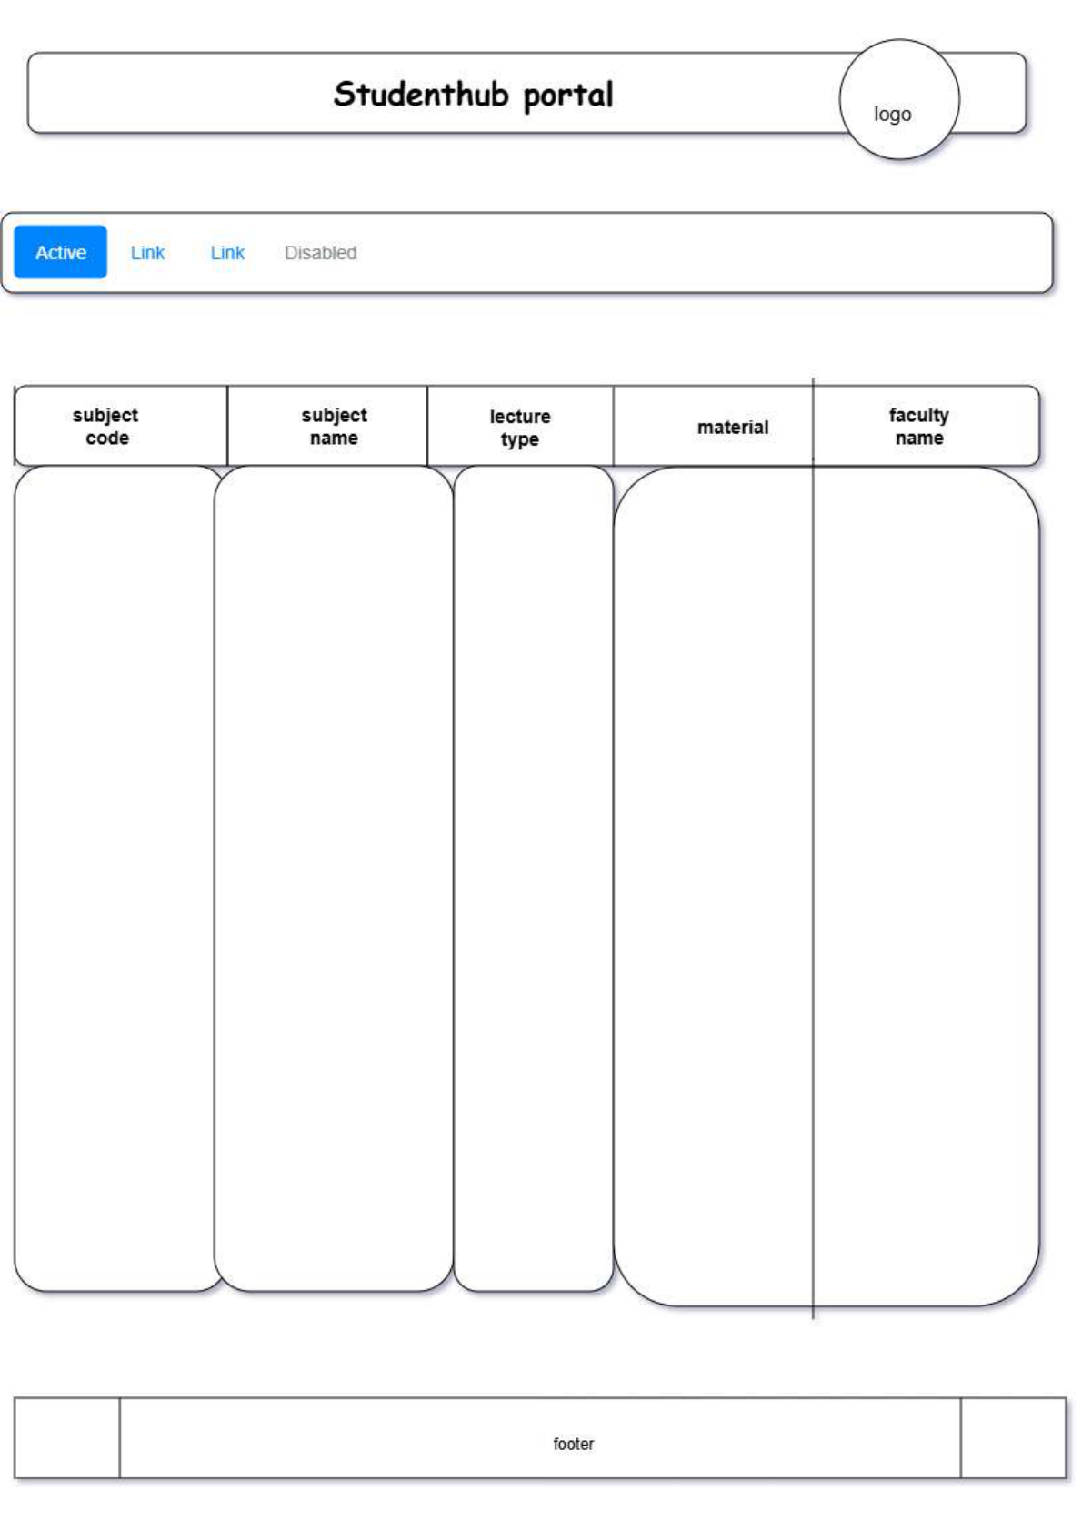
Fig 1.6 Wireframe of assignment: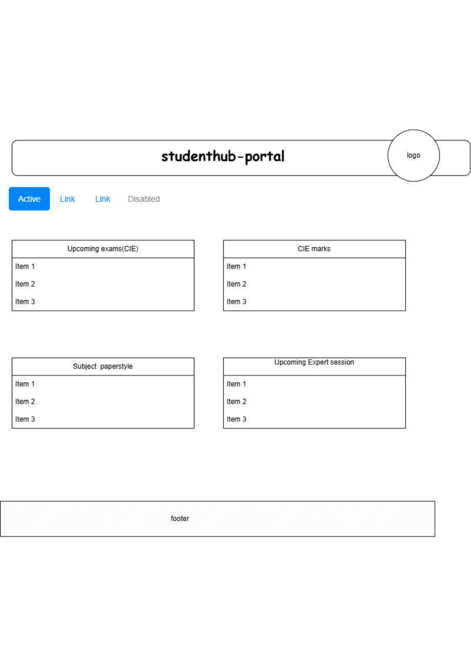
Fig 1.7 Wireframe of attendance page: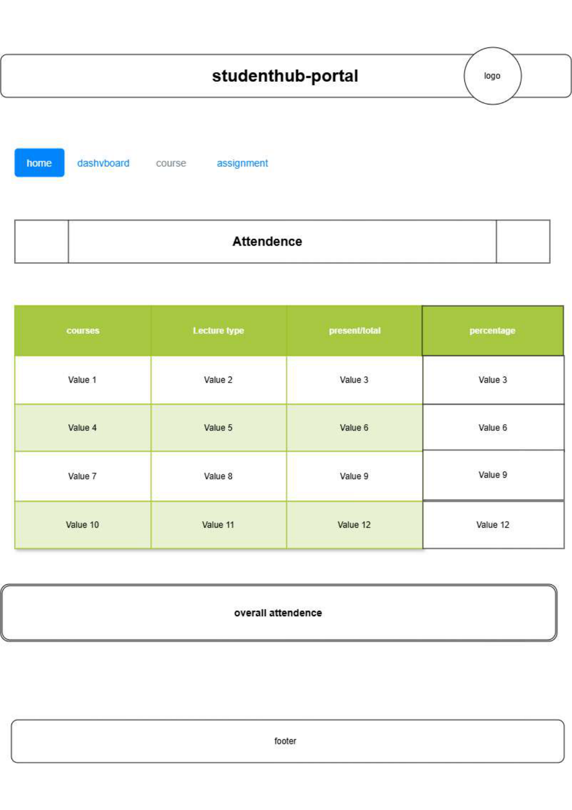
Fig 1.8 Wireframe of profile page: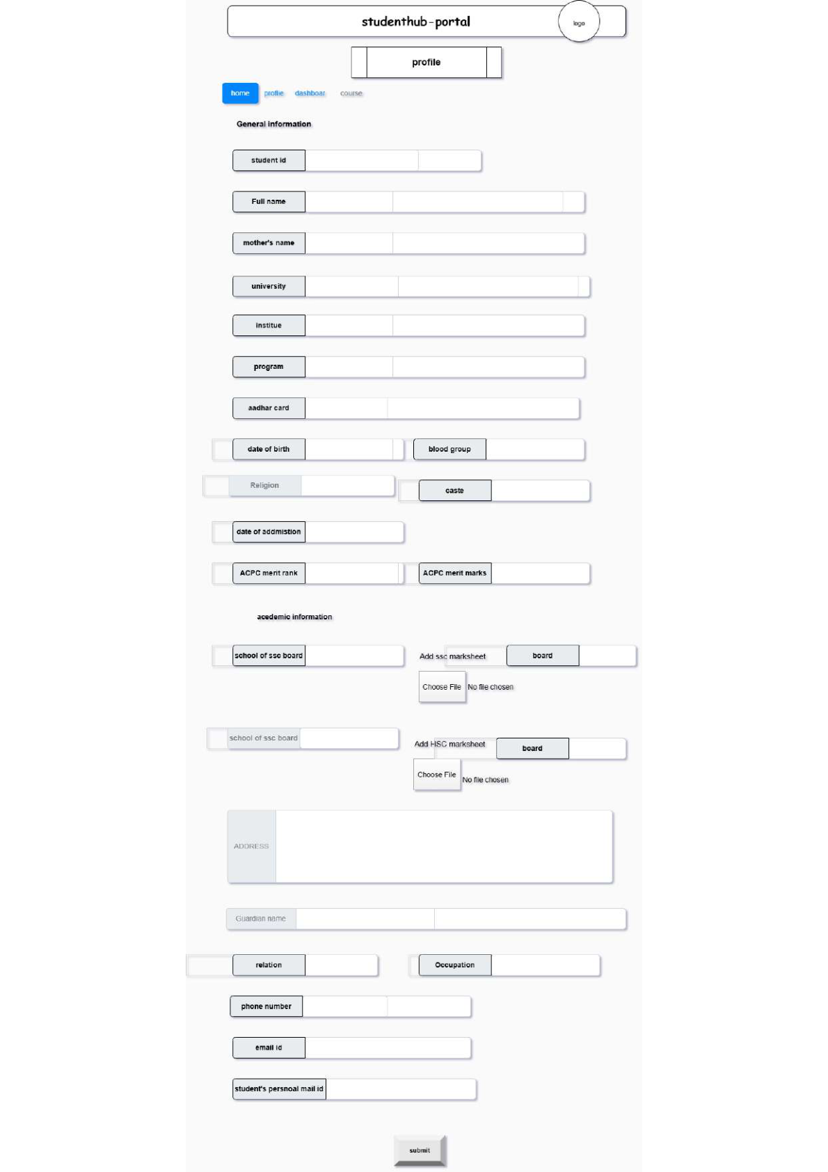
Fig 1.9 Wireframe of result page: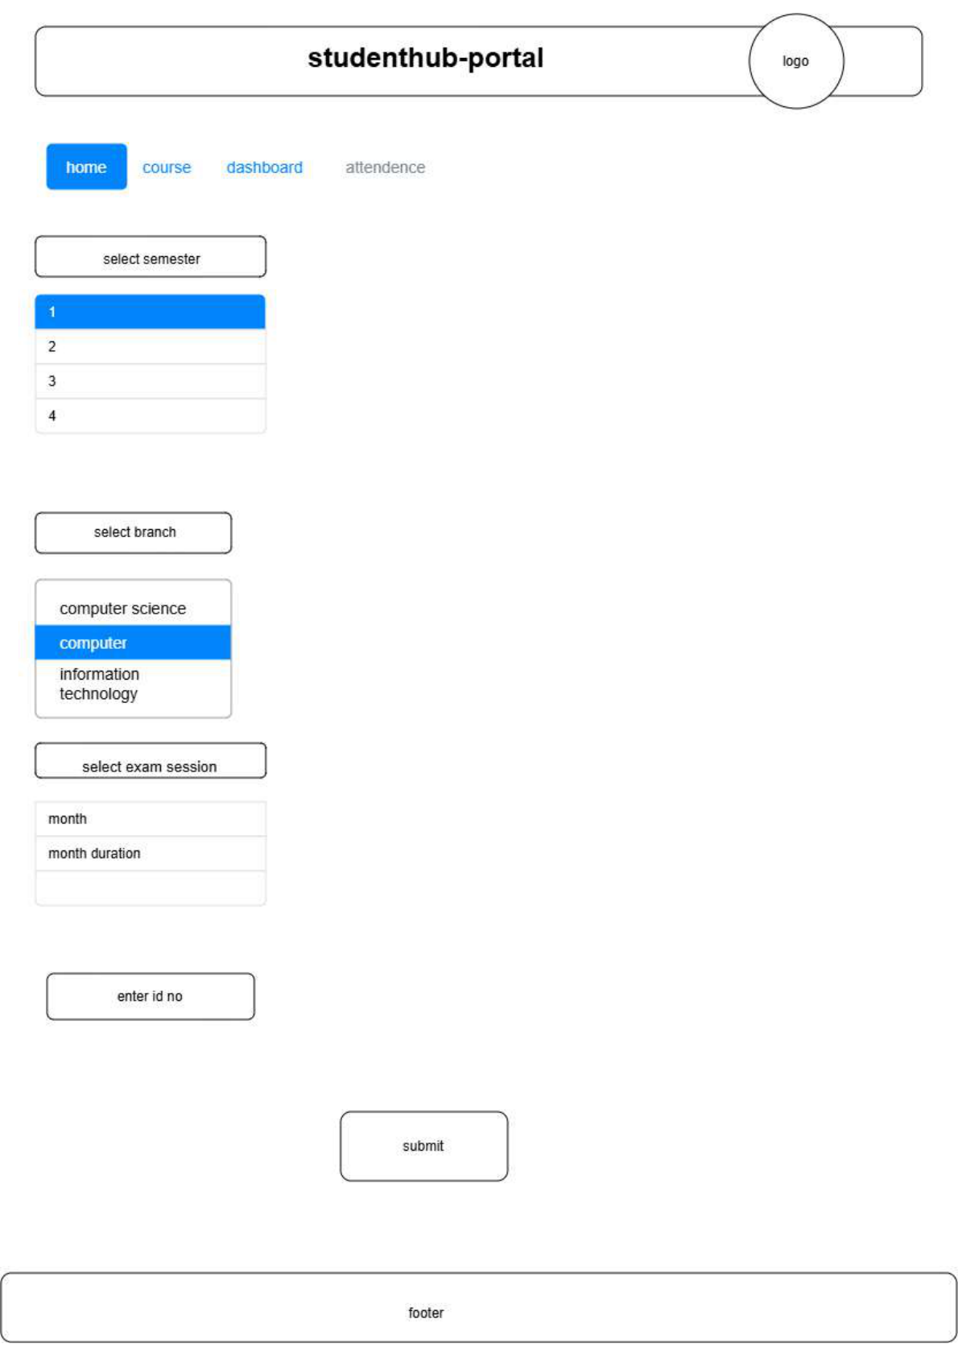
Fig 1.10 Wireframe of content page: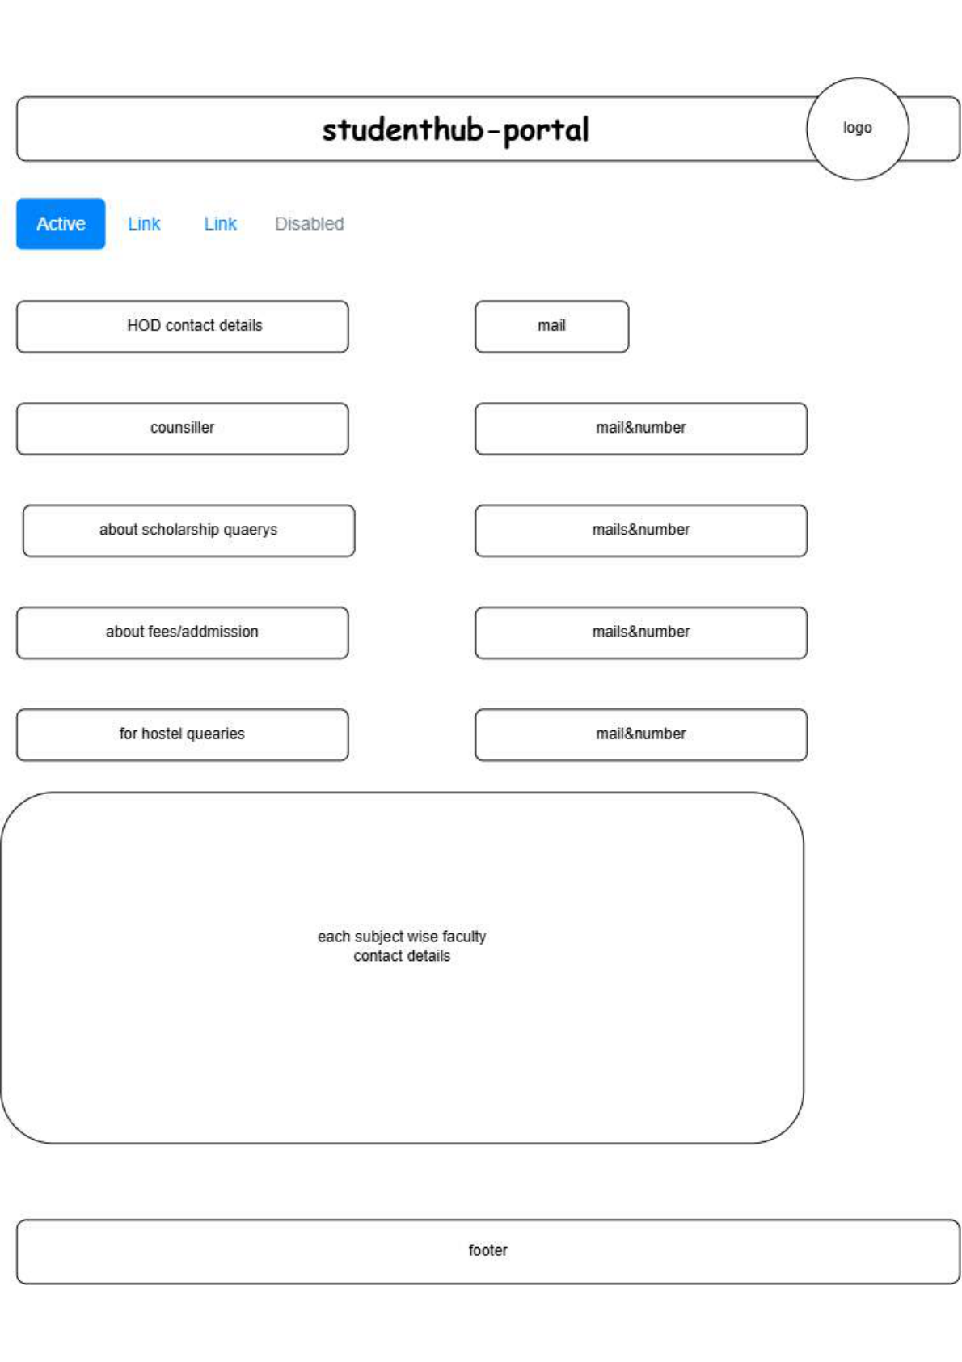

GitHub Repository Link:
https://github.com/joshitarana2621/studenthub-portal/tree/main/practical1

Challenges Faced:
-Understanding how to organize multiple HTML pages inside one project folder.
-Connecting all pages using correct relative links.
-Uploading the project to GitHub.

Learning Outcomes:
• Understood the importance of requirement analysis before development.
• Learned how to create a project folder structure.
• Understood the concept of URLs and webpage navigation.
• Learned how browsers process HTML files.
• Designed a basic sitemap and wireframe.
• Learned to maintain project versions using Git and GitHub.
• Improved my understanding of project planning before coding.

• Gained confidence in organizing a web development project.

Faculty Remarks: (Keep this blank for faculty)

