Department of Computer Engineering

Practical - 10: Secure Login/Logout with Sessions, Role-Based Access, Timeout, and Remember-Me Token

A. Theory
1. Are sessions started and destroyed securely?
Answer: Yes. A session should be started before using session variables and should be destroyed properly during logout.
2. Is password_verify() used correctly?
Answer: Yes. password_verify() is used to compare the entered password with the hashed password stored in the database.
3. Is unauthorized dashboard access blocked?
Answer: Yes. The dashboard should check whether the user is logged in before allowing access.
4. Is session timeout implemented?
Answer: Yes. The session should expire after a fixed period of inactivity so that the account remains secure.
5. Are admin and student users redirected to appropriate dashboards?
Answer: Yes. The user's role is checked after login and the user is redirected to the correct dashboard.

D. Evidence of Work (Screenshots)
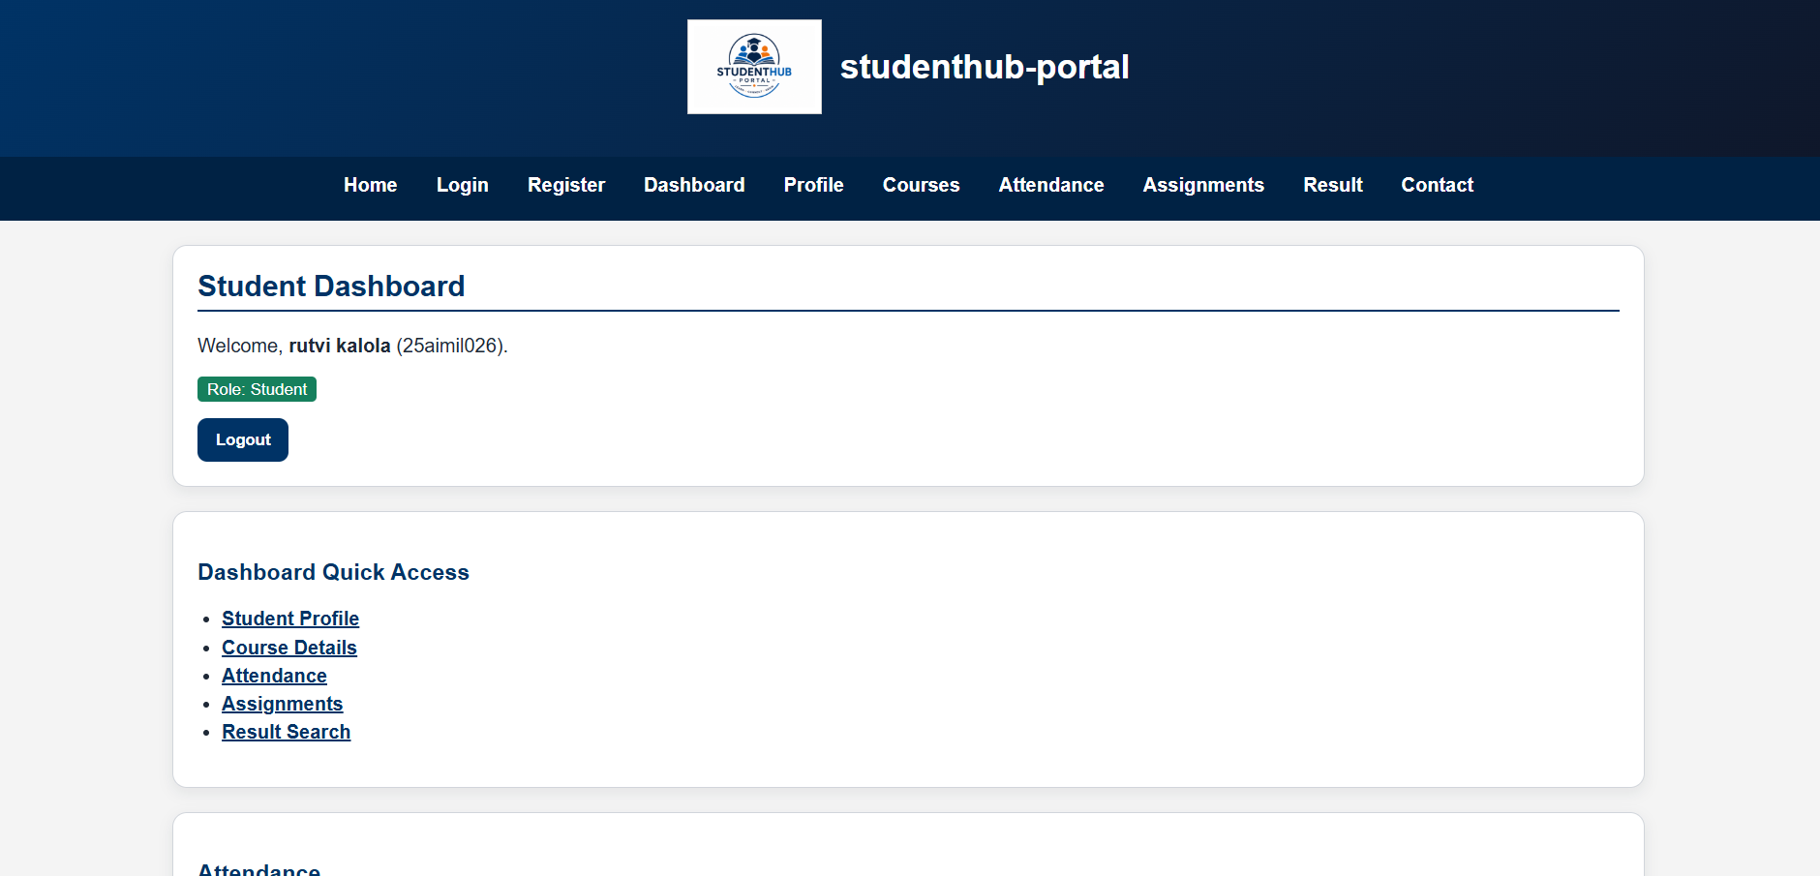

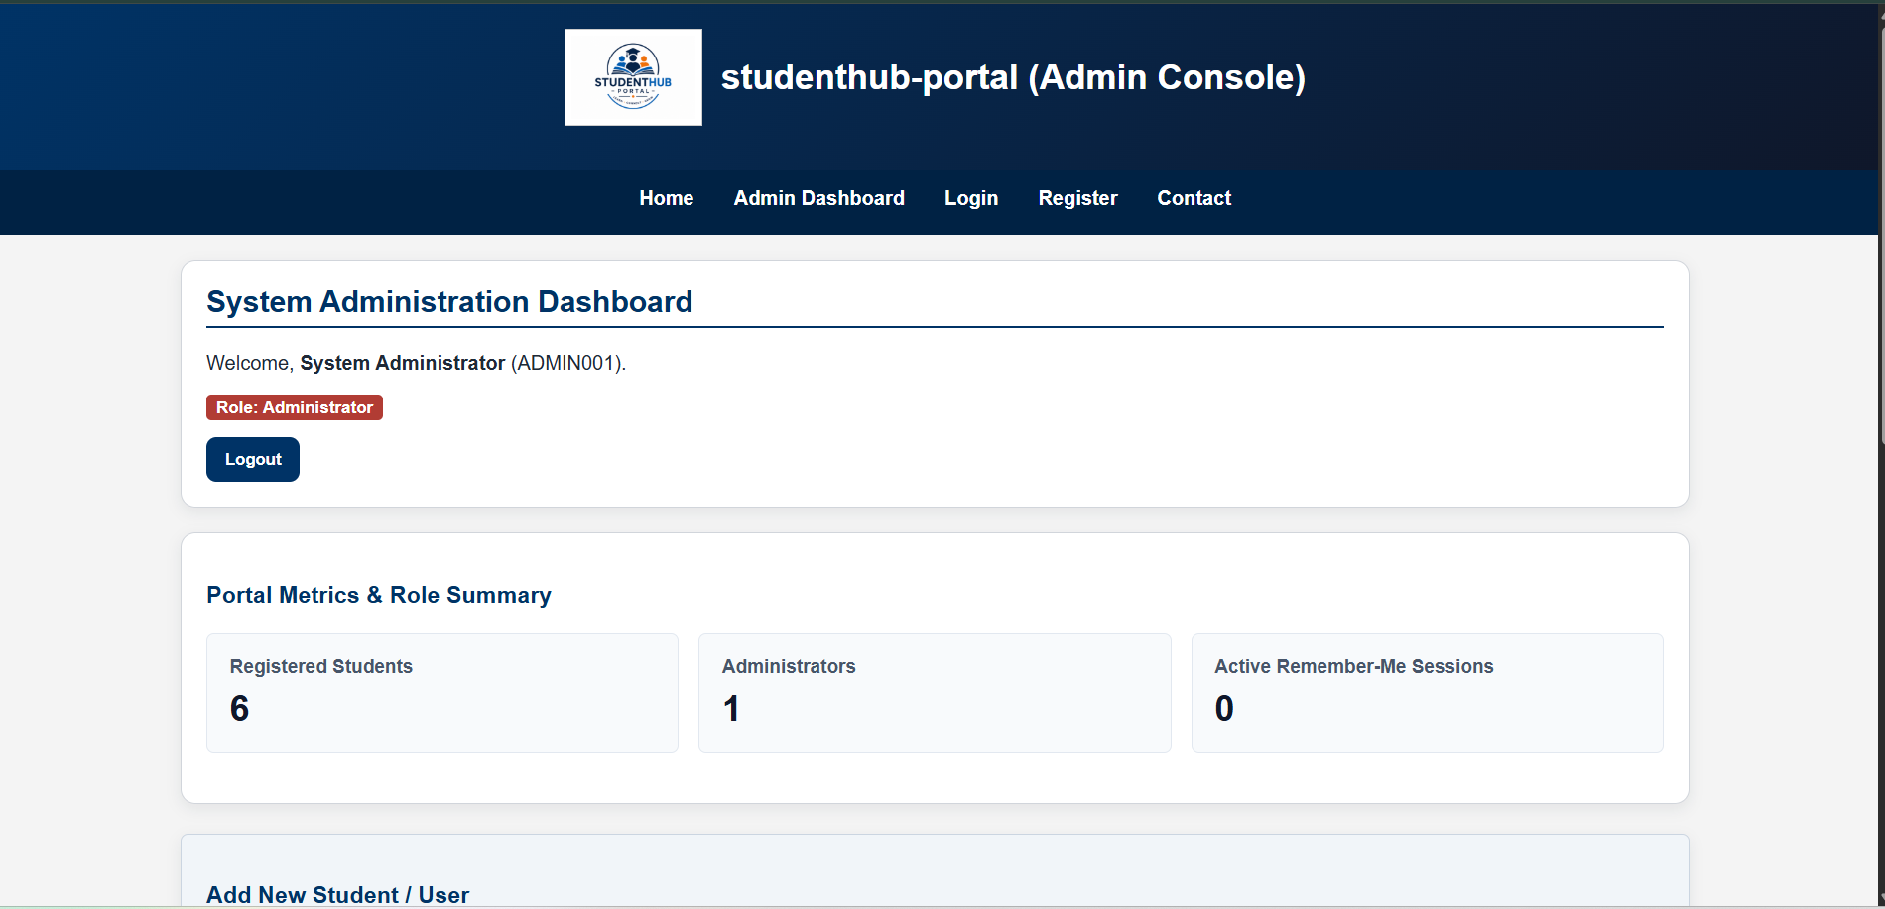

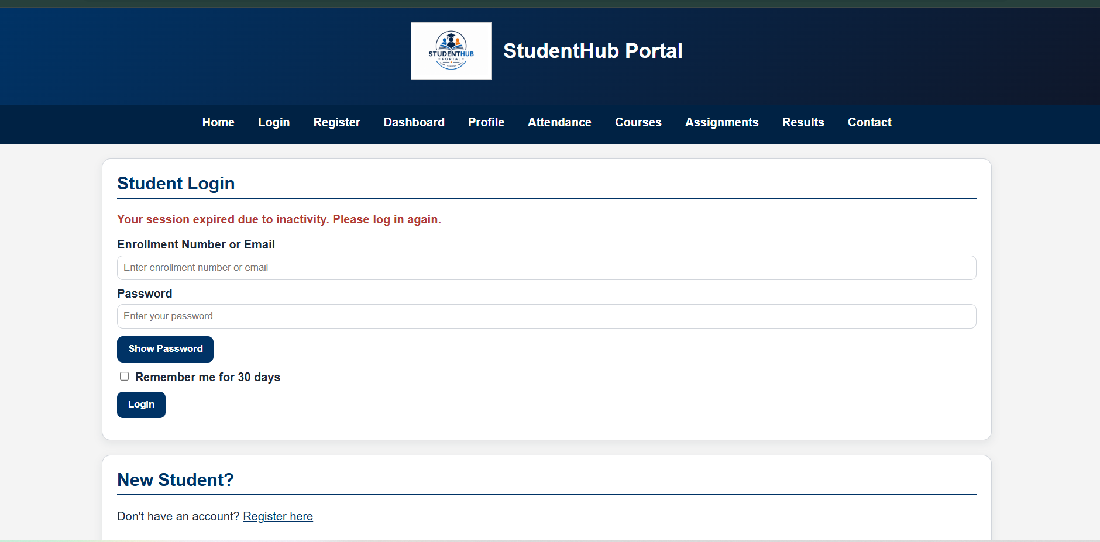

E. Test Cases
Write / paste your login, logout, role-based access, timeout and unauthorized access test cases here.

F. GitHub Repository Link
Paste GitHub repository link here.

G. Challenges Faced
• Understanding PHP sessions and session variables.
• Implementing password verification using password_verify().
• Restricting dashboard access for unauthorized users.
• Implementing session timeout.
• Redirecting users according to their roles.
H. Learning Outcomes
• Learned how to use PHP sessions for login and logout.
• Learned how to verify hashed passwords using password_verify().
• Learned how to restrict pages for unauthorized users.
• Learned how to implement role-based access.
• Learned how to implement session timeout.
I. Faculty Remarks

