Practical - 11

Practical Title: Student Management CRUD with Search and Filter
Problem Definition
Create a student management module to add, view, edit, delete, search, and filter student records. All database operations must use MySQLi statements and display clear success or failure messages.
A. Theory
1. Are SELECT, INSERT, UPDATE, and DELETE operations working?
Answer: Yes. SELECT is used to view records, INSERT adds a new student, UPDATE edits an existing record, and DELETE removes a record.
2. Is search by name, email, and course implemented?
Answer: Yes. The search feature can find student records using their name, email, or course. A filter can display records for a selected course.
3. Are delete operations confirmed before execution?
Answer: Yes. A confirmation message should be shown before deleting a student record to help prevent accidental deletion.

B. Evidence of Work (Screenshots)

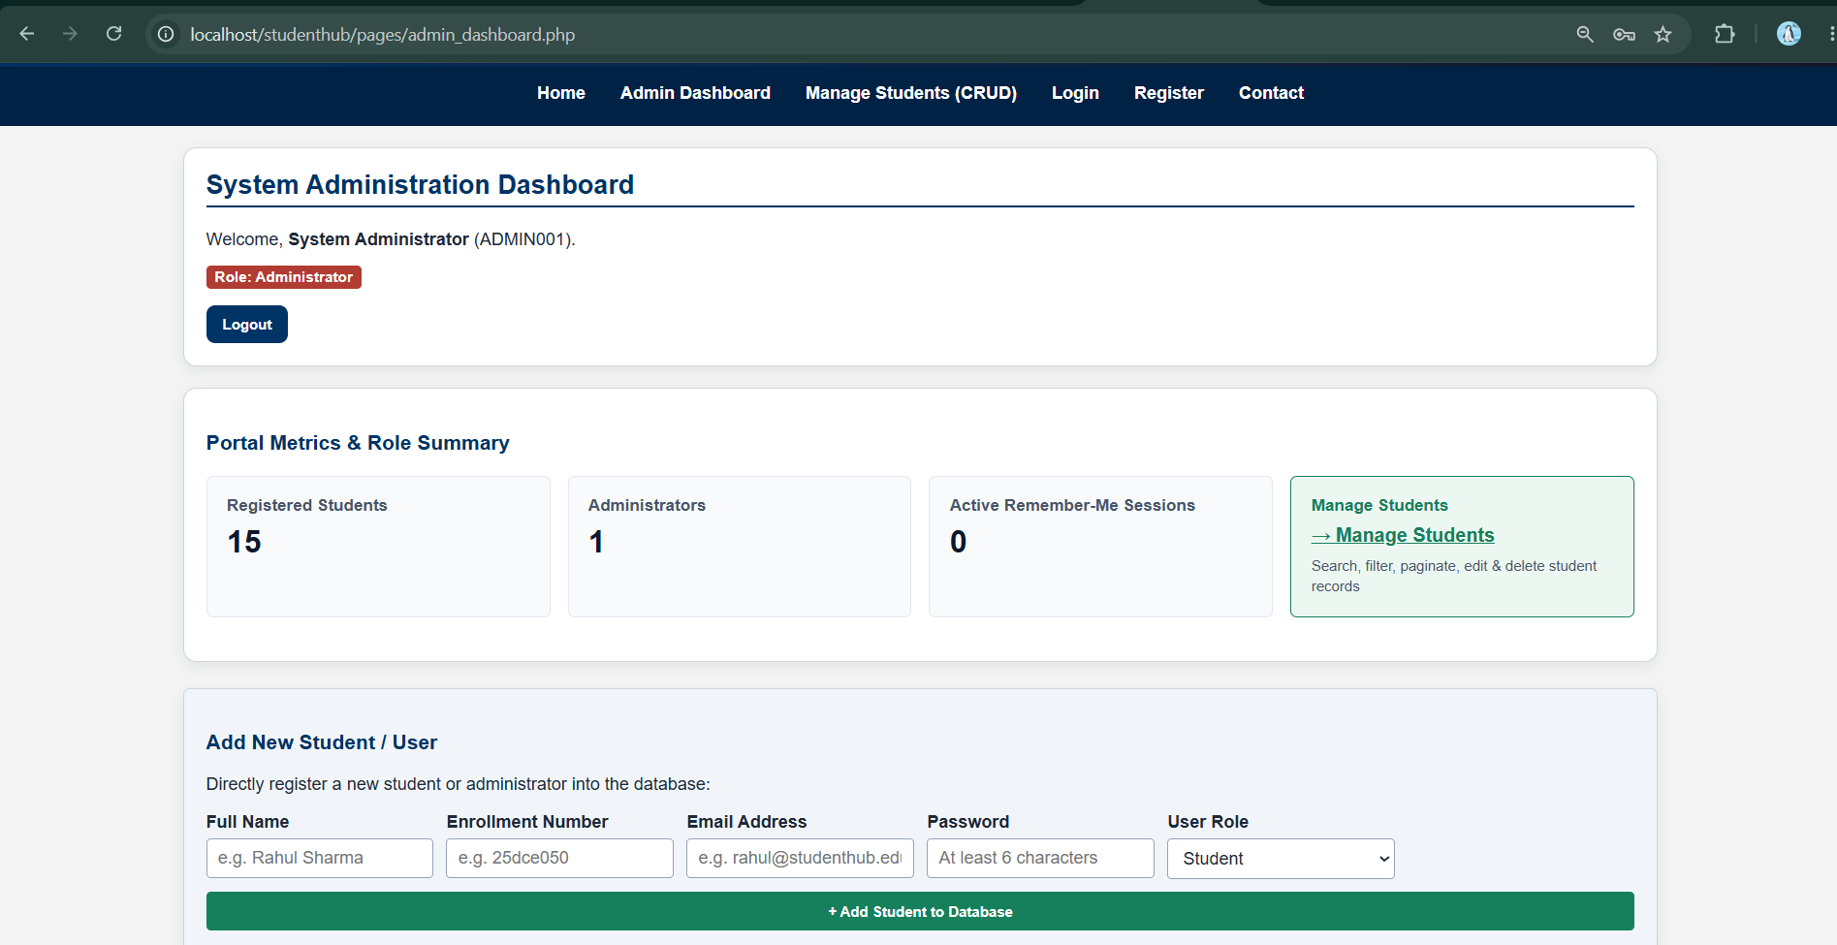

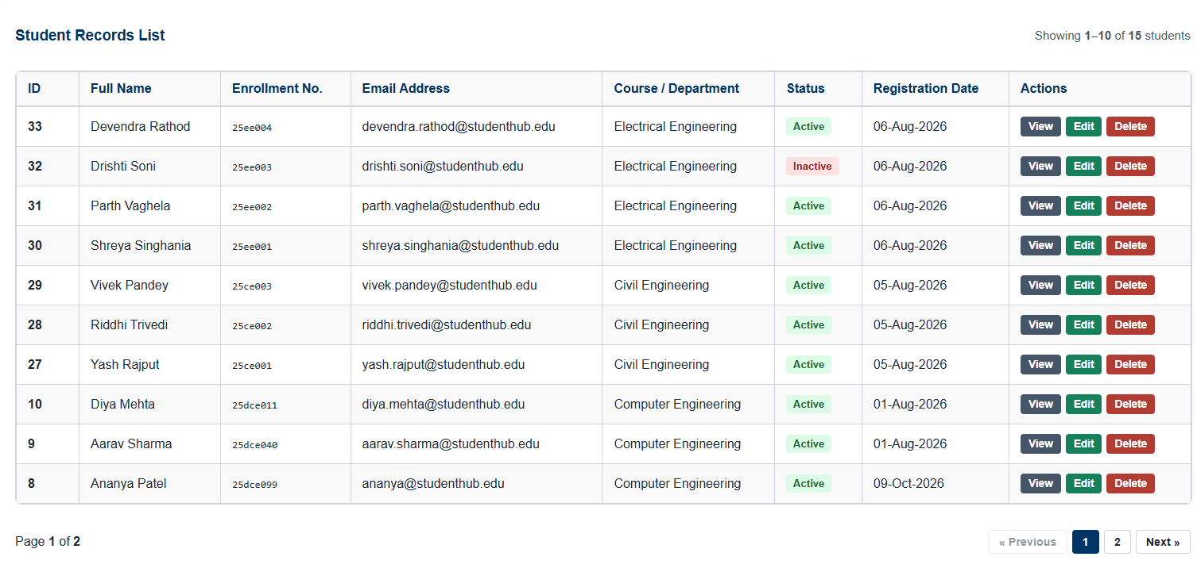

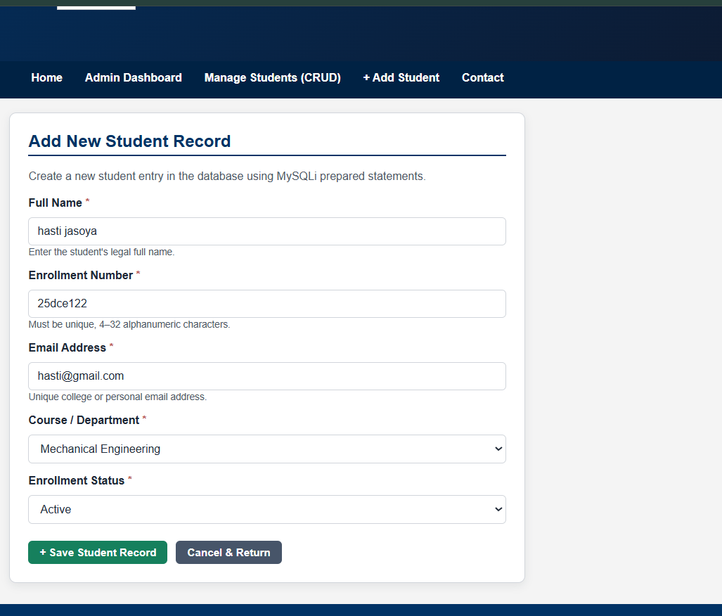

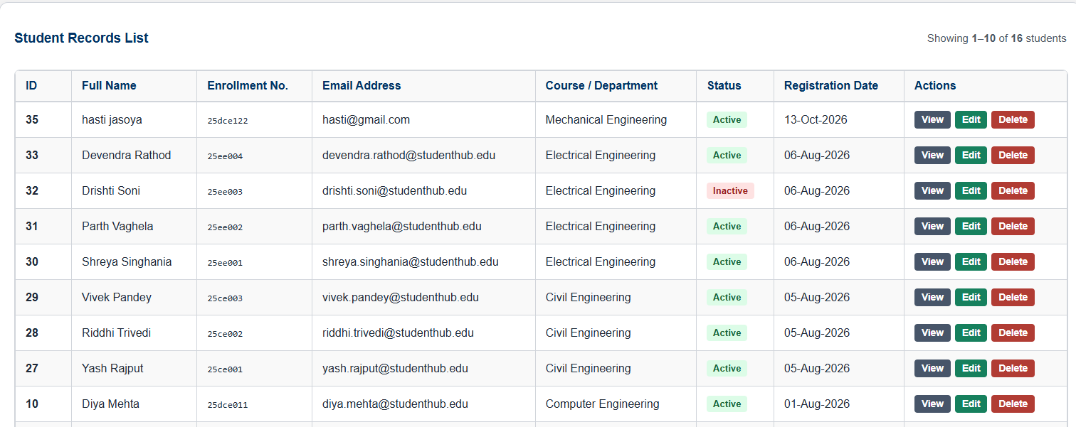

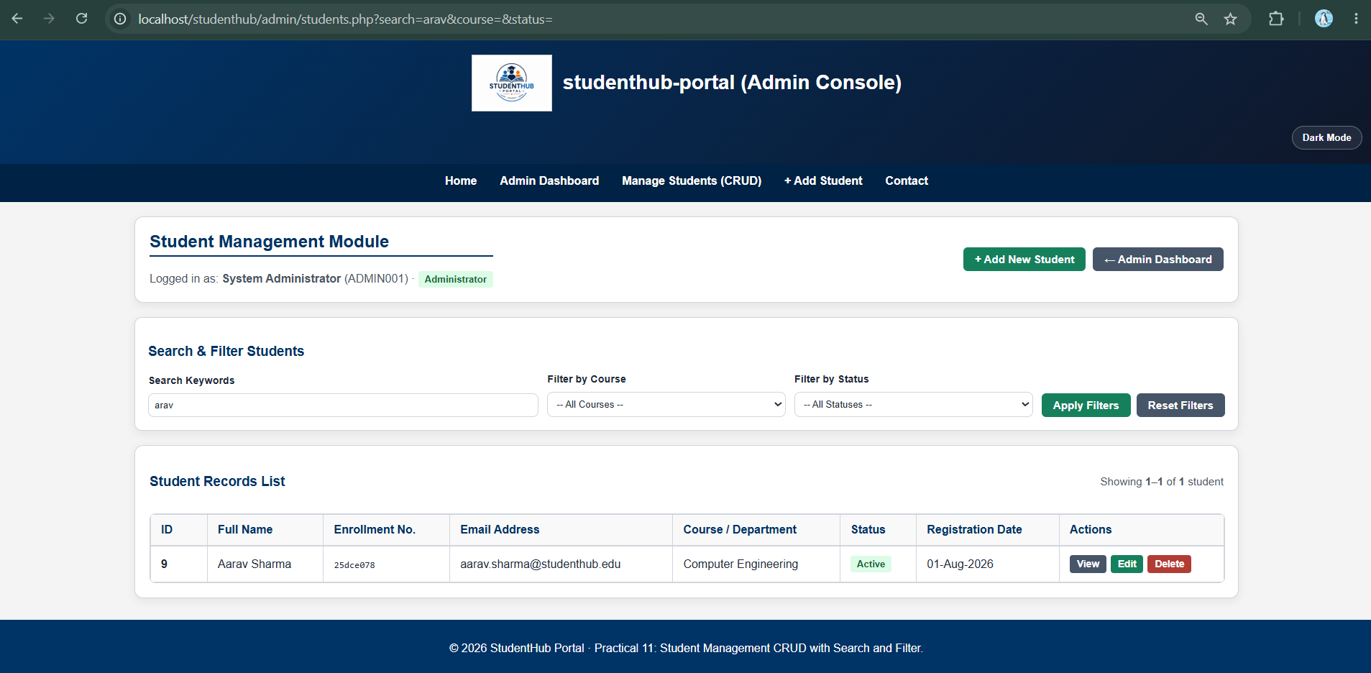

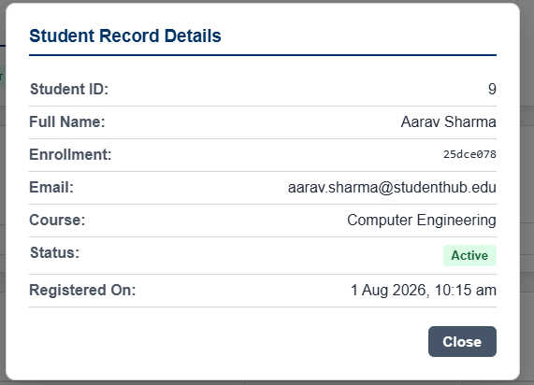

F. GitHub Repository Link
https://github.com/joshitarana2621/studenthub-portal/tree/main/practical11

G. Challenges Faced
• Understanding how to perform CRUD operations using PHP and MySQLi.
• Writing queries to search student records by name, email, or course.
• Filtering records and displaying the correct results.
• Showing clear success and failure messages after each operation.
• Adding a confirmation step before deleting a student record.
H. Learning Outcomes
• Learned how to add, view, update, and delete student records.
• Learned how to connect PHP with MySQL using MySQLi.
• Learned how to search and filter records.
• Learned how to display suitable messages for successful and failed operations.
• Learned why delete confirmation and input validation are important.

