Department of Computer Engineering
Practical - 2
Practical Title: Semantic HTML5 Pages with Accessibility-Ready Structure

Theory

- 1. Are semantic tags such as header, nav, main, section, article, aside, and footer used properly?
Answer: Yes, semantic tags such as <header>, <nav>, <main>, <section>, <article>, <aside>, and <footer> are used properly.
- <header> is used for the page header.
- <nav> is used for navigation menus.
- <main> contains the main content.
- <section> groups related content.
- <article> is used for independent content.
- <aside> contains side information or widgets.
- <footer> is used for footer information.

- 2. Are form labels, headings, image alt text, and navigation links accessible?
Answer: Yes, form labels, headings, image alt text, and navigation links are accessible.
- Form labels clearly describe input fields.
- Headings are structured properly (H1, H2, H3, etc.) for easy navigation.
- Image alt text provides descriptions for screen readers and when images cannot load.
- Navigation links are clear, descriptive, and easy to use.

- 3. Is the page structure consistent across all pages?
Answer: Yes, the page structure is consistent across all pages.
- The same header and navigation menu are used throughout the website.
- Content is organized in a similar manner on each page.
- The footer remains consistent across pages.
- Consistent design improves usability and user experience.

B. HTML Code
index page code:
<!-- index(1).html -->
<!DOCTYPE html>
<html lang="en">
<head>
<meta charset="UTF-8">
<meta name="viewport" content="width=device-width, initial-scale=1.0">
<title>StudentHub Portal</title>
<link rel="stylesheet" href="css/style.css">
</head>
<body>
<header>
<h1>studenthub portal</h1>
<img src="../images/logo.png" alt="logo" width="100">
</header>
<nav aria-label="Main Navigation">
<ul>
<li><a href="index.html">Home</a></li>
<li><a href="login.html">Login</a></li>
<li><a href="index.html">Register</a></li>
<li><a href="dashboard.html">Dashboard</a></li>
<li><a href="attendance.html">Attendance</a></li>
<li><a href="course.html">Courses</a></li>
<li><a href="assignment.html">Assignments</a></li>
<li><a href="result.html">Results</a></li>
<li><a href="profile.html">Profile</a></li>
<li><a href="contact.html">Contact</a></li>
</ul>
</nav>
</header>
<hr>
<hr>
<section>
<h2>Welcome to StudentHub Portal</h2>
<p>
Your one-stop platform for academics, attendance,
courses, assignments, events, results, and campus updates.
</p>
</section>
</header>
<hr>
<main>
<section>
<h2>About Our College</h2>
<p>
Our college is committed to providing quality education,
encouraging innovation, and supporting students in their
academic and personal growth.
</p>
<p>
We offer experienced faculty, modern laboratories,
a digital library, sports facilities, technical clubs,
cultural events, and excellent placement support to help
students build successful careers.
</p>
</section>
<hr>
<section>
<h2>Student Account</h2>
<p>Already have an account?</p>
<a href="login.html">
Login Here
</a>
<br><br>
<p>New to StudentHub?</p>
<a href="register.html">
Register Here
</a>
</section>
<hr>
<section>
<h2>Connect With Us</h2>
<ul>
<li>
<a href="https://www.instagram.com" target="_blank">
Instagram
</a>
</li>
<li>
<a href="https://www.facebook.com" target="_blank">
Facebook
</a>
</li>
<li>
<a href="https://www.linkedin.com" target="_blank">
LinkedIn
</a>
</li>
</ul>
</section>
<hr>
<section>
<h2>College Campus</h2>
<table>
<tr>
<td>
<img src="../images/campus1.jpg" alt="College Main Building" width="180">
</td>
<td>
<img src="../images/campus2.jpg" alt="College Library" width="180">
</td>
</tr>
<tr>
<td>
<img src="../images/campus3.jpg" alt="Sports Ground" width="180">
</td>
<td>
<img src="../images/campus4.jpg" alt="Computer Laboratory" width="180">
</td>
</tr>
</table>
</section>
<hr>
<section>
<h2>Latest Announcements</h2>
<article>
<h3>Upcoming Expert Sessions</h3>
<ul>
<li>
<strong>13 July 2026</strong> -
Generative AI Workshop
(10:00 AM - 3:00 PM)
<a href="https://www.example.com">
Register
</a>
</li>
<li>
<strong>15 July 2026</strong> -
Building Modern Applications
(12:00 PM - 3:00 PM)
<a href="https://www.example.com">
Register
</a>
</li>
<li>
<strong>17 August 2026</strong> -
Red Hat Workshop
(10:00 AM - 1:00 PM)
<a href="https://www.example.com">
Register
</a>
</li>
<li>
<strong>28 August 2026</strong> -
Coder Arcade 3.0
(9:30 AM - 4:20 PM)
<a href="https://www.example.com">
Register
</a>
</li>
<li>
<strong>27 September 2026</strong> -
TechFest 2.0
(9:30 AM - 3:30 PM)
<a href="https://www.example.com">
Register
</a>
</li>
</ul>
</article>
</section>
</main>
<hr>
<footer>
<p>&copy; 2026 StudentHub Portal. All Rights Reserved.</p>
<p>Email: info@studenthub.com</p>
</footer>
</body>
</html>
login page code:
<!-- login(1).html -->
<!DOCTYPE html>
<html lang="en">
<head>
<meta charset="UTF-8">
<title>Student Login - Studenthub Portal</title>
<link rel="stylesheet" href="css/style.css">
</head>
<body>
<header>
<h1>studenthub portal</h1>
<img src="../images/logo.png" alt="logo" width="100">
</header>
<nav>
<ul>
<li><a href="index.html">Home</a></li>
<li><a href="login.html">Login</a></li>
<li><a href="register.html">Register</a></li>
<li><a href="dashboard.html">Dashboard</a></li>
<li><a href="profile.html">Profile</a></li>
<li><a href="attendance.html">Attendance</a></li>
<li><a href="course.html">Courses</a></li>
<li><a href="assignment.html">Assignment</a></li>
<li><a href="result.html">Result</a></li>
<li><a href="contact.html">Contact</a></li>
</ul>
</nav>
<main>
<section id="student-login">
<h2>LOGIN</h2>
<form action="dashboard.html" method="get">
<p>
<label for="enrollment">Enrollment number</label><br>
<input type="text" id="enrollment" name="enrollment" required>
</p>
<p>
<label for="password">Password</label><br>
<input type="password" id="password" name="password" required>
</p>
<p>
<button type="submit">login</button>
</p>
</form>
</section>
<section id="new-student-register">
<p>new student ?</p>
<p><a href="register.html">register here</a></p>
</section>
<p><a href="index.html">&larr; back to home</a></p>
</main>
<footer>
<p>&copy; 2026 StudentHub Portal. All Rights Reserved.</p>
<p>Email: info@studenthub.com</p>
</footer>
</body>
</html>
Register page code:
<!-- register(1).html -->
<!DOCTYPE html>
<html lang="en">
<head>
<meta charset="UTF-8">
<title>New Student Register - Studenthub Portal</title>
<link rel="stylesheet" href="css/style.css">
</head>
<body>
<header>
<h1>studenthub portal</h1>
<img src="../images/logo.png" alt="logo" width="100">
</header>
<nav>
<ul>
<li><a href="index.html">Home</a></li>
<li><a href="login.html">Login</a></li>
<li><a href="register.html">Register</a></li>
<li><a href="dashboard.html">Dashboard</a></li>
<li><a href="profile.html">Profile</a></li>
<li><a href="course.html">Courses</a></li>
<li><a href="attendance.html">Attendance</a></li>
<li><a href="assignment.html">Assignments</a></li>
<li><a href="result.html">Result</a></li>
<li><a href="contact.html">Contact</a></li>
</ul>
</nav>
<main>
<section id="new-student-register">
<h2>Register</h2>
<form action="login.html" method="get">
<p>
<label for="fullname">Full name</label><br>
<input type="text" id="fullname" name="fullname" required>
</p>
<p>
<label for="enrollment">Enrollment id</label><br>
<input type="text" id="enrollment" name="enrollment" required>
</p>
<p>
<label for="email">Email</label><br>
<input type="email" id="email" name="email" required>
</p>
<p>
<label for="password">Password</label><br>
<input type="password" id="password" name="password" required>
</p>
<p>
<label for="confirm_password">Confirm password</label><br>
<input type="password" id="confirm_password" name="confirm_password" required>
</p>
<p>
<label for="college">college</label><br>
<input type="text" id="college" name="college" required>
<p>
<label for="branch">Branch</label>
<select id="branch" name="branch">
<option value="">branch list</option>
<option value="cs">Computer Science</option>
<option value="it">Information Technology</option>
<option value="ce">Computer Engineering</option>
</select>
</p>
<p>
<label for="semester">Current semester</label>
<select id="semester" name="semester">
<option value="">semester</option>
<option value="1">1</option>
<option value="2">2</option>
<option value="3">3</option>
<option value="4">4</option>
</select>
</p>
<p>
<button type="submit">confirm</button>
</p>
</form>
</section>
</main>
<footer>
<p>&copy; 2026 StudentHub Portal. All Rights Reserved.</p>
<p>Email: info@studenthub.com</p>
</footer>
</body>
</html>
dashboard code:
<!-- dashboard(1).html -->
<!DOCTYPE html>
<html lang="en">
<head>
<meta charset="UTF-8">
<title>Dashboard - Studenthub Portal</title>
<link rel="stylesheet" href="css/style.css">
</head>
<body>
<header>
<h1>studenthub-portal</h1>
<img src="../images/logo.png" alt="logo" width="100">
<h2>Welcome to Dashboard</h2>
</header>
<nav>
<ul>
<li><a href="index.html">Home</a></li>
<li><a href="login.html">Login</a></li>
<li><a href="register.html">Register</a></li>
<li><a href="dashboard.html">Dashboard</a></li>
<li><a href="profile.html">Profile</a></li>
<li><a href="course.html">Courses</a></li>
<li><a href="attendance.html">Attendance</a></li>
<li><a href="assignment.html">Assignments</a></li>
<li><a href="result.html">Result</a></li>
<li><a href="contact.html">Contact</a></li>
</ul>
</nav>
<main>
<section>
<h3>Dashboard Quick Access</h3>
<ul>
<li><a href="profile.html"><strong>Student Profile</strong></a></li>
<li><a href="course.html"><strong>Course Details</strong></a></li>
<li><a href="attendance.html"><strong>Attendance</strong></a></li>
<li><a href="assignment.html"><strong>Assignments</strong></a></li>
<li><a href="result.html"><strong>Result Search</strong></a></li>
</ul>
</section>
<section>
<h3>Attendance</h3>
<p>All over attendance-[85%]</p>
</section>
<section>
<h2>Today's Class Schedule</h2>
<table border="1">
<caption><strong>Lecture Timetable</strong></caption>
<thead>
<tr>
<th>Time</th>
<th>Subject</th>
<th>Faculty Name</th>
<th>Lecture Type</th>
</tr>
</thead>
<tbody>
<tr>
<td>09:00 AM - 10:00 AM</td>
<td>Object Oriented Programming</td>
<td>Dr. Priya Shah</td>
<td>Theory</td>
</tr>
<tr>
<td>10:00 AM - 11:00 AM</td>
<td>Data Structures</td>
<td>Prof. Amit Patel</td>
<td>Practical</td>
</tr>
<tr>
<td>11:15 AM - 12:15 PM</td>
<td>Digital Electronics</td>
<td>Dr. Neha Mehta</td>
<td>Theory</td>
</tr>
<tr>
<td>01:00 PM - 02:00 PM</td>
<td>Database Management System</td>
<td>Prof. Rajesh Kumar</td>
<td>Lab</td>
</tr>
<tr>
<td>02:15 PM - 03:15 PM</td>
<td>Web Development</td>
<td>Ms. Sneha Desai</td>
<td>Practical</td>
</tr>
</tbody>
</table>
</section>
<section>
<h3>college gallery</h3>
<figure>
<img src="../images/campus5.png" alt="college campus image" width="180">
<figcaption>college campus image</figcaption>
</figure>
<figure>
<img src="../images/classroom.png" alt="college classroom image" width="180">
<figcaption>college classroom image</figcaption>
</figure>
<figure>
<img src="../images/event.png" alt="collenge event image" width="180">
<figcaption>collenge event image</figcaption>
</figure>
<figure>
<img src="../images/lab.png" alt="college lab image" width="180">
<figcaption>college lab image</figcaption>
</figure>
</section>
<section >
<h2>little description about college</h2>
<p>
Our college is dedicated to providing quality education, modern learning facilities, and a supportive
environment for students. With experienced faculty, well-equipped laboratories, a digital library, and
various extracurricular activities, we help students develop the knowledge, skills, and confidence needed
for a successful future.
</p>
</section>
</main>
<footer>
<p>&copy; 2026 StudentHub Portal. All Rights Reserved.</p>
<p>Email: info@studenthub.com</p>
</footer>
</body>
</html>
Profile page code:
<!-- profile(1).html -->
<!DOCTYPE html>
<html lang="en">
<head>
<meta charset="UTF-8">
<meta name="viewport" content="width=device-width, initial-scale=1.0">
<title>StudentHub Portal - Profile</title>
<link rel="stylesheet" href="css/style.css">
</head>
<body>
<header>
<header>
<h1>studenthub portal</h1>
<img src="../images/logo.png" alt="logo" width="100">
</header>
<hr>
<nav aria-label="Main Navigation">
<ul>
<li><a href="index.html">Home</a></li>
<li><a href="login.html">Login</a></li>
<li><a href="register.html">Register</a></li>
<li><a href="dashboard.html">Dashboard</a></li>
<li><a href="attendance.html">Attendance</a></li>
<li><a href="course.html">Courses</a></li>
<li><a href="assignment.html">Assignments</a></li>
<li><a href="result.html">Results</a></li>
<li><a href="profile.html">Profile</a></li>
<li><a href="contact.html">Contact</a></li>
</ul>
</nav>
<hr>
</header>
<main>
<h2 align="center">PROFILE</h2>
<form>
<section>
<h3>General Information</h3>
<table cellpadding="8">
<tr>
<td>Student ID</td>
<td><input type="text"></td>
</tr>
<tr>
<td>Full Name</td>
<td><input type="text" size="50"></td>
</tr>
<tr>
<td>Mother's Name</td>
<td><input type="text" size="50"></td>
</tr>
<tr>
<td>University</td>
<td><input type="text"></td>
</tr>
<tr>
<td>Institute</td>
<td><input type="text"></td>
</tr>
<tr>
<td>Program</td>
<td><input type="text"></td>
</tr>
<tr>
<td>Aadhar Number</td>
<td><input type="text"></td>
</tr>
<tr>
<td>Date of Birth</td>
<td><input type="date"></td>
</tr>
<tr>
<td>Blood Group</td>
<td>
<select>
<option>Select</option>
<option>A+</option>
<option>A-</option>
<option>B+</option>
<option>B-</option>
<option>AB+</option>
<option>AB-</option>
<option>O+</option>
<option>O-</option>
</select>
</td>
</tr>
<tr>
<td>Religion</td>
<td><input type="text"></td>
</tr>
<tr>
<td>Caste</td>
<td><input type="text"></td>
</tr>
<tr>
<td>Date of Admission</td>
<td><input type="date"></td>
</tr>
<tr>
<td>ACPC Merit Rank</td>
<td><input type="number"></td>
</tr>
<tr>
<td>ACPC Merit Marks</td>
<td><input type="number"></td>
</tr>
</table>
</section>
<hr>
<section>
<h3>Academic Information</h3>
<table cellpadding="8">
<tr>
<td>SSC School</td>
<td><input type="text"></td>
</tr>
<tr>
<td>SSC Board</td>
<td><input type="text"></td>
</tr>
<tr>
<td>SSC Marksheet</td>
<td><input type="file"></td>
</tr>
<tr>
<td>HSC School</td>
<td><input type="text"></td>
</tr>
<tr>
<td>HSC Board</td>
<td><input type="text"></td>
</tr>
<tr>
<td>HSC Marksheet</td>
<td><input type="file"></td>
</tr>
</table>
</section>
<hr>
<section>
<h3>Contact Details</h3>
<table cellpadding="8">
<tr>
<td>Address</td>
<td>
<textarea rows="5" cols="50"></textarea>
</td>
</tr>
<tr>
<td>Guardian Name</td>
<td><input type="text" size="40"></td>
</tr>
<tr>
<td>Relation</td>
<td><input type="text"></td>
</tr>
<tr>
<td>Occupation</td>
<td><input type="text"></td>
</tr>
<tr>
<td>Phone Number</td>
<td><input type="tel"></td>
</tr>
<tr>
<td>College Email</td>
<td><input type="email"></td>
</tr>
<tr>
<td>Personal Email</td>
<td><input type="email"></td>
</tr>
</table>
</section>
<br>
<center>
<input type="submit" value="Submit">
<input type="reset" value="Reset">
</center>
</form>
</main>
<br>
<footer align="center">
<hr>
<p>&copy; 2026 StudentHub Portal</p>
</footer>
</body>
</html>
Course page code:
<!-- course.html -->
<!DOCTYPE html>
<html lang="en">
<head>
<meta charset="UTF-8">
<title>Courses - Studenthub Portal</title>
<link rel="stylesheet" href="css/style.css">
</head>
<body>
<header>
<h1>Studenthub portal</h1>
<img src="../images/logo.png" alt="logo" width="100">
<h2>Courses</h2>
</header>
<nav>
<ul>
<li><a href="../index.html">Home</a></li>
<li><a href="login.html">Login</a></li>
<li><a href="register.html">Register</a></li>
<li><a href="dashboard.html">Dashboard</a></li>
<li><a href="profile.html">Profile</a></li>
<li><a href="course.html">Courses</a></li>
<li><a href="attendance.html">Attendance</a></li>
<li><a href="assignment.html">Assignments</a></li>
<li><a href="result.html">Result</a></li>
<li><a href="contact.html">Contact</a></li>
</ul>
</nav>
<main>
<section>
<h2>Subject List &amp; Study Material</h2>
<p>Total no of Courses Enrolled:5</p>
<table border="1">
<thead>
<tr>
<th>subject code</th>
<th>subject name</th>
<th>Credit</th>
<th>lecture type</th>
<th>material</th>
<th>faculty name</th>
</tr>
</thead>
<tbody>
<tr>
<td>CS101</td>
<td>Computer Programming</td>
<td>4</td>
<td>Lecture &amp; Lab</td>
<td><a href="material1.pdf">Study Material PDF</a></td>
<td>Prof. Smith</td>
</tr>
<tr>
<td>CS102</td>
<td>Data Structures</td>
<td>4</td>
<td>Lecture</td>
<td><a href="material2.pdf">Study Material PDF</a></td>
<td>Dr. Johnson</td>
</tr>
<tr>
<td>CS103</td>
<td>Database Management</td>
<td>3</td>
<td>Lab</td>
<td><a href="material3.pdf">Study Material PDF</a></td>
<td>Prof. Williams</td>
</tr>
</tbody>
</table>
</section>
</main>
<footer>
<p>&copy; 2026 StudentHub Portal. All Rights Reserved.</p>
<p>Email: info@studenthub.com</p>
</footer>
</body>
</html>
<!-- attendance(1).html -->
<!DOCTYPE html>
<html lang="en">
<head>
<meta charset="UTF-8">
<title>Attendance - Studenthub Portal</title>
<link rel="stylesheet" href="css/style.css">
</head>
<body>
<header>
<h1>studenthub-portal</h1>
<img src="../images/logo.png" alt="logo" width="100">
<nav>
<ul>
<li><a href="index.html">Home</a></li>
<li><a href="login.html">Login</a></li>
<li><a href="register.html">Register</a></li>
<li><a href="dashboard.html">Dashboard</a></li>
<li><a href="profile.html">Profile</a></li>
<li><a href="course.html">Courses</a></li>
<li><a href="attendance.html">Attendance</a></li>
<li><a href="assignment.html">Assignments</a></li>
<li><a href="result.html">Result</a></li>
<li><a href="contact.html">Contact</a></li>
</ul>
</nav>
</header>
<main>
<h2>Attendence</h2>
<section >
<h3>View Attendance</h3>
<table border="1">
<thead>
<tr>
<th>courses</th>
<th>Lecture type</th>
<th>present/total</th>
<th>percentage</th>
</tr>
</thead>
<tbody>
<tr>
<td>CS101</td>
<td>Lecture </td>
<td>3/4</td>
<td>75%</td>
</tr>
<tr>
<td>cs101</td>
<td>Lab</td>
<td>1/2</td>
<td>50%</td>
</tr>
<tr>
<td>cs102</td>
<td>lec</td>
<td>1/4</td>
<td>25%</td>
</tr>
<tr>
<td>cs103</td>
<td>Lab</td>
<td>1/1</td>
<td>100%</td>
</tr>
</tbody>
</table>
</section>
<section >
<h3>overall attendence</h3>
<p>Attendance Report: Total present percentage calculated across all courses.</p>
</section>
</main>
<footer>
<p>&copy; 2026 StudentHub Portal. All Rights Reserved.</p>
<p>Email: info@studenthub.com</p>
</footer>
</body>
</html>
assignment page code:
<!-- assignment.html -->
<!DOCTYPE html>
<html lang="en">
<head>
<meta charset="UTF-8">
<title>Assignments & Notices - Studenthub Portal</title>
<link rel="stylesheet" href="css/style.css">
</head>
<body>
<header>
<h1>studenthub portal</h1>
<img src="../images/logo.png" alt="logo" width="100">
<nav aria-label="Main Navigation">
<ul>
<li><a href="index.html">Home</a></li>
<li><a href="login.html">Login</a></li>
<li><a href="index.html">Register</a></li>
<li><a href="dashboard.html">Dashboard</a></li>
<li><a href="attendance.html">Attendance</a></li>
<li><a href="course.html">Courses</a></li>
<li><a href="assignment.html">Assignments</a></li>
<li><a href="result.html">Results</a></li>
<li><a href="profile.html">Profile</a></li>
<li><a href="contact.html">Contact</a></li>
</ul>
</nav>
</header>
<main>
<h2>Assignments &amp; Notices</h2>
<section id="upcoming-exams">
<h3>Upcoming exams(CIE)</h3>
<ul>
<li>Item 1</li>
<li>Item 2</li>
<li>Item 3</li>
</ul>
</section>
<section id="cie-marks">
<h3>CIE marks</h3>
<ul>
<li>Item 1</li>
<li>Item 2</li>
<li>Item 3</li>
</ul>
</section>
<section id="subject-paperstyle">
<h3>Subject paperstyle</h3>
<ul>
<li>Item 1</li>
<li>Item 2</li>
<li>Item 3</li>
</ul>
</section>
<section id="expert-session">
<h3>Upcoming Expert session</h3>
<ul>
<li>Item 1</li>
<li>Item 2</li>
<li>Item 3</li>
</ul>
</section>
</main>
<footer>
<p>&copy; 2026 StudentHub Portal. All Rights Reserved.</p>
<p>Email: info@studenthub.com</p>
</footer>
</body>
</html>
Result page code:
<!-- result(1).html -->
<!DOCTYPE html>
<html lang="en">
<head>
<meta charset="UTF-8">
<title>Result - Studenthub Portal</title>
<link rel="stylesheet" href="css/style.css">
</head>
<body>
<header>
<h1>studenthub portal</h1>
<img src="../images/logo.png" alt="logo" width="100">
</header>
<nav>
<ul>
<li><a href="../index.html">Home</a></li>
<li><a href="../index.html#about-college">About College</a></li>
<li><a href="login.html">Login</a></li>
<li><a href="register.html">Register</a></li>
<li><a href="dashboard.html">Dashboard</a></li>
<li><a href="profile.html">Profile</a></li>
<li><a href="course.html">Courses</a></li>
<li><a href="attendance.html">Attendance</a></li>
<li><a href="assignment.html">Assignments</a></li>
<li><a href="result.html">Result</a></li>
<li><a href="contact.html">Contact</a></li>
</ul>
</nav>
<main>
<h2>Result Search</h2>
<form action="result.html" method="get">
<p>
<label for="select_semester">select semester</label><br>
<select id="select_semester" name="select_semester" size="4">
<option value="1" selected>1</option>
<option value="2">2</option>
<option value="3">3</option>
<option value="4">4</option>
</select>
</p>
<p>
<label for="select_branch">select branch</label><br>
<select id="select_branch" name="select_branch" size="3">
<option value="computer_science">computer science</option>
<option value="computer" selected>computer</option>
<option value="information_technology">information technology</option>
</select>
</p>
<p>
<label for="select_exam_session">select exam session</label><br>
<select id="select_exam_session" name="select_exam_session" size="2">
<option value="month">month</option>
<option value="month_duration">month duration</option>
</select>
</p>
<p>
<label for="id_no">enter id no</label><br>
<input type="text" id="id_no" name="id_no">
</p>
<p>
<button type="submit">submit</button>
</p>
</form>
</main>
<footer>
<p>&copy; 2026 StudentHub Portal. All Rights Reserved.</p>
<p>Email: info@studenthub.com</p>
</footer>
</body>
</html>
contact page:
<!-- contact(1).html -->
<!DOCTYPE html>
<html lang="en">
<head>
<meta charset="UTF-8">
<title>Contact - Studenthub Portal</title>
<link rel="stylesheet" href="css/style.css">
</head>
<body>
<header>
<h1>studenthub portal</h1>
<img src="../images/logo.png" alt="logo" width="100">
</header>
<nav>
<ul>
<li><a href="index.html">Home</a></li>
<li><a href="login.html">Login</a></li>
<li><a href="register.html">Register</a></li>
<li><a href="dashboard.html">Dashboard</a></li>
<li><a href="profile.html">Profile</a></li>
<li><a href="course.html">Courses</a></li>
<li><a href="attendance.html">Attendance</a></li>
<li><a href="assignment.html">Assignments</a></li>
<li><a href="result.html">Result</a></li>
<li><a href="contact.html">Contact</a></li>
</ul>
</nav>
<main>
<section id="contact-directory">
<h2>Contact Directory (Email &amp; Phone)</h2>
<table border="1">
<tr>
<td>HOD contact details</td>
<td><a href="mailto:hod@college.edu">mail</a> &amp; <a href="tel:+1234567890">1234567890</a></td>
</tr>
<tr>
<td>counsiller</td>
<td><a href="mailto:counselor@college.edu">mail</a> &amp; <a href="tel:+1234567891">1234567891</a></td>
</tr>
<tr>
<td>about scholarship quaerys</td>
<td><a href="mailto:scholarship@college.edu">mails</a> &amp; <a href="tel:+1234567892">1234567892</a></td>
</tr>
<tr>
<td>about fees/admission</td>
<td><a href="mailto:admissions@college.edu">mails</a> &amp; <a href="tel:+1234567893">1234567893</a></td>
</tr>
<tr>
<td>for hostel quearies</td>
<td><a href="mailto:hostel@college.edu">mail</a> &amp; <a href="tel:+1234567894">1234567894</a></td>
</tr>
</table>
</section>
<section id="campus-location">
<h2>Location &amp; Campus Address</h2>
<p><strong>Campus Address:</strong> University Road, Institutional Area, Tech Campus, City - 380001.</p>
<p><strong>Landmark:</strong> Near Central Public Park &amp; Metro Station Gate 2.</p>
<p><strong>Location Map:</strong> <a href="https://maps.google.com" target="_blank">View Campus Location on Google Maps</a></p>
</section>
<section id="faculty-contacts">
<h2>each subject wise faculty contact details</h2>
<p>CS101 - Prof. Smith (Email: <a href="mailto:smith@college.edu">smith@college.edu</a>, Phone: <a href="tel:1234567895">1234567895</a>)</p>
<p>CS102 - Dr. Johnson (Email: <a href="mailto:johnson@college.edu">johnson@college.edu</a>, Phone: <a href="tel:1234567896">1234567896</a>)</p>
<p>CS103 - Prof. Williams (Email: <a href="mailto:williams@college.edu">williams@college.edu</a>, Phone: <a href="tel:1234567897">1234567897</a>)</p>
</section>
</main>
<footer>
<p>&copy; 2026 StudentHub Portal. All Rights Reserved.</p>
<p>Email: info@studenthub.com</p>
</footer>
</body>
</html>

C. Evidence of Work (Screenshots)
Index page:
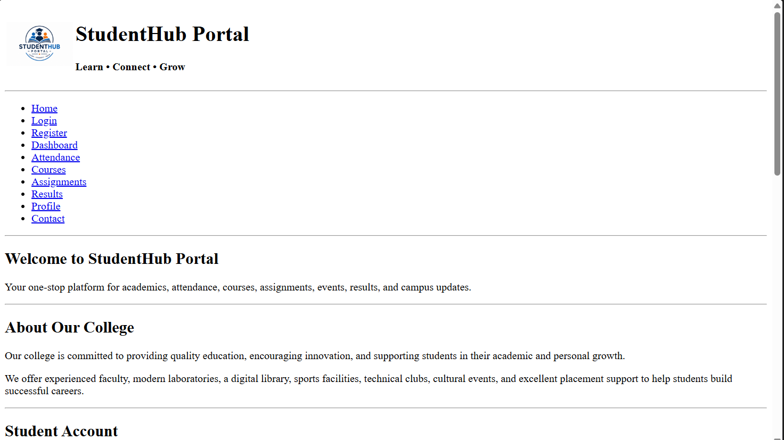
(Fig 1.1 )
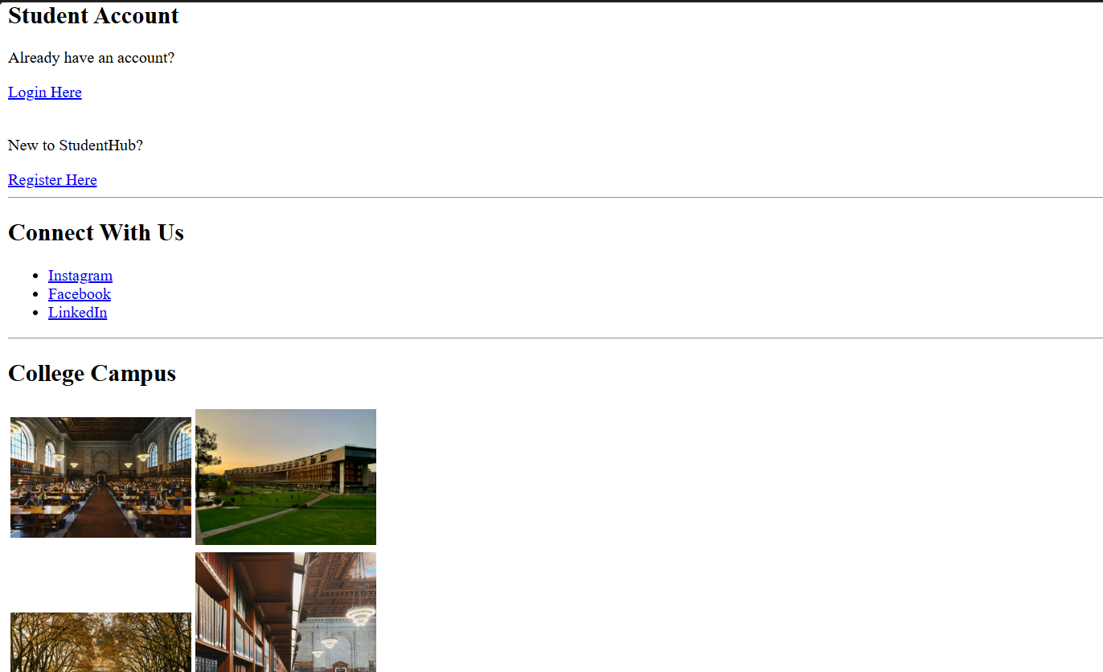
(Fig 1.2)

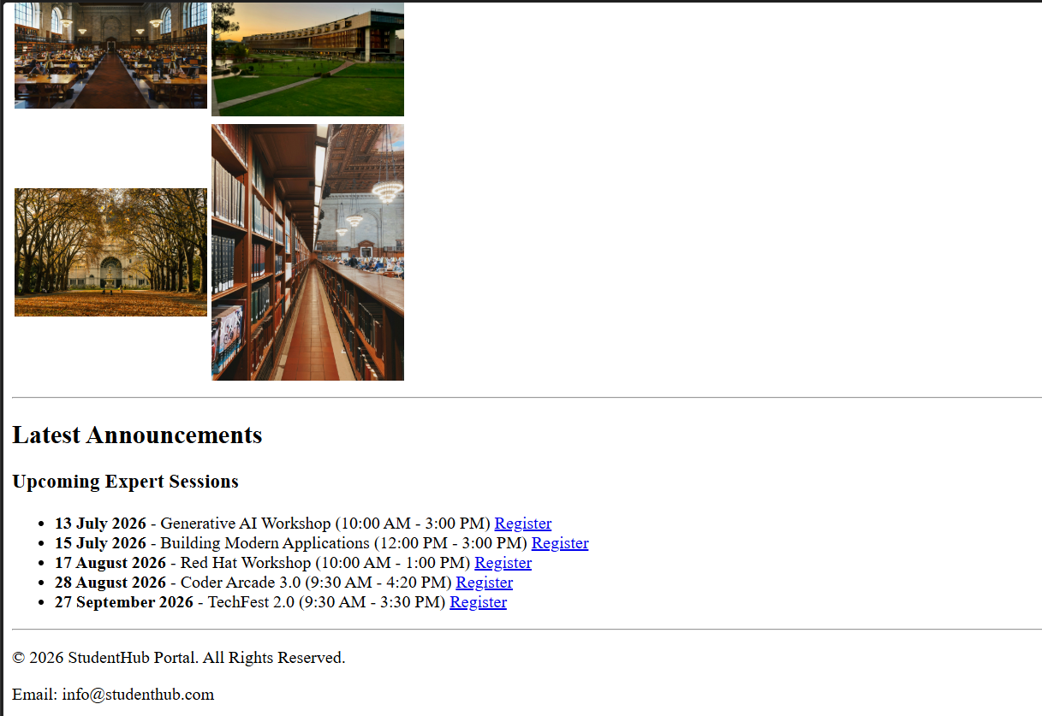
(fig 1.3)
Login page:
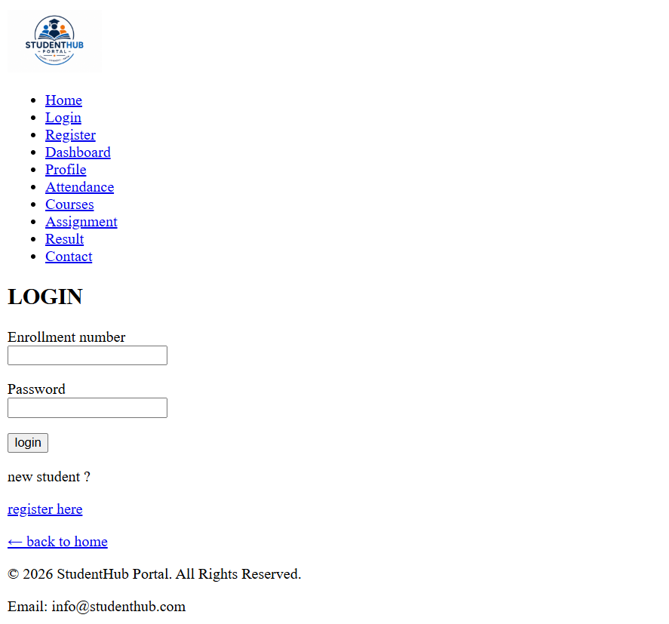
(fig 2)
Register page:
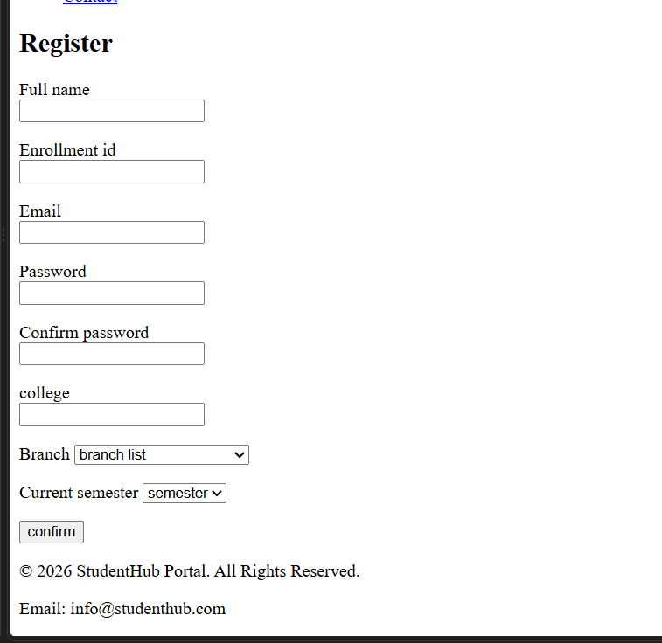
(fig 3)

Dashboard:
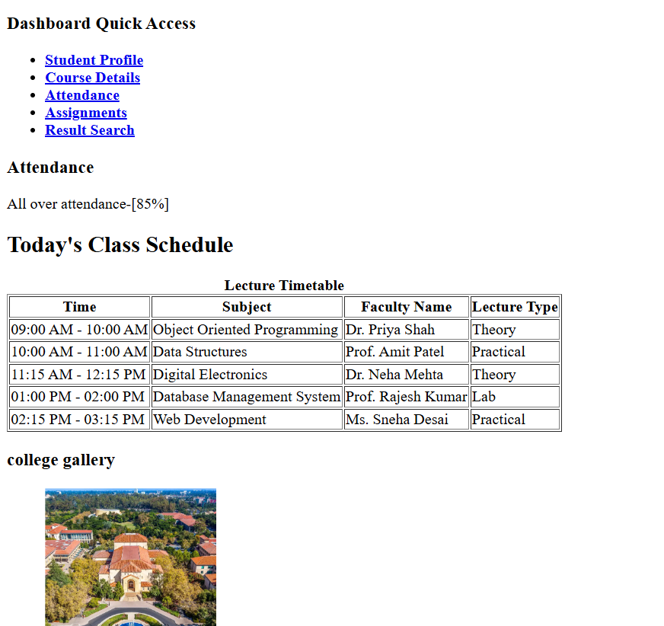
(fig 4.1)
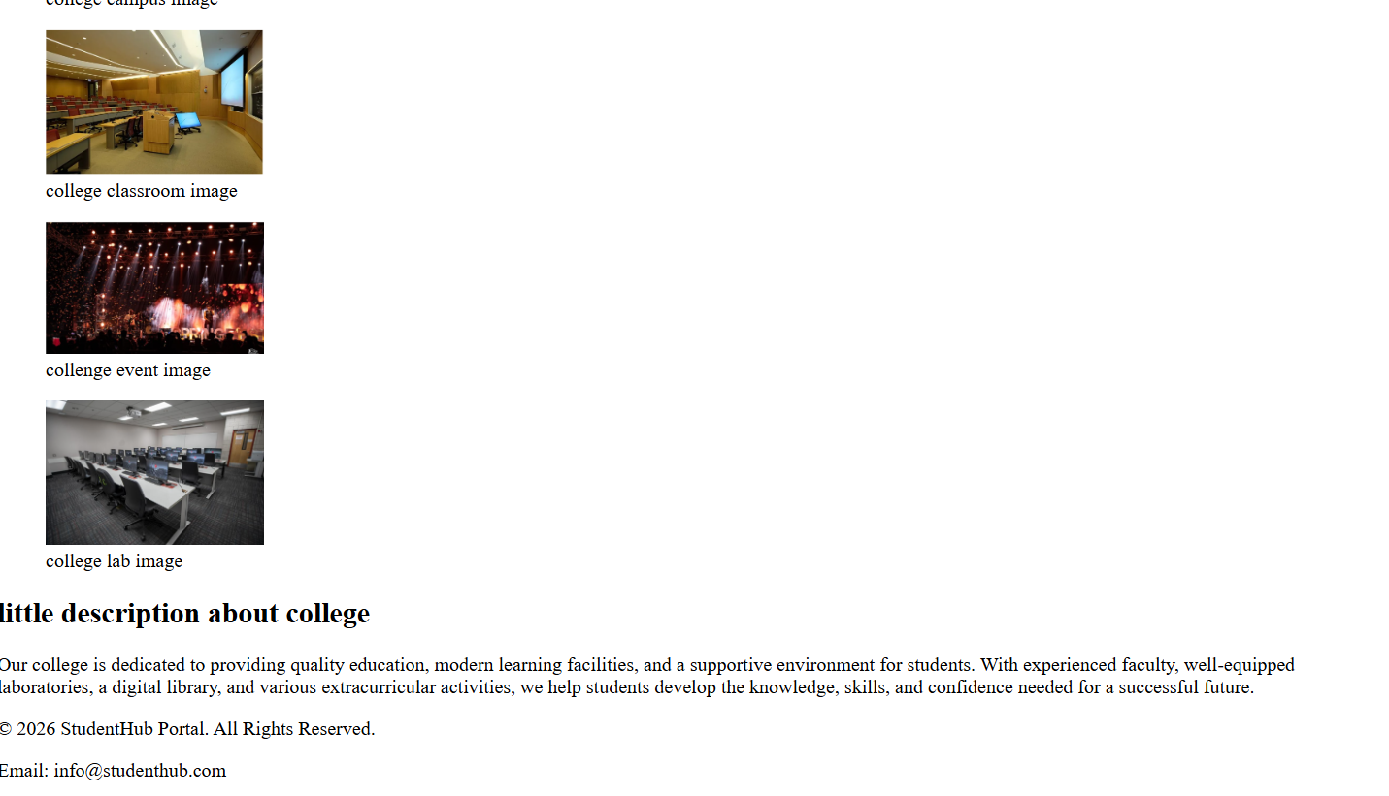
(fig 4.2)
Course:
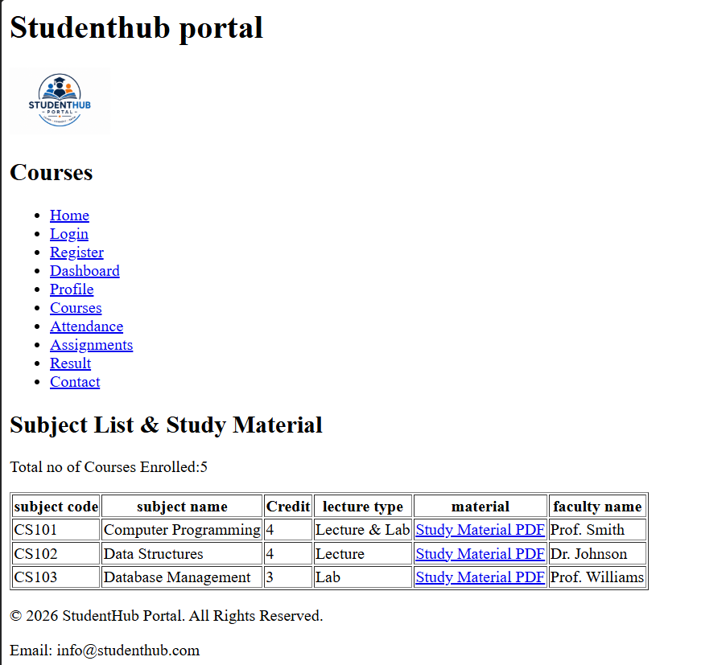
(fig 5)
Assignment page:
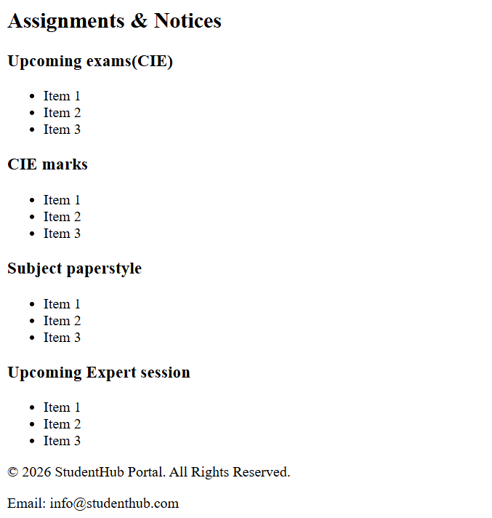
(fig 6)

Attendance page:
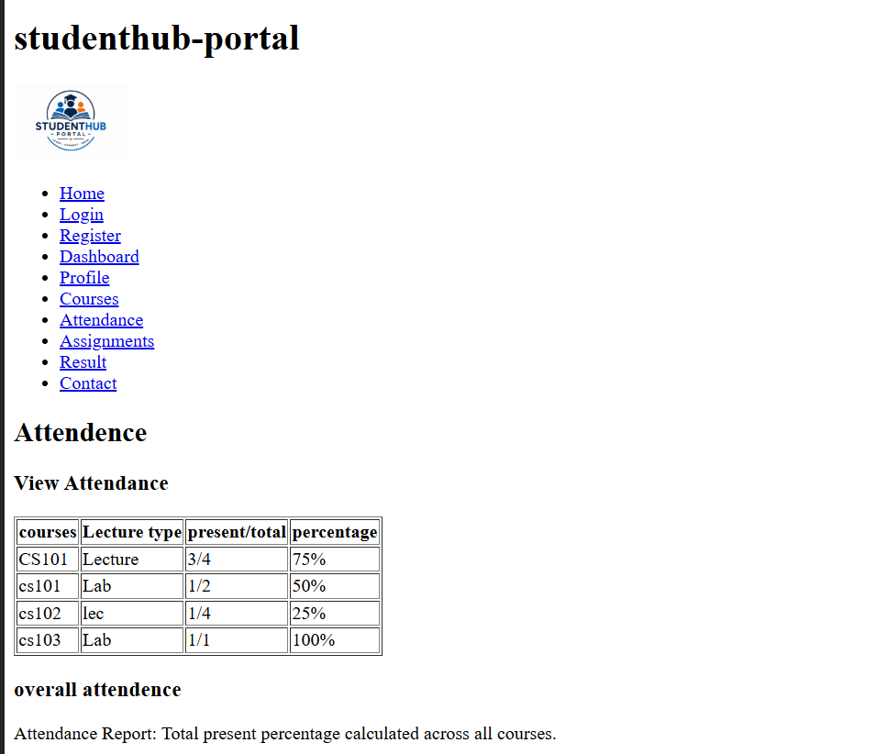
(Fig 7)

Contact page:
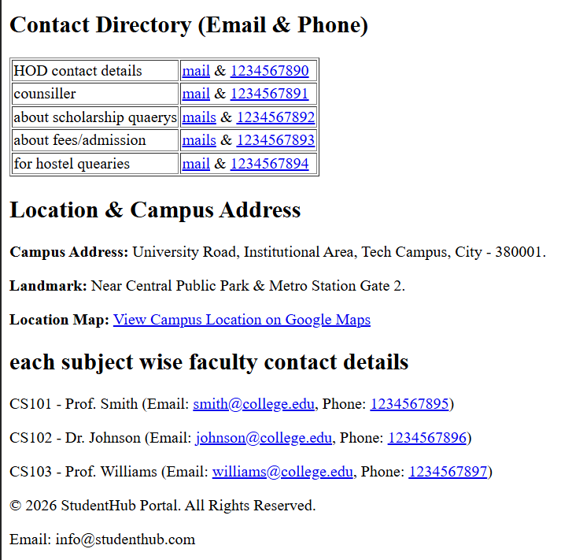
(fig 8)

Profile page:
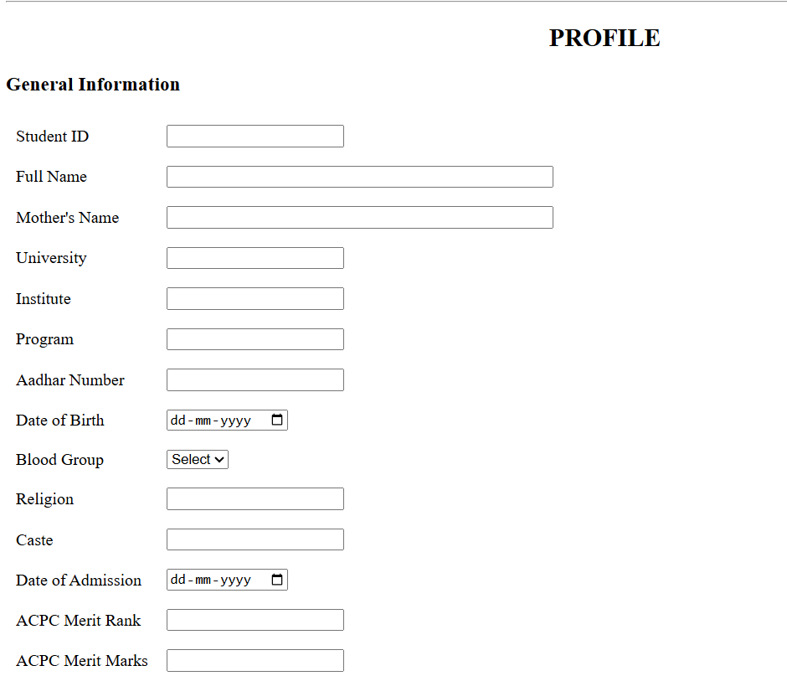
(fig 9.1)
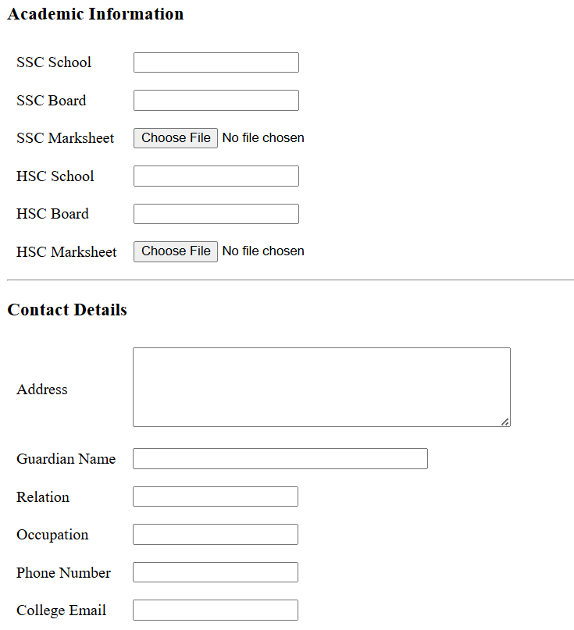
(fig 9.2)
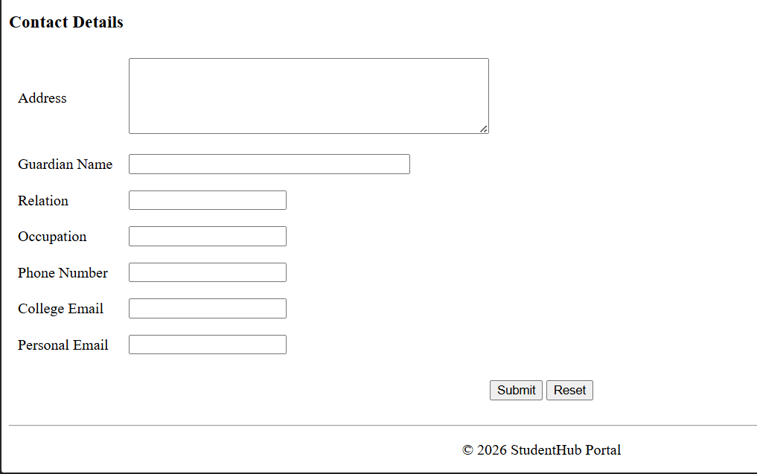
(fig 9.3)
Result page:
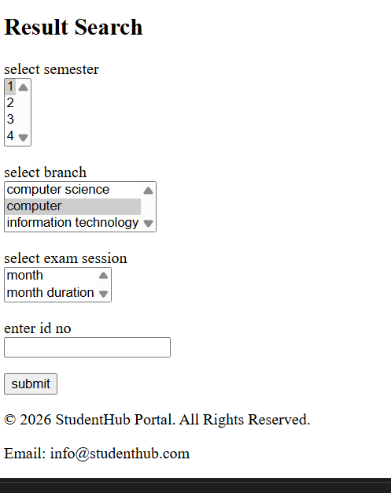
(fig 10)

D. GitHub Repository Link
https://github.com/joshitarana2621/studenthub-portal/tree/main/practical%202

E. Challenges Faced
- Understanding semantic HTML tags.
- Keeping the same layout on every page.
- Linking all pages correctly.

F. Learning Outcomes
- Learned to use HTML5 semantic tags.
- Learned basic accessibility features.
- Learned to create a well-structured website.

Faculty Remarks

