Department of Computer Engineering

Practical - 3
Practical Title: Responsive UI Design using CSS Grid, Flexbox, and Bootstrap/Tailwind

Theory

1. How does the layout adapt for mobile, tablet, and desktop screens?
Answer: The layout adapts using responsive web design techniques:
- Mobile screens: Content is usually displayed in a single column, with larger buttons and touch-friendly navigation.
- Tablet screens: The layout may use two columns and provide more spacing and content visibility.
- Desktop screens: The layout uses multiple columns, wider content areas, and full navigation menus to make use of the larger screen space.
This adaptation is commonly achieved using CSS media queries, flexbox, and grid layouts, which automatically adjust the design based on the screen size.

2. Which layout technique is used and why?
Answer: CSS Flexbox or CSS Grid is commonly used for layouts because it helps create responsive and flexible designs.
Why?
- Adjusts automatically to different screen sizes.
- Makes it easy to align and arrange elements.
- Reduces the amount of code needed for complex layouts.
- Improves user experience on mobile, tablet, and desktop devices.

3. Are typography, spacing, colors, and contrast readable?
Answer: Yes, the typography, spacing, colors, and contrast are readable because:
- Typography: Clear and easy-to-read fonts are used.
- Spacing: Adequate spacing between elements improves readability.
- Colors: Appropriate color combinations make content visually appealing.
- Contrast: Good contrast between text and background helps users read content easily.

4. Is the framework used consistently without unnecessary inline CSS?
Answer: Yes, the framework is used consistently without unnecessary inline CSS.
- Framework classes are used for styling and layout.
- Inline CSS is minimized or avoided.
- This keeps the code clean, maintainable, and consistent.
- It also improves readability and makes future updates easier.

B. HTML Code

Index page:
<!DOCTYPE html>
<html lang="en">
<head>
<meta charset="UTF-8">
<meta name="viewport" content="width=device-width, initial-scale=1.0">
<title>StudentHub Portal</title>
<link rel="stylesheet" href="css/style.css">
</head>
<body>
<header>
<h1>studenthub portal</h1>
<img src="../images/logo.png" alt="logo" width="100">
</header>
<nav aria-label="Main Navigation">
<ul>
<li><a href="index.html">Home</a></li>
<li><a href="login.html">Login</a></li>
<li><a href="index.html">Register</a></li>
<li><a href="dashboard.html">Dashboard</a></li>
<li><a href="attendance.html">Attendance</a></li>
<li><a href="course.html">Courses</a></li>
<li><a href="assignment.html">Assignments</a></li>
<li><a href="result.html">Results</a></li>
<li><a href="profile.html">Profile</a></li>
<li><a href="contact.html">Contact</a></li>
</ul>
</nav>
</header>
<hr>
<hr>
<section>
<h2>Welcome to StudentHub Portal</h2>
<p>
Your one-stop platform for academics, attendance,
courses, assignments, events, results, and campus updates.
</p>
</section>
</header>
<hr>
<main>
<section>
<h2>About Our College</h2>
<p>
Our college is committed to providing quality education,
encouraging innovation, and supporting students in their
academic and personal growth.
</p>
<p>
We offer experienced faculty, modern laboratories,
a digital library, sports facilities, technical clubs,
cultural events, and excellent placement support to help
students build successful careers.
</p>
</section>
<hr>
<section>
<h2>Student Account</h2>
<p>Already have an account?</p>
<a href="login.html">
Login Here
</a>
<br><br>
<p>New to StudentHub?</p>
<a href="register.html">
Register Here
</a>
</section>
<hr>
<section>
<h2>Connect With Us</h2>
<ul>
<li>
<a href="https://www.instagram.com" target="_blank">
Instagram
</a>
</li>
<li>
<a href="https://www.facebook.com" target="_blank">
Facebook
</a>
</li>
<li>
<a href="https://www.linkedin.com" target="_blank">
LinkedIn
</a>
</li>
</ul>
</section>
<hr>
<section>
<h2>College Campus</h2>
<table>
<tr>
<td>
<img src="../images/campus1.jpg" alt="College Main Building" width="180">
</td>
<td>
<img src="../images/campus2.jpg" alt="College Library" width="180">
</td>
</tr>
<tr>
<td>
<img src="../images/campus3.jpg" alt="Sports Ground" width="180">
</td>
<td>
<img src="../images/campus4.jpg" alt="Computer Laboratory" width="180">
</td>
</tr>
</table>
</section>
<hr>
<section>
<h2>Latest Announcements</h2>
<article>
<h3>Upcoming Expert Sessions</h3>
<ul>
<li>
<strong>13 July 2026</strong> -
Generative AI Workshop
(10:00 AM - 3:00 PM)
<a href="https://www.example.com">
Register
</a>
</li>
<li>
<strong>15 July 2026</strong> -
Building Modern Applications
(12:00 PM - 3:00 PM)
<a href="https://www.example.com">
Register
</a>
</li>
<li>
<strong>17 August 2026</strong> -
Red Hat Workshop
(10:00 AM - 1:00 PM)
<a href="https://www.example.com">
Register
</a>
</li>
<li>
<strong>28 August 2026</strong> -
Coder Arcade 3.0
(9:30 AM - 4:20 PM)
<a href="https://www.example.com">
Register
</a>
</li>
<li>
<strong>27 September 2026</strong> -
TechFest 2.0
(9:30 AM - 3:30 PM)
<a href="https://www.example.com">
Register
</a>
</li>
</ul>
</article>
</section>
</main>
<hr>
<footer>
<p>&copy; 2026 StudentHub Portal. All Rights Reserved.</p>
<p>Email: info@studenthub.com</p>
</footer>
</body>
</html>
login page:
<!DOCTYPE html>
<html lang="en">
<head>
<meta charset="UTF-8">
<title>Student Login - Studenthub Portal</title>
<link rel="stylesheet" href="css/style.css">
</head>
<body>
<header>
<h1>studenthub portal</h1>
<img src="../images/logo.png" alt="logo" width="100">
</header>
<nav>
<ul>
<li><a href="index.html">Home</a></li>
<li><a href="login.html">Login</a></li>
<li><a href="register.html">Register</a></li>
<li><a href="dashboard.html">Dashboard</a></li>
<li><a href="profile.html">Profile</a></li>
<li><a href="attendance.html">Attendance</a></li>
<li><a href="course.html">Courses</a></li>
<li><a href="assignment.html">Assignment</a></li>
<li><a href="result.html">Result</a></li>
<li><a href="contact.html">Contact</a></li>
</ul>
</nav>
<main>
<section id="student-login">
<h2>LOGIN</h2>
<form action="dashboard.html" method="get">
<p>
<label for="enrollment">Enrollment number</label><br>
<input type="text" id="enrollment" name="enrollment" required>
</p>
<p>
<label for="password">Password</label><br>
<input type="password" id="password" name="password" required>
</p>
<p>
<button type="submit">login</button>
</p>
</form>
</section>
<section id="new-student-register">
<p>new student ?</p>
<p><a href="register.html">register here</a></p>
</section>
<p><a href="index.html">&larr; back to home</a></p>
</main>
<footer>
<p>&copy; 2026 StudentHub Portal. All Rights Reserved.</p>
<p>Email: info@studenthub.com</p>
</footer>
</body>
</html>
register page:
<!DOCTYPE html>
<html lang="en">
<head>
<meta charset="UTF-8">
<title>New Student Register - Studenthub Portal</title>
<link rel="stylesheet" href="css/style.css">
</head>
<body>
<header>
<h1>studenthub portal</h1>
<img src="../images/logo.png" alt="logo" width="100">
</header>
<nav>
<ul>
<li><a href="index.html">Home</a></li>
<li><a href="login.html">Login</a></li>
<li><a href="register.html">Register</a></li>
<li><a href="dashboard.html">Dashboard</a></li>
<li><a href="profile.html">Profile</a></li>
<li><a href="course.html">Courses</a></li>
<li><a href="attendance.html">Attendance</a></li>
<li><a href="assignment.html">Assignments</a></li>
<li><a href="result.html">Result</a></li>
<li><a href="contact.html">Contact</a></li>
</ul>
</nav>
<main>
<section id="new-student-register">
<h2>Register</h2>
<form action="login.html" method="get">
<p>
<label for="fullname">Full name</label><br>
<input type="text" id="fullname" name="fullname" required>
</p>
<p>
<label for="enrollment">Enrollment id</label><br>
<input type="text" id="enrollment" name="enrollment" required>
</p>
<p>
<label for="email">Email</label><br>
<input type="email" id="email" name="email" required>
</p>
<p>
<label for="password">Password</label><br>
<input type="password" id="password" name="password" required>
</p>
<p>
<label for="confirm_password">Confirm password</label><br>
<input type="password" id="confirm_password" name="confirm_password" required>
</p>
<p>
<label for="college">college</label><br>
<input type="text" id="college" name="college" required>
</p>
<p>
<label for="branch">Branch</label>
<select id="branch" name="branch">
<option value="">branch list</option>
<option value="cs">Computer Science</option>
<option value="it">Information Technology</option>
<option value="ce">Computer Engineering</option>
</select>
</p>
<p>
<label for="semester">Current semester</label>
<select id="semester" name="semester">
<option value="">semester</option>
<option value="1">1</option>
<option value="2">2</option>
<option value="3">3</option>
<option value="4">4</option>
</select>
</p>
<p>
<button type="submit">confirm</button>
</p>
</form>
</section>
</main>
<footer>
<p>&copy; 2026 StudentHub Portal. All Rights Reserved.</p>
<p>Email: info@studenthub.com</p>
</footer>
</body>
</html>
dashboard page:
<!DOCTYPE html>
<html lang="en">
<head>
<meta charset="UTF-8">
<title>Dashboard - Studenthub Portal</title>
<link rel="stylesheet" href="css/style.css">
</head>
<body>
<header>
<h1>studenthub-portal</h1>
<img src="../images/logo.png" alt="logo" width="100">
<h2>Welcome to Dashboard</h2>
</header>
<nav>
<ul>
<li><a href="index.html">Home</a></li>
<li><a href="login.html">Login</a></li>
<li><a href="register.html">Register</a></li>
<li><a href="dashboard.html">Dashboard</a></li>
<li><a href="profile.html">Profile</a></li>
<li><a href="course.html">Courses</a></li>
<li><a href="attendance.html">Attendance</a></li>
<li><a href="assignment.html">Assignments</a></li>
<li><a href="result.html">Result</a></li>
<li><a href="contact.html">Contact</a></li>
</ul>
</nav>
<main>
<section>
<h3>Dashboard Quick Access</h3>
<ul>
<li><a href="profile.html"><strong>Student Profile</strong></a></li>
<li><a href="course.html"><strong>Course Details</strong></a></li>
<li><a href="attendance.html"><strong>Attendance</strong></a></li>
<li><a href="assignment.html"><strong>Assignments</strong></a></li>
<li><a href="result.html"><strong>Result Search</strong></a></li>
</ul>
</section>
<section>
<h3>Attendance</h3>
<p>All over attendance-[85%]</p>
</section>
<section>
<h2>Today's Class Schedule</h2>
<table border="1">
<caption><strong>Lecture Timetable</strong></caption>
<thead>
<tr>
<th>Time</th>
<th>Subject</th>
<th>Faculty Name</th>
<th>Lecture Type</th>
</tr>
</thead>
<tbody>
<tr>
<td>09:00 AM - 10:00 AM</td>
<td>Object Oriented Programming</td>
<td>Dr. Priya Shah</td>
<td>Theory</td>
</tr>
<tr>
<td>10:00 AM - 11:00 AM</td>
<td>Data Structures</td>
<td>Prof. Amit Patel</td>
<td>Practical</td>
</tr>
<tr>
<td>11:15 AM - 12:15 PM</td>
<td>Digital Electronics</td>
<td>Dr. Neha Mehta</td>
<td>Theory</td>
</tr>
<tr>
<td>01:00 PM - 02:00 PM</td>
<td>Database Management System</td>
<td>Prof. Rajesh Kumar</td>
<td>Lab</td>
</tr>
<tr>
<td>02:15 PM - 03:15 PM</td>
<td>Web Development</td>
<td>Ms. Sneha Desai</td>
<td>Practical</td>
</tr>
</tbody>
</table>
</section>
<section>
<h3>college gallery</h3>
<figure>
<img src="../images/campus5.png" alt="college campus image" width="180">
<figcaption>college campus image</figcaption>
</figure>
<figure>
<img src="../images/classroom.png" alt="college classroom image" width="180">
<figcaption>college classroom image</figcaption>
</figure>
<figure>
<img src="../images/event.png" alt="collenge event image" width="180">
<figcaption>collenge event image</figcaption>
</figure>
<figure>
<img src="../images/lab.png" alt="college lab image" width="180">
<figcaption>college lab image</figcaption>
</figure>
</section>
<section >
<h2>little description about college</h2>
<p>
Our college is dedicated to providing quality education, modern learning facilities, and a supportive
environment for students. With experienced faculty, well-equipped laboratories, a digital library, and
various extracurricular activities, we help students develop the knowledge, skills, and confidence needed
for a successful future.
</p>
</section>
</main>
<footer>
<p>&copy; 2026 StudentHub Portal. All Rights Reserved.</p>
<p>Email: info@studenthub.com</p>
</footer>
</body>
</html>
Profile page:
<!DOCTYPE html>
<html lang="en">
<head>
<meta charset="UTF-8">
<meta name="viewport" content="width=device-width, initial-scale=1.0">
<title>StudentHub Portal - Profile</title>
<link rel="stylesheet" href="css/style.css">
</head>
<body>
<header>
<header>
<h1>studenthub portal</h1>
<img src="../images/logo.png" alt="logo" width="100">
</header>
<hr>
<nav aria-label="Main Navigation">
<ul>
<li><a href="index.html">Home</a></li>
<li><a href="login.html">Login</a></li>
<li><a href="register.html">Register</a></li>
<li><a href="dashboard.html">Dashboard</a></li>
<li><a href="attendance.html">Attendance</a></li>
<li><a href="course.html">Courses</a></li>
<li><a href="assignment.html">Assignments</a></li>
<li><a href="result.html">Results</a></li>
<li><a href="profile.html">Profile</a></li>
<li><a href="contact.html">Contact</a></li>
</ul>
</nav>
<hr>
</header>
<main>
<h2 align="center">PROFILE</h2>
<form>
<section>
<h3>General Information</h3>
<table cellpadding="8">
<tr>
<td>Student ID</td>
<td><input type="text"></td>
</tr>
<tr>
<td>Full Name</td>
<td><input type="text" size="50"></td>
</tr>
<tr>
<td>Mother's Name</td>
<td><input type="text" size="50"></td>
</tr>
<tr>
<td>University</td>
<td><input type="text"></td>
</tr>
<tr>
<td>Institute</td>
<td><input type="text"></td>
</tr>
<tr>
<td>Program</td>
<td><input type="text"></td>
</tr>
<tr>
<td>Aadhar Number</td>
<td><input type="text"></td>
</tr>
<tr>
<td>Date of Birth</td>
<td><input type="date"></td>
</tr>
<tr>
<td>Blood Group</td>
<td>
<select>
<option>Select</option>
<option>A+</option>
<option>A-</option>
<option>B+</option>
<option>B-</option>
<option>AB+</option>
<option>AB-</option>
<option>O+</option>
<option>O-</option>
</select>
</td>
</tr>
<tr>
<td>Religion</td>
<td><input type="text"></td>
</tr>
<tr>
<td>Caste</td>
<td><input type="text"></td>
</tr>
<tr>
<td>Date of Admission</td>
<td><input type="date"></td>
</tr>
<tr>
<td>ACPC Merit Rank</td>
<td><input type="number"></td>
</tr>
<tr>
<td>ACPC Merit Marks</td>
<td><input type="number"></td>
</tr>
</table>
</section>
<hr>
<section>
<h3>Academic Information</h3>
<table cellpadding="8">
<tr>
<td>SSC School</td>
<td><input type="text"></td>
</tr>
<tr>
<td>SSC Board</td>
<td><input type="text"></td>
</tr>
<tr>
<td>SSC Marksheet</td>
<td><input type="file"></td>
</tr>
<tr>
<td>HSC School</td>
<td><input type="text"></td>
</tr>
<tr>
<td>HSC Board</td>
<td><input type="text"></td>
</tr>
<tr>
<td>HSC Marksheet</td>
<td><input type="file"></td>
</tr>
</table>
</section>
<hr>
<section>
<h3>Contact Details</h3>
<table cellpadding="8">
<tr>
<td>Address</td>
<td>
<textarea rows="5" cols="50"></textarea>
</td>
</tr>
<tr>
<td>Guardian Name</td>
<td><input type="text" size="40"></td>
</tr>
<tr>
<td>Relation</td>
<td><input type="text"></td>
</tr>
<tr>
<td>Occupation</td>
<td><input type="text"></td>
</tr>
<tr>
<td>Phone Number</td>
<td><input type="tel"></td>
</tr>
<tr>
<td>College Email</td>
<td><input type="email"></td>
</tr>
<tr>
<td>Personal Email</td>
<td><input type="email"></td>
</tr>
</table>
</section>
<br>
<center>
<input type="submit" value="Submit">
<input type="reset" value="Reset">
</center>
vo
</main>
<br>
<footer align="center">
<hr>
<p>&copy; 2026 StudentHub Portal</p>
</footer>
</body>
</html>
course page:
<!DOCTYPE html>
<html lang="en">
<head>
<meta charset="UTF-8">
<title>Courses - Studenthub Portal</title>
<link rel="stylesheet" href="css/style.css">
</head>
<body>
<header>
<h1>Studenthub portal</h1>
<img src="../images/logo.png" alt="logo" width="100">
<h2>Courses</h2>
</header>
<nav>
<ul>
<li><a href="../index.html">Home</a></li>
<li><a href="login.html">Login</a></li>
<li><a href="register.html">Register</a></li>
<li><a href="dashboard.html">Dashboard</a></li>
<li><a href="profile.html">Profile</a></li>
<li><a href="course.html">Courses</a></li>
<li><a href="attendance.html">Attendance</a></li>
<li><a href="assignment.html">Assignments</a></li>
<li><a href="result.html">Result</a></li>
<li><a href="contact.html">Contact</a></li>
</ul>
</nav>
<main>
<section>
<h2>Subject List &amp; Study Material</h2>
<p>Total no of Courses Enrolled:5</p>
<table border="1">
<thead>
<tr>
<th>subject code</th>
<th>subject name</th>
<th>Credit</th>
<th>lecture type</th>
<th>material</th>
<th>faculty name</th>
</tr>
</thead>
<tbody>
<tr>
<td>CS101</td>
<td>Computer Programming</td>
<td>4</td>
<td>Lecture &amp; Lab</td>
<td><a href="material1.pdf">Study Material PDF</a></td>
<td>Prof. Smith</td>
</tr>
<tr>
<td>CS102</td>
<td>Data Structures</td>
<td>4</td>
<td>Lecture</td>
<td><a href="material2.pdf">Study Material PDF</a></td>
<td>Dr. Johnson</td>
</tr>
<tr>
<td>CS103</td>
<td>Database Management</td>
<td>3</td>
<td>Lab</td>
<td><a href="material3.pdf">Study Material PDF</a></td>
<td>Prof. Williams</td>
</tr>
</tbody>
</table>
</section>
</main>
<footer>
<p>&copy; 2026 StudentHub Portal. All Rights Reserved.</p>
<p>Email: info@studenthub.com</p>
</footer>
</body>
</html>
attendance page:
<!DOCTYPE html>
<html lang="en">
<head>
<meta charset="UTF-8">
<title>Attendance - Studenthub Portal</title>
<link rel="stylesheet" href="css/style.css">
</head>
<body>
<header>
<h1>studenthub-portal</h1>
<img src="../images/logo.png" alt="logo" width="100">
<nav>
<ul>
<li><a href="index.html">Home</a></li>
<li><a href="login.html">Login</a></li>
<li><a href="register.html">Register</a></li>
<li><a href="dashboard.html">Dashboard</a></li>
<li><a href="profile.html">Profile</a></li>
<li><a href="course.html">Courses</a></li>
<li><a href="attendance.html">Attendance</a></li>
<li><a href="assignment.html">Assignments</a></li>
<li><a href="result.html">Result</a></li>
<li><a href="contact.html">Contact</a></li>
</ul>
</nav>
</header>
<main>
<h2>Attendence</h2>
<section >
<h3>View Attendance</h3>
<table border="1">
<thead>
<tr>
<th>courses</th>
<th>Lecture type</th>
<th>present/total</th>
<th>percentage</th>
</tr>
</thead>
<tbody>
<tr>
<td>CS101</td>
<td>Lecture </td>
<td>3/4</td>
<td>75%</td>
</tr>
<tr>
<td>cs101</td>
<td>Lab</td>
<td>1/2</td>
<td>50%</td>
</tr>
<tr>
<td>cs102</td>
<td>lec</td>
<td>1/4</td>
<td>25%</td>
</tr>
<tr>
<td>cs103</td>
<td>Lab</td>
<td>1/1</td>
<td>100%</td>
</tr>
</tbody>
</table>
</section>
<section >
<h3>overall attendence</h3>
<p>Attendance Report: Total present percentage calculated across all courses.</p>
</section>
</main>
<footer>
<p>&copy; 2026 StudentHub Portal. All Rights Reserved.</p>
<p>Email: info@studenthub.com</p>
</footer>
</body>
</html>
assignment page:
<!DOCTYPE html>
<html lang="en">
<head>
<meta charset="UTF-8">
<title>Assignments & Notices - Studenthub Portal</title>
<link rel="stylesheet" href="css/style.css">
</head>
<body>
<header>
<h1>studenthub portal</h1>
<img src="../images/logo.png" alt="logo" width="100">
<nav aria-label="Main Navigation">
<ul>
<li><a href="index.html">Home</a></li>
<li><a href="login.html">Login</a></li>
<li><a href="index.html">Register</a></li>
<li><a href="dashboard.html">Dashboard</a></li>
<li><a href="attendance.html">Attendance</a></li>
<li><a href="course.html">Courses</a></li>
<li><a href="assignment.html">Assignments</a></li>
<li><a href="result.html">Results</a></li>
<li><a href="profile.html">Profile</a></li>
<li><a href="contact.html">Contact</a></li>
</ul>
</nav>
</header>
<main>
<h2>Assignments &amp; Notices</h2>
<section id="upcoming-exams">
<h3>Upcoming exams(CIE)</h3>
<ul>
<li>Item 1</li>
<li>Item 2</li>
<li>Item 3</li>
</ul>
</section>
<section id="cie-marks">
<h3>CIE marks</h3>
<ul>
<li>Item 1</li>
<li>Item 2</li>
<li>Item 3</li>
</ul>
</section>
<section id="subject-paperstyle">
<h3>Subject paperstyle</h3>
<ul>
<li>Item 1</li>
<li>Item 2</li>
<li>Item 3</li>
</ul>
</section>
<section id="expert-session">
<h3>Upcoming Expert session</h3>
<ul>
<li>Item 1</li>
<li>Item 2</li>
<li>Item 3</li>
</ul>
</section>
</main>
<footer>
<p>&copy; 2026 StudentHub Portal. All Rights Reserved.</p>
<p>Email: info@studenthub.com</p>
</footer>
</body>
</html>
result page:
<!DOCTYPE html>
<html lang="en">
<head>
<meta charset="UTF-8">
<title>Result - Studenthub Portal</title>
<link rel="stylesheet" href="css/style.css">
</head>
<body>
<header>
<h1>studenthub portal</h1>
<img src="../images/logo.png" alt="logo" width="100">
</header>
<nav>
<ul>
<li><a href="../index.html">Home</a></li>
<li><a href="../index.html#about-college">About College</a></li>
<li><a href="login.html">Login</a></li>
<li><a href="register.html">Register</a></li>
<li><a href="dashboard.html">Dashboard</a></li>
<li><a href="profile.html">Profile</a></li>
<li><a href="course.html">Courses</a></li>
<li><a href="attendance.html">Attendance</a></li>
<li><a href="assignment.html">Assignments</a></li>
<li><a href="result.html">Result</a></li>
<li><a href="contact.html">Contact</a></li>
</ul>
</nav>
<main>
<h2>Result Search</h2>
<form action="result.html" method="get">
<p>
<label for="select_semester">select semester</label><br>
<select id="select_semester" name="select_semester" size="4">
<option value="1" selected>1</option>
<option value="2">2</option>
<option value="3">3</option>
<option value="4">4</option>
</select>
</p>
<p>
<label for="select_branch">select branch</label><br>
<select id="select_branch" name="select_branch" size="3">
<option value="computer_science">computer science</option>
<option value="computer" selected>computer</option>
<option value="information_technology">information technology</option>
</select>
</p>
<p>
<label for="select_exam_session">select exam session</label><br>
<select id="select_exam_session" name="select_exam_session" size="2">
<option value="month">month</option>
<option value="month_duration">month duration</option>
</select>
</p>
<p>
<label for="id_no">enter id no</label><br>
<input type="text" id="id_no" name="id_no">
</p>
<p>
<button type="submit">submit</button>
</p>
</form>
</main>
<footer>
<p>&copy; 2026 StudentHub Portal. All Rights Reserved.</p>
<p>Email: info@studenthub.com</p>
</footer>
</body>
</html>
contact:
<!DOCTYPE html>
<html lang="en">
<head>
<meta charset="UTF-8">
<title>Contact - Studenthub Portal</title>
<link rel="stylesheet" href="css/style.css">
</head>
<body>
<header>
<h1>studenthub portal</h1>
<img src="../images/logo.png" alt="logo" width="100">
</header>
<nav>
<ul>
<li><a href="index.html">Home</a></li>
<li><a href="login.html">Login</a></li>
<li><a href="register.html">Register</a></li>
<li><a href="dashboard.html">Dashboard</a></li>
<li><a href="profile.html">Profile</a></li>
<li><a href="course.html">Courses</a></li>
<li><a href="attendance.html">Attendance</a></li>
<li><a href="assignment.html">Assignments</a></li>
<li><a href="result.html">Result</a></li>
<li><a href="contact.html">Contact</a></li>
</ul>
</nav>
<main>
<section id="contact-directory">
<h2>Contact Directory (Email &amp; Phone)</h2>
<table border="1">
<tr>
<td>HOD contact details</td>
<td><a href="mailto:hod@college.edu">mail</a> &amp; <a href="tel:+1234567890">1234567890</a></td>
</tr>
<tr>
<td>counsiller</td>
<td><a href="mailto:counselor@college.edu">mail</a> &amp; <a href="tel:+1234567891">1234567891</a></td>
</tr>
<tr>
<td>about scholarship quaerys</td>
<td><a href="mailto:scholarship@college.edu">mails</a> &amp; <a href="tel:+1234567892">1234567892</a></td>
</tr>
<tr>
<td>about fees/admission</td>
<td><a href="mailto:admissions@college.edu">mails</a> &amp; <a href="tel:+1234567893">1234567893</a></td>
</tr>
<tr>
<td>for hostel quearies</td>
<td><a href="mailto:hostel@college.edu">mail</a> &amp; <a href="tel:+1234567894">1234567894</a></td>
</tr>
</table>
</section>
<section id="campus-location">
<h2>Location &amp; Campus Address</h2>
<p><strong>Campus Address:</strong> University Road, Institutional Area, Tech Campus, City - 380001.</p>
<p><strong>Landmark:</strong> Near Central Public Park &amp; Metro Station Gate 2.</p>
<p><strong>Location Map:</strong> <a href="https://maps.google.com" target="_blank">View Campus Location on Google Maps</a></p>
</section>
<section id="faculty-contacts">
<h2>each subject wise faculty contact details</h2>
<p>CS101 - Prof. Smith (Email: <a href="mailto:smith@college.edu">smith@college.edu</a>, Phone: <a href="tel:1234567895">1234567895</a>)</p>
<p>CS102 - Dr. Johnson (Email: <a href="mailto:johnson@college.edu">johnson@college.edu</a>, Phone: <a href="tel:1234567896">1234567896</a>)</p>
<p>CS103 - Prof. Williams (Email: <a href="mailto:williams@college.edu">williams@college.edu</a>, Phone: <a href="tel:1234567897">1234567897</a>)</p>
</section>
</main>
<footer>
<p>&copy; 2026 StudentHub Portal. All Rights Reserved.</p>
<p>Email: info@studenthub.com</p>
</footer>
</body>
</html>

C. CSS /
body {
font-family: Arial, Helvetica, sans-serif;
background-color: #f4f4f4;
margin: 0;
padding: 0;
color: #333333;
}
/* Header Styles */
header {
background-color: #003366; /* Standard Navy Blue */
color: #ffffff;
text-align: center;
padding: 20px;
}
header h1 {
margin: 0;
font-size: 28px;
}
header h2 {
margin: 10px 0 0 0;
font-size: 18px;
}
header img {
max-width: 100px;
background-color: #ffffff;
padding: 5px;
border: 1px solid #cccccc;
}
header table {
margin: 0 auto;
}
header table td {
color: #ffffff;
padding: 10px;
}
/* Navigation Bar */
nav {
background-color: #002244; /* Darker Navy Blue */
padding: 10px;
}
nav ul {
list-style-type: none;
margin: 0;
padding: 0;
text-align: center;
}
nav li {
display: inline;
margin: 0 10px;
}
nav a {
color: #ffffff;
text-decoration: none;
font-weight: bold;
padding: 5px 10px;
}
nav a:hover {
background-color: #0055a5; /* Bright Blue Hover */
text-decoration: underline;
}
/* Main Container */
main {
width: 80%;
margin: 20px auto;
}
h2 {
color: #003366;
border-bottom: 2px solid #003366;
padding-bottom: 5px;
margin-top: 0;
}
h3 {
color: #002244;
}
/* Forms and Buttons */
form p {
margin: 10px 0;
}
label {
font-weight: bold;
}
input[type="text"],
input[type="email"],
input[type="password"],
input[type="number"],
select,
textarea {
width: 100%;
padding: 8px;
margin-top: 5px;
border: 1px solid #999999;
box-sizing: border-box;
}
button,
input[type="submit"] {
background-color: #003366;
color: #ffffff;
border: none;
padding: 10px 15px;
cursor: pointer;
font-weight: bold;
}
button:hover,
input[type="submit"]:hover {
background-color: #0055a5;
}
/* Tables */
table {
width: 100%;
border-collapse: collapse;
margin-top: 15px;
}
caption {
font-weight: bold;
margin-bottom: 5px;
text-align: left;
}
th, td {
border: 1px solid #cccccc;
padding: 10px;
text-align: left;
}
th {
background-color: #e0e0e0;
color: #003366;
}
tr:nth-child(even) {
background-color: #f9f9f9;
}
/* Image Galleries */
figure {
display: inline-block;
border: 1px solid #cccccc;
padding: 5px;
margin: 10px;
background-color: #ffffff;
text-align: center;
}
figure img {
display: block;
}
figcaption {
margin-top: 5px;
font-size: 12px;
}
/* Lists */
ul {
padding-left: 20px;
}
li {
margin-bottom: 5px;
}
/* Links */
a {
color: #003366;
text-decoration: underline;
}
a:hover {
color: #0055a5;
}
/* Footer Styling */
footer {
background-color: #003366;
color: #ffffff;
text-align: center;
padding: 15px;
margin-top: 30px;
clear: both;
}
footer a {
color: #ffffff;
margin: 0 10px;
}

D. Evidence of Work (Screenshots)

Index page:
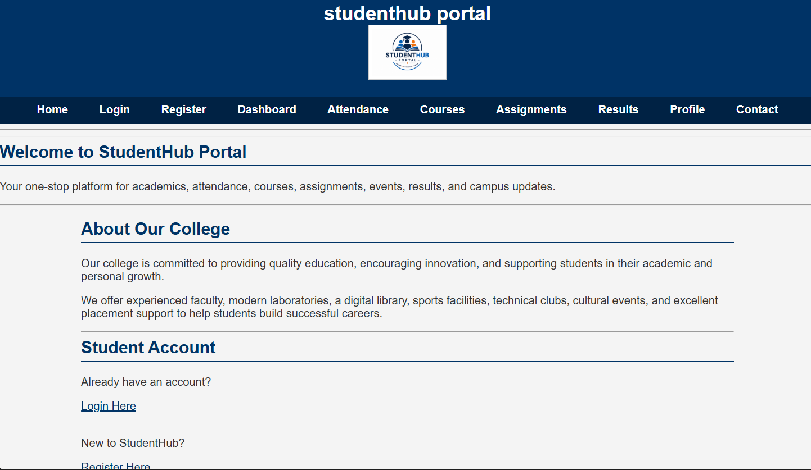
(fig 1.1)
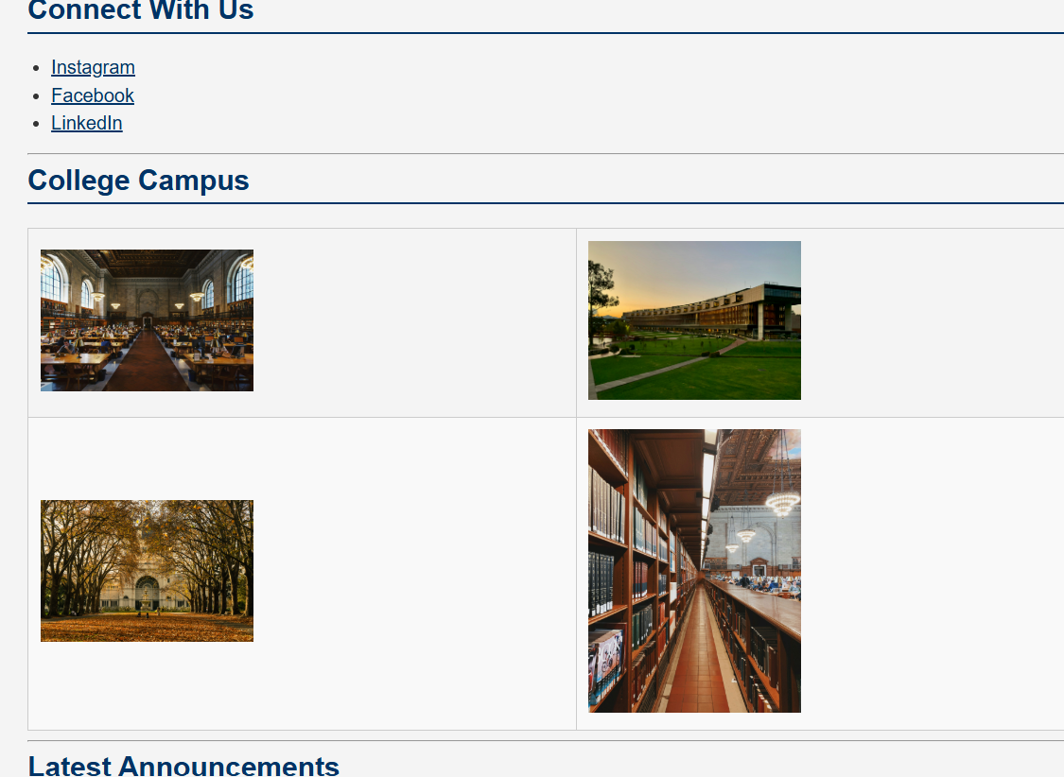
(fig 1.2)
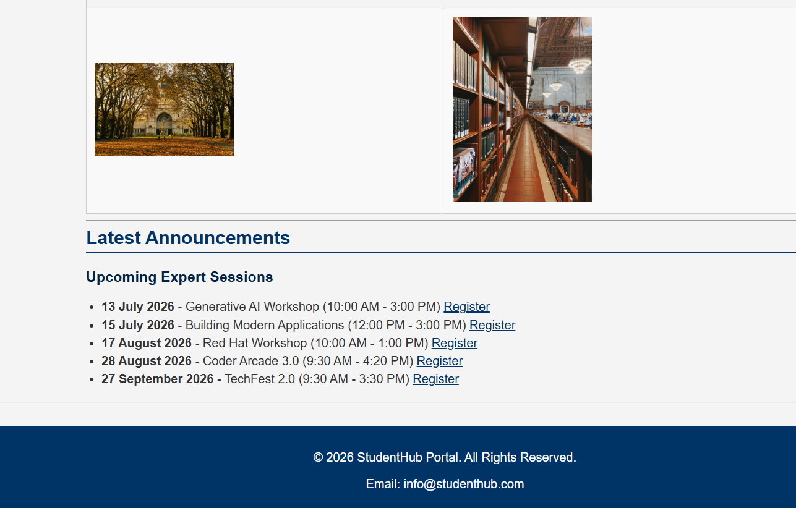
(fig 1.3)
Login page:
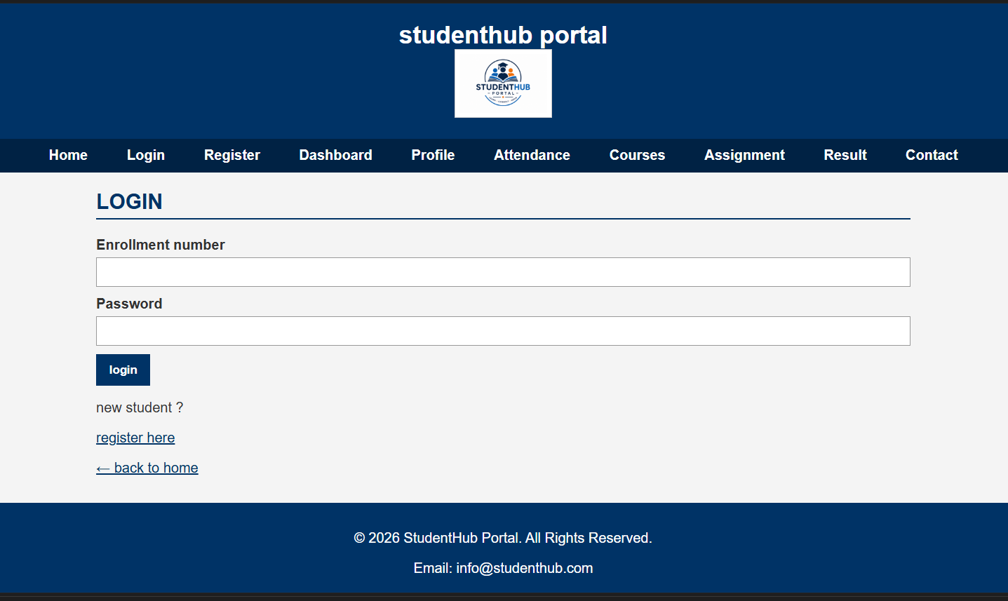
(fig 2)

Register page:
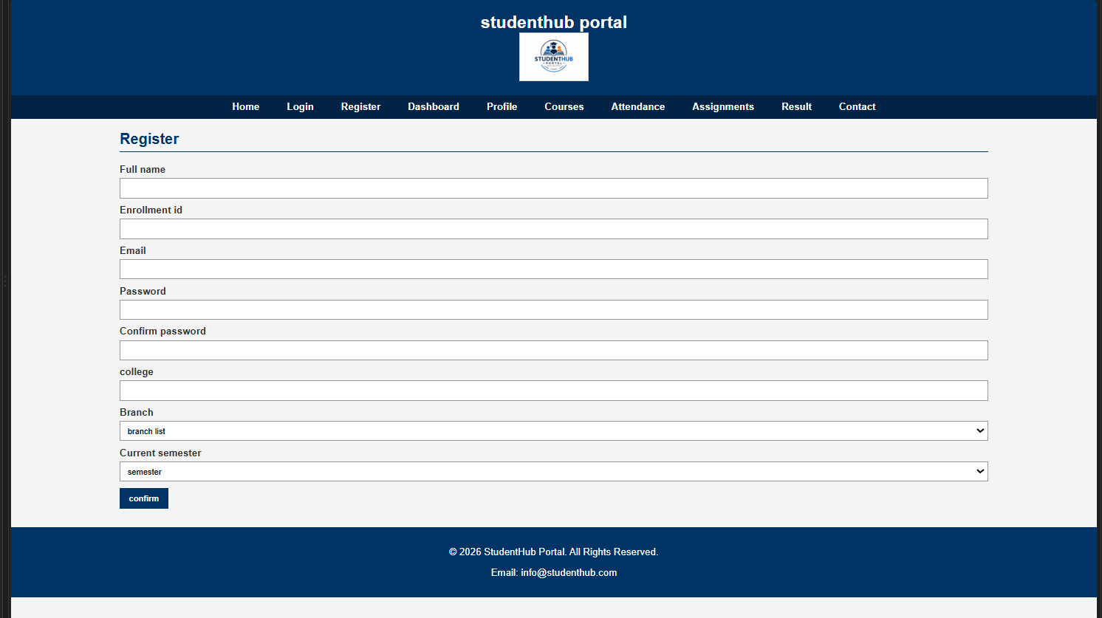
(fig 3)
Dashboard:
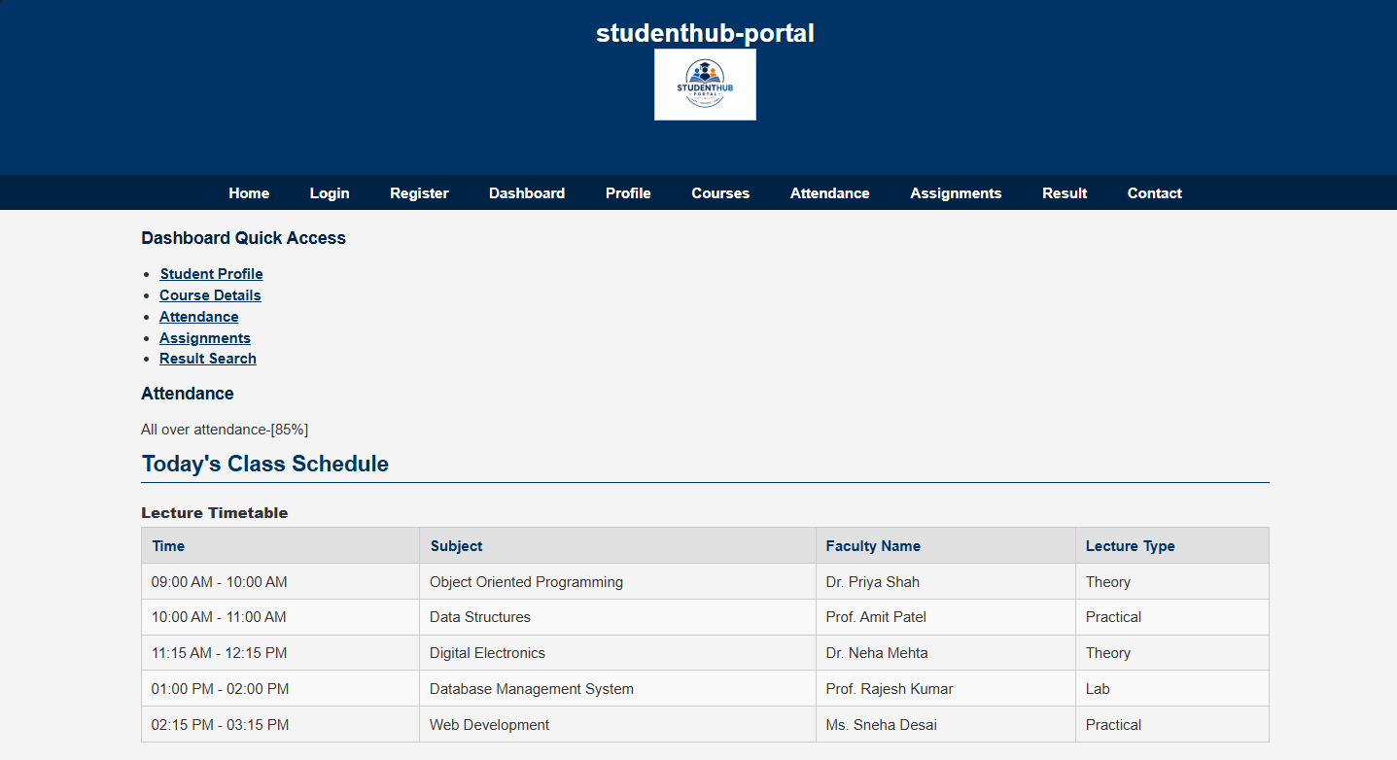
(fig 4.1)
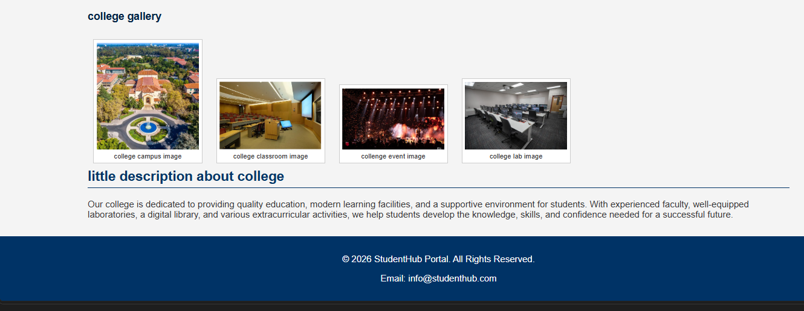
(fig 4.2)
Course:
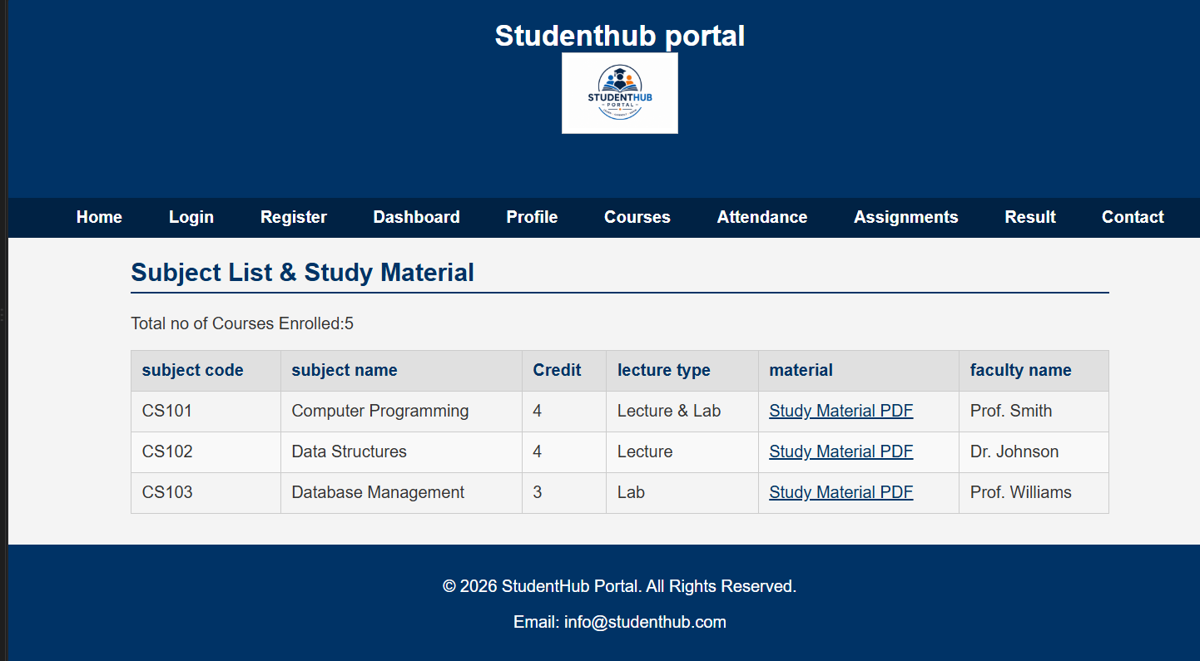
(fig 5)

Assignment:
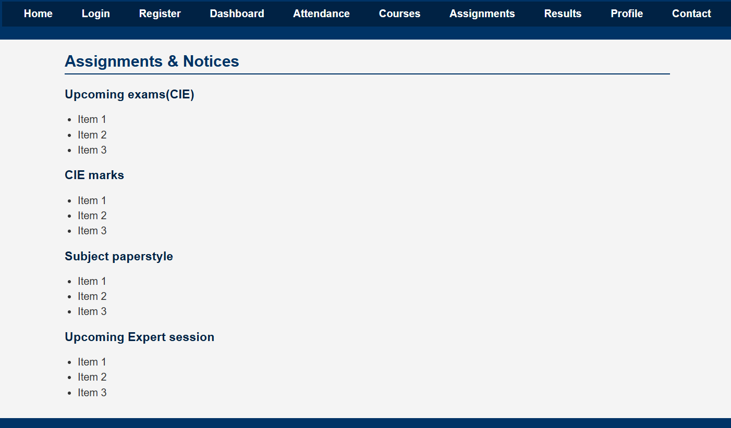
(fig 6)
Attendance:
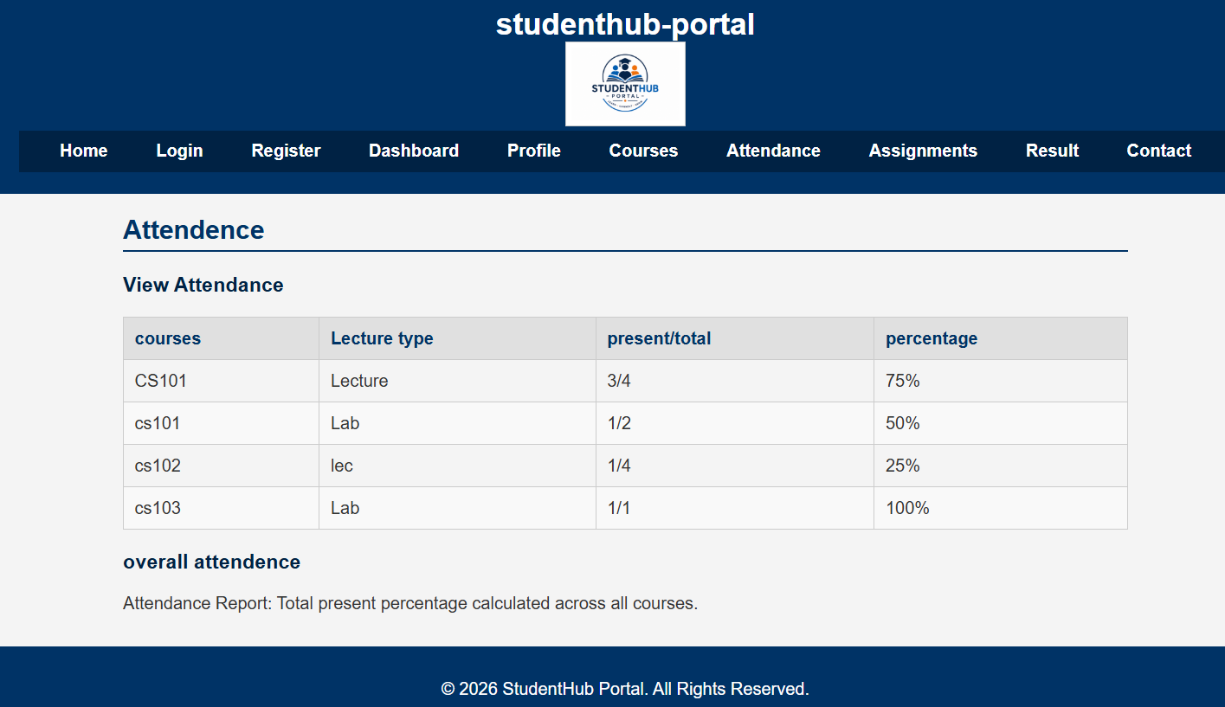
(fig 7)
Profile:
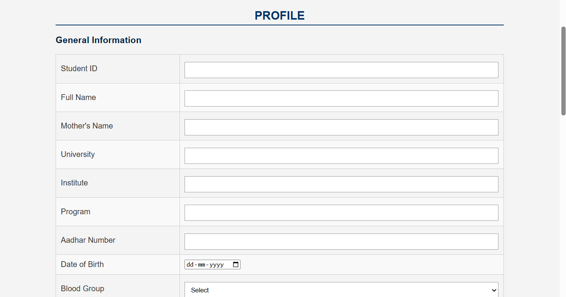
(fig 8.1)
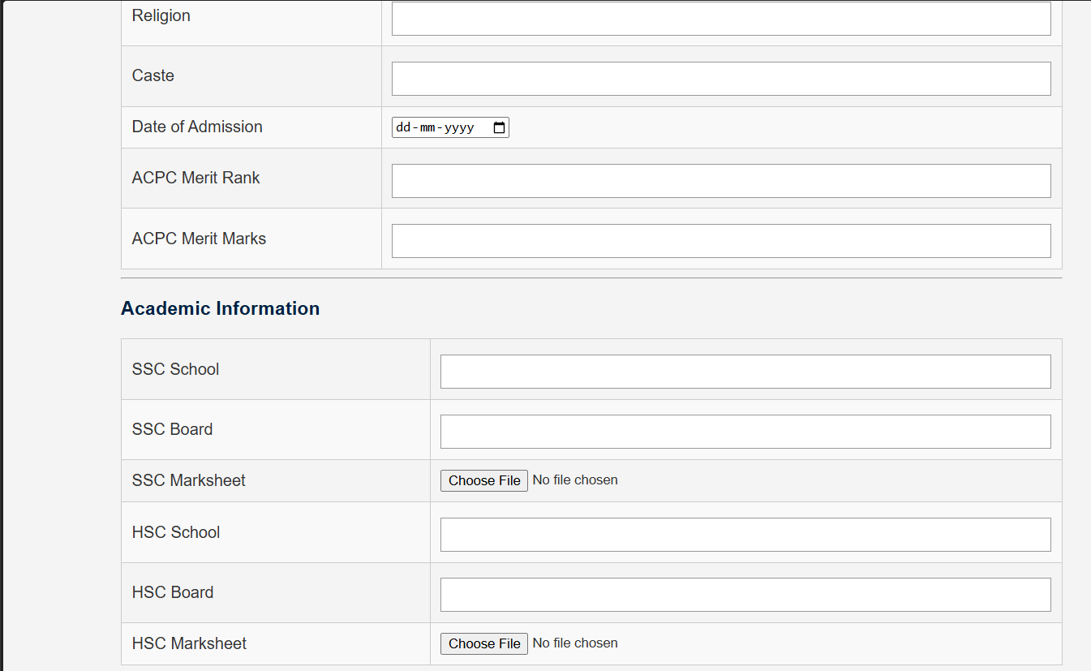
(fig 8.2)
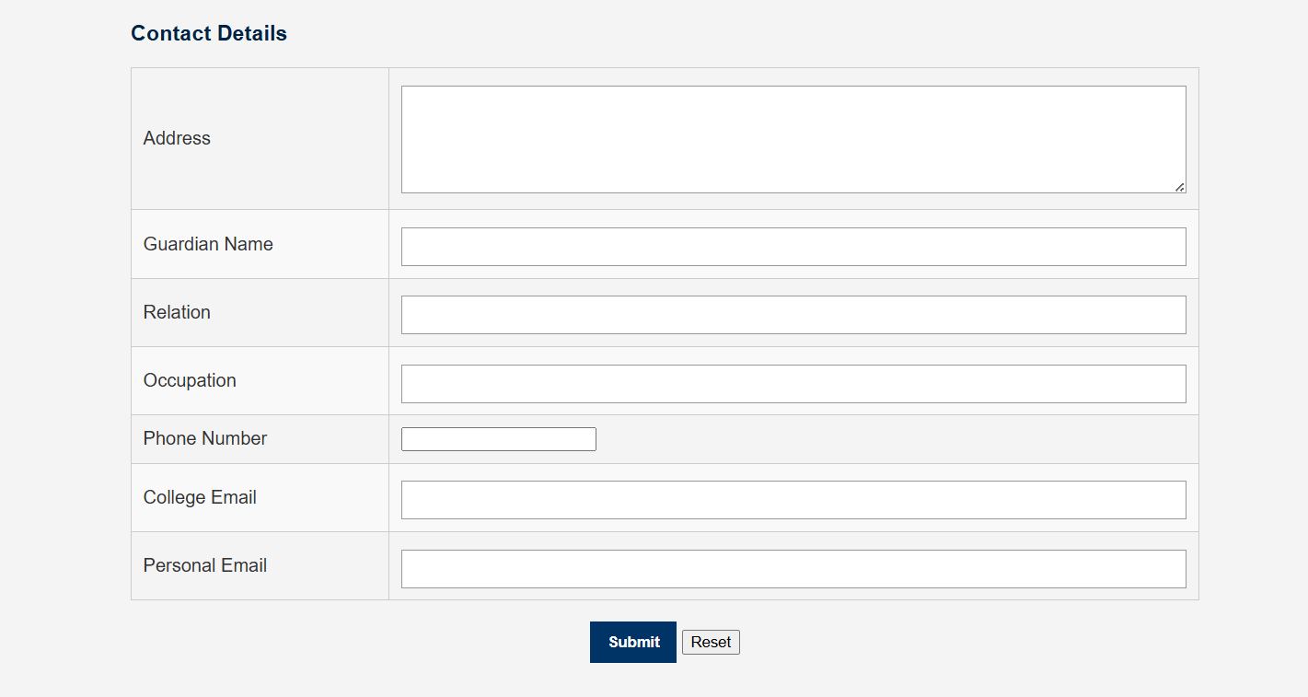
(fig 8.3)
Contact:
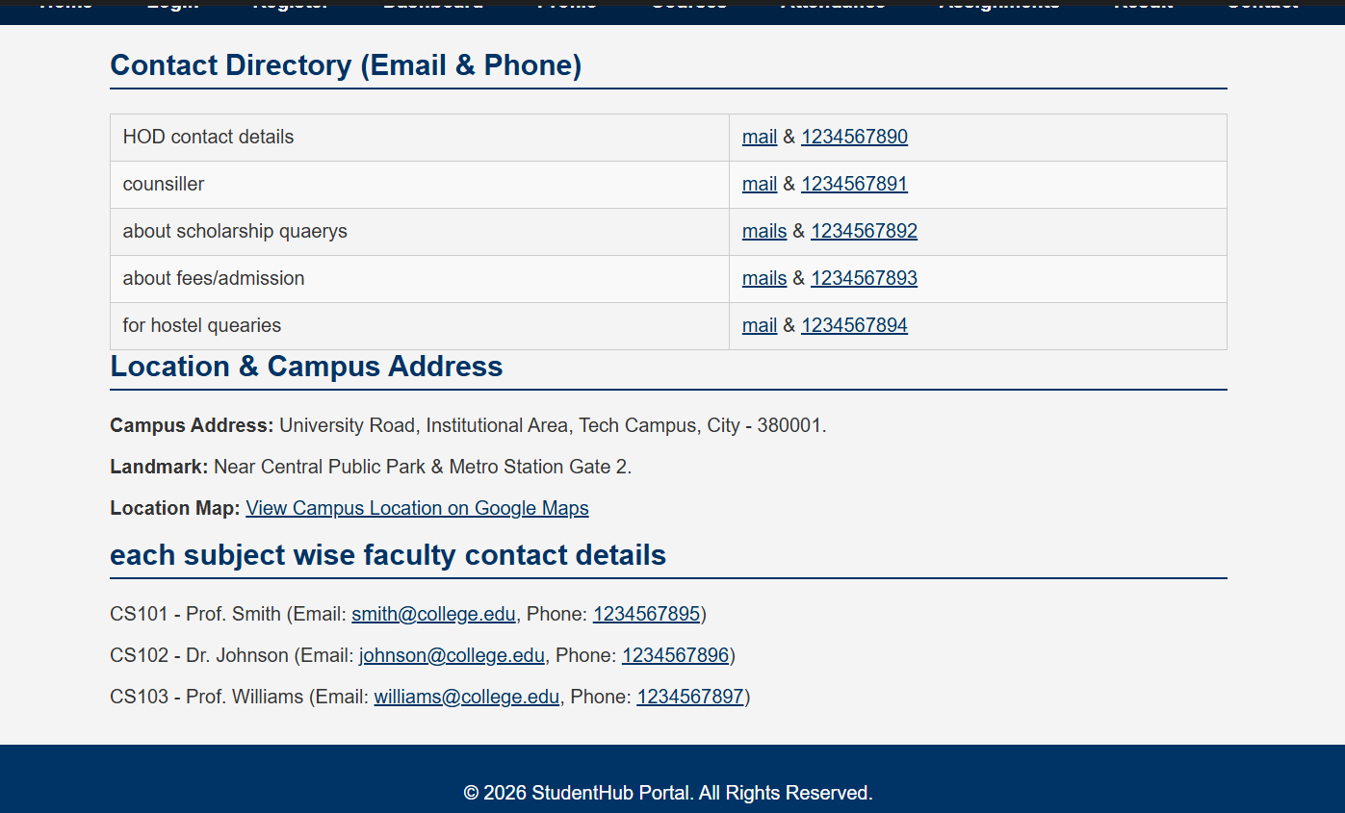
(fig 9.)
Result:
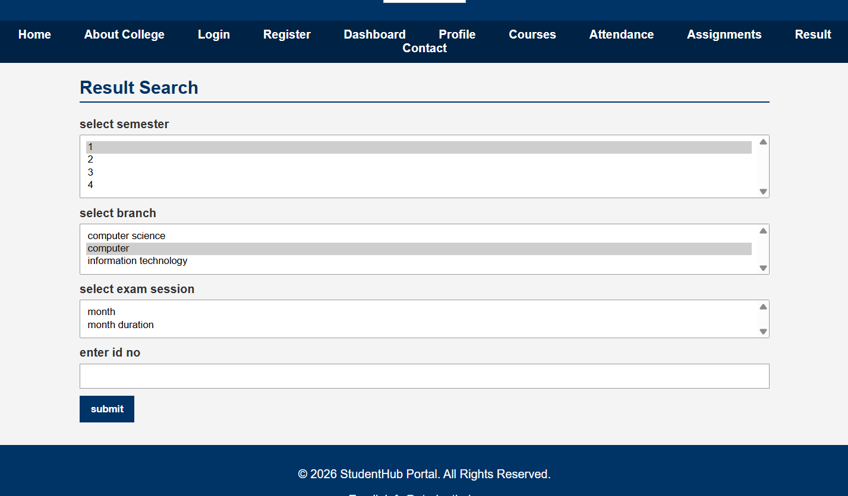
(fig 10)

E. GitHub Repository Link
https://github.com/joshitarana2621/studenthub-portal/tree/main/practical%203

F. Challenges Faced
- Making the layout responsive.
- Adjusting spacing for different devices.
- Using Flexbox and Grid correctly.

G. Learning Outcomes
- Learned responsive web design.
- Learned CSS Grid and Flexbox.
- Learned Bootstrap/Tailwind basics.
- Improved UI design skills.

Faculty Remarks

