Department of Computer Engineering

Practical - 4: JavaScript DOM Manipulation, Event Handling, and UI Interactivity

A. Theory
1. How are DOM elements selected and modified?
Answer: DOM elements are selected using methods such as getElementById(), querySelector(), and querySelectorAll(). After selecting an element, JavaScript can modify its text, HTML, classes, attributes, and styles.
2. Are event listeners attached correctly?
Answer: Yes. Event listeners are attached to the required buttons and UI controls so that the corresponding action occurs when the user interacts with the webpage.
3. Is localStorage used for remembering theme choice?
Answer: Yes. localStorage is used to save the selected light or dark theme. The saved theme can be read again when the page loads.
4. Does interactivity improve usability without breaking accessibility?
Answer: Yes. Interactive features improve usability when controls are clearly labelled, keyboard-friendly, and do not make important content inaccessible.

B. Evidence of Work (Screenshots):

1.dark-mode:






2. login:


3 . Register:
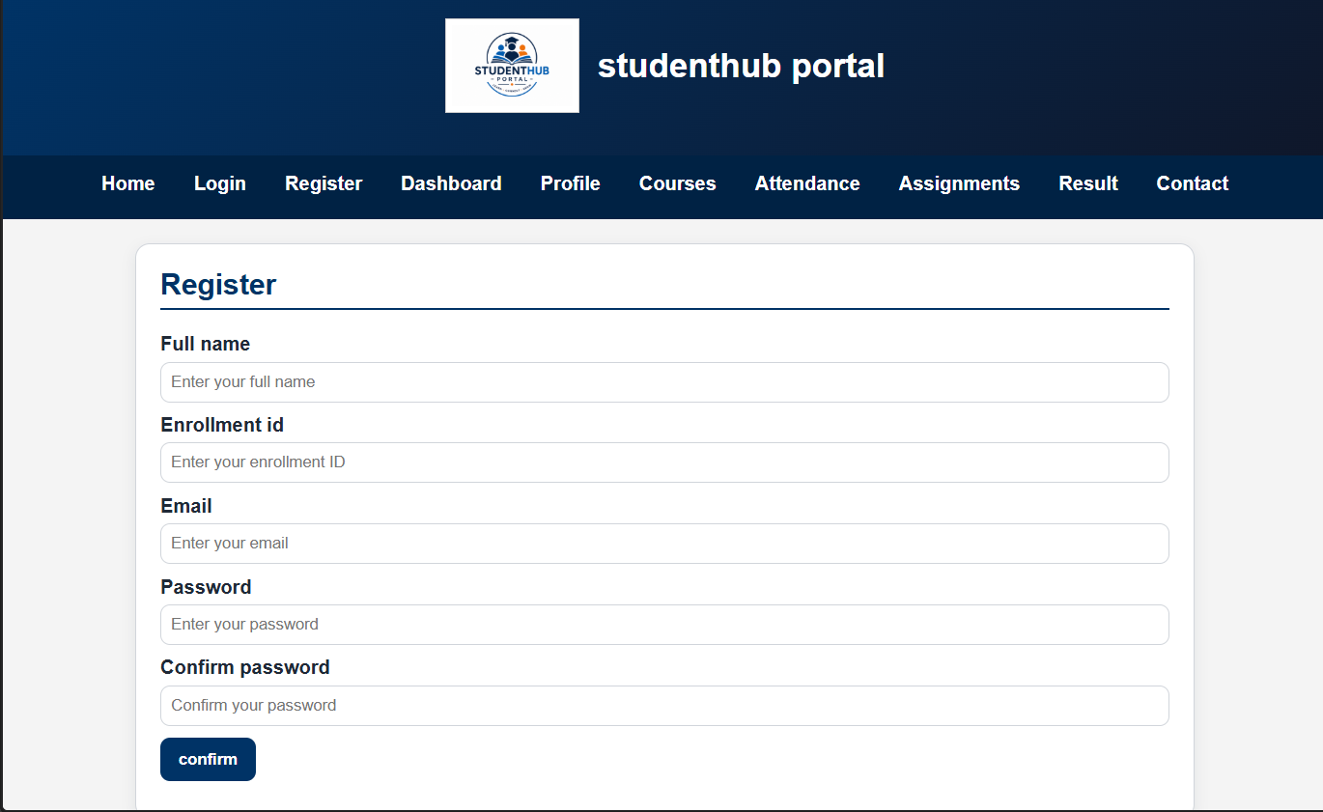

4. Dash-Board:
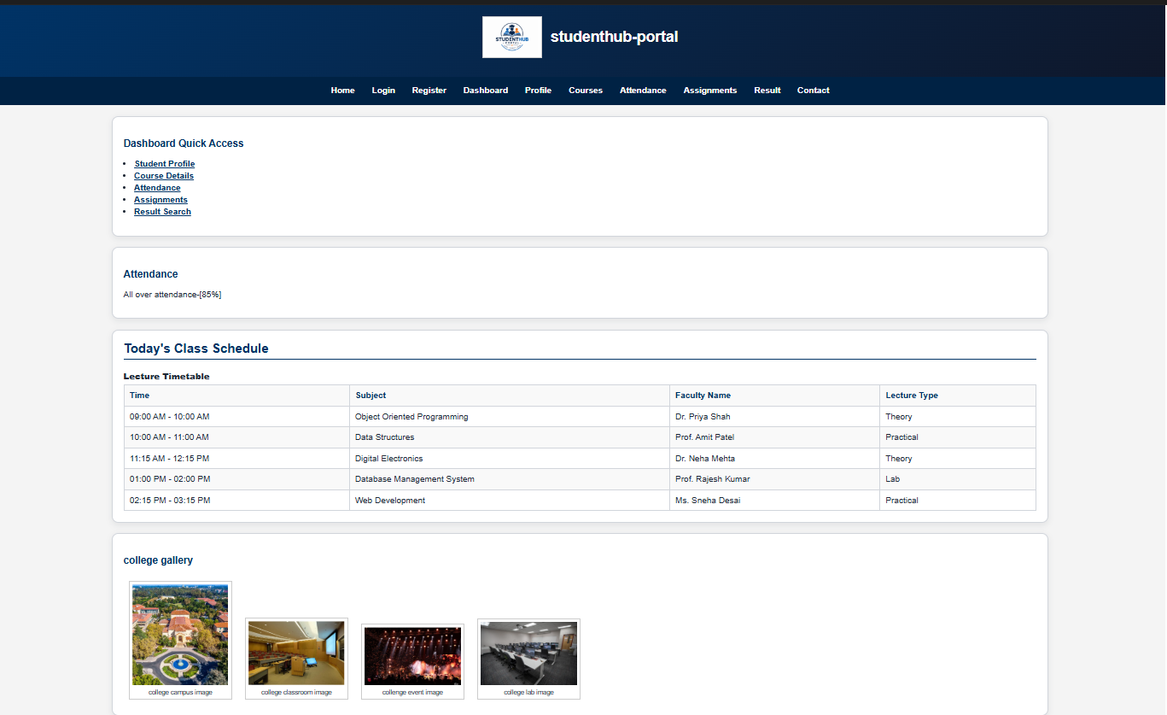

5. contact:
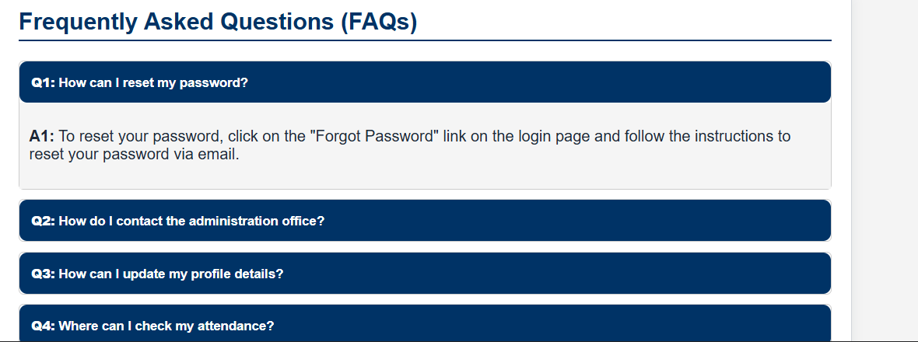

C. Challenges Faced
- Understanding DOM selection and modification.
- Attaching event listeners correctly.
- Implementing multiple interactive UI components.
- Using localStorage to remember the selected theme.

D. Learning Outcomes
- Learned to select and modify DOM elements using JavaScript.
- Learned to handle user events using event listeners.
- Learned to create interactive UI components.
- Learned to use localStorage for saving UI preferences.
-Learned how to make toggle funciton

E. GitHub link
https://github.com/joshitarana2621/studenthub-portal

