Department of Computer Engineering

Practical – 5: Registration Form with Frontend Validation and User-Friendly Error Handling

A. Theory
1. Are correct input types and attributes used?
Answer: Yes. Suitable input types and attributes are used for the registration form, such as email, password, required and other suitable attributes.
2. Are validation errors displayed near the relevant fields?
Answer: Yes. Validation errors are displayed near the fields where the user has entered incorrect or missing information.
3. Is password strength checked?
Answer: Yes. Password strength is checked using JavaScript validation and a message can be shown to the user.
4. Is the form accessible using keyboard and screen-reader-friendly labels?
Answer: Yes. Labels are provided for the form fields so the form is easier to use with keyboard and screen readers.

B. OUTPUT:

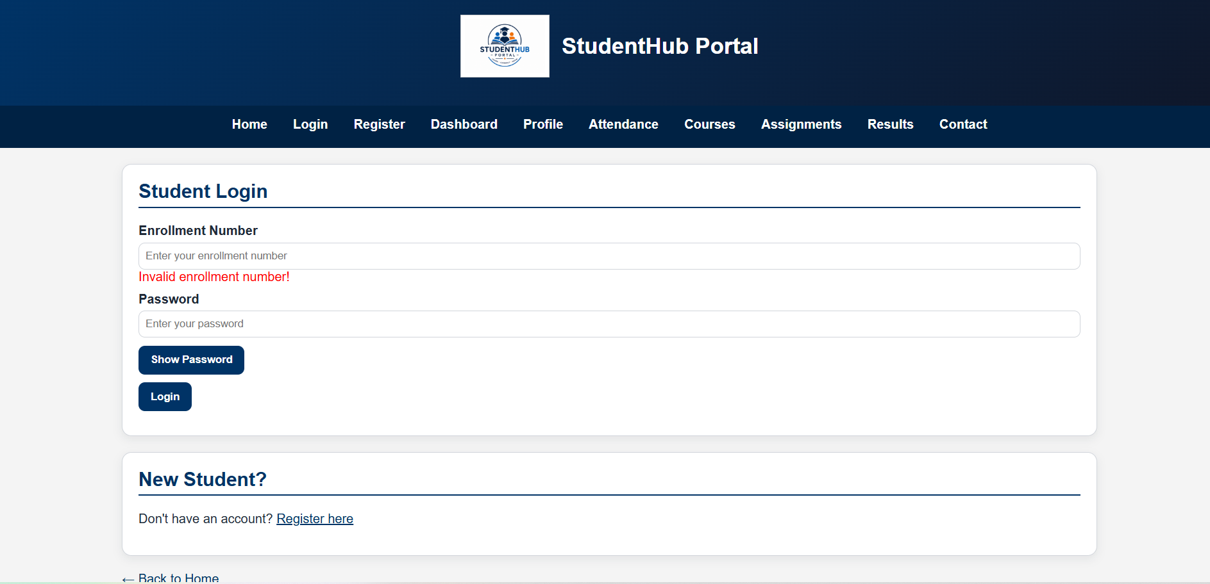

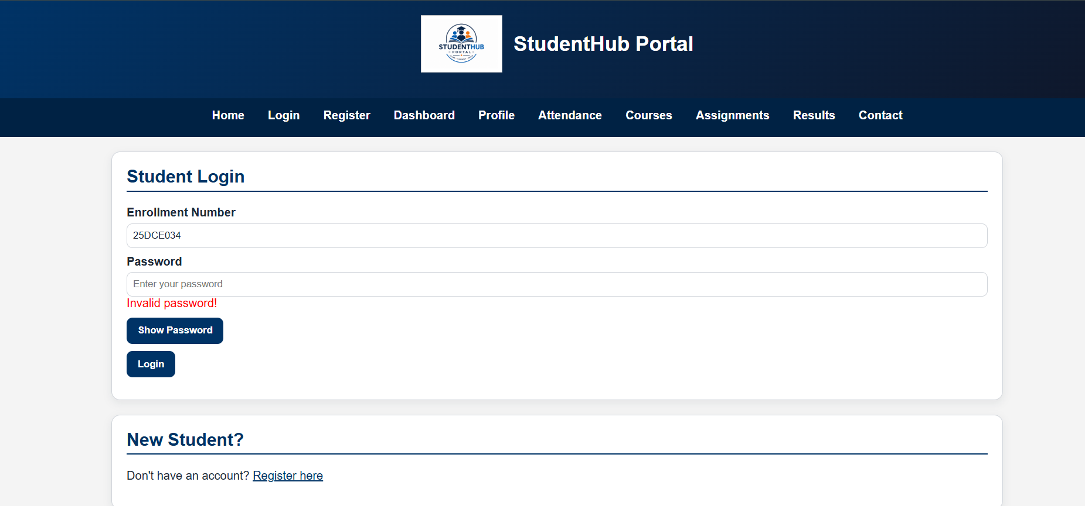

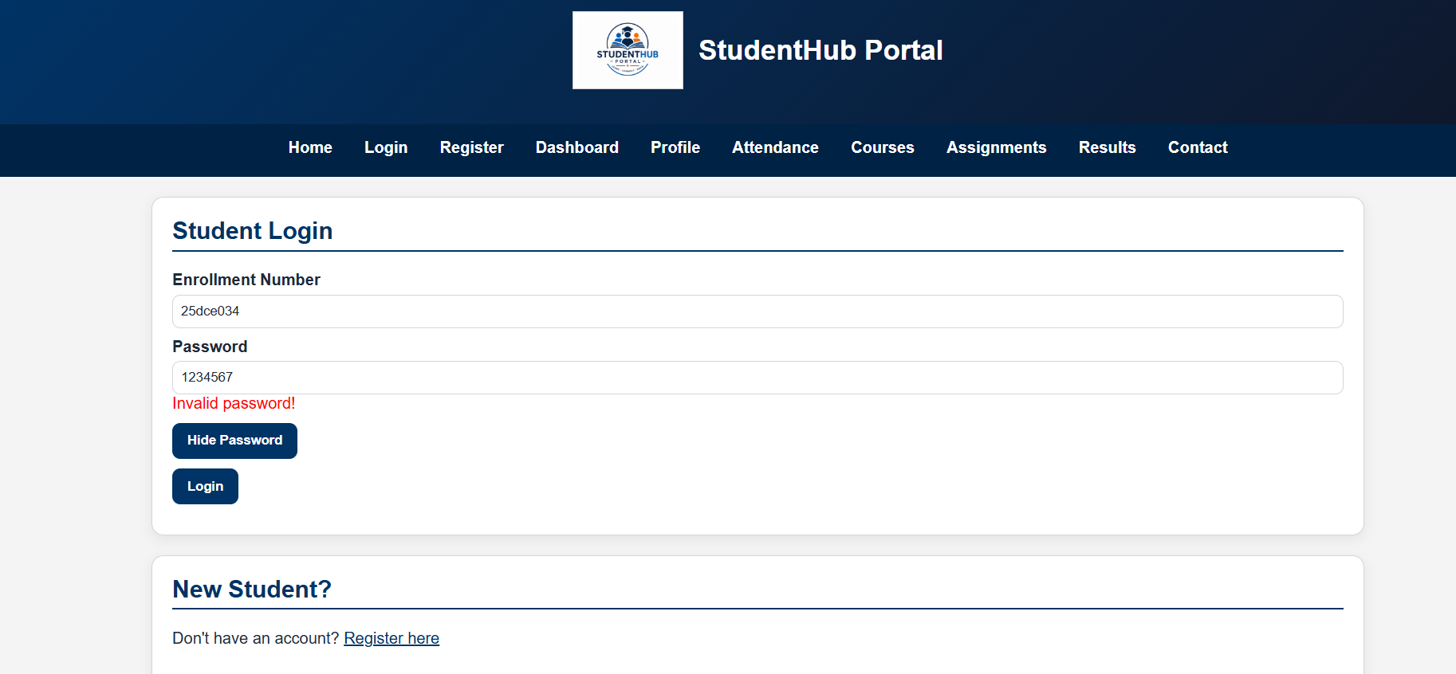
[predefined length of password is 6]
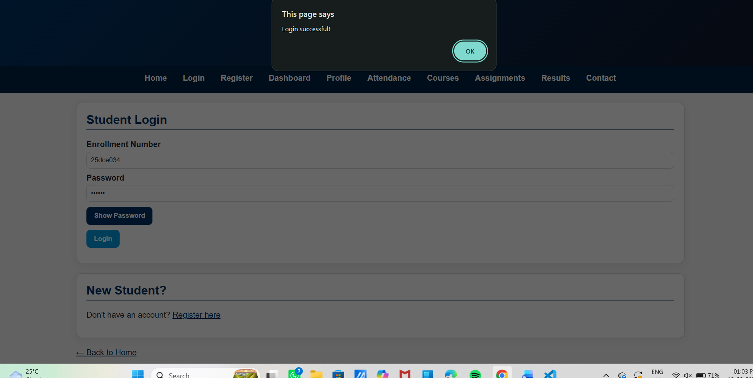

REGISTER PAGE:

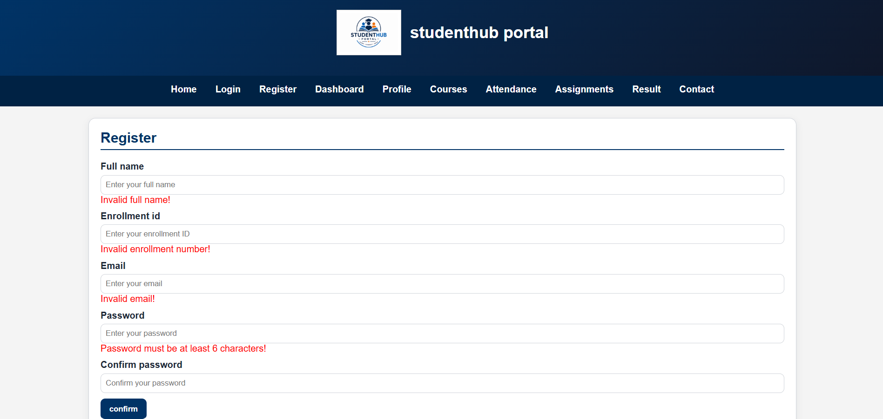

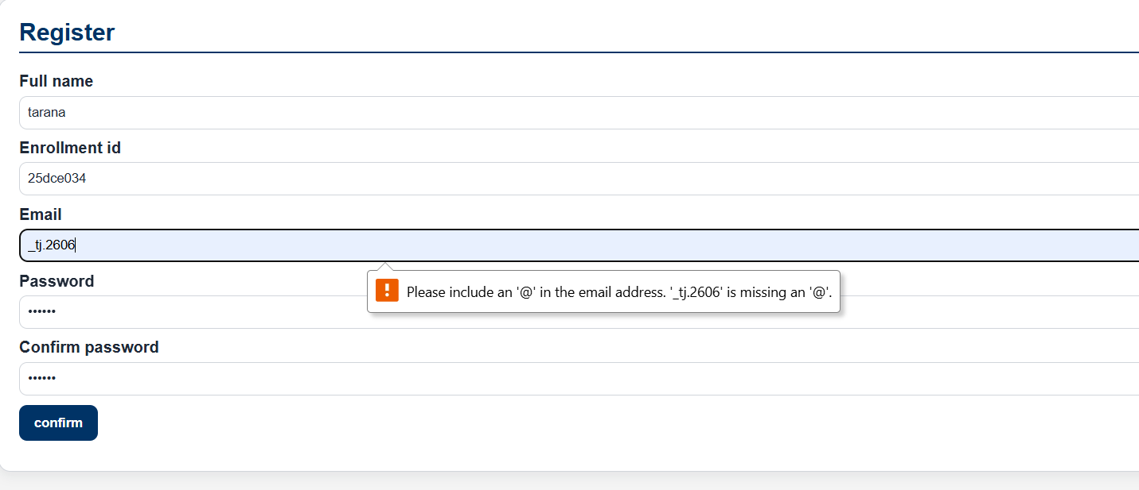
[invalid mail error]
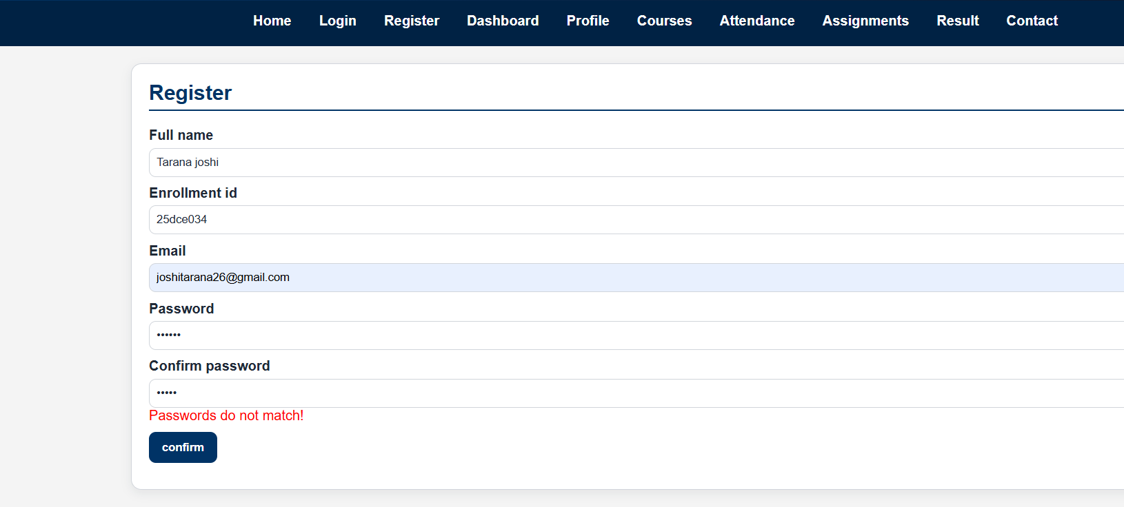
[password don’t match error]
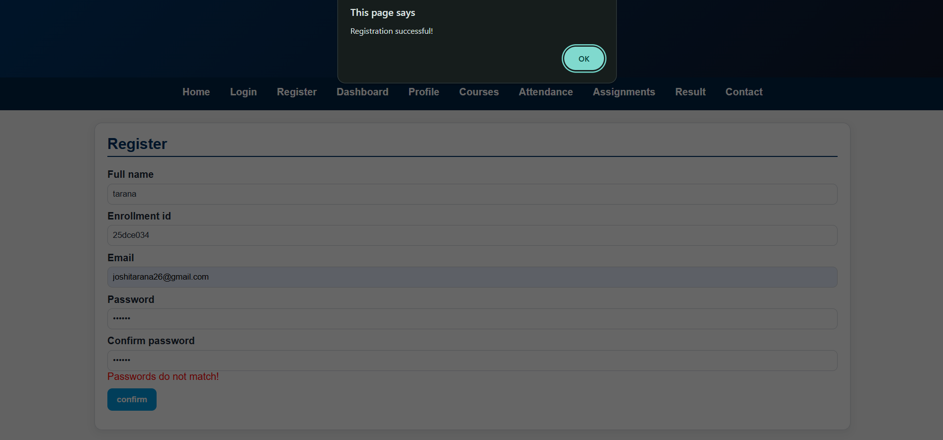

C. Challenges Faced

- Writing validation conditions for different fields.
- Creating regular expressions for validation.
- Showing error messages near the correct fields.
- Checking valid and invalid input cases.

D. Learning Outcomes

- Learned how to create a registration form using HTML.
- Learned how to validate form inputs using JavaScript.
- Learned how to use regular expressions for validation.
- Learned how to display user-friendly error messages.

G. GitHub- link
https://github.com/joshitarana2621/studenthub-portal/tree/main/practical5

