Department of Computer Engineering

Practical - 6: Rendering External JSON Data using Fetch API, Search and Filter

A. Theory
1. How is JSON fetched, parsed, and rendered?
Answer: JSON data is fetched using the Fetch API. The response is converted into JSON and then displayed on the webpage using JavaScript.
2. Which array methods are used for search, filter, sort, and pagination?
Answer: Methods such as filter(), sort(), and slice() can be used for searching, filtering, sorting, and displaying records page by page.
3. How are loading and error states handled?
Answer: A loading message is displayed while data is being fetched. If the request fails, an error message is displayed.
4. How is modularity maintained in JavaScript files?
Answer: Separate functions can be used for fetching data, displaying records, searching, filtering, sorting, and pagination. This keeps the code easy to maintain.

Output:
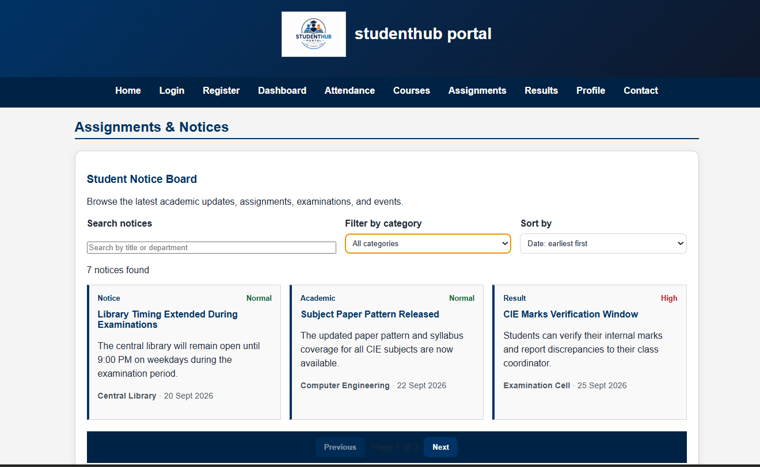

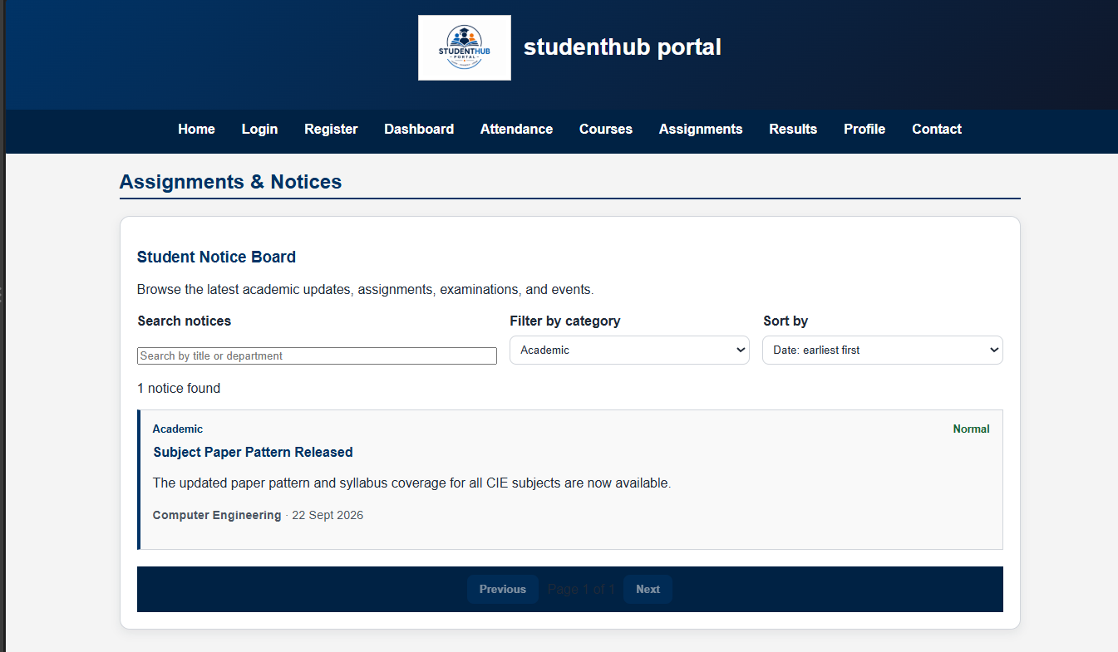
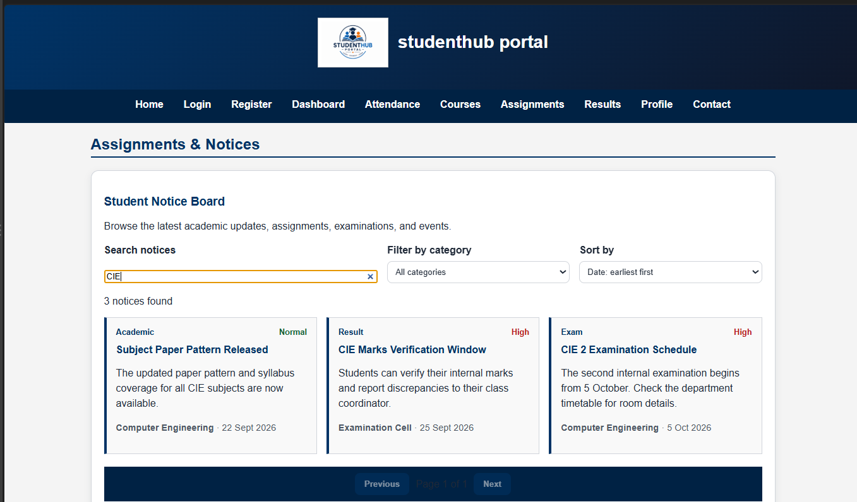

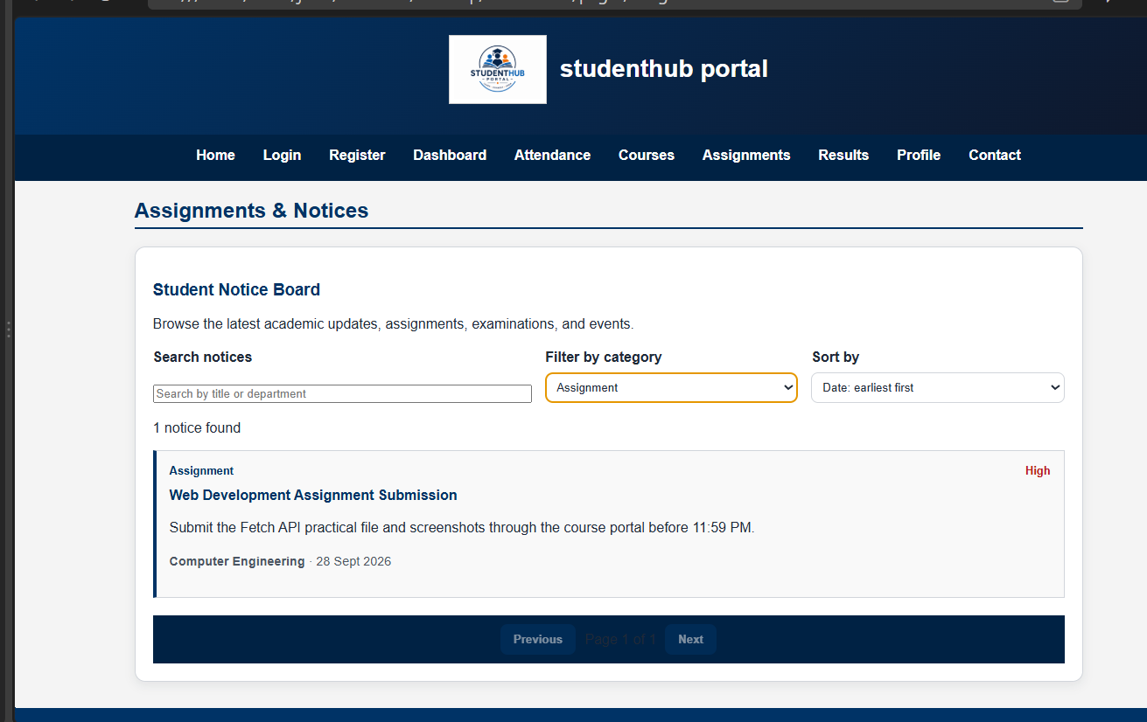

C. Challenges Faced
- Fetching JSON data using Fetch API.
- Displaying JSON records dynamically on the webpage.
- Implementing search, filter and sorting.
- Implementing pagination and handling errors.

D. Learning Outcomes
- Learned how to fetch JSON data using Fetch API.
- Learned how to display external data using JavaScript.
- Learned how to use array methods for search, filter and sorting.
- Learned how to implement pagination and error handling.

E. GitHub-link:
https://github.com/joshitarana2621/studenthub-portal

