Department of Computer Engineering

Practical - 7: PHP Form Processing with Server-Side Validation and CSV/JSON File Storage

A. Theory
1. Is the form submitted using POST?
Answer: Yes. The form data is submitted using the POST method so that the data can be received and processed by the PHP file.

2. Are inputs validated and sanitized server side?
Answer: Yes. PHP is used to check the input values and sanitize them before storing the data.

3. Is file writing handled safely?
Answer: The data is written to a CSV or JSON file after validation. The file is opened and written carefully so that records are stored correctly.

4. Are success and error responses displayed clearly?
Answer: Yes. A success message is displayed when the data is stored correctly and an error message is displayed when the input is invalid.

B. Output:
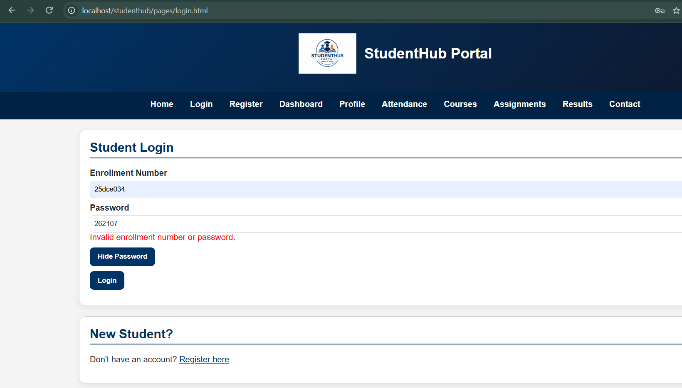
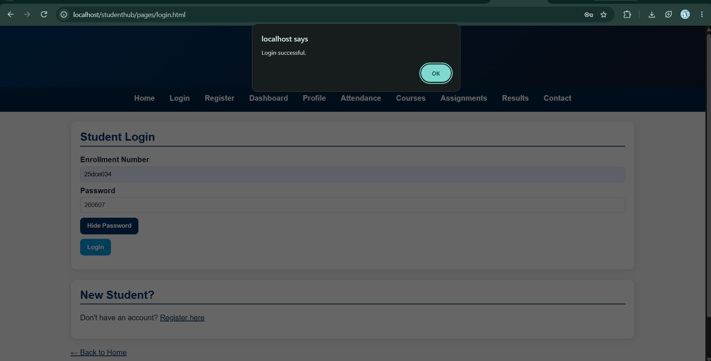
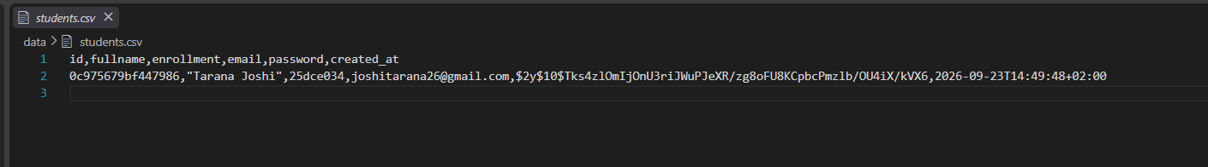
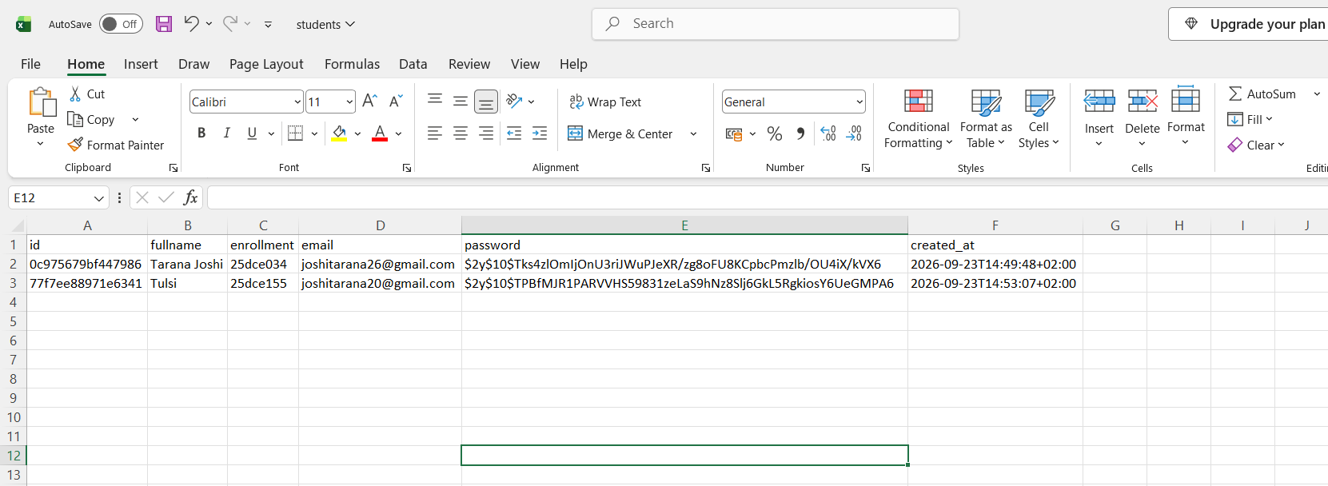

C. Challenges Faced
• Receiving form data using the POST method.
• Validating and sanitizing form inputs using PHP.
• Storing submitted data in CSV / JSON format.
• Displaying success and error messages.

D. Learning Outcomes
• Learned how to process HTML form data using PHP.
• Learned how to validate and sanitize data on the server side.
• Learned how to store form records in CSV / JSON files.
• Learned how to display success and error messages.

E.GitHub-link:

https://github.com/joshitarana2621/studenthub-portal

