Department of Computer Engineering

Practical - 9: Secure User Registration with Database Insert, Duplicate Email Check, and Password Hashing

A. Theory
1. Is password_hash() used before storing passwords?
Answer: Yes. password_hash() is used to hash the password before storing it in the database.
2. Is duplicate email/username checked?
Answer: Yes. The email or username is checked before inserting the new user record into the database.
3. Are frontend and backend validations consistent?
Answer: Yes. The same basic input checks are performed on the frontend and backend so that inva

B.output

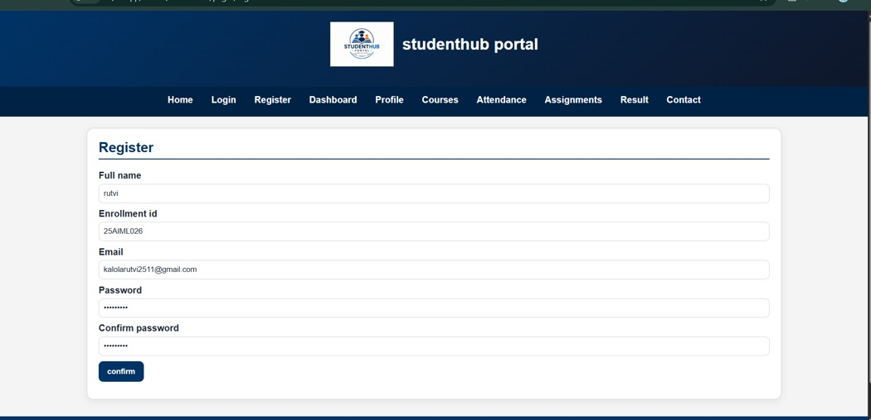

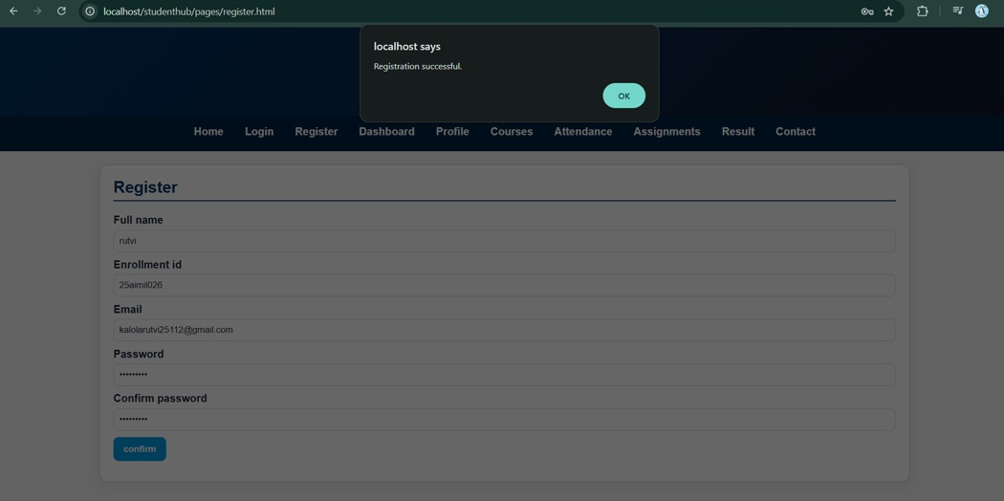

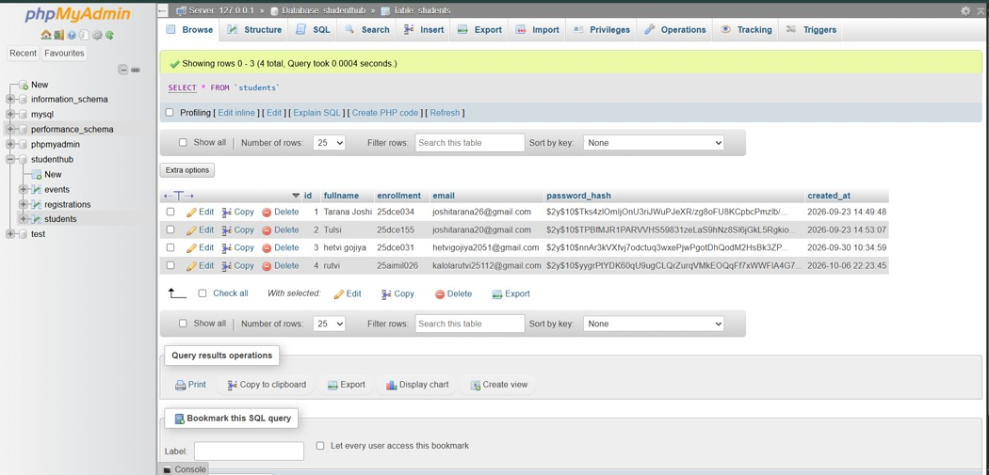

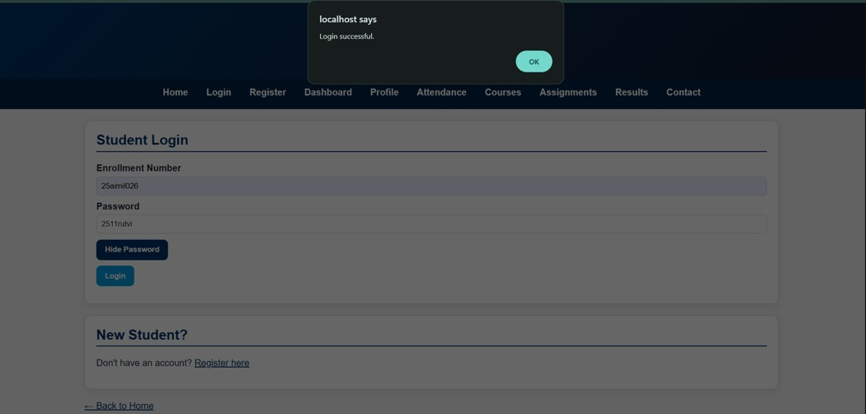

C. GitHub Repository Link
Paste GitHub repository link here.

D. Challenges Faced
• Connecting the registration form with the MySQL database.
• Checking duplicate email or username before inserting data.
• Using password_hash() to store passwords securely.
• Performing validation on both frontend and backend.
E. Learning Outcomes
• Learned how to insert registration data into MySQL.
• Learned how to check duplicate email and username.
• Learned how to hash passwords using password_hash().
• Learned how to perform basic secure form validation.

