CSA0607-Design and Analysis of Algorithms
CO2-AT2
Student Name: A. Sai Joshitha (192424220)
Q11. A banking system stores daily transaction amounts in a list where new entries are appended randomly, causing disorder. The system needs to sort data periodically for reporting.
a) Analyze how Selection Sort and Bubble Sort would work in this scenario.
b) Compare the number of comparisons and swaps required by both methods.
c) Recommend the most suitable sorting technique with proper justification.
Aim
To analyze the performance of Selection Sort and Bubble Sort for sorting daily banking transaction amounts.
a) Explanation
Selection Sort
- Finds the smallest element in the unsorted portion.
- Swaps it with the first unsorted element.
- Repeats until the list is sorted.
Bubble Sort
- Compares adjacent elements.
- Swaps them if they are in the wrong order.
- Repeats until no swaps occur.
Algorithm
Selection Sort
- Start from first element.
- Find minimum element.
- Swap with current element.
- Repeat.
Bubble Sort
- Compare adjacent elements.
- Swap if needed.
- Repeat until sorted.

CODE
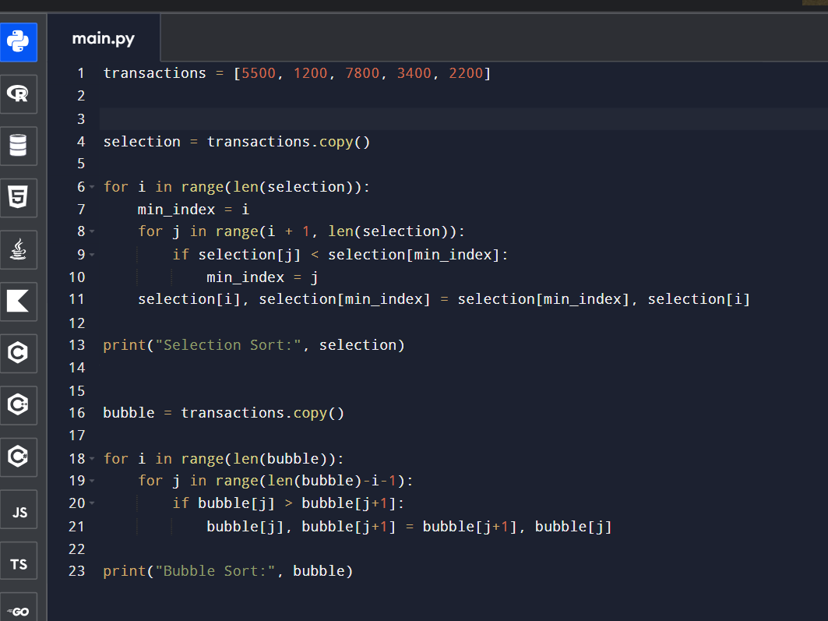

Output:
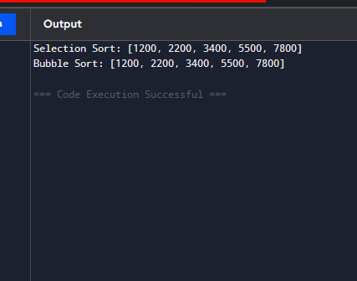

b) Comparison
Feature | Selection Sort | Bubble Sort
Comparisons | O(n²) | O(n²)
Swaps | O(n) | O(n²)
Best Case | O(n²) | O(n)
Worst Case | O(n²) | O(n²)

c) Recommendation
Selection Sort is preferable because it performs fewer swaps, making it more efficient when writing data is costly.

Q12. A delivery company maintains GPS coordinates of delivery points and computes distances between every pair to find the closest drop location. As the number of locations increases, delays are observed.
a) Explain how the brute-force closest pair algorithm operates in this scenario.
b) Derive the time complexity of computing all pair distances.
c) Analyze why the performance degrades with large datasets.
Aim
To find the minimum distance between delivery locations.
a) Explanation
The algorithm calculates the distance between every pair of delivery locations and stores the minimum distance.
Algorithm
- Read all coordinates.
- Compare every pair.
- Calculate Euclidean distance.
- Store minimum distance.
Code
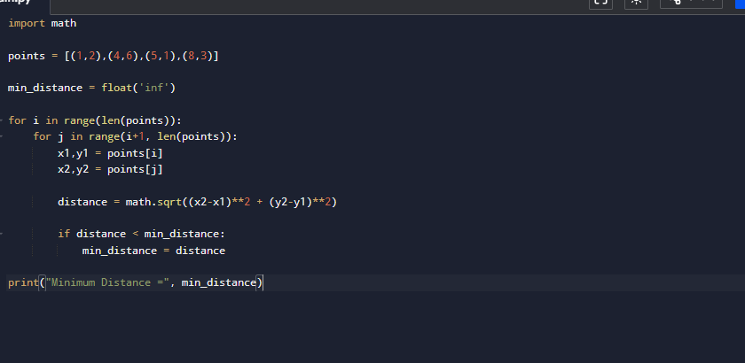
Output:
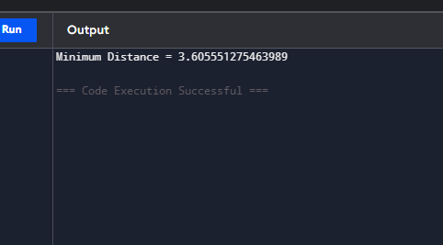

b) Time Complexity
Number of comparisons
n(n−1)/2
Time Complexity
O(n²)

c) Why Slow?
- Every point is compared with every other point.
- Number of comparisons grows rapidly.
- Large datasets increase execution time.

Q13. A university portal stores student IDs in an unsorted format due tocontinuous registrations. During exams, quick lookup of student IDs isrequired.
a) Explain how Linear Search works for retrieving student records.
b) Analyze best, average, and worst-case time complexities.
c) Justify whether sorting the dataset would improve performance.
Aim
To search student IDs stored in an unsorted list.
a) Explanation
Linear Search checks every student ID until the required ID is found.
Algorithm
- Start from first element.
- Compare with target.
- If found, stop.
- Otherwise continue.
Code
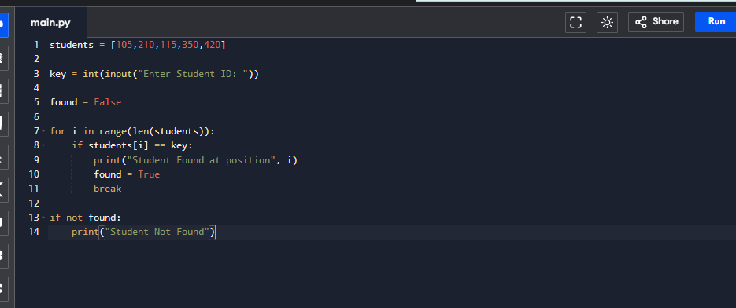

Output
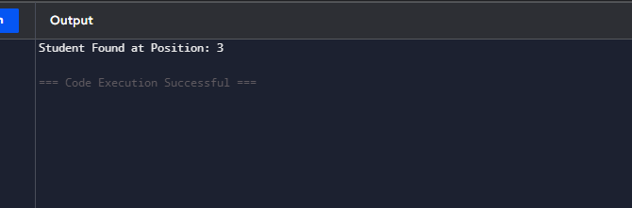

b) Time Complexity
Case | Complexity
Best | O(1)
Average | O(n)
Worst | O(n)

c) Justification
Sorting the data allows Binary Search.
Binary Search
O(log n)
which is much faster for repeated searches.

Q14. A mapping application determines the outer boundary of a set of plotted land coordinates using a brute-force convex hull method. The dataset size increases significantly over time.
a) Explain how the brute-force convex hull algorithm works in this case.
b) Analyze the computational complexity of checking all point pairs.
c) Discuss why this approach becomes inefficient for large inputs.
Aim
To determine the outer boundary of plotted land coordinates.
a) Explanation
Every pair of points is checked.
If all remaining points lie on one side of the line, the pair belongs to the convex hull.

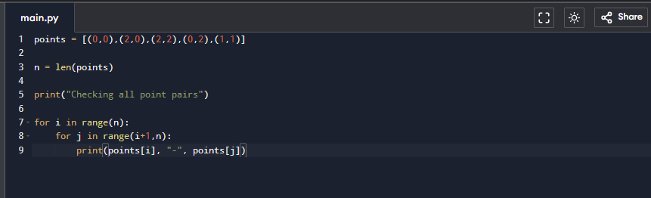
Code

Output
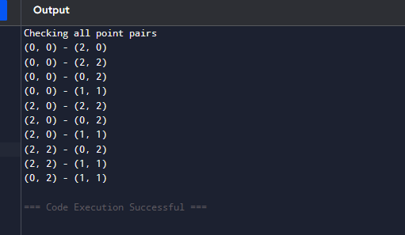

b) Complexity
Checking every pair
O(n²)
Checking all other points
O(n)
Overall
O(n³)

c) Why Inefficient?
- Every pair is tested.
- Every remaining point must be checked.
- Large datasets produce very high computation time.

Q15. A plagiarism detection system scans large documents to match a given pattern using brute-force string matching. The document size is very large and pattern occurrences are rare.
a) Explain how brute-force string matching operates in this scenario.
b) Analyze its time complexity.
c) Discuss why the approach becomes inefficient for large text inputs.
Aim
To detect plagiarism by matching a pattern inside a document.
a) Explanation
The pattern is compared character by character with every possible position in the text.
Algorithm
- Start from first character.
- Compare pattern.
- If mismatch occurs, shift by one position.
- Repeat.
Code
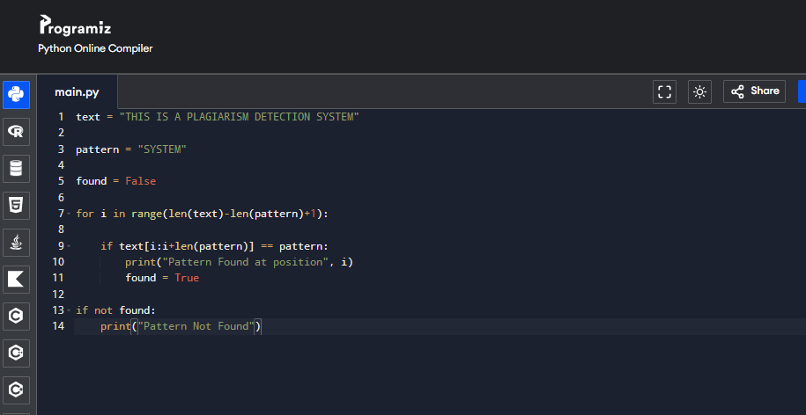
Output
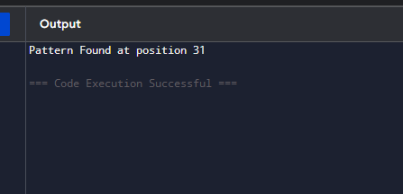
b) Time Complexity
- Best Case: O(n)
- Worst Case: O(n × m)
where:
- n = length of the text
- m = length of the pattern
c) Why Inefficient?
- The pattern is checked at every position in the document.
- Many unnecessary character comparisons are performed.
- For large documents with rare pattern occurrences, execution time increases significantly.

