Classification Prediction and Analysis on Quality of Wine

Joshitha Mandali
Towson University
jmanda2@students.towson.edu

Introduction

In this project, I am trying to propose a data mining approach to predict and visualize the human wine taste preferences amongst the red and white wine. The dataset that has been chosen to perform Exploratory Data Analysis, for the Assignment-2 is “Wine Quality”. This dataset was downloaded from “UCI Machine Learning Repository” which is center for Machine Learning and Intelligent Systems. In this paper three classification techniques were applied, under a computationally efficient procedure that performs simultaneous variable and model selection. The Random Forest achieved promising results, outperforming the logistic regression and Gaussian algorithms.

Dataset Description

The data in the dataset consists of two datasets which are related to red and white variants of the Portuguese "Vinho Verde" wine. These datasets could be viewed as Regression or Classification tasks. The classes were not balanced like for instance there were many more normal wines than excellent and poor ones. Additionally, the classes were not ordered. To detect few excellent or poor wines, outlier detection algorithms could be used. Authors were unsure if all input variables were relevant.
Initially there were red wine dataset and white wine dataset in two separate files so there two datasets were combined to perform the analysis
The attributes are split into the following:

- fixed acidity
- volatile acidity
- citric acid
- residual sugar
- chlorides
- free sulfur dioxide
- total sulfur dioxide
- density
- pH
- sulphates
- alcohol
Output variable (based on sensory data):
- Quality (score between 0 and 10)

Exploratory Data Analysis

A) Description of the data:

We need to know the different kinds of data and other statistics of the data loaded before proceeding with further steps. data.describe() generated results in descriptive statistics that summarizes dispersion, central tendency, shape of dataset distribution.

Loading the dataset:

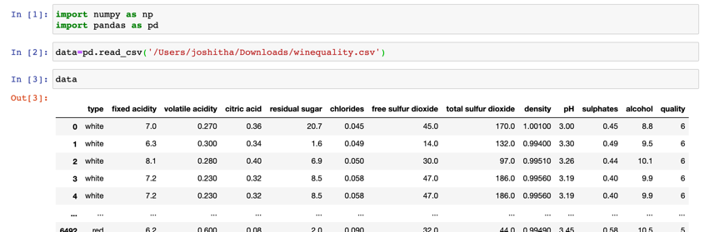

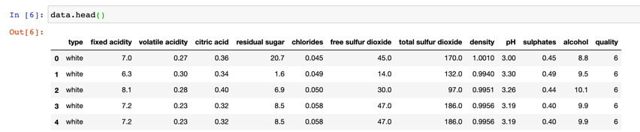
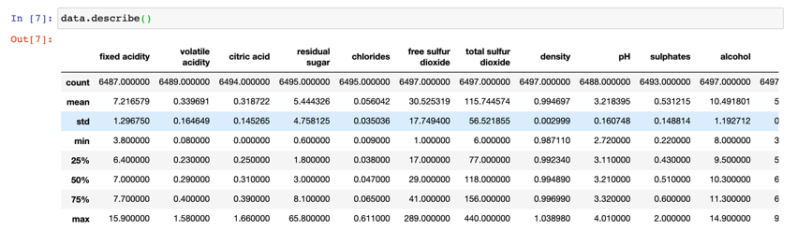

The data describe generated result index of count, mean, std, min, 25%, 50%, 75%, max.

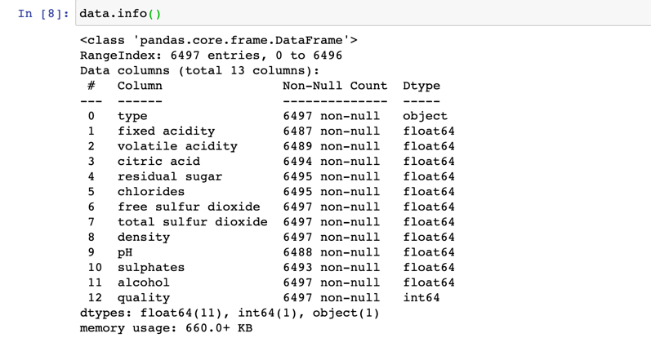
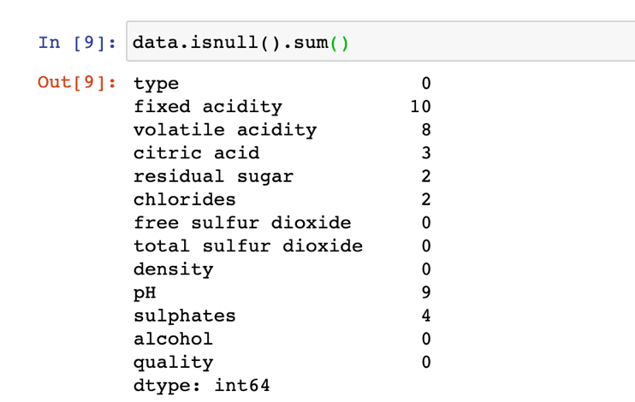

Few observations can be made by looking at the data. Like there are missing values across the data frame, which need to be handled. Columns “Fixed acidity”, “Volatile acidity”, “Citric acid”, “residual sugar”, “chlorides” “pH”, “sulphates” contains many duplicates and needs to be parsed for extracting it in a numerical quantity, it looks like a string (object) right now. Firstly, we replace those null values with some value and remove few columns which are not required for our analysis

B) Handling Missing data:

Missing values:

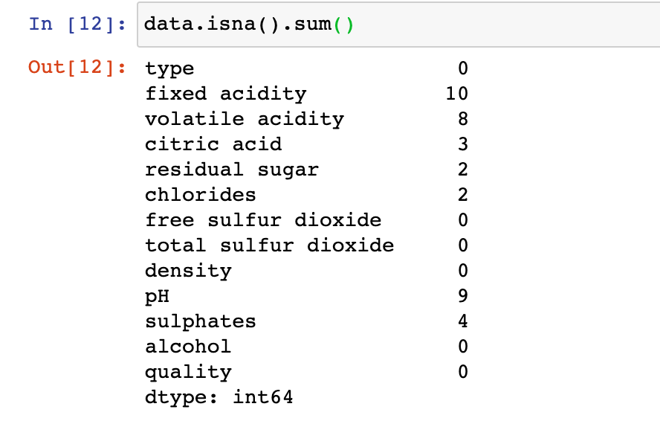

Dropping the columns “Citric acid”, “residual sugar”, “chlorides” as they seemed irrelevant to the analysis that we are doing in this project.

After dropping the columns, following are the remaining null value columns

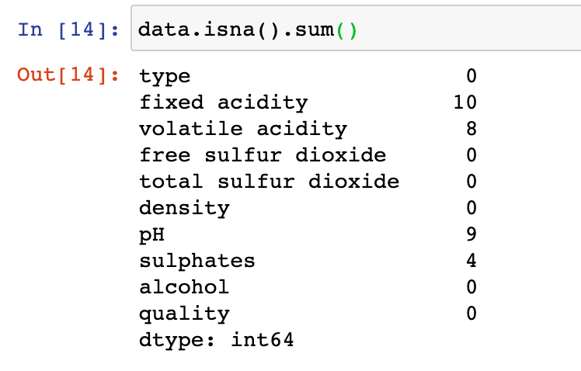

Replacing the null values in the column “Fixed acidity”, “Volatile acidity”, “pH” and “sulphates” with some random values as shown in below image and checking if there are still any null values remaining after replacing

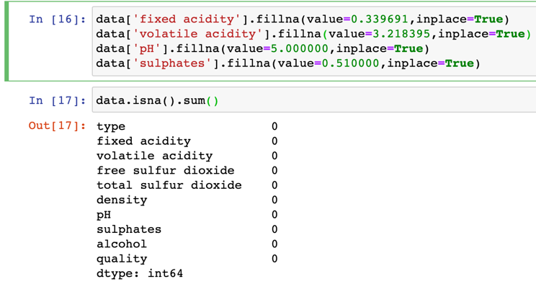

IV. Data Visualizing

Plotting a heatmap with the cleaned data
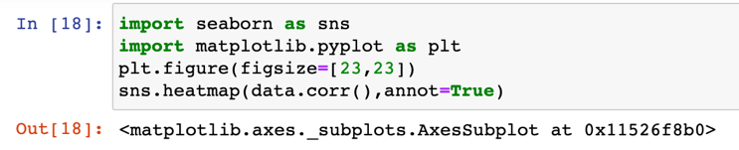

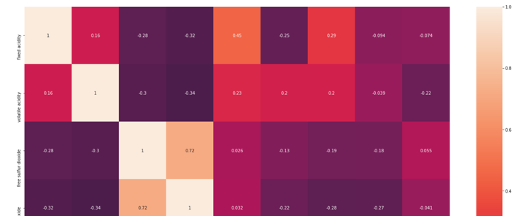

Plotting the quality count of wine to see in what ratio is the number. From the plot we can see that number 6, 5 and 7 has the highest value of quality counts respectively.

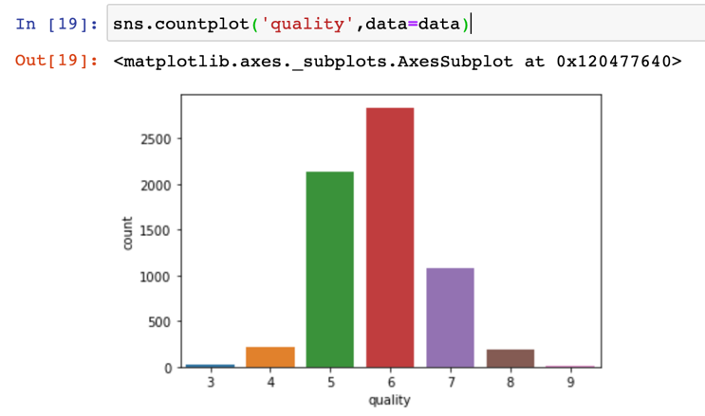
Finding out the unique value counts to replace the number with a string value

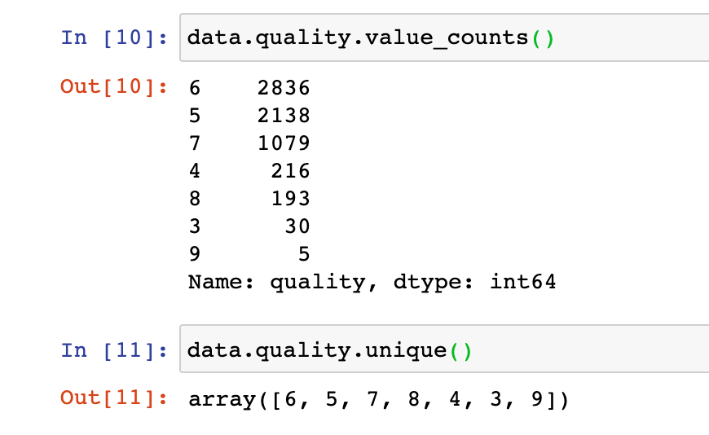

Replacing the quality count with two string values bad or good.

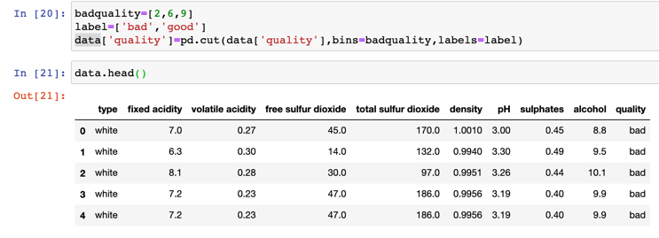

After replacing the quality column with string values below is the plot bar of the quality which can be easily understood.

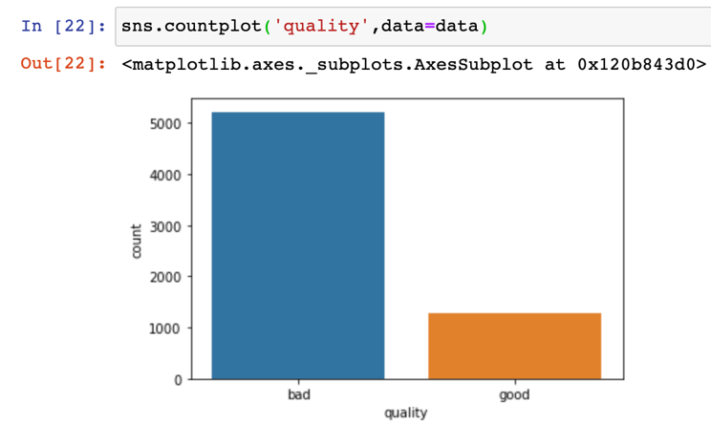
Plotting a bar graph of column quality against column alcohol.

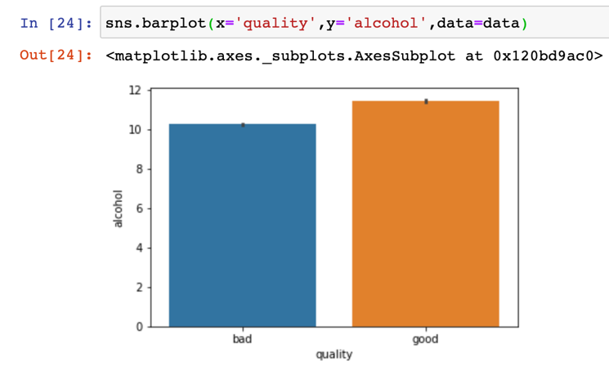

V. Data Preprocessing

A) Input Split:

Setting the X with the attributes and y with the target variable
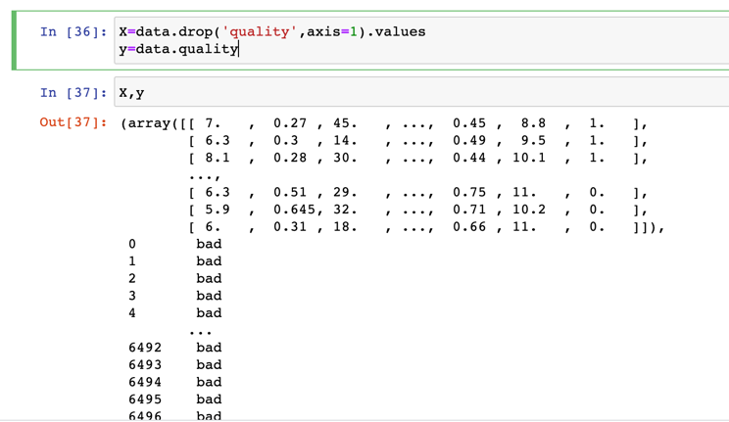

Using train_test_split to split the data into training and testing sets
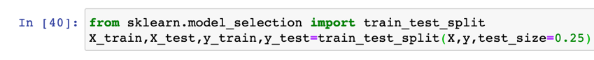

Finding out shape of the trained data
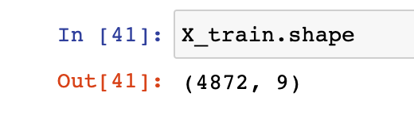

B) Feature Scaling:

Normalizing the X and y values
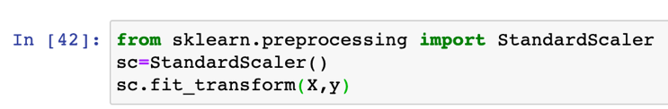

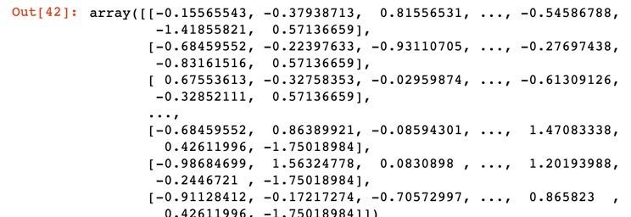

VI. Classification Algorithms

Logistic Regression Classifier

Logistic regression is a classification algorithm, used when the value of the target variable is categorical in nature. Logistic regression is most commonly used when the data in question has binary output, so when it belongs to one class or another, or is either a 0 or 1.

It is basically a supervised classification algorithm. In a classification problem, the target variable (or output), y, can take only discrete values for given set of features (or inputs), X. The model builds a regression model to predict the probability that a given data entry belongs to the category numbered as “1”. Just like Linear regression assumes that the data follows a linear function, Logistic regression models the data using the sigmoid function [4]

Random Forest

A Random Forest is an ensemble technique capable of performing both regression and classification tasks with the use of multiple decision trees and a technique called Bootstrap and Aggregation, commonly known as bagging.

The basic idea behind this is to combine multiple decision trees in determining the final output rather than relying on individual decision trees.
Random Forest has multiple decision trees as base learning models. We randomly perform row sampling and feature sampling from the dataset forming sample datasets for every model. This part is called Bootstrap [4]

GaussianNB

In Gaussian Naive Bayes, continuous values associated with each feature are assumed to be distributed according to a Gaussian distribution. A Gaussian distribution is also called Normal distribution. When plotted, it gives a bell-shaped curve which is symmetric about the mean of the feature values as shown below [4]

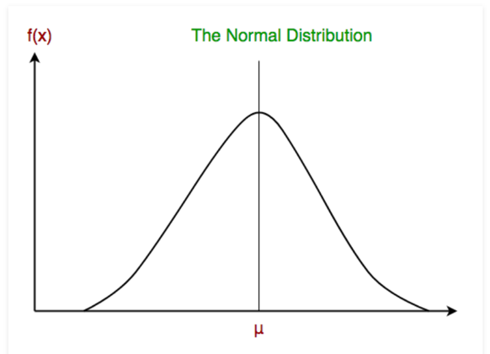

VII. Experimental Settings

A) Logistic Regression

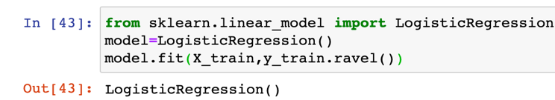

Cross Validation Mean Score for logistic regression model

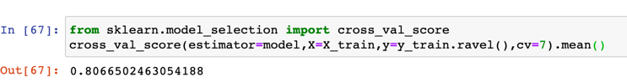

Accuracy score of trained data for logistic regression model

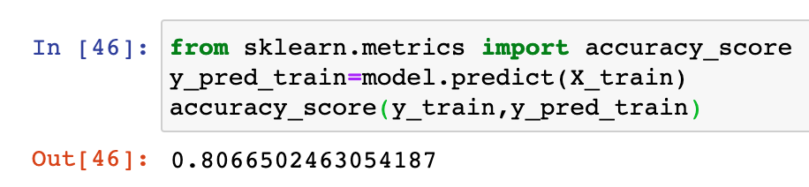

Accuracy score of test data for logistic regression model

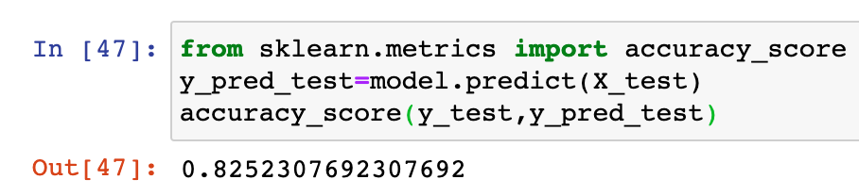

Confusion Matrix for logistic regression model

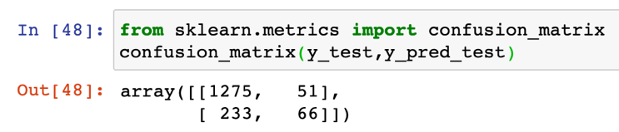

B) Random Forest Classifier

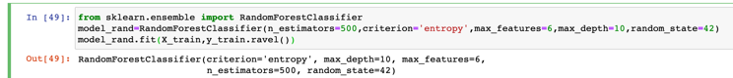

Cross Validation Mean Score for random forest classifier model

Accuracy score of trained data for random forest classifier model

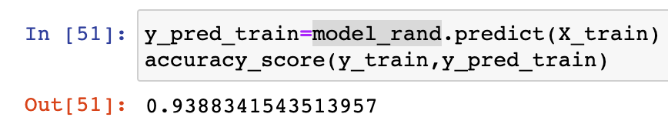

Accuracy score of test data for random forest classifier model

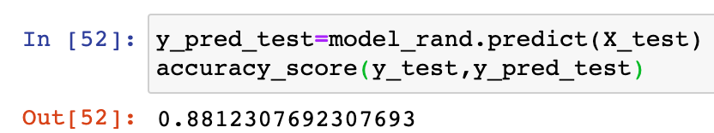

Confusion Matrix for random forest classifier model

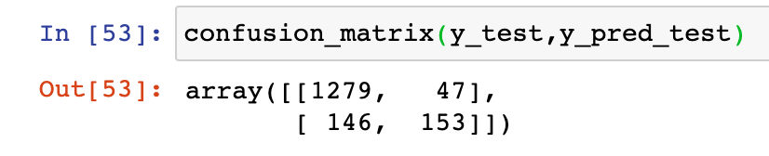

C) GaussianNB

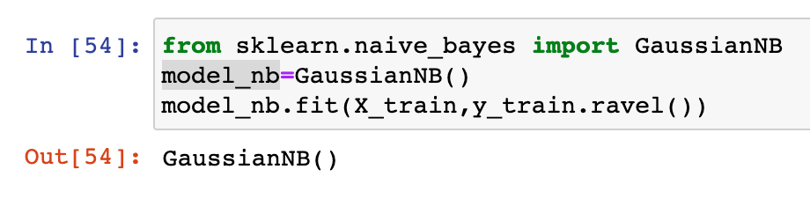
Cross Validation Mean Score for GaussianNB model

Accuracy score of trained data GaussianNB model

Algorithm | Cross Validation | Accuracy score test and train | Confusion Matric
Logistic Regression | 0.806 | 0.806, 0.825 | array([[1275,51],[233,66]]
Random Forest | 0.855 | 0.938, 0.881 | array([[1279,47],[146,153]]
GaussianNB | 0.785 | 0.788, 0.796 | array([[1149,177],[154,145]]
Table (1) Results

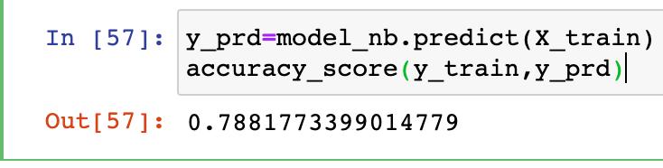

Accuracy score of test data GaussianNB model

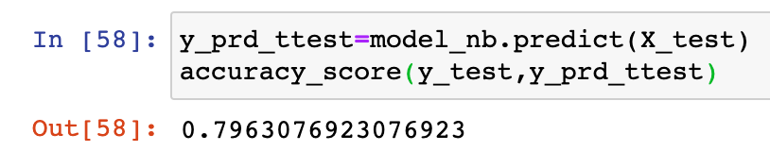

Confusion Matrix for random forest classifier model

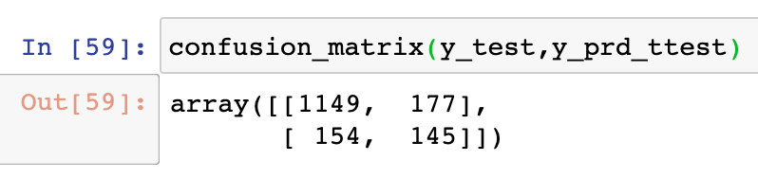

VIII. Results

FromTable1 results, we can clearly see that the Random Forest achieved promising results, outperforming the logistic regression and Gaussian algorithms.

IX. Conclusion
In this paper, I have chosen Wine Quality dataset from UCI Machine Learning Repository and have performed exploratory data analysis, data preprocessing on the dataset and finally three classification techniques were applied, under a computationally efficient procedure that performs simultaneous variable and model selection.
Section VII and VIII shows the three-classification model experimental settings, performed cross validation, accuracy score and Confusion metrics to verify which models predicts better results, And clearly seen that The Random Forest achieved promising results, outperforming the logistic regression and Gaussian algorithms.

References
[1] http://archive.ics.uci.edu/ml/datasets.php
[2] https://www.kaggle.com/
[3]https://www.sciencedirect.com/science/article/pii/S0167923609001377
[4] https://www.geeksforgeeks.org/

