🛡️ GigShield – AI-Powered Income Protection Platform
🚀 Overview
GigShield is an innovative AI-powered parametric insurance platform designed to protect the weekly earnings of gig workers such as food delivery partners (Zomato, Swiggy, etc.) across India.
Gig workers are highly vulnerable to external disruptions that are beyond their control. Events like heavy rainfall, extreme heat, or sudden curfews can completely halt their ability to work, leading to instant income loss.
👉 GigShield solves this problem by offering a smart, automated income protection system that detects such events and provides instant payouts without manual claims.

🌍 Problem Statement
Gig workers face multiple real-world challenges:
- ❌ No fixed salary or income stability
- 🌧️ Work disruption due to extreme weather
- 🚫 App shutdowns during strikes/curfews
- 🕒 Delays and complexity in traditional insurance claims
👉 Existing insurance solutions:
- Are slow
- Require manual verification
- Do not cover short-term income loss

💡 Our Solution
GigShield introduces a Parametric Insurance Model where:
- 📡 External events are automatically monitored
- ⚡ Claims are instantly triggered
- 💰 Payouts are credited without user intervention
This creates a zero-friction insurance experience for gig workers.

🧭 Methodology & System Flow

The system operates in three major stages:
1️⃣ Onboarding Flow
- User enters basic details (Name, Platform, City)
- Minimal friction ensures quick access
- System prepares user profile for risk evaluation

2️⃣ AI Risk Profiling Engine
- AI evaluates:
  - 🌦️ Weather patterns (rainfall, heatwaves)
  - 🚨 Social disruptions (strikes, curfews)
  - 📊 Historical city-level data
- Generates:
  - 📈 Risk Score
  - 💸 Weekly Premium (dynamic pricing)

3️⃣ Real-Time Claim Automation
- Continuously monitors external conditions
- When thresholds are met:
  - ⚡ Trigger detected (e.g., Heatwave > 45°C)
  - 🤖 Claim auto-generated
  - 💰 Instant payout credited
- Updates:
  - 📜 AI Claim Log
  - 💼 Protected Earnings

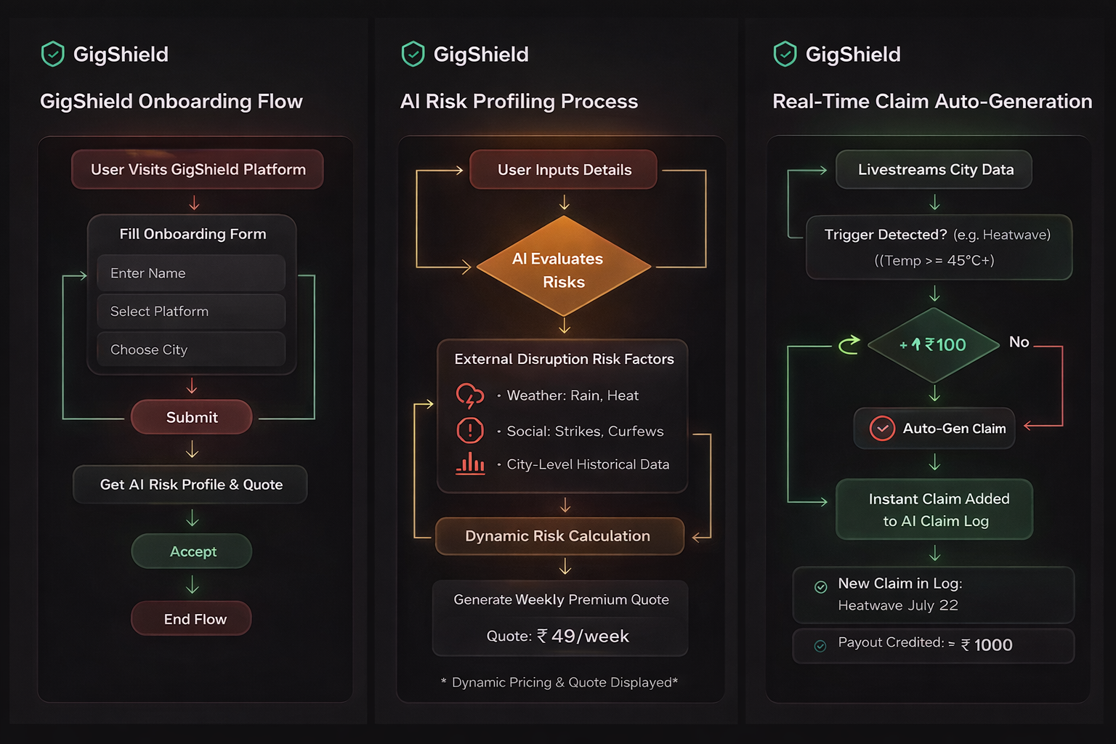

🎯 Core Features
🔹 Smart Onboarding
- Simple and quick user registration
- Focused only on essential details

🔹 AI-Powered Risk Assessment
- Dynamic pricing based on:
  - Location
  - Environmental risks
- Simulated AI scanning experience

🔹 Live Policy Dashboard
- Displays:
  - 💰 Total Protected Earnings
  - 📡 System Status (Normal / Triggered)
- Provides real-time monitoring interface

🔹 Disruption Simulation Engine
Allows users to test real-world scenarios:
- 🌧️ Severe Waterlogging (>50mm/hr rainfall)
- 🌡️ Extreme Heatwave (>45°C)
- 🚫 Social Curfew / Strike
👉 Helps demonstrate real-time system behavior.

🔹 Automated Claim System
- No paperwork
- No human intervention
- Instant settlement
- Transparent claim logging

🖥️ Tech Stack
Layer | Technology
Frontend | ⚛️ React (Vite)
Styling | 🎨 Vanilla CSS (Custom Design System)
UI Design | 🌙 Dark Mode + Glassmorphism
Logic | 🤖 Simulated AI Engine

🎨 UI/UX Design Philosophy
GigShield focuses on:
- 🔥 Premium and trustworthy appearance
- 🌙 Dark mode for modern experience
- ✨ Glassmorphism for depth and clarity
- ⚡ Smooth and responsive interactions

📂 Project Structure
GigShield/
│── assets/
│ └── gigshield-flowcharts.png
│── src/
│ ├── components/ # Reusable UI components
│ ├── pages/ # Application pages
│ ├── styles/ # Custom CSS system
│── public/
│── index.html
│── package.json
│── README.md

▶️ How to Run the Project
# Clone the repository
git clone https://github.com/your-username/gigshield.git

# Navigate to the project directory
cd gigshield

# Install dependencies
npm install

# Start development server
npm run dev
👉 Open in browser:
http://localhost:5173

🧪 Testing the Prototype
Follow these steps to experience the system:
- Fill onboarding form
- Generate AI risk profile
- Accept policy & activate dashboard
- Trigger simulation events:
  - Rain
  - Heatwave
  - Curfew
- Observe:
  - Instant claim generation
  - Earnings update

⚙️ How It Works (Simplified)
User → AI Risk Engine → Policy Activated
→ Event Trigger Detected
→ Auto Claim Generated
→ Instant Payout Credited

🚀 Key Innovations
- ⚡ Parametric Insurance Model
- 🤖 AI-driven risk pricing
- 📡 Real-time disruption tracking
- 💰 Instant automated payouts

🔮 Future Enhancements
- 🌐 Integration with real-time weather APIs
- 📍 GPS-based location tracking
- 🧠 Advanced ML risk prediction models
- 💳 Payment gateway integration
- 📱 Mobile application (Android/iOS)
- 🔔 Push notifications for alerts

👨‍💻 Team Members
- Joshitha
- V Padma Priya
- V Gnana Deep
- Phanindra

⭐ Final Note
GigShield represents a step towards financial security for gig workers, combining AI, automation, and modern UI/UX to solve a real-world problem with efficiency and scalability.

