## Course: Visual Analytics for Policy and Management

### Joshua Jenkins

# Univariate

### Exercises

link='https://github.com/EvansDataScience/VisualAnalytics_2_tabularData/raw/master/data/eduwa.rda'  
  
#getting the data TABLE from the file in the cloud:  
load(file=url(link))

### Exercise 1

library(ggplot2)

head(eduwa$LocaleType,50) #first fifty values

## [1] Suburb City City Town City City Suburb City Rural Rural   
## [11] City City City City Suburb Rural Rural Rural Suburb City   
## [21] Suburb Suburb Suburb Suburb City City Suburb Suburb Rural Rural   
## [31] Rural Suburb City City Rural City City Rural Rural City   
## [41] Town Town Rural City Suburb City City Rural City City   
## Levels: City Rural Suburb Town

table(eduwa$High.Grade,exclude = 'nothing')

##   
## PK KG 1 2 3 4 5 6 7 8 9 10 11 12 13   
## 82 7 6 16 19 45 755 266 11 427 15 7 5 757 9

absoluteT=table(eduwa$LocaleType,exclude = 'nothing')  
prop.table(absoluteT)

##   
## City Rural Suburb Town <NA>   
## 0.29419036 0.20807581 0.32880099 0.13926658 0.02966625

ToPlot=prop.table(absoluteT)  
barplot(ToPlot)

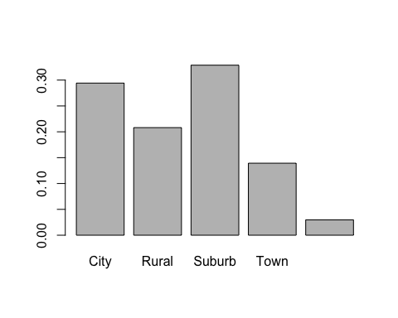

library(ggplot2)

paletteHereNew=c('gray')

plotLabels=paste0(round(ToPlot,2),'%') # labels for the slices

par(mgp=c(1,0.5,0))   
location=barplot(ToPlot,  
 col = paletteHereNew,  
 border=NA,  
 main="Offenses in Washington DC",  
 xlim=c(0,50),   
 xlab = '(in %)',  
 cex.names=0.6,  
 cex.lab=0.6,  
 las=2,  
 horiz = T,  
 xaxt="n") # no x-axis, so I customize it below...  
  
text(x=ToPlot,y=location,labels=plotLabels,pos = 4,cex = 0.7)   
title(sub="DC Public Safety", adj=0,cex.sub=0.7,line = 3)   
  
#reference line  
abline(v=25,lty=3,lwd=3)  
  
  
# customizing tick values  
newXvalues<-c(0,10,25,40,50) # you just want to show this on the axis  
axis(side=1,   
 at=newXvalues,   
 labels = newXvalues,  
 cex.axis=0.8)

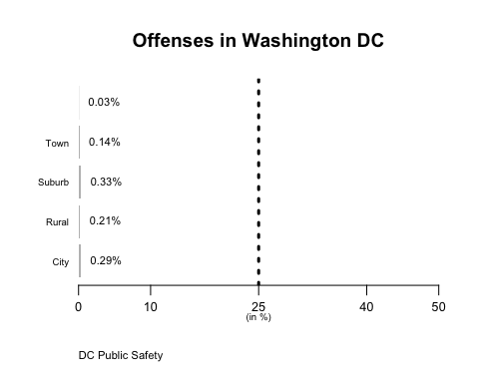

tableFreq=as.data.frame(ToPlot)  
names(tableFreq)=c("offense","pct")

tableFreq

## offense pct  
## 1 City 0.29419036  
## 2 Rural 0.20807581  
## 3 Suburb 0.32880099  
## 4 Town 0.13926658  
## 5 <NA> 0.02966625

base= ggplot(data = tableFreq,   
 aes(x = reorder(offense,-pct),  
 y = pct))

library(scales)

tableFreq

## offense pct  
## 1 City 0.29419036  
## 2 Rural 0.20807581  
## 3 Suburb 0.32880099  
## 4 Town 0.13926658  
## 5 <NA> 0.02966625

base= ggplot(data = tableFreq,   
 aes(x = reorder(offense,-pct),  
 y = pct))   
plot1 = base + geom_bar(fill ="gray",  
 stat = 'identity')   
plot2 = plot1 + labs(title="Offenses in Washington, DC",  
 x =NULL,   
 y = NULL,  
 caption = "DC Public Safety")  
plot3 = plot2 + scale_y_continuous(breaks=c(0,10, 25,40,50),  
 limits = c(0, 50),   
 labels=scales::unit_format(suffix = '%'))  
plot4 = plot3 + theme(panel.background = element_rect(fill = "white",  
 colour = "grey50"),  
 plot.caption = element_text(hjust = 0),   
 plot.title = element_text(hjust = 0.5))  
plot5 = plot4 + geom_text(aes(y = pct ,  
 label = paste0(round(pct,2), '%')),  
 vjust=1, # if flipping 'hjust'  
 size = 3)  
plot6 = plot5 + geom_hline(yintercept = 25, #where  
 linetype="dashed",   
 size=1.5, #thickness  
 alpha=0.5) #transparency  
plot6

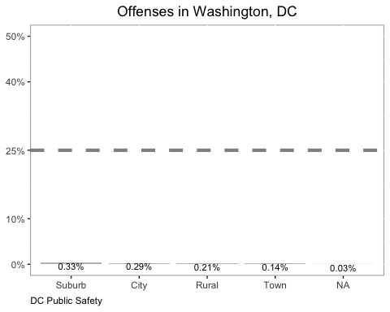

### Exercise 2

base = ggplot(tableFreq, aes(x=offense,pct))  
lolliplot1=base + geom_segment(aes(y = 0,   
 x = offense,   
 yend = pct,   
 xend = offense), color = "grey50")   
lolliplot1 + geom_point()

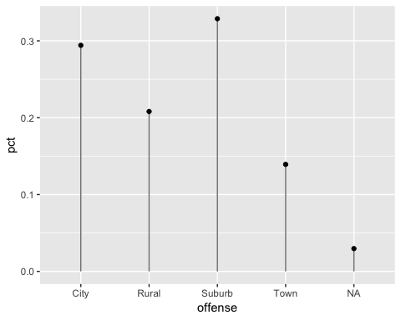

tableFreq[order(tableFreq$pct),]

## offense pct  
## 5 <NA> 0.02966625  
## 4 Town 0.13926658  
## 2 Rural 0.20807581  
## 1 City 0.29419036  
## 3 Suburb 0.32880099

tableFreqO=tableFreq[order(tableFreq$pct),]  
  
  
base = ggplot(tableFreqO, aes(offense,pct))   
lolliplot1=base + geom_segment(aes(y = 0,   
 x = offense,   
 yend = pct,   
 xend = offense), color = "gray")   
lolliplot2 = lolliplot1 + geom_point()  
lolliplot2 + scale_x_discrete(limits=tableFreqO$offense)

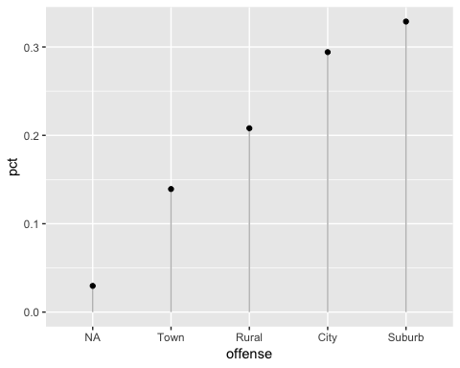

lolliplot3 = lolliplot2 + geom_hline(yintercept = 25,  
 linetype = "dashed",  
 size = 1.5,  
 alpha = 0.5)  
lolliplot4 = lolliplot3 + labs(title="Offenses in Washington, DC",  
 x =NULL,   
 y = NULL,  
 caption = "DC Public Safety")  
lolliplot4

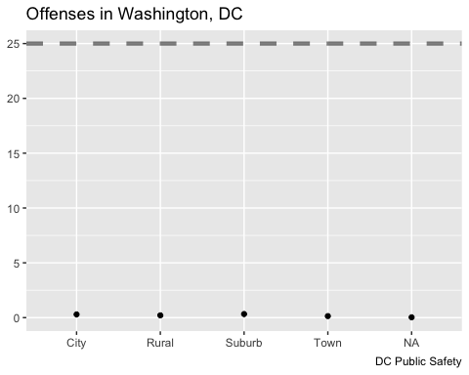

### Exercise 3

table(eduwa$High.Grade,exclude = 'nothing')

##   
## PK KG 1 2 3 4 5 6 7 8 9 10 11 12 13   
## 82 7 6 16 19 45 755 266 11 427 15 7 5 757 9

frqTabO=as.data.frame(prop.table(table(eduwa$High.Grade)))  
names(frqTabO)=c('grade','pct')  
frqTabO

## grade pct  
## 1 PK 0.033786568  
## 2 KG 0.002884219  
## 3 1 0.002472188  
## 4 2 0.006592501  
## 5 3 0.007828595  
## 6 4 0.018541409  
## 7 5 0.311083642  
## 8 6 0.109600330  
## 9 7 0.004532344  
## 10 8 0.175937371  
## 11 9 0.006180470  
## 12 10 0.002884219  
## 13 11 0.002060157  
## 14 12 0.311907705  
## 15 13 0.003708282

base = ggplot(frqTabO,aes(x=grade,y=pct))  
base + geom_bar(stat = 'identity')

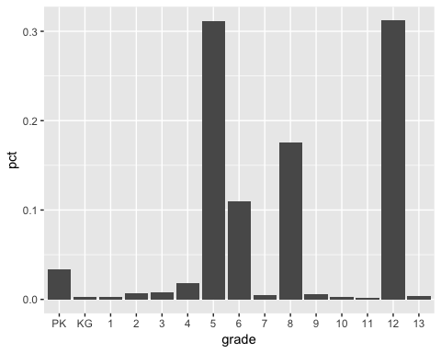

box1 = ggplot(eduwa, aes(y=as.numeric(High.Grade)))   
box1 = box1 + geom_boxplot() + coord_flip() # to show it horizontally  
  
box1

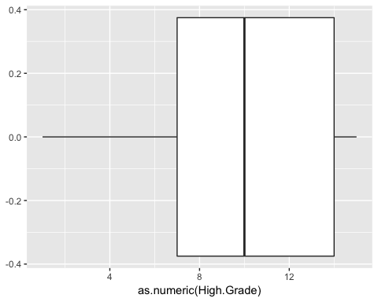

ordLabels= levels(eduwa$High.Grade)  
box2 = box1 + scale_y_continuous(labels=ordLabels,breaks=1:15)  
box3 = box2 + labs(title = 'Terminal Grades in Washington State',  
 caption = "US Department of Education")  
box3

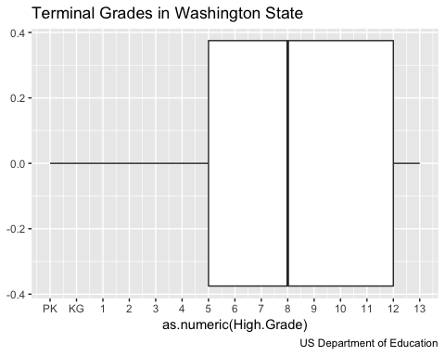

### Exercise 4

length(unique(eduwa$Free.Lunch))

## [1] 549

eduwa3=eduwa[complete.cases(eduwa$Free.Lunch),]  
dataHist=hist(eduwa3$Free.Lunch)

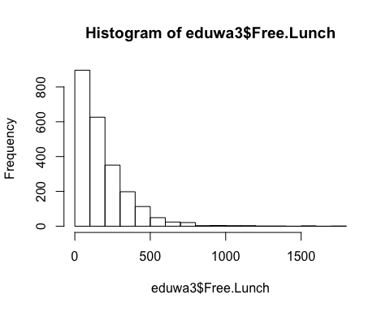

par(mgp=c(1,0.5,0))   
location=hist(eduwa3$Free.Lunch,  
 col = paletteHereNew,  
 border=NA,  
 main="Number of Free Lunch Recipients in Washington State Pubic Schools",  
 sub = "US Department of Education",  
 xlim=c(0,1500),   
 xlab = '(in %)')   
  
  
abline(v=25,lty=3,lwd=3)  
  
  
newXvalues<-c(0,10,25,40,50) # you just want to show this on the axis  
axis(side=1,   
 at=newXvalues,   
 labels = newXvalues,  
 cex.axis=0.8)

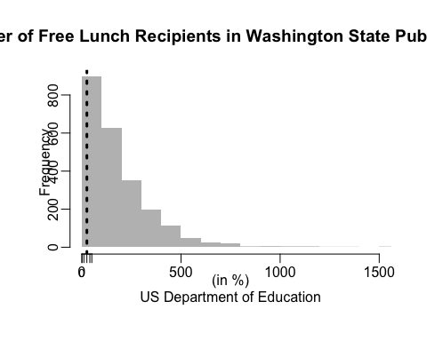

base= ggplot(eduwa3,aes(x = Free.Lunch))   
h1= base + geom_histogram(binwidth = 20,boundary=0) #changing width  
h1= h1 + stat_bin(binwidth = 20, aes(label=..count..),   
 geom = "text",boundary = 0,vjust=-0.5)  
h1

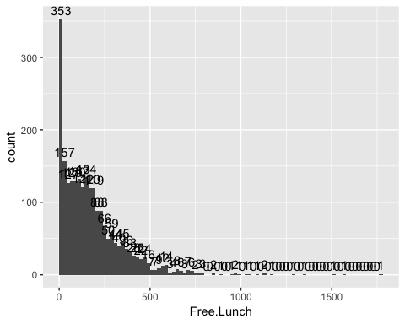

ggplot_build(h1)$data[[1]]

## y count x xmin xmax density ncount ndensity PANEL  
## 1 353 353 10 0 20 7.687282e-03 1.000000000 1.000000000 1  
## 2 157 157 30 20 40 3.418990e-03 0.444759207 0.444759207 1  
## 3 127 127 50 40 60 2.765679e-03 0.359773371 0.359773371 1  
## 4 129 129 70 60 80 2.809233e-03 0.365439093 0.365439093 1  
## 5 130 130 90 80 100 2.831010e-03 0.368271955 0.368271955 1  
## 6 132 132 110 100 120 2.874564e-03 0.373937677 0.373937677 1  
## 7 121 121 130 120 140 2.635017e-03 0.342776204 0.342776204 1  
## 8 134 134 150 140 160 2.918118e-03 0.379603399 0.379603399 1  
## 9 120 120 170 160 180 2.613240e-03 0.339943343 0.339943343 1  
## 10 119 119 190 180 200 2.591463e-03 0.337110482 0.337110482 1  
## 11 88 88 210 200 220 1.916376e-03 0.249291785 0.249291785 1  
## 12 88 88 230 220 240 1.916376e-03 0.249291785 0.249291785 1  
## 13 66 66 250 240 260 1.437282e-03 0.186968839 0.186968839 1  
## 14 50 50 270 260 280 1.088850e-03 0.141643059 0.141643059 1  
## 15 59 59 290 280 300 1.284843e-03 0.167138810 0.167138810 1  
## 16 44 44 310 300 320 9.581882e-04 0.124645892 0.124645892 1  
## 17 40 40 330 320 340 8.710801e-04 0.113314448 0.113314448 1  
## 18 45 45 350 340 360 9.799652e-04 0.127478754 0.127478754 1  
## 19 36 36 370 360 380 7.839721e-04 0.101983003 0.101983003 1  
## 20 33 33 390 380 400 7.186411e-04 0.093484419 0.093484419 1  
## 21 26 26 410 400 420 5.662021e-04 0.073654391 0.073654391 1  
## 22 25 25 430 420 440 5.444251e-04 0.070821530 0.070821530 1  
## 23 22 22 450 440 460 4.790941e-04 0.062322946 0.062322946 1  
## 24 24 24 470 460 480 5.226481e-04 0.067988669 0.067988669 1  
## 25 16 16 490 480 500 3.484321e-04 0.045325779 0.045325779 1  
## 26 7 7 510 500 520 1.524390e-04 0.019830028 0.019830028 1  
## 27 7 7 530 520 540 1.524390e-04 0.019830028 0.019830028 1  
## 28 9 9 550 540 560 1.959930e-04 0.025495751 0.025495751 1  
## 29 12 12 570 560 580 2.613240e-04 0.033994334 0.033994334 1  
## 30 14 14 590 580 600 3.048780e-04 0.039660057 0.039660057 1  
## 31 3 3 610 600 620 6.533101e-05 0.008498584 0.008498584 1  
## 32 4 4 630 620 640 8.710801e-05 0.011331445 0.011331445 1  
## 33 8 8 650 640 660 1.742160e-04 0.022662890 0.022662890 1  
## 34 6 6 670 660 680 1.306620e-04 0.016997167 0.016997167 1  
## 35 3 3 690 680 700 6.533101e-05 0.008498584 0.008498584 1  
## 36 7 7 710 700 720 1.524390e-04 0.019830028 0.019830028 1  
## 37 6 6 730 720 740 1.306620e-04 0.016997167 0.016997167 1  
## 38 2 2 750 740 760 4.355401e-05 0.005665722 0.005665722 1  
## 39 3 3 770 760 780 6.533101e-05 0.008498584 0.008498584 1  
## 40 3 3 790 780 800 6.533101e-05 0.008498584 0.008498584 1  
## 41 0 0 810 800 820 0.000000e+00 0.000000000 0.000000000 1  
## 42 0 0 830 820 840 0.000000e+00 0.000000000 0.000000000 1  
## 43 2 2 850 840 860 4.355401e-05 0.005665722 0.005665722 1  
## 44 0 0 870 860 880 0.000000e+00 0.000000000 0.000000000 1  
## 45 1 1 890 880 900 2.177700e-05 0.002832861 0.002832861 1  
## 46 0 0 910 900 920 0.000000e+00 0.000000000 0.000000000 1  
## 47 0 0 930 920 940 0.000000e+00 0.000000000 0.000000000 1  
## 48 1 1 950 940 960 2.177700e-05 0.002832861 0.002832861 1  
## 49 2 2 970 960 980 4.355401e-05 0.005665722 0.005665722 1  
## 50 1 1 990 980 1000 2.177700e-05 0.002832861 0.002832861 1  
## 51 0 0 1010 1000 1020 0.000000e+00 0.000000000 0.000000000 1  
## 52 1 1 1030 1020 1040 2.177700e-05 0.002832861 0.002832861 1  
## 53 1 1 1050 1040 1060 2.177700e-05 0.002832861 0.002832861 1  
## 54 0 0 1070 1060 1080 0.000000e+00 0.000000000 0.000000000 1  
## 55 1 1 1090 1080 1100 2.177700e-05 0.002832861 0.002832861 1  
## 56 0 0 1110 1100 1120 0.000000e+00 0.000000000 0.000000000 1  
## 57 2 2 1130 1120 1140 4.355401e-05 0.005665722 0.005665722 1  
## 58 0 0 1150 1140 1160 0.000000e+00 0.000000000 0.000000000 1  
## 59 1 1 1170 1160 1180 2.177700e-05 0.002832861 0.002832861 1  
## 60 0 0 1190 1180 1200 0.000000e+00 0.000000000 0.000000000 1  
## 61 0 0 1210 1200 1220 0.000000e+00 0.000000000 0.000000000 1  
## 62 0 0 1230 1220 1240 0.000000e+00 0.000000000 0.000000000 1  
## 63 0 0 1250 1240 1260 0.000000e+00 0.000000000 0.000000000 1  
## 64 0 0 1270 1260 1280 0.000000e+00 0.000000000 0.000000000 1  
## 65 1 1 1290 1280 1300 2.177700e-05 0.002832861 0.002832861 1  
## 66 0 0 1310 1300 1320 0.000000e+00 0.000000000 0.000000000 1  
## 67 0 0 1330 1320 1340 0.000000e+00 0.000000000 0.000000000 1  
## 68 1 1 1350 1340 1360 2.177700e-05 0.002832861 0.002832861 1  
## 69 0 0 1370 1360 1380 0.000000e+00 0.000000000 0.000000000 1  
## 70 0 0 1390 1380 1400 0.000000e+00 0.000000000 0.000000000 1  
## 71 0 0 1410 1400 1420 0.000000e+00 0.000000000 0.000000000 1  
## 72 0 0 1430 1420 1440 0.000000e+00 0.000000000 0.000000000 1  
## 73 0 0 1450 1440 1460 0.000000e+00 0.000000000 0.000000000 1  
## 74 0 0 1470 1460 1480 0.000000e+00 0.000000000 0.000000000 1  
## 75 0 0 1490 1480 1500 0.000000e+00 0.000000000 0.000000000 1  
## 76 1 1 1510 1500 1520 2.177700e-05 0.002832861 0.002832861 1  
## 77 0 0 1530 1520 1540 0.000000e+00 0.000000000 0.000000000 1  
## 78 0 0 1550 1540 1560 0.000000e+00 0.000000000 0.000000000 1  
## 79 1 1 1570 1560 1580 2.177700e-05 0.002832861 0.002832861 1  
## 80 0 0 1590 1580 1600 0.000000e+00 0.000000000 0.000000000 1  
## 81 0 0 1610 1600 1620 0.000000e+00 0.000000000 0.000000000 1  
## 82 0 0 1630 1620 1640 0.000000e+00 0.000000000 0.000000000 1  
## 83 0 0 1650 1640 1660 0.000000e+00 0.000000000 0.000000000 1  
## 84 0 0 1670 1660 1680 0.000000e+00 0.000000000 0.000000000 1  
## 85 0 0 1690 1680 1700 0.000000e+00 0.000000000 0.000000000 1  
## 86 0 0 1710 1700 1720 0.000000e+00 0.000000000 0.000000000 1  
## 87 0 0 1730 1720 1740 0.000000e+00 0.000000000 0.000000000 1  
## 88 0 0 1750 1740 1760 0.000000e+00 0.000000000 0.000000000 1  
## 89 1 1 1770 1760 1780 2.177700e-05 0.002832861 0.002832861 1  
## group ymin ymax colour fill size linetype alpha  
## 1 -1 0 353 NA grey35 0.5 1 NA  
## 2 -1 0 157 NA grey35 0.5 1 NA  
## 3 -1 0 127 NA grey35 0.5 1 NA  
## 4 -1 0 129 NA grey35 0.5 1 NA  
## 5 -1 0 130 NA grey35 0.5 1 NA  
## 6 -1 0 132 NA grey35 0.5 1 NA  
## 7 -1 0 121 NA grey35 0.5 1 NA  
## 8 -1 0 134 NA grey35 0.5 1 NA  
## 9 -1 0 120 NA grey35 0.5 1 NA  
## 10 -1 0 119 NA grey35 0.5 1 NA  
## 11 -1 0 88 NA grey35 0.5 1 NA  
## 12 -1 0 88 NA grey35 0.5 1 NA  
## 13 -1 0 66 NA grey35 0.5 1 NA  
## 14 -1 0 50 NA grey35 0.5 1 NA  
## 15 -1 0 59 NA grey35 0.5 1 NA  
## 16 -1 0 44 NA grey35 0.5 1 NA  
## 17 -1 0 40 NA grey35 0.5 1 NA  
## 18 -1 0 45 NA grey35 0.5 1 NA  
## 19 -1 0 36 NA grey35 0.5 1 NA  
## 20 -1 0 33 NA grey35 0.5 1 NA  
## 21 -1 0 26 NA grey35 0.5 1 NA  
## 22 -1 0 25 NA grey35 0.5 1 NA  
## 23 -1 0 22 NA grey35 0.5 1 NA  
## 24 -1 0 24 NA grey35 0.5 1 NA  
## 25 -1 0 16 NA grey35 0.5 1 NA  
## 26 -1 0 7 NA grey35 0.5 1 NA  
## 27 -1 0 7 NA grey35 0.5 1 NA  
## 28 -1 0 9 NA grey35 0.5 1 NA  
## 29 -1 0 12 NA grey35 0.5 1 NA  
## 30 -1 0 14 NA grey35 0.5 1 NA  
## 31 -1 0 3 NA grey35 0.5 1 NA  
## 32 -1 0 4 NA grey35 0.5 1 NA  
## 33 -1 0 8 NA grey35 0.5 1 NA  
## 34 -1 0 6 NA grey35 0.5 1 NA  
## 35 -1 0 3 NA grey35 0.5 1 NA  
## 36 -1 0 7 NA grey35 0.5 1 NA  
## 37 -1 0 6 NA grey35 0.5 1 NA  
## 38 -1 0 2 NA grey35 0.5 1 NA  
## 39 -1 0 3 NA grey35 0.5 1 NA  
## 40 -1 0 3 NA grey35 0.5 1 NA  
## 41 -1 0 0 NA grey35 0.5 1 NA  
## 42 -1 0 0 NA grey35 0.5 1 NA  
## 43 -1 0 2 NA grey35 0.5 1 NA  
## 44 -1 0 0 NA grey35 0.5 1 NA  
## 45 -1 0 1 NA grey35 0.5 1 NA  
## 46 -1 0 0 NA grey35 0.5 1 NA  
## 47 -1 0 0 NA grey35 0.5 1 NA  
## 48 -1 0 1 NA grey35 0.5 1 NA  
## 49 -1 0 2 NA grey35 0.5 1 NA  
## 50 -1 0 1 NA grey35 0.5 1 NA  
## 51 -1 0 0 NA grey35 0.5 1 NA  
## 52 -1 0 1 NA grey35 0.5 1 NA  
## 53 -1 0 1 NA grey35 0.5 1 NA  
## 54 -1 0 0 NA grey35 0.5 1 NA  
## 55 -1 0 1 NA grey35 0.5 1 NA  
## 56 -1 0 0 NA grey35 0.5 1 NA  
## 57 -1 0 2 NA grey35 0.5 1 NA  
## 58 -1 0 0 NA grey35 0.5 1 NA  
## 59 -1 0 1 NA grey35 0.5 1 NA  
## 60 -1 0 0 NA grey35 0.5 1 NA  
## 61 -1 0 0 NA grey35 0.5 1 NA  
## 62 -1 0 0 NA grey35 0.5 1 NA  
## 63 -1 0 0 NA grey35 0.5 1 NA  
## 64 -1 0 0 NA grey35 0.5 1 NA  
## 65 -1 0 1 NA grey35 0.5 1 NA  
## 66 -1 0 0 NA grey35 0.5 1 NA  
## 67 -1 0 0 NA grey35 0.5 1 NA  
## 68 -1 0 1 NA grey35 0.5 1 NA  
## 69 -1 0 0 NA grey35 0.5 1 NA  
## 70 -1 0 0 NA grey35 0.5 1 NA  
## 71 -1 0 0 NA grey35 0.5 1 NA  
## 72 -1 0 0 NA grey35 0.5 1 NA  
## 73 -1 0 0 NA grey35 0.5 1 NA  
## 74 -1 0 0 NA grey35 0.5 1 NA  
## 75 -1 0 0 NA grey35 0.5 1 NA  
## 76 -1 0 1 NA grey35 0.5 1 NA  
## 77 -1 0 0 NA grey35 0.5 1 NA  
## 78 -1 0 0 NA grey35 0.5 1 NA  
## 79 -1 0 1 NA grey35 0.5 1 NA  
## 80 -1 0 0 NA grey35 0.5 1 NA  
## 81 -1 0 0 NA grey35 0.5 1 NA  
## 82 -1 0 0 NA grey35 0.5 1 NA  
## 83 -1 0 0 NA grey35 0.5 1 NA  
## 84 -1 0 0 NA grey35 0.5 1 NA  
## 85 -1 0 0 NA grey35 0.5 1 NA  
## 86 -1 0 0 NA grey35 0.5 1 NA  
## 87 -1 0 0 NA grey35 0.5 1 NA  
## 88 -1 0 0 NA grey35 0.5 1 NA  
## 89 -1 0 1 NA grey35 0.5 1 NA

hist(eduwa3$Free.Lunch,labels = T,xlab="Free Lunch", xaxt="n", main = "Number of Free Lunch Recipients in Washington State Pubic Schools", )   
axis(side=1, at=dataHist$breaks)  
abline(h=400,lty=3,lwd=3)

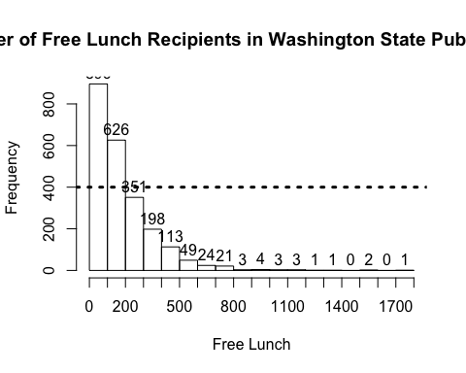

### Exercise 5

tapply(eduwa$Student.Teacher.Ratio, eduwa$County, mean,na.rm=T)

## Adams Asotin Benton Chelan Clallam   
## 14.80769 19.11111 20.38947 18.65000 19.27600   
## Clark Columbia Cowlitz Douglas Ferry   
## 19.19744 11.30000 20.38974 16.47222 16.82727   
## Franklin Garfield Grant Grays Harbor Island   
## 18.10323 17.35000 17.52449 16.33846 19.53000   
## Jefferson King Kitsap Kittitas Klickitat   
## 16.57857 18.80203 19.24030 18.93529 14.82632   
## Lewis Lincoln Mason Okanogan Pacific   
## 18.93902 11.56000 16.76316 19.73226 22.39375   
## Pend Oreille Pierce San Juan Skagit Skamania   
## 15.47778 18.77931 15.90000 22.47209 16.37000   
## Snohomish Spokane Stevens Thurston Wahkiakum   
## 20.49239 18.13542 19.61765 19.29231 18.15000   
## Walla Walla Whatcom Whitman Yakima   
## 15.55652 23.77213 13.27083 19.97500

eduwa4=eduwa[complete.cases(eduwa$Student.Teacher.Ratio),]  
  
tapply(eduwa4$Student.Teacher.Ratio,   
 eduwa4$County,   
 mean)

## Adams Asotin Benton Chelan Clallam   
## 14.80769 19.11111 20.38947 18.65000 19.27600   
## Clark Columbia Cowlitz Douglas Ferry   
## 19.19744 11.30000 20.38974 16.47222 16.82727   
## Franklin Garfield Grant Grays Harbor Island   
## 18.10323 17.35000 17.52449 16.33846 19.53000   
## Jefferson King Kitsap Kittitas Klickitat   
## 16.57857 18.80203 19.24030 18.93529 14.82632   
## Lewis Lincoln Mason Okanogan Pacific   
## 18.93902 11.56000 16.76316 19.73226 22.39375   
## Pend Oreille Pierce San Juan Skagit Skamania   
## 15.47778 18.77931 15.90000 22.47209 16.37000   
## Snohomish Spokane Stevens Thurston Wahkiakum   
## 20.49239 18.13542 19.61765 19.29231 18.15000   
## Walla Walla Whatcom Whitman Yakima   
## 15.55652 23.77213 13.27083 19.97500

meanValues=tapply(eduwa4$Student.Teacher.Ratio,   
 eduwa4$County,   
 mean)

hist(meanValues)

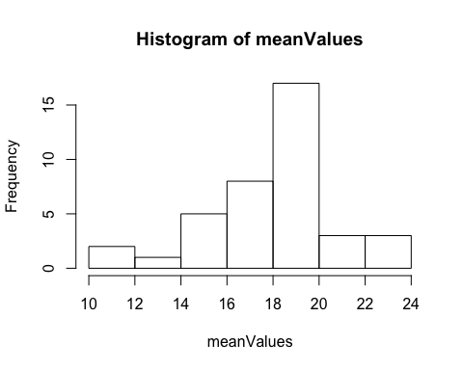

plot(eduwa$Student.Teacher.Ratio)  
abline(v=mean(meanValues),lty=3,lwd=3,col='blue')

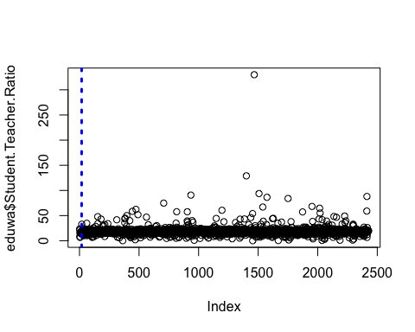

mvDense=density(meanValues)  
plot(mvDense,main="Student Teacher Ratio",col='black',xlab="Student Teacher Ratios", ylab= "frequency", sub = "US Department of Education")  
  
abline(v=mean(meanValues),lty=3,lwd=3,col='blue') #mean  
abline(v=median(meanValues),lty=3,lwd=3,col='red')#median  
legend(x="right",  
 legend=c('mean','median'),  
 fill = c('blue','red'),bty = 'n') #no box in the legend

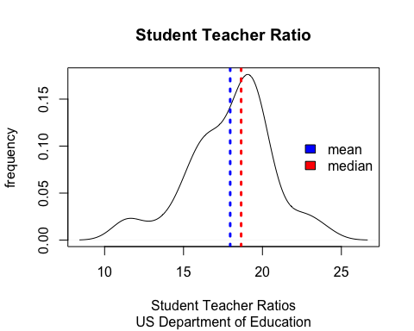

hist(meanValues, main="Student Teacher Ratio",col='gray',xlab="Student Teacher Ratios", ylab= "frequency", sub = "US Department of Education")

