Title: Defining and detecting quantum speedup
Authors: Troels F. Rønnow,1 Zhihui Wang,2,3 Joshua Job,3,4 Sergio Boixo,5 Sergei V. Isakov,6 David Wecker,7 John M. Martinis,8 Daniel A. Lidar,2,3,4,9 Matthias Troyer1,*
Affiliations:
1Theoretische Physik, ETH Zurich, 8093 Zurich, Switzerland
2Department of Chemistry, University of Southern California, Los Angeles, California 90089, USA
3Center for Quantum Information Science & Technology, University of Southern California, Los Angeles, California 90089, USA
4Department of Physics, University of Southern California, Los Angeles, California 90089, USA
5Google, 150 Main St, Venice Beach, CA, 90291
6Google, Brandschenkestrasse 110, 8002 Zurich, Switzerland
7Quantum Architectures and Computation Group, Microsoft Research, Redmond, WA 98052, USA
8Department of Physics, University of California Santa Barbara, CA 93106-9530, USA
9Department of Electrical Engineering, University of Southern California, Los Angeles, California 90089, USA
*Correspondence to: troyer@phys.ethz.ch.
Abstract: The development of small-scale quantum devices raises the question of how to fairly assess and detect quantum speedup. Here we show how to define and measure quantum speedup, and how to avoid pitfalls that might mask or fake such a speedup. We illustrate our discussion with data from tests run on a D-Wave Two device with up to 503 qubits. Using random spin glass instances as a benchmark, we find no evidence of quantum speedup when the entire data set is considered, and obtain inconclusive results when comparing subsets of instances on an instance-by-instance basis. Our results do not rule out the possibility of speedup for other classes of problems and illustrate the subtle nature of the quantum speedup question.
One Sentence Summary: A brief summary of the main result of your paper, without excessive jargon and less than 150 characters.
Main Text: The interest in quantum computing originates in the potential of a quantum computer to solve certain computational problems much faster than is possible classically. Examples are the factoring of integers (1) or the simulation of quantum systems (2,3). In these examples, a quantum algorithm is exponentially faster than the best known classical algorithm. According to the extended Church-Turing thesis, all classical computers are equivalent up to polynomial factors (4). Similarly, all proposed models of quantum computation are polynomially equivalent, so that a finding of exponential quantum speedup will be model-independent. In other cases, in particular on small devices, or when the quantum speedup is polynomial, defining and detecting quantum speedup becomes more subtle.
Denoting the time used by a specific classical device or algorithm to solve a problem of size N by C(N) and the time used on the quantum device by Q(N), we define quantum speedup as the asymptotic behavior of the ratio
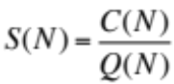, | (1)
for N → ∞. Subtleties appear in the choice of classical algorithms, in defining C(N) and Q(N) if the runtime depends not just on the size N of a problem but also on the specific problem instance, and in extrapolating to the asymptotic limit.
Depending on our knowledge of classical algorithms for a given problem we may consider four different types of quantum speedup. The optimal scenario is one of a “provable quantum speedup,” where there exists a proof that no classical algorithm can outperform a given quantum algorithm. The best known example is Grover’s search algorithm (5), which, in the query complexity setting, exhibits a provable quadratic speedup over the best possible classical algorithm (6). A “strong quantum speedup” was defined in (7) by using the performance of the best classical algorithm for C(N), whether such an algorithm is known or not. Unfortunately, the performance of the best classical algorithm is unknown for many interesting problems. In the case of factoring, for example, a proof of a classical super-polynomial lower-bound is not known. A less ambitious goal is therefore desirable, and thus one usually defines “quantum speedup” (without additional adjectives) by comparing to the best available classical algorithm instead of the best possible classical algorithm.
A weaker scenario is one where a quantum algorithm is designed to make use of quantum effects, but it is not known whether these quantum effects provide an advantage over classical algorithms or where a device is a putative or candidate quantum information processor. To capture this scenario, which is of central interest to us in this work, we define “limited quantum speedup” as a speedup obtained when comparing specifically with classical algorithms that ‘correspond’ to the quantum algorithm in the sense that they implement the same algorithmic approach, but on classical hardware. A natural example is quantum annealing (8, 9) or adiabatic quantum optimization (10) implemented on a candidate physical quantum information processor vs corresponding classical algorithms such as simulated annealing (SA) (11) (which performs annealing on a classical Monte Carlo simulation of the Ising spin glass and makes no use of quantum effects) or simulated quantum annealing (SQA) (12, 13) (a classical algorithm mimicking quantum annealing in a path-integral quantum Monte Carlo simulation). In this comparison a limited quantum speedup would be a demonstration that quantum effects improve the annealing algorithm.
To illustrate the subtleties in detecting quantum speedup, even after a classical reference algorithm is chosen, we will compare the performance of an experimental 503-qubit D-Wave Two (DW2) device to classical algorithms and analyze the evidence for quantum speedup on the benchmark problem of random spin glass instances. Specifically, we consider the problem of finding the ground state of an Ising spin glass model described by a “problem Hamiltonian”
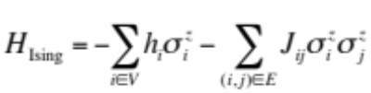 | (2)
with N binary variables σ_{i}^{z} = ±1. The local fields {h_{i}} and couplings {J_{ij}} are fixed and define a problem instance of the Ising model. The spins occupy the vertices V of a graph G = {V, E} with edge set E. We will consider the distributions of the time to solution over many random spin glass problems instances with zero local fields on the ‘Chimera graph’ realized by the DW2 device (see Supplementary Material (14) for a definition of that graph and why we choose h_{i} = 0). This problem is NP-hard (15) and all known classical algorithms scale super-polynomially not only for the hardest but also for typical instances. While quantum mechanics is not expected to reduce the super-polynomial scaling to polynomial, a quantum algorithm might still scale better with problem size N than any classical algorithm.
The D-Wave devices (16–19) are designed to be physical realizations of quantum annealing using superconducting flux qubits and programmable fields {h_{i}} and couplings {J_{ij}}. Quantum annealing is implemented by initializing the system in the ground state of a transverse magnetic field 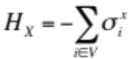, where the σ’s denote the Pauli matrices; H_{X} is turned off adiabatically while H_{Ising} is turned on simultaneously. A measurement of each qubit in the computational basis then determines the ground state of H_{Ising} with a probability affected by many factors, including thermal excitations and implementation errors (20). Tests on small problems on D-Wave One (DW1) (21) and DW2 devices (22) have shown that for small problem sizes the device correlates well with the predictions of a quantum master equation. For larger problem sizes a 108 qubit DW1 device correlated well with simulated quantum annealing (SQA) (20), which indicates that despite decoherence and coupling to a thermal bath, the behavior of the device is consistent with it actually performing quantum annealing (23, 24). However, for these benchmarks both SQA and the DW1 device are also well described by a semi-classical mean-field version of SQA (25), which raises the question whether quantum effects play an important role. The approach adopted here, of seeking evidence of a (limited) quantum speedup, directly addresses the crucial question of whether large-scale quantum effects create a potential for the devices to outperform classical algorithms. To test this possibility we compare the performance of a DW2 device to two ‘corresponding’ classical algorithms: SA and SQA.
Since quantum speedup concerns the asymptotic scaling of S(N) we consider the subtleties of estimating it from small problem sizes N, and inefficiencies at small problem sizes that can fake or mask a speedup. In the context of annealing, the optimal choice of the annealing time ta turns out to be crucial for estimating asymptotic scaling. To illustrate this we first consider the time to solution using SA and SQA run at different fixed annealing times ta, independent of the problem size N. Figure 1A shows the scaling of the median total annealing time (over 1000 different random instances on the D-Wave Chimera graph – see Supplementary Material (14)) for SQA to find a solution at least once with probability p = 0.99. Corresponding times for SA are shown in figure S10. We observe that at constant t_{a}, as long as t_{a} is long enough to find the ground state almost every time, the scaling of the total effort is at first relatively flat. The total effort then rises more rapidly, once one reaches problem sizes for which the chosen annealing time is too short, and the success probabilities are thus low, requiring many repetitions. Extrapolations to N → ∞ need to consider the lower envelope of all curves, which corresponds to choosing an optimal annealing time 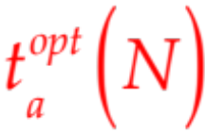 for each N.
Figure 1B demonstrates that when using fixed annealing times no conclusion can be drawn from annealing (simulated or in a device) about the asymptotic scaling. The initial slow increase at constant t_{a} is misleading and instead the optimal annealing time needs to be used for each problem size N. To illustrate this we show in Figure 1B the real “speedup” ratio of the scaling of SA and SQA (actually a slowdown), and a fake speedup due to a constant and excessively long annealing time ta for SQA. Since SA outperforms SQA on our benchmark set, it is our algorithm of choice in the comparisons with the DW2 reported below.
A related issue is the scaling of hardware resources (computational gates and memory) with problem size, which must be identical for the devices we compare. A device whose hardware resources scale as N can achieve an intrinsic parallel speedup compared to a fixed size device. Such is the case for the DW2, which uses N (out of 512) qubits and O(N) couplers and classical logical control gates to solve a spin glass instance with N spin variables in time T_{DW}(N). Considering quantum speedup for N → ∞ we need to compare a (hypothetical) larger DW2 device with the number of qubits and couplers growing as O(N) to a (hypothetical) classical device with O(N) gates or processing units. Since SA (and SQA) are perfectly parallelizable for the bipartite Chimera graphs realized by the DW2, we can relate the scaling of the time T_{C}(N) on such a device to the time T_{SA}(N) for SA on a fixed size classical CPU by T_{C}(N) ∼ T_{SA}/N and obtain
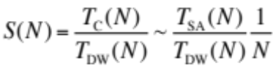. | (3)
We finally address the question of how to measure time when the time to solution depends on the specific problem instance. When a device is used as a tool for solving computational problems, the question of interest is to determine which device is better for almost all possible problem instances. If instead the focus is on the underlying physics of a device then it might suffice to find a subclass of instances where a speedup is exhibited. These two questions lead to different quantities of interest.
To illustrate the considerations we now turn to our results. Figure 2 shows the scaling of the time to find the ground state for various quantiles, from the easiest instances (1%) to the hardest (99%), comparing the DW2 and SA. We chose the values of the couplings J_{ij} from 2r discrete values {n/r}, with n ∈ ±{1, … , r − 1, r}, and call r the “range”. Since we do not a priori know the hardness of a given problem instance we have to assume the worst case and perform a sufficient number of repetitions R to be able to solve even the hardest problem instances. Hence the scaling for the highest quantiles is the most informative. Here, we consider only the pure annealing times, ignoring setup and readout times that scale subdominantly (see (14) for wall-clock results).
We observe for both the DW2 and SA, for sufficiently large N, that the total time to solution for each quantile q scales as 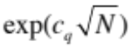 (with c_{q}>0 a constant) as reported previously for SA and SQA (20). The origin of the 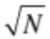 exponent is well understood for exact solvers as reflecting the treewidth of the Chimera graph (14, 26). While the SA code was run at an optimized annealing time for each problem size N, the DW2 has a minimal annealing time of t_{a} =20μs,which is longer than the optimal time for all problem sizes (14). Therefore the observed slope of the DW2 data can only be taken as a lower bound for the asymptotic scaling. With this in mind, we observe similar scaling for SA and the DW2 for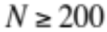.
How can we probe for a speedup in light of this similar scaling? With algorithms such as SA or quantum annealing, where the time to solution depends on the problem instance, it is impractical to experimentally find the hardest problem instance. If instead we target a fraction of q% of the instances then we should consider the qth quantile in the scaling plots shown in Figure 2. The appropriate speedup quantity is then the ratio of these quantiles (“RofQ”). Denoting a quantile q of a random variable X by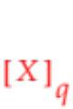we define this as

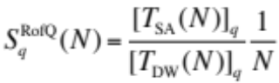. | (4)
Plotting this quantity for the DW2 vs SA in Figure 3 (A and B) we find no evidence for a limited quantum speedup in the interesting regime of large N and large q (almost all instances). That is, while for all quantiles and for both ranges the initial slope is positive, when N and q become large enough we observe a turnaround and eventually a negative slope. While we observe a positive slope for quantiles smaller than the median, this is of limited interest since we have not been able to identify a priori which instances will be easy. Taking into account that due to the fixed suboptimal annealing times the speedup defined in Eq. (4) is an upper bound, we conclude that there is no evidence of a speedup over SA for this particular benchmark.
S_{q}^{RofQ}(N) measures the speedup while comparing different sets of instances for DW and SA, each determined by the respective quantile. Now we consider instead whether there is a speedup for a (potentially small) subset of the same problem instances. To this end we study the scaling of the ratios of the time to solution for individual instances, and display in Figure 3 (C and D) the scaling of various quantiles of the ratio (“QofR”)
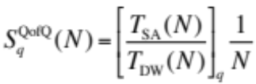. | (4)
For r = 7 all the quantiles bend down for sufficiently large N, so that there is no evidence of a limited quantum speedup. There does seem to be an indication of such a speedup compared to SA in the low quantiles for r = 1, i.e., for those instances whose speedup ratio was high. However, the instances contributing here are not run at the optimal annealing time, and more work is needed to establish that the potential r = 1 speedup result persists for those instances for which one can be sure that the annealing time is optimal.
Next we consider the distribution of solution times at a fixed problem size. This does not address the speedup question since no scaling can be extracted, but illuminates instead the question of correlation between the performance of the DW2 and SA. To this end we perform individual comparisons for each instance and show in Figure 4A-B the time to solution for the same instances for the DW2 and SA. We observe a wide scatter (in agreement with the DW1 results of Ref. (20)) and find that while the DW2 is sometimes up to 10× faster in pure annealing time, there are many cases where it is ≥ 100× slower.
It is not yet known whether a quantum annealer or even a perfectly coherent adiabatic quantum optimizer can exhibit (limited) quantum speedup at all, although there are promising indications from theory (27), simulation (13), and experiments on spin glass materials (9). Experimental tests are thus important. There are several candidate explanations for the absence of a clear quantum speedup in our tests. Perhaps quantum annealing simply does not provide any advantages over simulated (quantum) annealing or other classical algorithms for the problem class we have studied (28); or, perhaps, the noisy implementation in the DW2 cannot realize quantum speedup and is thus not better than classical devices. Alternatively, a speedup might be masked by calibration errors, improvements might arise from error correction (29), or other problem classes might exhibit a speedup. Future studies will probe these alternatives and aim to determine whether one can find a class of problem instances for which an unambiguous speedup over classical hardware can be observed.
While we used specific processors and algorithms for illustration, the considerations about a reliable determination of quantum speedup presented here are general. For any speedup analysis, using the same scaling of hardware resources for both quantum and classical devices is required to disentangle parallel and quantum speedup. And, for any quantum algorithm where the runtime must be determined experimentally, a careful extrapolation to large problem sizes is important to avoid mistaking inefficiencies at small problem sizes for signs of quantum speedup.

References and Notes:
- P. W. Shor, Foundations of Computer Science, 1994 Proceedings., 35th Annual Symposium on pp. 124–134 (20-22 Nov 1994).
- R. Feynman, International Journal of Theoretical Physics 21, 467 (1982).
- S. Lloyd, Science 273, 1073 (1996).
- I. Parberry, SIGACT News 18, 54 (1986).
- L. K. Grover, Physical Review Letters 79, 325 (1997).
- C. Bennett, E. Bernstein, G. Brassard, U. Vazirani, SIAM Journal on Computing 26, 1510 (1997).
- A. Papageorgiou, J. F. Traub, Phys. Rev. A 88, 022316 (2013).
- T. Kadowaki, H. Nishimori, Phys. Rev. E 58, 5355 (1998).
- J. Brooke, D. Bitko, T. Rosenbaum, G. Aeppli, Science 284, 779 (1999).
- E. Farhi, et al., Science 292, 472 (2001).
- S. Kirkpatrick, C. D. Gelatt, M. P. Vecchi, Science 220, 671 (1983).
- R. Martonˇa ́k, G. E. Santoro, E. Tosatti, Phys. Rev. B 66, 094203 (2002).
- G. E. Santoro, R. Martonak, E. Tosatti, R. Car, Science 295, 2427 (2002).
- T. F. Rønnow, et al., Supplementary material for “Defining and detecting quantum speedup”.
- F. Barahona, Journal of Physics A: Mathematical and General 15, 3241 (1982).
- R. Harris, et al., Phys. Rev. B 82, 024511 (2010).
- M. W. Johnson, et al., Superconductor Science and Technology 23, 065004 (2010).
- A. J. Berkley, et al., Superconductor Science and Technology 23, 105014 (2010).
- M. W. Johnson, et al., Nature 473, 194 (2011).
- S. Boixo, et al., Nat. Phys. 10, 218 (2014).
- S. Boixo, T. Albash, F. M. Spedalieri, N. Chancellor, D. A. Lidar, arXiv:1212.1739 (2012).
- W. Vinci, T. Albash, A. Mishra, P. A. Warburton, D. A. Lidar, arXiv:1403.4228 (2014).
- J. A. Smolin, G. Smith, arXiv:1305.4904 (2013).
- L. Wang, et al., arXiv:1305.5837 (2013).
- S. W. Shin, G. Smith, J. A. Smolin, U. Vazirani, arXiv:1401.7087 (2014).
- V. Choi, Quantum Information Processing 10, 343 (2011).
- R. D. Somma, D. Nagaj, M. Kieferova ́, Physical Review Letters 109, 050501 (2012).
- H. G. Katzgraber, F. Hamze, R. S. Andrist, Physical Review X 4, 021008 (2014).
- K. L. Pudenz, T. Albash, D. A. Lidar, Nature Commun. 5, 3243 (2014).
- S. Isakov, I. Zintchenko, T. Rønnow, M. Troyer, arXiv:1401.1084 (2014).
- G. Bhanot, D. Duke, R. Salvador, J. Stat. Phys. 44, 985 (1986).
- H.-O. Heuer, Comput. Phys. Commun. 59, 387 (1990).
- R. Dechter, Artificial Intelligence 113, 41 (1999).
- A. P. Young, H. G. Katzgraber, Phys. Rev. Lett. 93, 207203 (2004).
- C. C. McGeoch, C. Wang, Proceedings of the 2013 ACM Conference on Computing Frontiers (2013).
- M. S. Sarandy, D. A. Lidar, Physical Review Letters 95, 250503 (2005).
- S. Santra, G. Quiroz, G. V. Steeg, D. A. Lidar, arXiv:1307.3931 (2013).

Acknowledgments: We thank N. Allen, M. Amin, E. Farhi, M. Mohseni, H. Neven, and C. McGeoch for useful discussions and comments. We are grateful to I. Zintchenko for providing the an_ss_ge_nf_bp simulated annealing code before publication of the code with Ref. (30). This project was supported by the Swiss National Science Foundation through the National Competence Center in Research NCCR QSIT, the ARO MURI Grant No. W911NF11-1-0268, ARO grant number W911NF-12-1-0523, the Lockheed Martin Corporation and Microsoft Research. Simulations were performed on clusters at Microsoft Research and ETH Zurich an on supercomputers of the Swiss Center for Scientific Computing CSCS. We acknowledge hospitality of the Aspen Center for Physics, supported by NSF grant PHY-1066293.

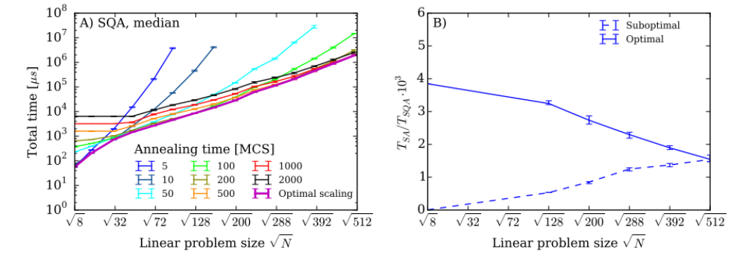

Fig. 1: Pitfalls when detecting speedup. A) The typical (median) time to find a ground state at least once with 99% probability for spin glasses with ±1 couplings using SQA at constant annealing time. The lower envelope of the curves at constant ta corresponds to the total effort at an optimal size-dependent annealing time and can be used to infer the asymptotic scaling. The initial, relatively a flat slope at fixed N is due to suboptimal performance at small problem sizes N, and should therefore not be interpreted as speedup. Annealing times are given in units of Monte Carlo steps (MCS), corresponding to one update per spin. B) The speedup of SQA over SA for two cases. If SQA is run suboptimally at small sizes by choosing a fixed large annealing time t_{a} = 10000 MCS (dashed line) a speedup is feigned. This is due to suboptimal performance on small sizes and not indicative of the real asymptotic behavior when both codes are run optimally (solid line).

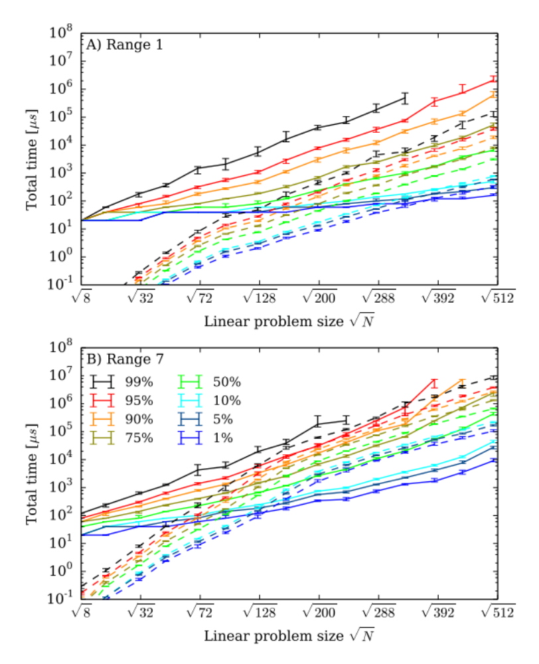

Fig. 2: Scaling of time to solution for the ranges r = 1 (panel A) and r = 7 (panel B). Shown is the scaling of the pure annealing time to find the ground state at least once with a probability p = 0.99 for various quantiles of hardness, for simulated annealing (SA, dashed) and the DW2 (solid). The solid lines terminate for the highest quantiles because the DW2 did not solve the hardest instances for 12 large problem sizes within the maximum number of repetitions (at least 32000) of the annealing we performed.

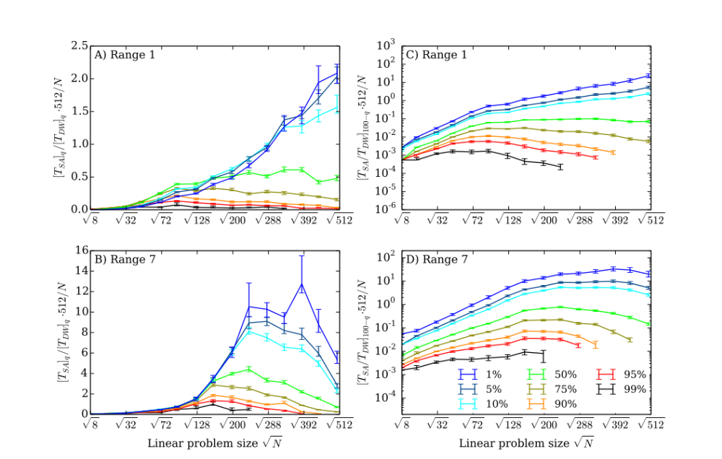

Fig. 3: Speedup of the DW2 compared to SA. A) and B) for the ratio of the quantiles (RofQ), C) and D) for the quantiles of the ratio (QofR). For a random variable X with distribution p(x) and values in x ∈ [0, ∞) we define, as usual, the qth quantile as 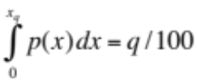, which we solve for x_{q} and plot as a function . In the QofR case we use x_{100−q} so that high quantiles still correspond to instances that are hard for the DW2. We terminate the curves when the DW2 does not find the ground state for large N at high percentiles. In these plots we multiplied Eqs. (4) and (5) by 512 so that the speedup value at N = 512 directly compares one DW2 processor against one classical CPU. An overall positive slope suggests a possible limited quantum speedup, subject to the caveats discussed in the text. A negative slope indicates that SA outperforms the DW2.

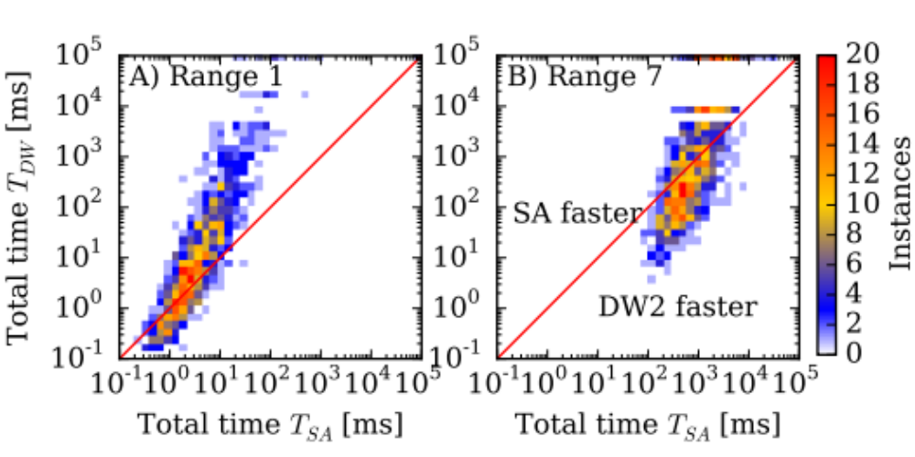

Fig. 4: Instance-by-instance comparison of annealing times. Shown is a scatter plot of the pure annealing time for the DW2 compared to SA using an average over 16 gauges (see (14)) on the DW2 for A) r = 1 and B) r = 7. The color scale indicates the number of instances in each square. Instances below the diagonal red line are faster on the DW2, those above are faster using SA. Instances for which the DW2 did not find the solution with 10000 repetitions per gauge are shown at the top of the frame (no such instances were found for SA).

Supplementary Materials:
The Supplementary Material accompanying this manuscript provides details about the classical simulation algorithms, the DW2 device, the procedure used to determine annealing times, and additional data on scaling with problem size. References (30–37) are only used in the Supplementary Material.

Supplementary Materials:

A fifth type of quantum speedup
In the main text we defined and discussed four types of quantum speedup: provable quantum speedup, strong quantum speedup, quantum speedup (the standard notion), and limited quantum speedup. The standard notion of quantum speedup depends on there being a consensus about the “best available” algorithm, and this consensus may be time and community-dependent. For example, it may be the case, though it seems unlikely, that a classified polynomial-time factoring algorithm is available to parts of the intelligence community. In the absence of a consensus about what is the best classical algorithm, we define “potential (quantum) speedup” as a speedup compared to a specific classical algorithm or a set of classical algorithms. An example is the simulation of the time evolution of a quantum system, where the propagation of the wave function on a quantum computer would be exponentially faster than a direct integration of Schrödinger’s equation on a classical computer. A potential quantum speedup can of course be trivially attained by deliberately choosing a poor classical algorithm, so that here too one must make a genuine attempt to compare against the best classical algorithms known, and any potential quantum speedup might be short-lived if a better classical algorithm is found.
Concerning the limited quantum speedup concept that is of central interest to us in this work, we only compare quantum annealing to classical simulated annealing and simulated quantum annealing. Another example of a limited quantum speedup would be Shor’s factoring algorithm running on a fully coherent quantum computer vs a classical computer where the period finding using a quantum circuit has been replaced by a classical period finding algorithm.

Annealing methods
Quantum annealing
To perform quantum annealing one maps the Ising variables 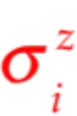 to Pauli z-matrices and adds a transverse magnetic field in the x-direction to induce quantum fluctuations, thus obtaining the time-dependent quantum Hamiltonian
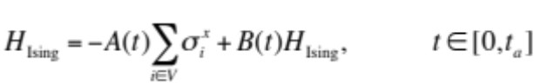 | (1)
The annealing schedule starts at time t = 0 with just the transverse field term (i.e., B(0) = 0) and A(0) ≫ k_{B}T, where T is the temperature, which is kept constant. The system is then in a simple quantum state with (to an excellent approximation) all spins aligned in the x direction, corresponding to a uniform superposition over all 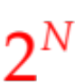 computational basis states (products of eigenstates of the ). During the annealing process the problem Hamiltonian magnitude B(t) is increased and the transverse field A(t) is decreased, ending with A(t_{a}) = 0, and couplings much larger than the temperature: B(t_{a})max(max_{ij} |J_{ij}|,max_{i} |h_{i}|) ≫ k_{B}T. At this point the system will again be trapped in a local minimum, and by repeating the process one may hope to find the global minimum. Quantum annealing can be viewed as a finite-temperature variant of the adiabatic quantum algorithm (10). Examples of annealing schedules used in our work are shown in Figure S1.

Simulated annealing (SA)
Simulated annealing (11) performs a Monte Carlo simulation on the model of Eq. (1), starting from a random initial state at high temperature. During the course of the simulation the temperature is lowered towards zero. At the end of the annealing schedule, at low temperature, the spin configuration of the system ends up in in a local minimum. By repeating the simulation many times one may hope to find the global minimum. More specifically, SA is performed by sequentially iterating through all spins and proposing to flip them based on a Metropolis algorithm using the Boltzmann weight of the configuration at finite temperature. During the annealing schedule we linearly increase the inverse temperature over time from an initial value of β = 0.1 to a final value of β = 3r. For the case of ±1 couplings (r = 1), and for r = 3 we use a highly optimized multispin-coded algorithm based on Refs. (31, 32). This algorithm performs updates on 64 copies in parallel, updating all at once. For the r = 7 simulations we use a code optimized for bipartite lattices. Implementations of the simulated annealing codes are available in Ref. (30). We used the code an ms_r1_nf for r = 1, the code an_ms_r3_nf for r = 3 and the code an_ss_ge_nf_bp for r = 7.

Simulated quantum annealing (SQA)
Simulated quantum annealing (12,13) is an annealing algorithm based on discrete time path-integral quantum Monte Carlo simulations of the transverse field Ising model, following the above annealing schedule at a constant low temperature, but using Monte Carlo dynamics instead of the open system evolution of a quantum system. This amounts to sampling the world line configurations of the quantum Hamiltonian (1) while slowly changing the couplings. The algorithm we used is similar to that of Ref. (12), but uses cluster updates along the imaginary time direction, typically with 64 time slices. Our annealing schedule is linear, as shown in Figure S1B): the Ising couplings are ramped up linearly while the transverse field is ramped down linearly over time. Our SQA results for ranges 1 and 7, complementing Figure 2 in the main text, are shown in Figure S2.
All three annealing methods mentioned above are heuristic. They are not guaranteed to find the global optimum in a single annealing run, but only find it with a certain instance-dependent success probability s ≤ 1. We determine the true ground state energy using an exact belief propagation algorithm (33). We then perform at least 1000 repetitions of the annealing for each instance, count how often the ground state has been found by comparing to the exact result, and use this to estimate the success probability s for each problem instance. See Table S1 for the exact number of repetitions performed on the DW2 device.

The D-Wave Two Vesuvius device
Layout
The Chimera graph of the DW2 used in our tests is shown in Figure S3. Each unit cell is a balanced K_{4,4} bipartite graph. In the ideal Chimera graph (of 512 qubits) the degree of each vertex is 6. For the scaling analysis we considered L × L′ rectangular sub-lattices of the Chimera graph, and restricted our simulations and tests on the DW2 to the subset of functional qubits within these subgraphs. More generally the N = 2cL²-vertex Chimera graph comprises an L × L grid of K_{c,c} unit cells, and the (so-called TRIAD) construction of Ref. (26) can be used to embed the complete L-vertex graph K_{L}, where L = 4c. The treewidth of the N = 2cL²-vertex Chimera graph comprising an L × L grid of K_{c,c} unit cells is 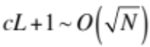 (26). The treewidth of the 512-vertex Chimera graph shown in Figure S3 is 33. Dynamic programming can always find the true ground state of the corresponding Ising model in a time that is exponential in the treewidth, i.e., that scales as exp(a N).

Annealing schedule
Nominally, the DW2 performs annealing by implementing the time-dependent Hamiltonian (1). However, in reality the transverse field varies somewhat from qubit to qubit and the actual Hamiltonian realized is described more accurately as
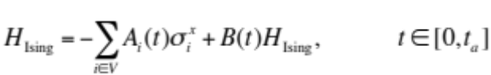 | (2)
The annealing schedules A_{i}(t) and B(t) used in the device are shown in figure S1A). We used the minimal annealing time of t_{a} = 20μs provided by the device since this always gave us the shortest total time-to-solution (see below). The source of this minimal annealing time is engineering restrictions in the DW2. There are four annealing lines, and their synchronization becomes harder for faster annealing schedules. The filtering of the input control lines introduces some additional distortion in the annealing control. Programming the DW2
The DW2 is programmed by providing the sets of couplings J_{ij} and local longitudinal fields h_{i} (which together define a problem instance by specifying H_{Ising}), the number of repetitions R of the annealing to be performed, the annealing time t_{a}, and a number of other parameters which were included in our wall-clock results and which are described below.
The family of problem instances we use for our benchmarking tests employ couplings J_{ij} on all edges of N = 8LL′-vertex subgraphs of the Chimera graph of the DW2, comprising L × L′ unit cells, with L,L′ ∈ {1,...,8}. We set the fields h_{i} = 0 since nonzero values of the fields hi destroy the spin glass phase that exists at zero field, thus making the instances easier (34). We choose the values of the couplings J_{ij} from 2r discrete values {n/r}, with n ∈ {−r, −r − 1, … ,−1,1, … ,r − 1,r}, and call r the “range”. Thus when the range r = 1 we only pick values J_{ij} = ±1. This choice is the least susceptible to calibration errors of the device, but the large degeneracy of the ground states in these cases makes finding a ground state somewhat easier. At the opposite end we consider r = 7, which is the upper limit given the four bits of accuracy of the couplings in the DW2. These problem instances are harder since there are fewer degenerate minima, but they also suffer more from calibration errors in the device.

Gauge averaging
Calibration inaccuracies cause the couplings J_{ij} and h_{i} that are realized in the DW2 to be slightly different from the intended and programmed values (∼ 5% variation). These calibration errors can sometimes lead to the ground states of the model realized in the device being different from the perfect model. To overcome these problems it is advantageous to perform annealing on the device with multiple encodings of a problem instance into the couplers of the device (20). To realize these different encodings we use a gauge freedom in realizing the Ising spin glass: for each qubit we can freely define which of the two qubits states corresponds to σ_{i} = +1 and σ_{i} = −1. More formally this corresponds to a gauge transformation that changes spins 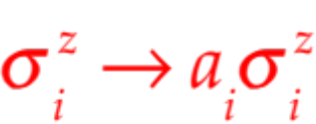, with a_{i} = ±1 and the couplings as J_{ij} → a_{i}a_{j}J_{ij} and h_{i} → a_{i}h_{i}. The simulations are invariant under such a gauge transformation, but (due to calibration errors which break the gauge symmetry) the results returned by the DW2 are not.
If the success probability of one annealing run is denoted by s, then the probability of failing to find the ground state after R independent repetitions (annealing runs) each having success probability s is 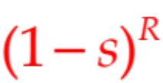, and the total success probability of finding the ground state at least once in R repetitions is
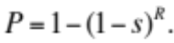 | (3)
Thus the number of repetitions needed to find the ground state at least once with probability P is found by isolating R in Eq. (3). Following (20), after splitting these repetitions into R/G repetitions for each of G gauge choices with success probabilities s_{g}, the total success probability becomes
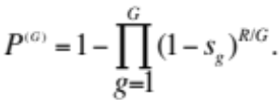 | (4)
If we use the geometric mean of the failure probabilities of the individual gauges to define
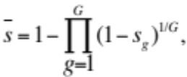 | (5)
then Eq. (4) can be written in the same form as Eq. (3):
(6)
We thus use the geometric mean s in our scaling analysis.

Annealing and wall-clock times
A complementary distinction is that between wall-clock time, denoting the full time-to-solution, and the pure annealing time. Wall-clock time is the total time to find a solution and is the relevant quantity when one is interested in the performance of a device for applications and has been used in Ref. (35). It includes the setup, cooling, annealing and readout times on the DW2, and the setup, annealing and measurement time for the classical annealing codes. The pure annealing time for R repetitions is straightforwardly defined as
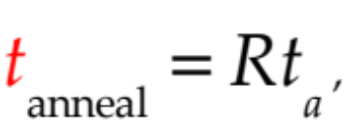 | (7)
where t_{a} the time used for a single annealing run. It is the relevant quantity when one is interested in the intrinsic physics of the annealing processes and in scaling to larger problem sizes on future devices.
In order to measure wallclock times on the DW2 we have performed tests with varying numbers of repetitions R and performed a linear regression analysis to fit the total wall clock time for each problem size to the form t_{p}(N)+Rt_{r}(N), where t_{p}(N) is the total preprocessing time and t_{r}(N) is the total run time per repetition for an N -spin problem. The values of t_{p} and t_{r} are summarized in Table S2. With these numbers we obtain the total wall clock time for R annealing runs split over G gauges (with R/G annealing runs each) as
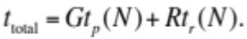 | (8)
To calculate pure annealing times for the simulated annealer we determine the total effort in units of Monte Carlo updates (attempted spin flips), and then convert to time by dividing by the number of updates that the codes can perform per second (30). Our classical reference CPU is an 8-core Intel Xeon E5-2670 CPU, which was introduced around the same time as the DW2.
To obtain wall-clock times we measure the actual time needed to perform a simulation on the same Intel Xeon E5-2670 CPU. Since the multi-spin codes perform at 64 repetitions in parallel, we always make at least 1024 repetitions when running 16 threads on 8 cores. This causes the initially flatter scaling in wall-clock times as compared to pure annealing times (Figure S4). The measured initialization time includes all preparations needed for the algorithm to run, and the spin flip rate was computed for the 99% quantile for 503 qubits. For smaller system sizes or lower quantiles, the spin flip rate is lower since the problems are not hard enough to benefit from parallelization over several cores.
While not as interesting from a complexity theory point of view, it is instructive to also compare wall-clock times for the above benchmarks, as we do in Figure S4. We observe that the DW2 performs similarly to SA run on a single classical CPU, for sufficiently large problem sizes and at high range values. Note that the large constant programming overhead of the DW2 masks the exponential increase of time-to-solution that is obvious in the plots of pure annealing time.
Considering the wall-clock times, the advantage of the DW2 seen in Figure 4 A-B (in the main text) for some instances tends to disappear, since it is penalized by the need for programming the device with multiple different gauge choices. Figure S5A-F shows that for one gauge choice there are some instances, for r = 7, where the DW2 is faster, but many instances where it never finds a solution. Using 16 gauges the DW2 finds the solution in most cases, but is always slower than the classical annealer on a classical CPU for r = 1, as can be seen in Figure S5A and D. For r = 7 the DW2 is sometimes faster than a single classical CPU. Overall, the performance of the DW2 is better for r = 7 than for r = 1, and comparable to SA only when just the pure annealing time is considered. The difference compared to the results of Ref. (35) is due to the use of optimized classical codes using a full CPU in our comparison, as opposed to the use of generic optimization codes using only a single CPU core in Ref. (35).

Optimal annealing times
As discussed in the main text we need to determine the optimal annealing time 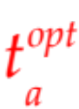 for every problem size N in order to make meaningful extrapolations of the time to find a solution. To determine we perform annealing runs at a different annealing times t_{a}, determine the success probabilities s(t_{a}) of 1000 instances, and from them the required number of repetitions R(t_{a}) to find the ground state with a probability of 99%. That is, we solve Eq. (6) for R while setting P (G) = 0.99:
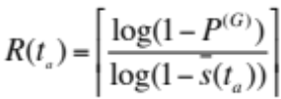. | (9)
The total effort R(t_{a})t_{a} diverges for t_{a} → 0 and t_{a} → ∞ and has a minimum at an optimal annealing time . The reason is that for short t_{a} the success probability 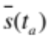 goes to zero, which leads to a diverging total effort, while for large t_{a} the time also grows since one always needs to perform at least one annealing run and the total effort is thus bounded from below by t_{a}.
In Figure S6 (left) we plot various quantiles of the total effort R(t_{a})t_{a} for the simulated annealer as a function of t to determine the optimal annealing time . For the DW2 we find, as shown in Figure S6 (right) that the minimal annealing time of 20μs is always longer than the optimal time and we thus always use the device in a suboptimal mode. As a consequence the scaling of time-to-solution is underestimated, as explained in detail in the main text.
While one can in principle look for an optimal annealing time for each individual problem instance, our approach is to instead determine an averaged optimal annealing time 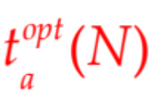 for each problem size N by annealing many instances at a various annealing times t_{a}, and then use these for all future problems of that size.

Resource usage and speedup from parallelism
In the main text we explained that in order to avoid mistaking a parallel speedup for a quantum speedup we need to scale hardware resources (computational gates and memory) in the same way for the devices we compare, and employ these resources optimally. These considerations are not universal but need to be carefully applied for each comparison of a quantum algorithm and device to a classical one. Here we provide several independent derivations that lead us to the same conclusion.
Recall that in the main text we argued that the quantum part of speedup is estimated by comparing the times required by two devices with the same hardware scaling, giving
, | (10)
which is Eq. (3) of the main text. The factor 1/N in the speedup calculation discounts for the intrinsic parallel speedup of the analog device whose hardware resources scale as N, compared to a fixed size classical device used for the timings.

Derivation assuming fixed computational resources
In the consideration of how to disentangle parallel and quantum speedup it may seem more natural to assume fixed computational resources of a given device. We will show that this leads to the same scaling as Eq. (10).
We might be tempted to define the speedup in this case as 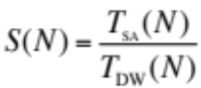. However, in this manner only a fraction N/512 of the qubits are used while the classical code uses the available CPU fully, independently of problem size. This suboptimal use of the DW2 may again be incorrectly interpreted as speedup. The same issue would appear when comparing a classical analog annealer against a classical simulated annealer.
As in the discussion of optimal annealing times above, we need to ensure an optimal implementation to correctly assess speedup. For the DW2 (or a similarly constructed classical analog annealer) this means that one should always attempt to make use of the entire device: we should perform as many annealing runs in parallel as possible. Let us denote the machine size by M (e.g., M = 512 in the DW2 case). With this we define a new, optimized, annealing time
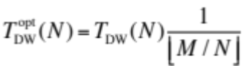, | (11)
and the speedup in our case is then
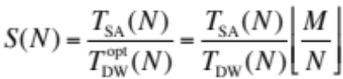. | (12)
Omitting the floor function (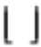), which only gives subdominant corrections in the limit M → ∞ we recover Eq. (10).

Derivation from the scaling of the annealing time.
The conclusion that the speedup function includes a factor proportional to 1/N is validated from yet another perspective, that focuses on the annealing time. Instead of embedding 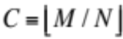 different instances in parallel, we can embed C replicas of a given instance. Each replica r (where r ∈ {1, . . . , C }) results in a guess E_{r,i} of the ground state energy for the ith run, and we can take E_{i} = min_{r} E_{r,i} as the proposed solution for that run. If the replicas are independent and each has equal probability s of finding the ground state, then using C replicas the probability that at least one will find the ground state is 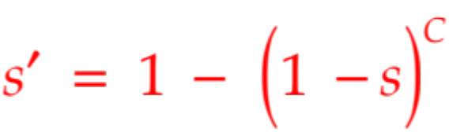, which is also the probability that E_{i} is the ground state energy for the ith run. Repeating the argument leading to Eq. (9), the number of repetitions required to find the ground state at least once with probability p is then:
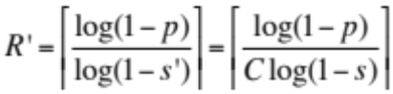, | (13)
while 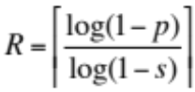. It is easy to show that R′ − 1 ≤ R/C ≤ R′. Focusing log(1 − s) on the pure annealing time we have 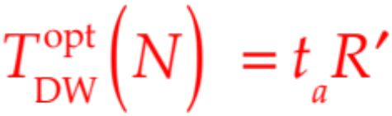 and T_{DW}(N) = t_{a}R, which DW yields Eq. (11) in the limit of large R.

Additional scaling data: range 3
Scaling plots for range 3 instances, requiring 3 bits of precision in the couplings, are shown in Figure S7, complementing Figure 2 in the main text. Figure S8 (left) displays the ratio of quantiles and, like Figure 3 in the main text, does not exhibit a limited quantum speedup. Figure S8 (right) displays the results for the quantiles of ratio of time-to-solution. The results are intermediate between those seen in Figure 3 in the main text for r = 1, 7, namely, while for r = 1 there appears to be a limited quantum speedup (relative to SA) for the higher quantiles, this speedup disappears for r = 7; for r = 3 we observe a flattening of the speedup curves starting at the 10th percentile, while the higher percentiles bend down. The same suboptimality remarks discussed in this context in the main text apply. We have obtained similar results (not shown) for ranges r = 2, 4, 5, 6 and for instances including random longitudinal fields.
Figure S9 shows the instance-by-instance comparisons for the pure annealing time. The conclusions are very similar to those obtained based on Figure 4 in the main text using the r = 1, 7 data.

Arguments for and against a speedup on the DW2
Let us consider in more detail the speedup results discussed in the main text and above. We have argued that the apparent limited quantum speedup seen in the r = 1 results of Figure 3 in the main text must be treated with care due to the suboptimal annealing time. It might then be tempting to argue that, strictly speaking, the comparison with suboptimal-time instances cannot be used for claiming a slowdown either, i.e., that we simply cannot infer how the DW2 will behave for optimal-time instances by basing the analysis on suboptimal times only.
However, let us make the assumption that, along with the total time, the optimal annealing time also grows with problem size N. This assumption is supported by the SA and SQA data shown in Figure 1 in the main text and Figure S10, and is plausible as long as the growing annealing time does not become counterproductive due to coupling to the thermal bath (36). By definition, 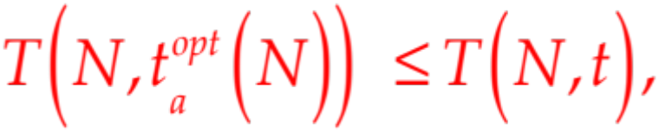 where we have added the explicit dependence on the annealing time, and t_{a} is a fixed annealing time. Thus
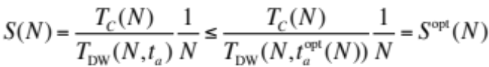. | (14)
Under our assumption, 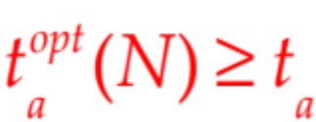for small N, but for sufficiently large N the optimal annealing time grows so that . Thus there must be a problem aa size N∗ at which 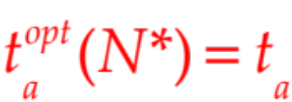, and hence at this special problem size we also have S(N∗) = S^{opt}(N∗). However, the minimal annealing time of 20μs is longer than the optimal time for all problem sizes (see Figure S6), i.e., N∗ > 503 in our case. Therefore, if S(N) is a decreasing function of N for sufficiently large N, as we indeed observe in all our RofQ results (recall Figure 3A and B in the main text), then since S^{opt}(N) ≥ S(N) and S(N∗) = S^{opt}(N∗), it follows that S^{opt}(N) too must be a decreasing function for a range of N values, at least until N∗. This shows that the slowdown conclusion holds also for the case of optimal annealing times.
For the instance-by-instance comparison (QofR), no such conclusion can be drawn for the subset of instances (at r = 1) corresponding to the high quantiles where S^{QofR}(N) is an increasing function of N. This limited quantum speedup may or may not persist for larger problem sizes or if optimal annealing times are used.

Additional Discussion
In this work we have discussed challenges in properly defining and assessing quantum speedup, and used comparisons between a DW2 and simulated classical and quantum annealing to illustrate these challenges. Strong or provable quantum speedup, implying speedup of a quantum algorithm or device over any classical algorithm, is an elusive goal in most cases and one thus usually defines quantum speedup as a speedup compared to the best available classical algorithm. We have introduced the notion of limited quantum speedup, referring to a more restricted comparison to ‘corresponding’ classical algorithms solving the same task, such as a quantum annealer compared to a classical annealing algorithm.
Quantum speedup is most easily defined and detected in the case of an exponential speedup, where the details of the quantum or classical hardware do not matter since they only contribute subdominant polynomial factors. In the case of an unknown or a polynomial quantum speedup one must be careful to fairly compare the classical and quantum devices, and, in particular, to scale hardware resources in the same manner. Otherwise parallel speedup might be mistaken for (or hide) quantum speedup.
An experimental determination of quantum speedup suffers from the problem that all measurements are limited to finite problem sizes N, while we are most interested in the asymptotic behavior for large N. To arrive at a reliable extrapolation it is advantageous to focus the scaling analysis on the part of the execution time that becomes dominant for large problem sizes N, which in our example is the pure annealing time, and not the total wall-clock time. For each problem size we furthermore need to ensure that neither the quantum device nor the classical algorithm are run suboptimally, since this might hide or fake quantum speedup.
If the time to solution depends not only on the problem size N but also on the specific problem instance, then one needs to carefully choose the relevant quantity to benchmark. We argued that in order to judge the performance over many possible inputs of a randomized benchmark test, one needs to study the high quantiles, and define speedup by considering the ratio of the quantiles of time to solution. If, on the other hand, one is interested in finding out whether there is a speedup for some subset of problem instances, then one can instead perform an instance-by-instance comparison by focusing on the quantiles of the ratio of time to solution.
We chose to focus here on the benchmark problem of random zero-field Ising problems parametrized by the range of couplings. We did not find evidence of limited quantum speedup for the DW2 relative to simulated annealing in our particular benchmark set when we considered the ratio of quantiles of time to solution, which is the relevant quantity for the performance of a device as an optimizer. We note that random spin glass problems, while an interesting and important physics problem, may not be the most relevant benchmark for practical applications, for which other benchmarks may have to be studied.
When we focus on subsets of problem instances in an instance-by-instance comparison, we observe a possibility for a limited quantum speedup for a fraction of the instances. (The fact that some problems are solved faster on classical hardware and some on the DW2 raises the possibility of a hybrid approach that benefits by solving a problem instance using both, and then selecting the best solution found.) However, since the DW2 runs at a suboptimal annealing time for most of the corresponding problem instances, the observed speedup may be an artifact of attempting to solve the smaller problem sizes using an excessively long annealing time. This difficulty can only be overcome by fixing the issue of suboptimal annealing times, e.g., by finding problem classes for which the annealing time is demonstrably already optimal. Alternatively, other problem classes might exhibit a speedup. For example, it is possible that a randomized benchmark with a tunable “hardness knob”, such as the clause density in the MAX-2SAT problem (37), will allow for a more fine-tuned exploration of the performance potential of a quantum annealer than a purely randomized benchmark such as we have used here. It was also proposed that embedding 3D spin-glass problems into the Chimera graph, with a finite critical temperature, might yield problem classes that are better suited as benchmarks for quantum annealing (28).

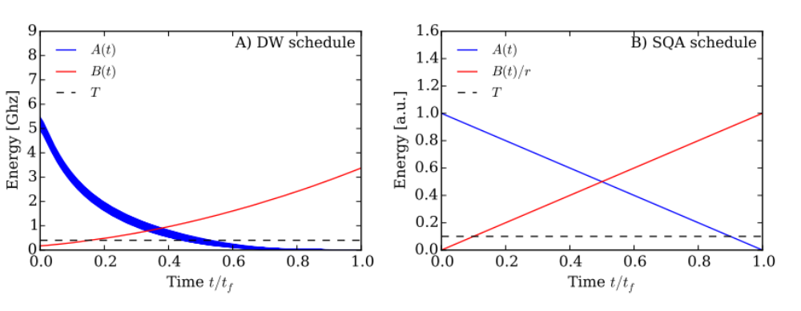
Fig. S1: Annealing schedules. A) The amplitudes of the transverse fields A_{i}(t) [decreasing, blue; see Eq. (2)] and the longitudinal couplings B(t) (increasing, red) as a function of time. The device temperature of T = 18mK is indicated by the black horizontal dashed line. B) The linear annealing schedule used in simulated quantum annealing.

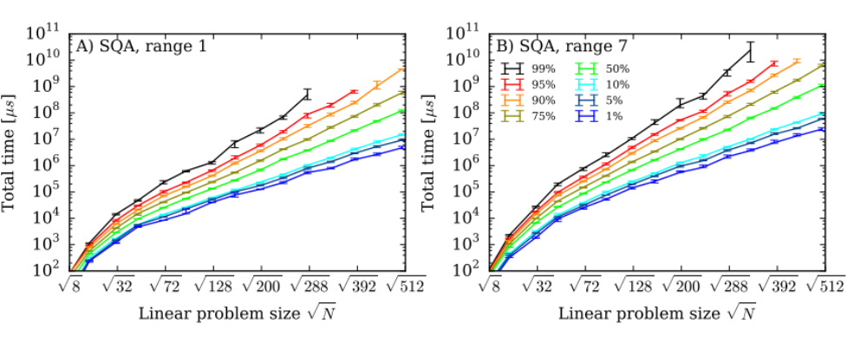
Fig. S2: Scaling of time-to-solution for SQA. Shown is the time-to-solution A) for range r = 1 and B) for range r = 7.

N ≤ 238 | N ≤ 284, 332 | N ≤ 385, 439 | N ≤ 503
1000 | 2000 | 5000 | 10000
Table S1: Repetitions of annealing runs used on the DW2. This table summarizes the total number of repetitions used to estimate the success probabilities on the DW2 for various system sizes.

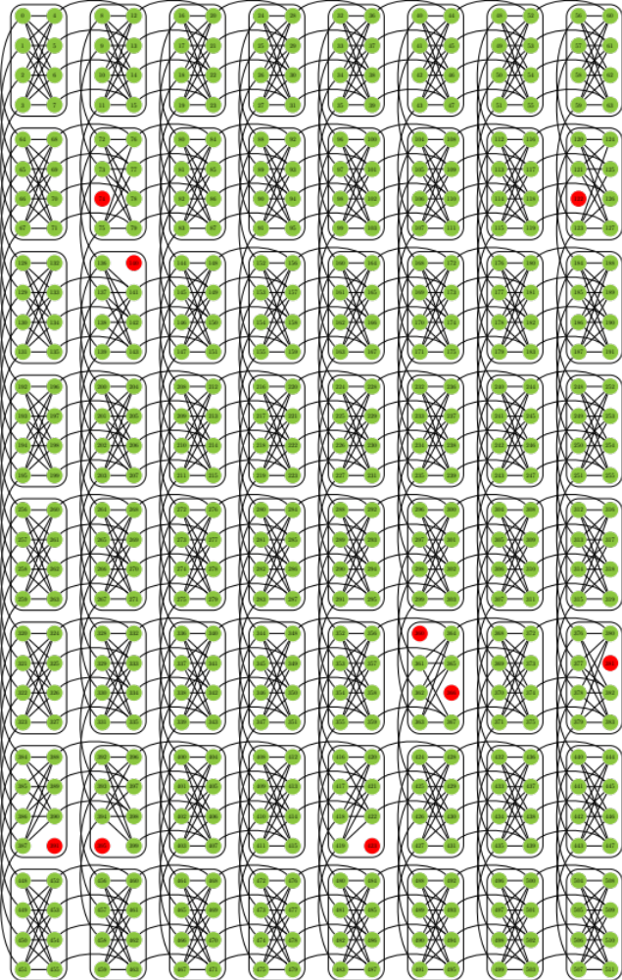
Fig. S3: Qubits and couplers in the D-Wave Two device. The DW2 “Vesuvius” chip consists of an 8 × 8 two-dimensional square lattice of eight-qubit unit cells, with open boundary conditions. The qubits are each denoted by circles, connected by programmable inductive couplers as shown by the lines between the qubits. Of the 512 qubits of the device located at the University of Southern California used in this work, the 503 qubits marked in green and the couplers connecting them are functional.

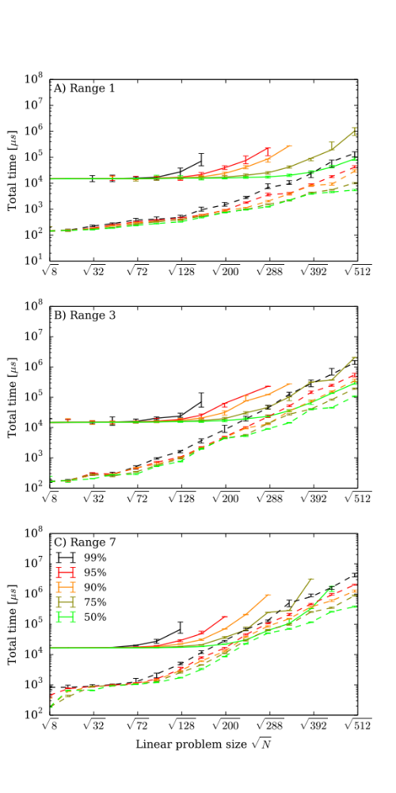 | 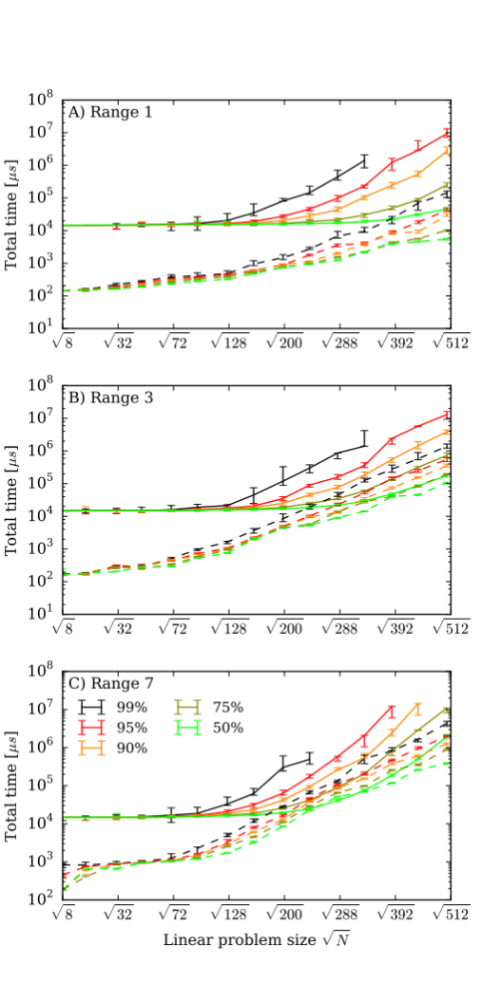
Fig. S4: Comparing wall-clock times. A comparison of the wall-clock time to find the solution with probability p = 0.99 for SA running on a single CPU (dashed lines) compared to the DW2 [solid lines] using a single gauge choice in the left column and 16 gauges in the right column. A) for range r = 1, B) for range r = 3, C) for range r = 7. Shown are curves from the median (50th quantile) to the 99th quantile. The large constant programming overhead of the DW2 masks the exponential increase of time-to-solution that is obvious in the plots of pure annealing time.

N | t_{p} [ms] | t_{r} [µs]
8 | 14.7 ± 0.3 | 51.0 ± 0.2
16 | 14.8 ± 0.3 | 53.0 ± 0.2
31 | 14.8 ± 0.3 | 57.9 ± 0.2
47 | 14.9 ± 0.4 | 60.6 ± 0.2
70 | 15.0 ± 0.4 | 64.5 ± 0.2
94 | 15.2 ± 0.3 | 68.3 ± 0.2
126 | 15.6 ± 0.2 | 73.1 ± 0.2
158 | 15.5 ± 0.2 | 78.0 ± 0.2
198 | 15.5 ± 0.2 | 80.8 ± 0.2
238 | 15.7 ± 0.2 | 83.5 ± 0.2
284 | 15.8 ± 0.2 | 83.6 ± 0.1
332 | 16.0 ± 0.3 | 87.1 ± 0.2
385 | 16.6 ± 1.0 | 87.1 ± 0.6
439 | 16.6 ± 0.1 | 90.4 ± 0.1
503 | 16.6 ± 0.2 | 90.5 ± 0.1

Table S2: Wallclock times on the DW2. Listed are measured programming times t_{p} and annealing plus readout times t_{r} (for a pure annealing time of 20μs) on the DW2 for various problem sizes.

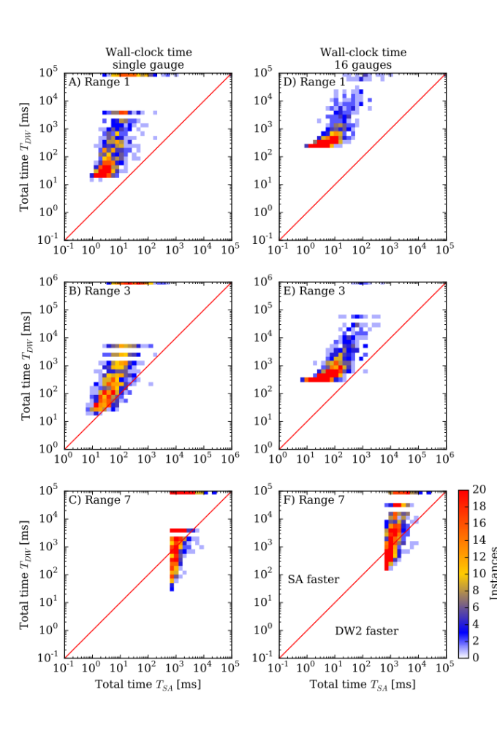
Fig. S5: Instance-by-instance comparison. Shown is a scatter plot of the total time for the DW2 device (DW) compared to a simulated classical annealer (SA) A and D) for r = 1, B and E) for r = 3, and C and F) for r = 7. A, B and C) wall- clock time using a single gauge on the DW2, and, D, E and F) wall-clock time using 16 gauges on the DW2. The color scale indicates the number of instances in each square. Instances below the diagonal red line are faster on the DW2, those above are faster classically. Instances for which the DW2 device did not find the solution are shown at the top. SA found a solution for every instance of this benchmark.

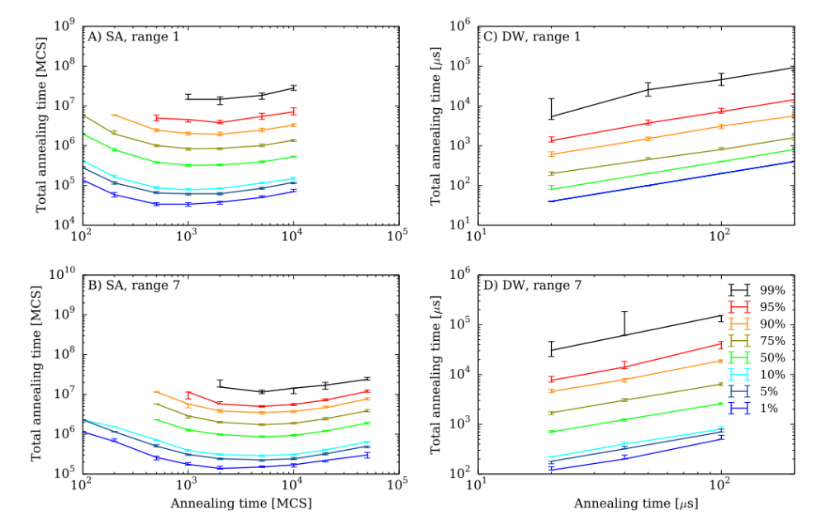
Fig. S6: Optimal annealing times for the simulated annealer and for the D-Wave device. Shown is the total effort R(t_{a})t_{a} as a function of annealing time t_{a} for various quantiles of problems with r = 1 and r = 7. A) and B) SA, where the minimum of the total effort determines the optimal annealing time topt. C) and a D) DW2, where we find a monotonically increasing total effort, meaning that the optimal time is always shorter than the minimal annealing time of 20μs.

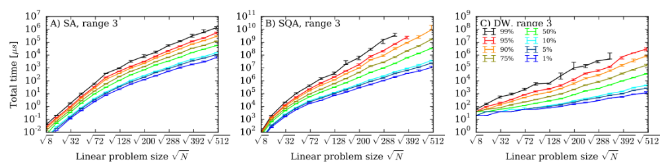
Fig. S7: Scaling of time-to-solution for r = 3. Shown is the scaling for the time to find the ground state with a probability of 99% for various quantiles of hardness for A) the simulated annealer, B) the simulated quantum annealer, and C) the DW2 device.

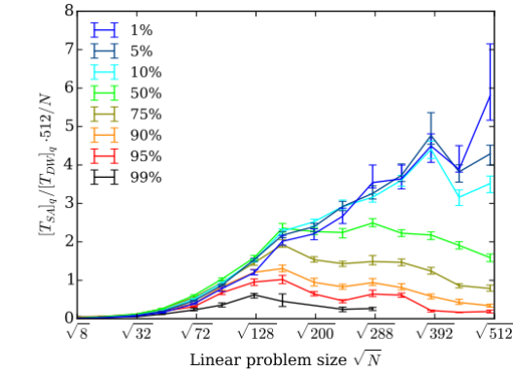 | 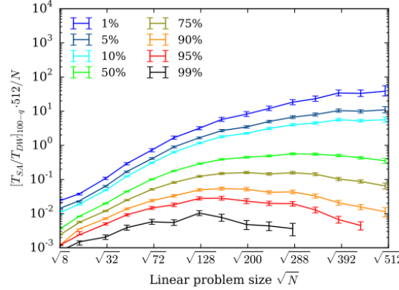

Fig. S8: Speedup for the DW2 device compared to SA for instances with r = 3. 16 gauges were used. Left: the ratio of quantiles (RofQ). Right: quantiles of the ratio (QofR). The results are intermediate between the r = 1 and r = 7 results as discussed in the text.

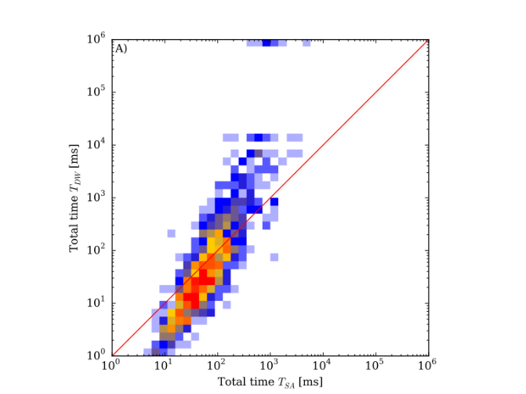
Fig. S9: Instance-by-instance comparison for r = 3. Comparison between time-to-solution for SA and DW2 using pure annealing times and using 16 gauges.

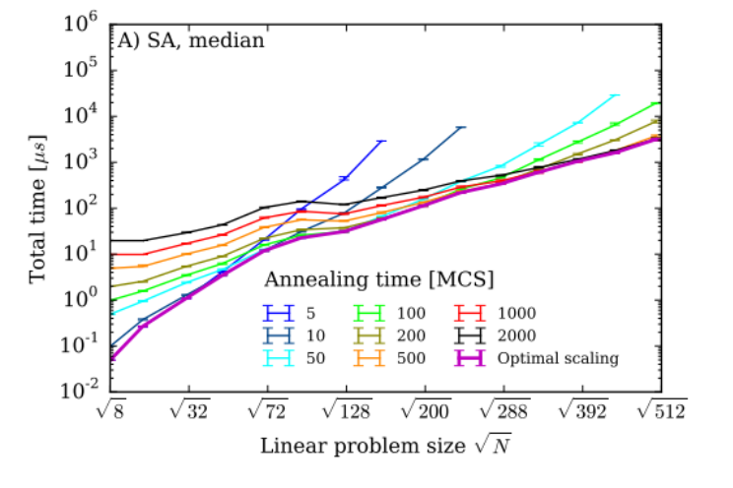
Fig. S10: Optimal annealing times for SA. Shown is the time-to-solution for various quantiles as a function of annealing time (Monte Carlo steps) for SA range r = 1. This supplements Figure 1 in the main text.

