LABORATORY EXERCISE 7

FILE UPLOADS (COURSE MATERIALS)

Learning Objectives
By the end of this laboratory exercise, students should be able to:
- Design and implement a database schema for managing file uploads related to courses.
- Utilize CodeIgniter's File Uploading Library to handle file uploads securely.
- Create an administrative interface for uploading and managing course materials.
- Implement access control to ensure only enrolled students can download materials.
- Enhance the user interface with Bootstrap for a clean and functional file management system.

Prerequisite student experiences and knowledge
Before starting this exercise, students should have:
- Completed Laboratory Exercise 6 (Course Enrollment System).
- A solid understanding of CodeIgniter's MVC structure and database operations.
- Experience with HTML forms and Bootstrap styling.
- Basic knowledge of handling file inputs in HTML.
- Familiarity with user authentication and session management in CodeIgniter.

Background
A core feature of any Learning Management System (LMS) is the distribution of learning resources. This involves allowing instructors to upload various file types (such as PDFs, PowerPoint presentations, and documents) and making them available to enrolled students. CodeIgniter provides a robust File Uploading Library that simplifies the process of validating, uploading, and securing files. This exercise will integrate this functionality into the LMS, ensuring that file management is seamless and secure.

Materials/Resources
- Personal Computer with Internet Access
- XAMPP/WAMP/LAMP server installed
- CodeIgniter Framework (latest version)
- Visual Studio Code or any code editor
- Git and GitHub Account
- Web Browser (Chrome, Firefox, etc.)
Laboratory Activity
Step 1: Create a Database Migration for Materials Table
- Create a new migration file for the materials table.
Run: php spark make:migration CreateMaterialsTable
- Open the newly created file in app/Database/Migrations/.
- In the up() method, define the table with the following fields:
- id (Primary Key, Auto-Increment)
- course_id (INT, Foreign Key referencing the `courses` table)
- file_name (VARCHAR(255)) to store the original filename
- file_path (VARCHAR(255)) to store the path to the uploaded file
- created_at (DATETIME)
- In the down() method, define how to drop the table.
Run the migration: php spark migrate

Step 2: Create a Model for Materials
- Navigate to app/Models/ and create a file named MaterialModel.php.
- Create a model class with methods to:
- insertMaterial($data) Insert a new material record.
- getMaterialsByCourse($course_id) Get all materials for a specific course.

Step 3: Create or Modify a Controller for Materials
- You can create a new Materials.php controller or add methods to an existing admin controller.
- Add the following methods:
- upload($course_id) Displays the file upload form and handles the file upload process.
- delete($material_id) Handles the deletion of a material record and the associated file.
- download($material_id) Handles the file download for enrolled students.

Step 4: Implement File Upload Functionality
- In the upload($course_id) method, check for a POST request.
- Load CodeIgniter's File Uploading Library and Validation Library.
- Configure the upload preferences (upload path, allowed file types, maximum file size).
- Perform the file upload. If successful, prepare data (course_id, file_name, file_path) and save it to the database using the MaterialModel.
- Set a flash message indicating success or failure and redirect back to the course management page.

Step 5: Create the File Upload View
- Create a view file.
- The view should contain a form with the enctype="multipart/form-data" attribute and a file input field.
- Style the form using Bootstrap classes.

Step 6: Display Downloadable Materials for Students
- In the student dashboard or a dedicated course view, use the MaterialModel to fetch materials for the courses the student is enrolled in.
- Create a view that lists these materials, displaying the file name and a download button/link for each.
- The download link should point to the download($material_id) method in your controller.

Step 7: Implement the Download Method
- In the download($material_id) method:
- Check if the current user is logged in and enrolled in the course associated with the material.
- Retrieve the file path from the database using the `$material_id`.
- Use CodeIgniter's download() helper function or the Response class to force the file download securely.

Step 8: Update Routes
- Update app/Config/Routes.php to include routes for the new functionalities.
$routes->get('/admin/course/(:num)/upload', 'Materials::upload/$1');
$routes->post('/admin/course/(:num)/upload', 'Materials::upload/$1');
$routes->get('/materials/delete/(:num)', 'Materials::delete/$1');
$routes->get('/materials/download/(:num)', 'Materials::download/$1');

Step 9: Test the Application
- Run the application and test the complete flow:
- Log in as an admin/instructor.
- Navigate to a course and upload a file (PDF, PPT).
- Verify the file is saved in the designated folder and a record is added to the `materials` table.
- Log in as a student enrolled in the course.
- Navigate to the course page and verify the material is listed.
- Test the download functionality.
- Test accessing the download link while not enrolled (it should be restricted).

Step 9: Push to GitHub
- Add, commit, and push your changes to your GitHub repository.

Output / Results
- Screenshot of the materials table schema from your database (phpMyAdmin or equivalent).
- Screenshots of the file upload form (admin side) and the student view showing the list of downloadable materials.
- Screenshot of the server's file system (upload directory) showing the uploaded file.
- A screenshot of the GitHub repository with the latest commit for this exercise.

QUESTIONS:
- What are the security risks associated with file uploads, and how did you mitigate them using CodeIgniter's File Uploading Library?
File uploads are a common feature in many web applications, but they present considerable security risks if not handled correctly. One major concern is the possibility of users uploading malicious files, such as scripts disguised as harmless documents or images, which could then be executed on the server. Attackers may also attempt to upload excessively large files to exhaust server storage or processing resources, resulting in denial-of-service issues. To mitigate these risks when working with CodeIgniter, its File Uploading Library provides several built-in security mechanisms. By configuring allowed file types, maximum file sizes, and designated upload directories located outside the public root, developers can limit exposure to harmful files. Additionally, CodeIgniter automatically assigns encrypted file names, reducing the likelihood of file overwrites or direct file access. Validating uploads through these settings ensures that only legitimate and safe files are processed by the application.
- Explain the purpose of the enctype="multipart/form-data" attribute in the form tag for file uploads.
To support secure and successful file uploads, the HTML form must include the attribute enctype="multipart/form-data". This encoding type instructs the browser to package and transmit both regular form inputs and binary file data to the server properly. Without this attribute, uploaded files would either fail to transfer or arrive corrupted because the browser would default to standard URL-encoded form submission. In essence, multipart/form-data is essential for correctly formatting file content, ensuring the server—particularly frameworks like CodeIgniter—can interpret and process the uploaded data safely.
- Why is it important to check if a student is enrolled in a course before allowing them to download a material? How does this enforce application security?. Beyond upload security, controlling access to materials is equally important in maintaining application integrity. Checking whether a student is enrolled in a course before permitting them to download course materials ensures that sensitive or paid content is not accessed by unauthorized users. This access control mechanism protects intellectual property, prevents data leaks, and ensures that users interact with the system according to their assigned permissions. From a security standpoint, enrollment verification enforces authorization rules, a core component of application security. It ensures that even if a user obtains a direct download link, they cannot access the material without proper permissions, thereby reducing the risk of unauthorized distribution.

Output / Results

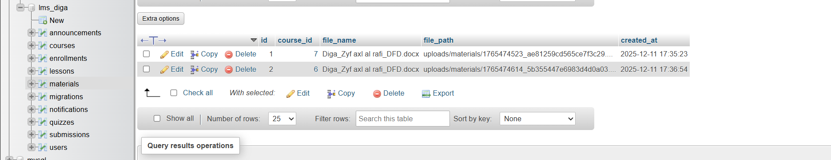

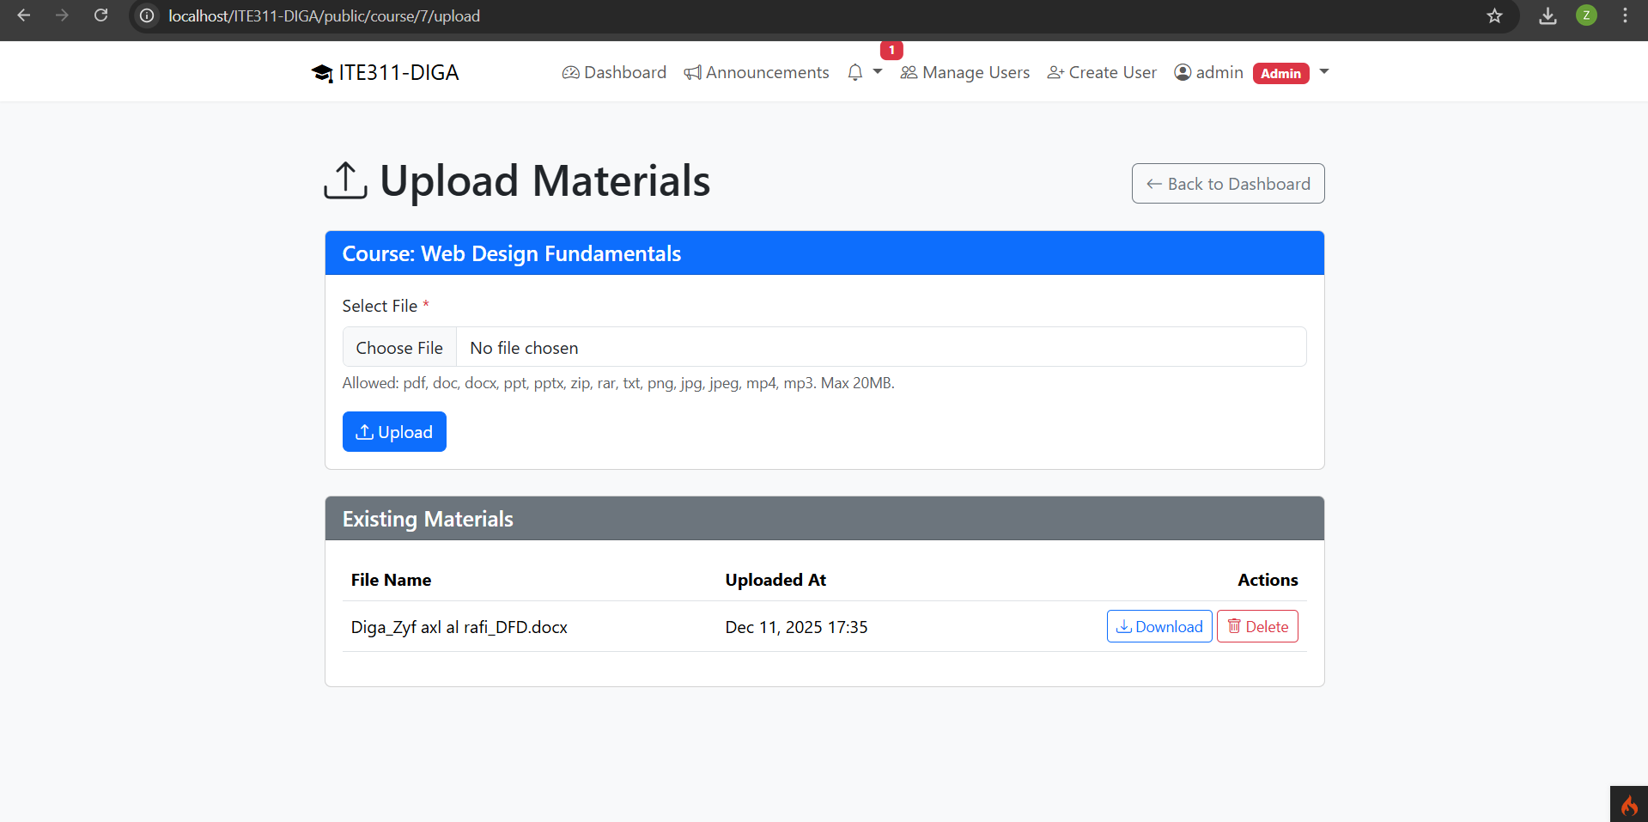

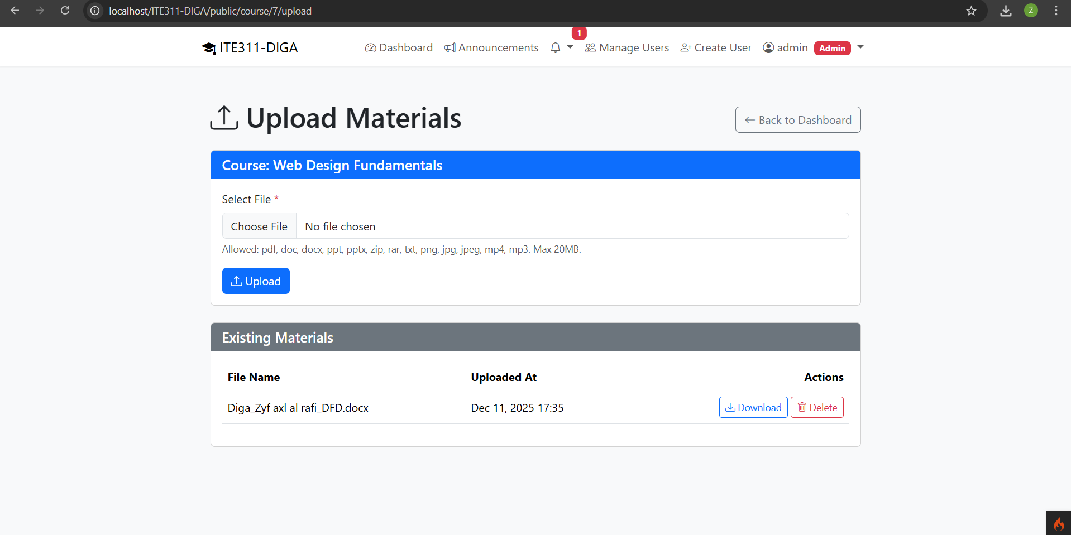

Conclusion
In conclusion, secure file handling and proper access control are fundamental to building a robust and trustworthy system. CodeIgniter’s File Uploading Library mitigates several upload-related risks through strict file validation and controlled handling. Meanwhile, the multipart/form-data attribute ensures that files are transmitted safely and accurately. Finally, validating a student's enrollment before granting access to course materials reinforces strong authorization practices, protecting both system data and user resources. Together, these practices form a comprehensive approach to improving security within a web application.

