Jiaxi Kang 1002413328 Lab4 Report

4.1

|dx/dt = [3 4; 5 4] x - [2 1; 1 3] [4; 5]|

a)

Equilibrium Solutions: x1 = 3, x2 = 1

b)

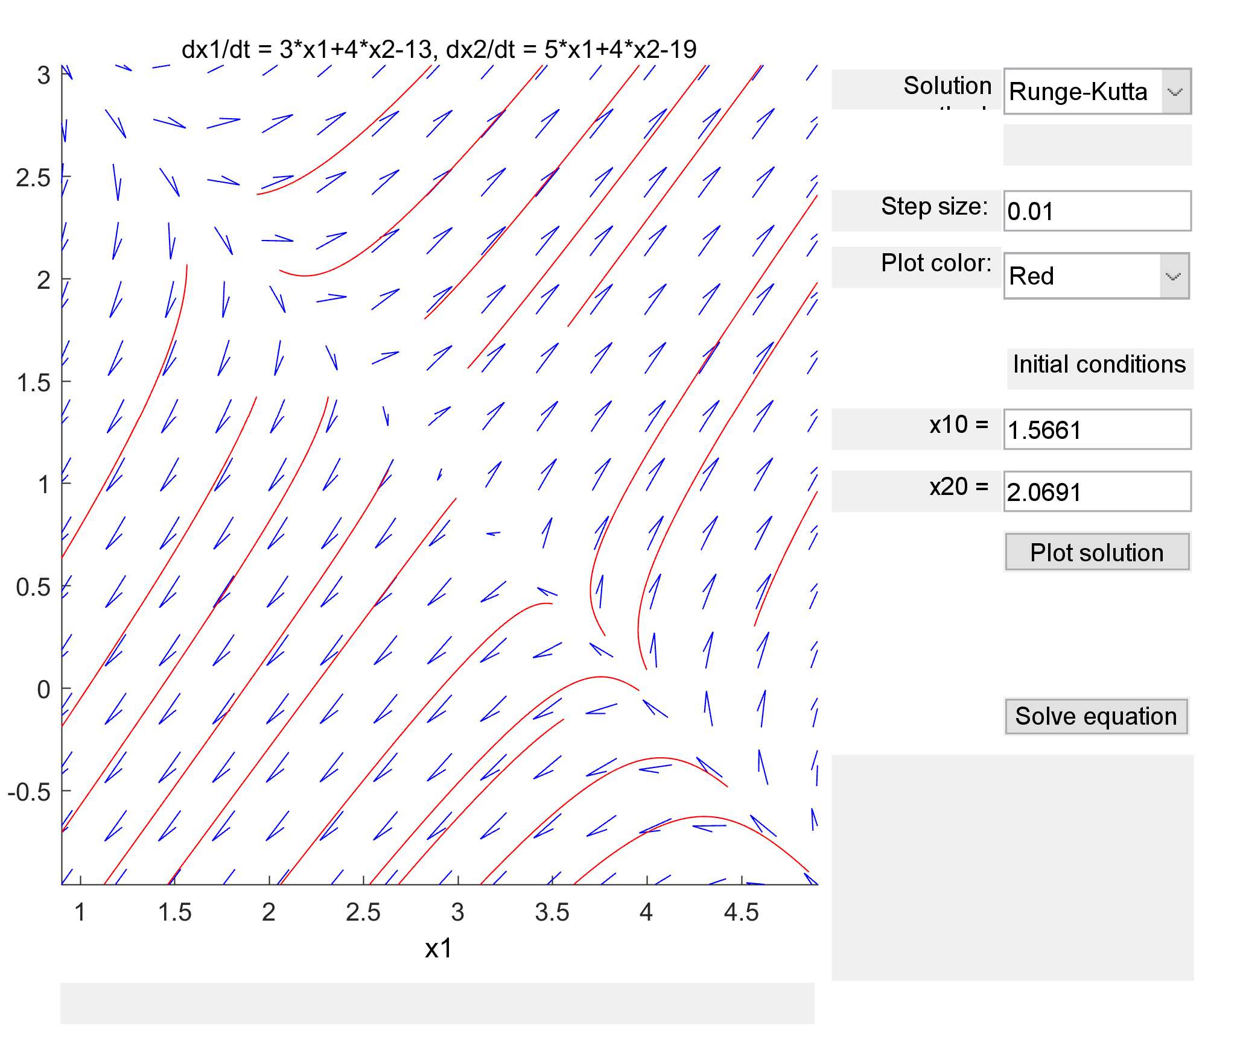

c) Unstable, saddle point at x1 = 3, x2 = 1

d)

Since λ1 < 0 < λ2, the equilibrium point must be an unstable saddle point.

4.2 |dx/dt = [-3 -4; -5 -4] x - [13; 19]|

a)

x1 = -3, x2 = -1

b)

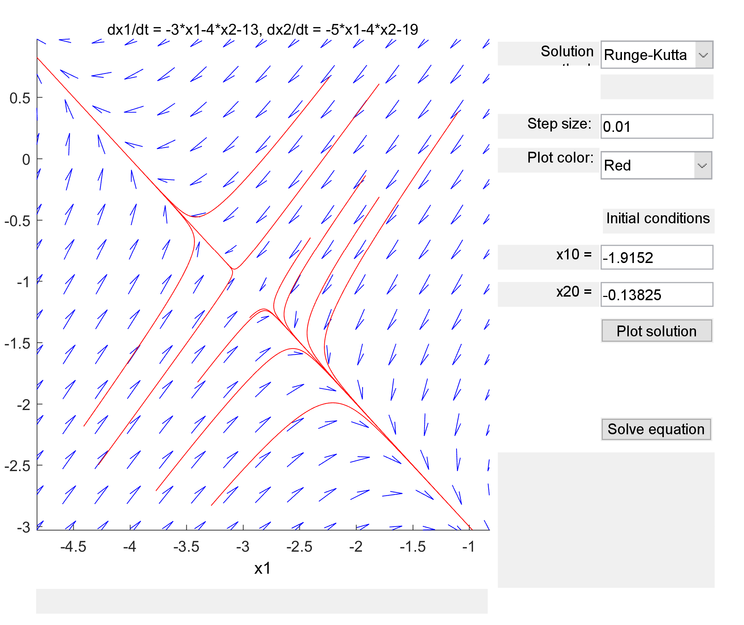

c)

Equilibrium point is an unstable saddle point.

d)

Since λ1 < 0 < λ2, the equilibrium point must be an unstable saddle point.

4.3 |dx/dt = [4 -2; 2 -1] x + [8; 4]|

a) Equilibrium solution is a line 0=4\*x1 – 2\*x2 + 8

b)

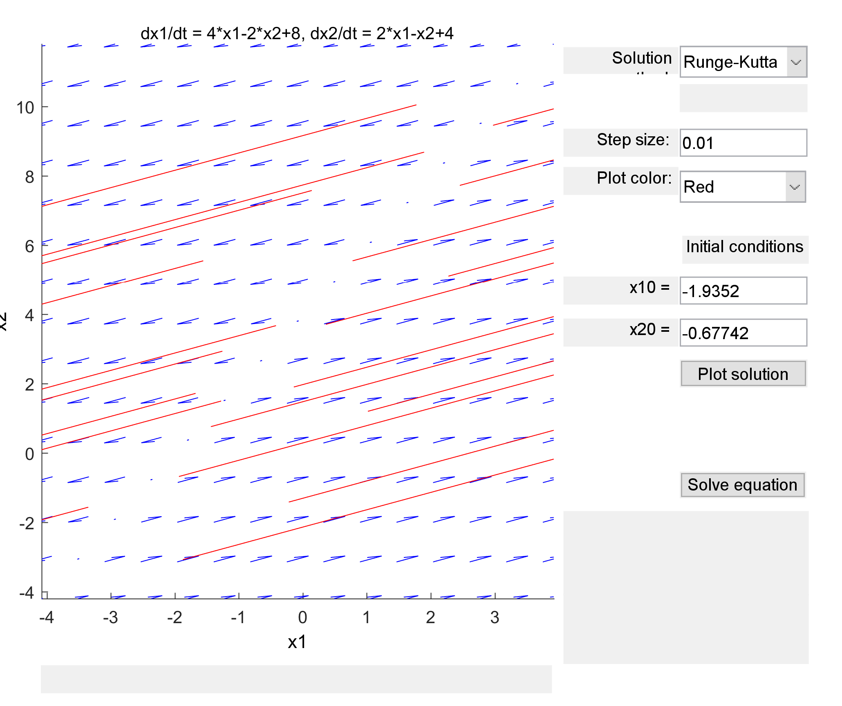

c)

The equilibrium line is unstable as the solution is moving away from the line.

d)

Cannot use eigenvalues to argue stability because the determinant of the matrix is 0.

4.4 |dx/dt = [-4 2; -2 1] x + [8; 4]|

a)

Equilibrium solution is a line x2 = 2x1 – 4

b)

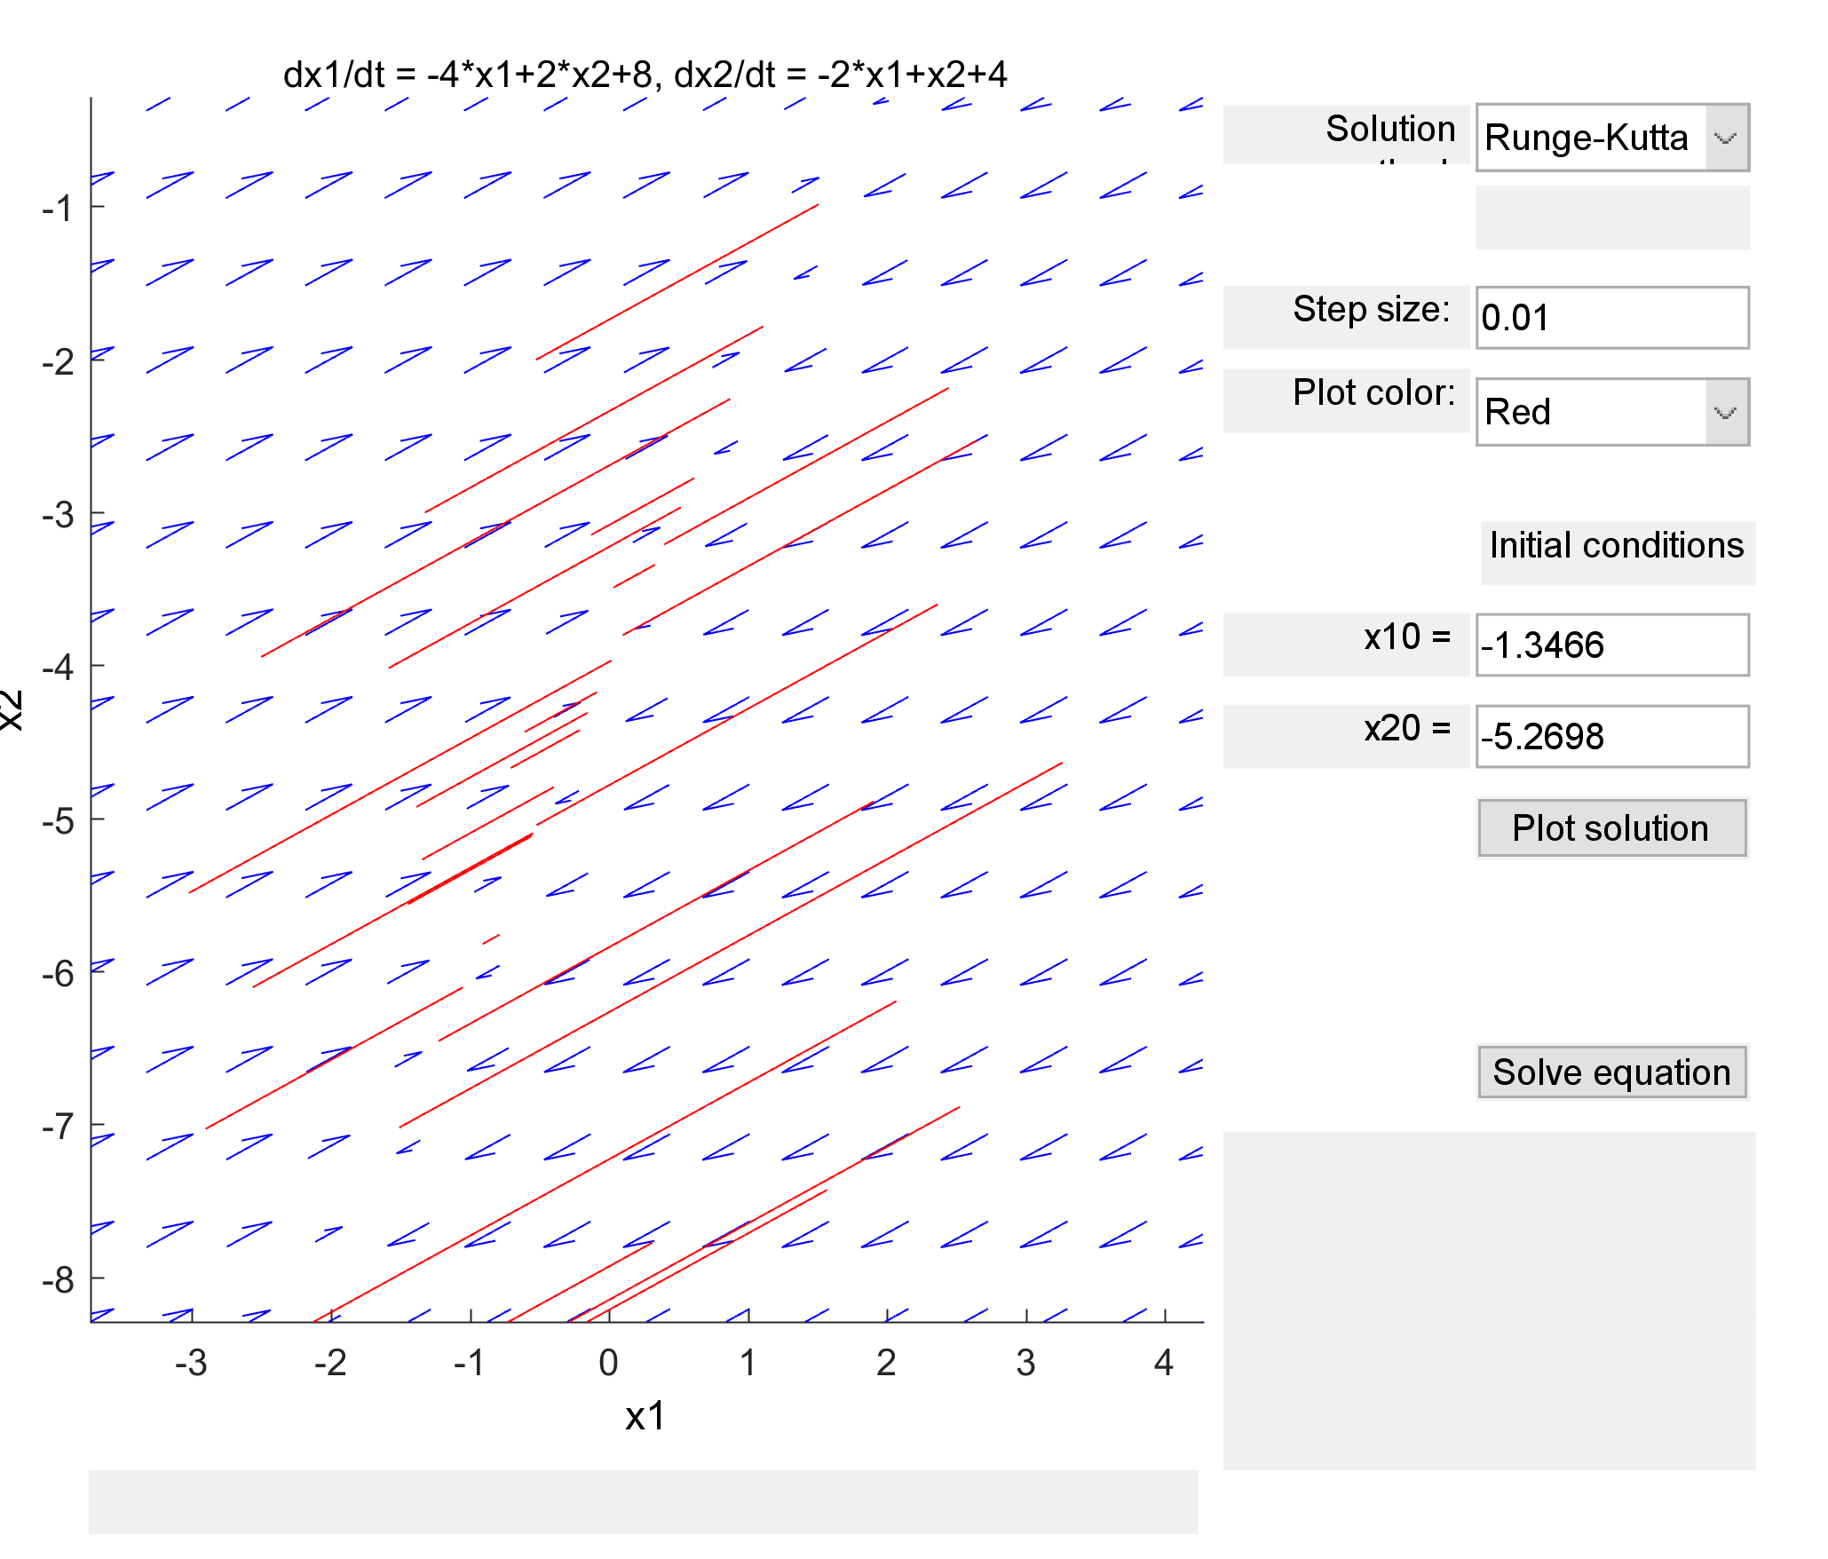

c) Equilibrium solution is a stable line because solutions are moving towards it

d)

Cannot determine because the determinant of the matrix is zero.

4.5 |dx/dt = [0 -1; 1 -1] x + [1; 0]|

a) Equilibrium point is at x1 = 1, x2 = 1

b)

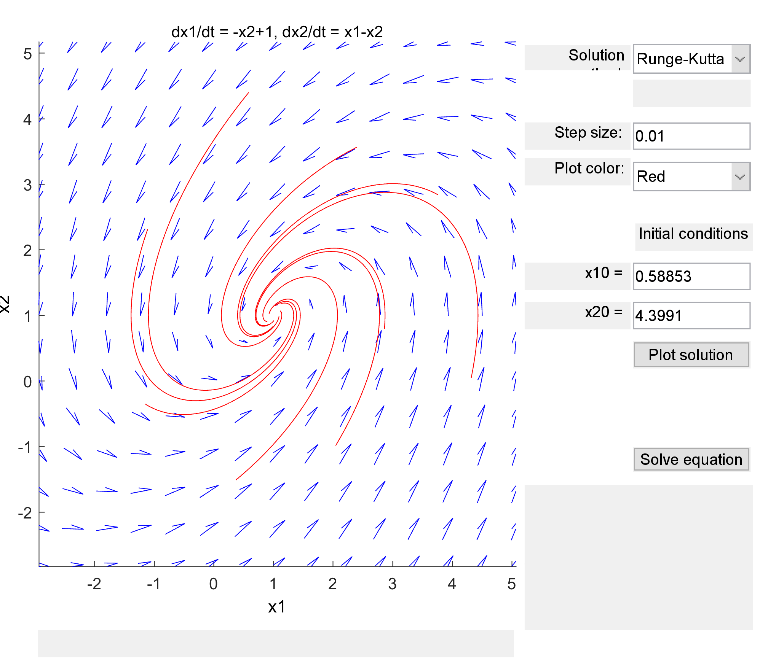

c) This is an asymptotically stable spiral point (spiral sink) with counter-clockwise direction.

d)

Since the eigenvalue is a complex number with the real component less than 0, it must be an asymptotically stable spiral point.

4.6 |dx/dt = [0 1; -1 1] x + [1; 0]|

a) Equilibrium point is at x1 = -1, x2 = -1

b)

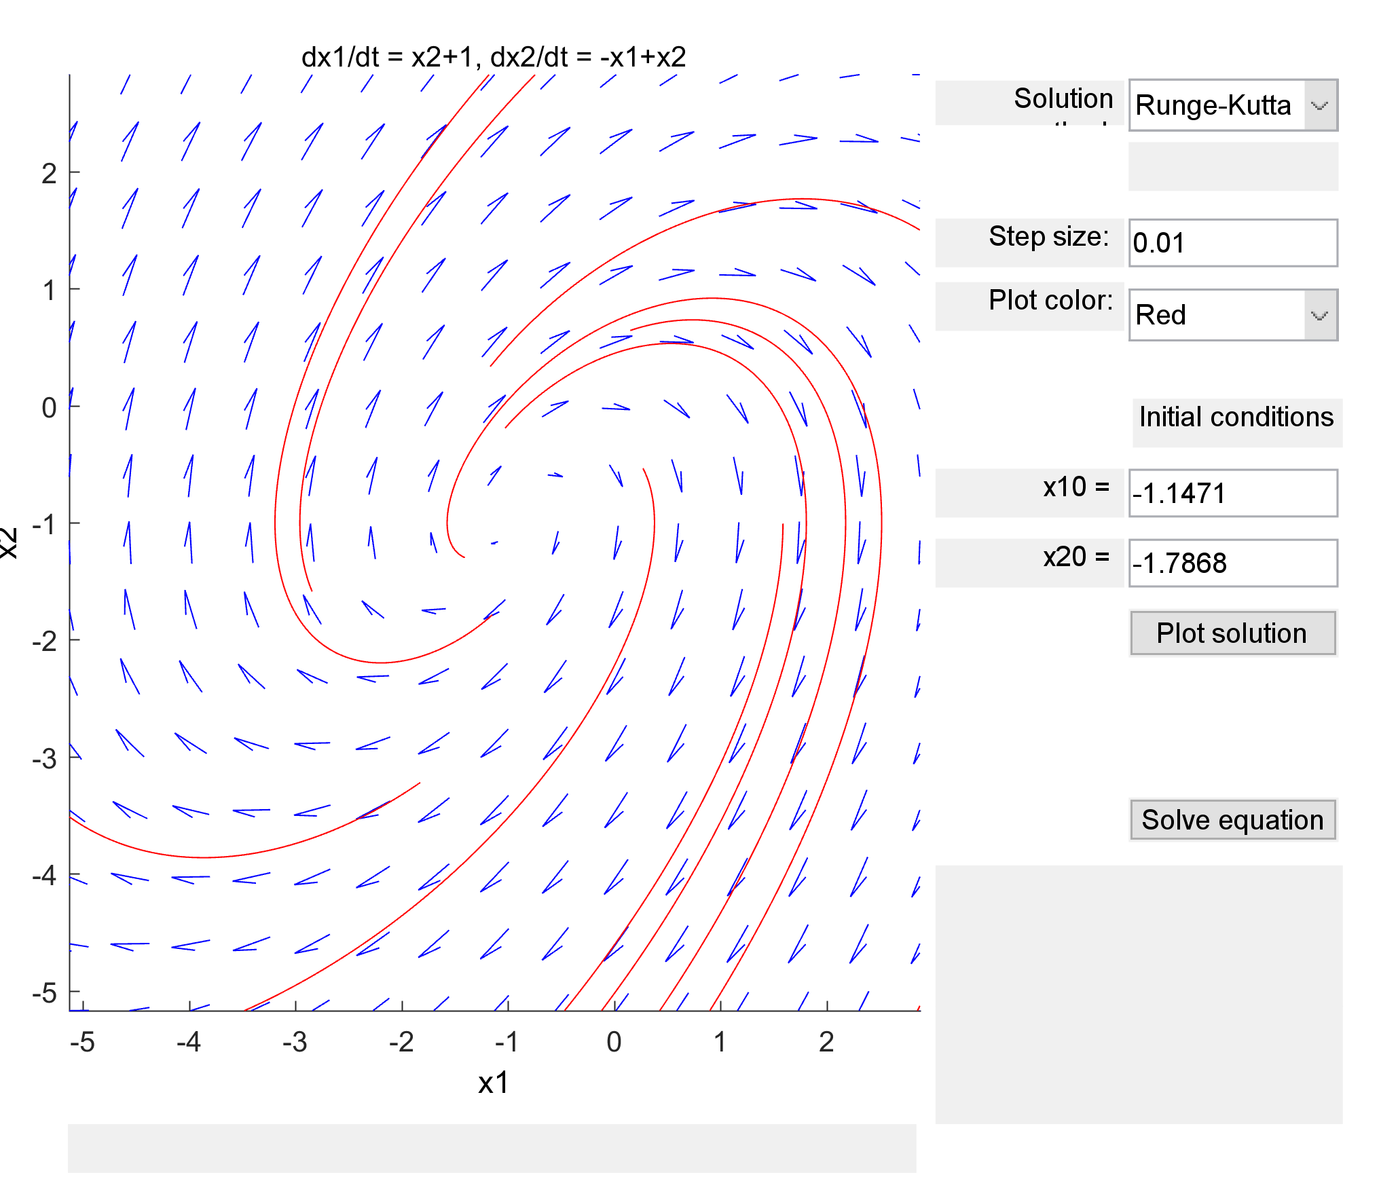

c) This is an unstable spiral center (spiral source) with a clockwise direction.

d)

Since the eigenvalue is a complex number with the real component greater than 0, it must be an unstable spiral point.

4.7 |dx/dt = [-1 1; -5 1] x|

a) Equilibrium point is x1 = 0, x2 = 0

b)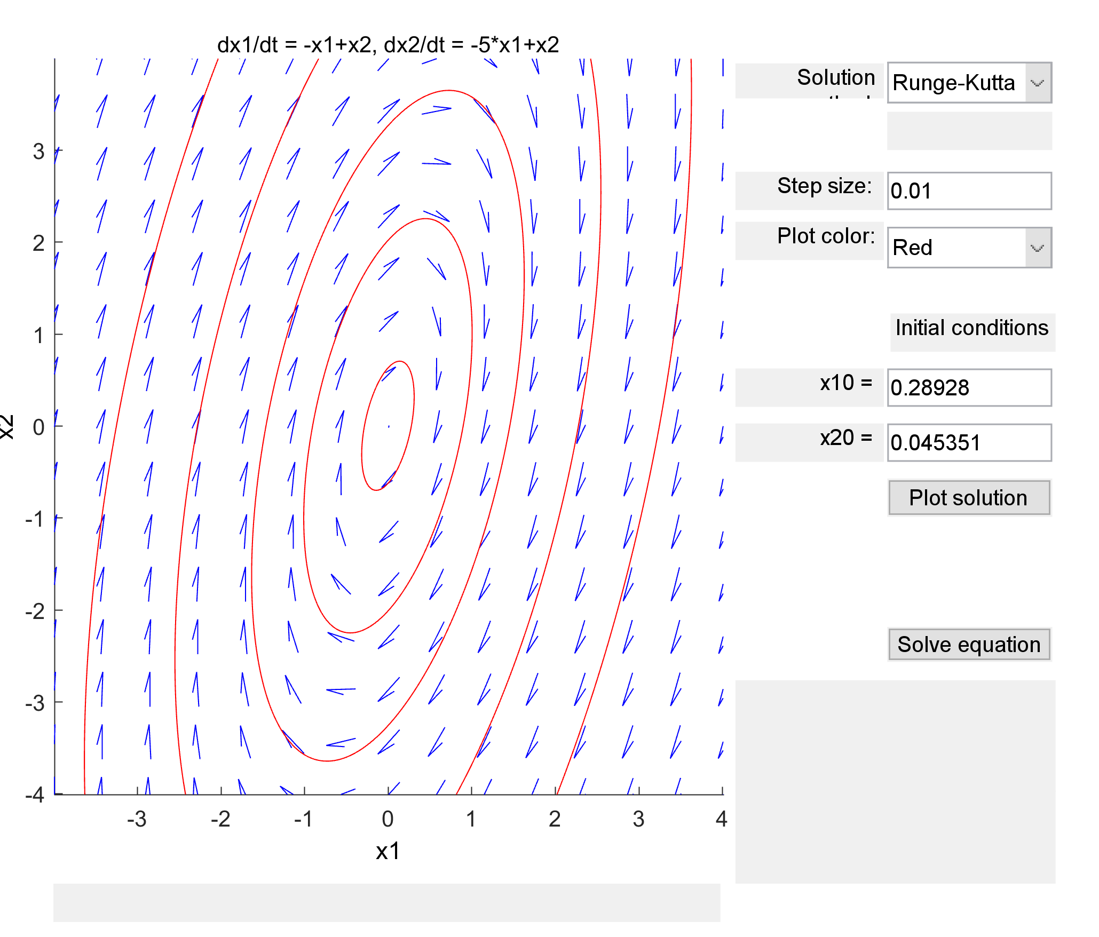

c) This is a stable center point moving in clockwise direction

d)

Since the eigenvalue is purely imaginary, it must be a stable center point.

4.8 |dx/dt = [1 -1; 5 -1] x|

a) Equilibrium solution at x1 = 0, x2 = 0

b)

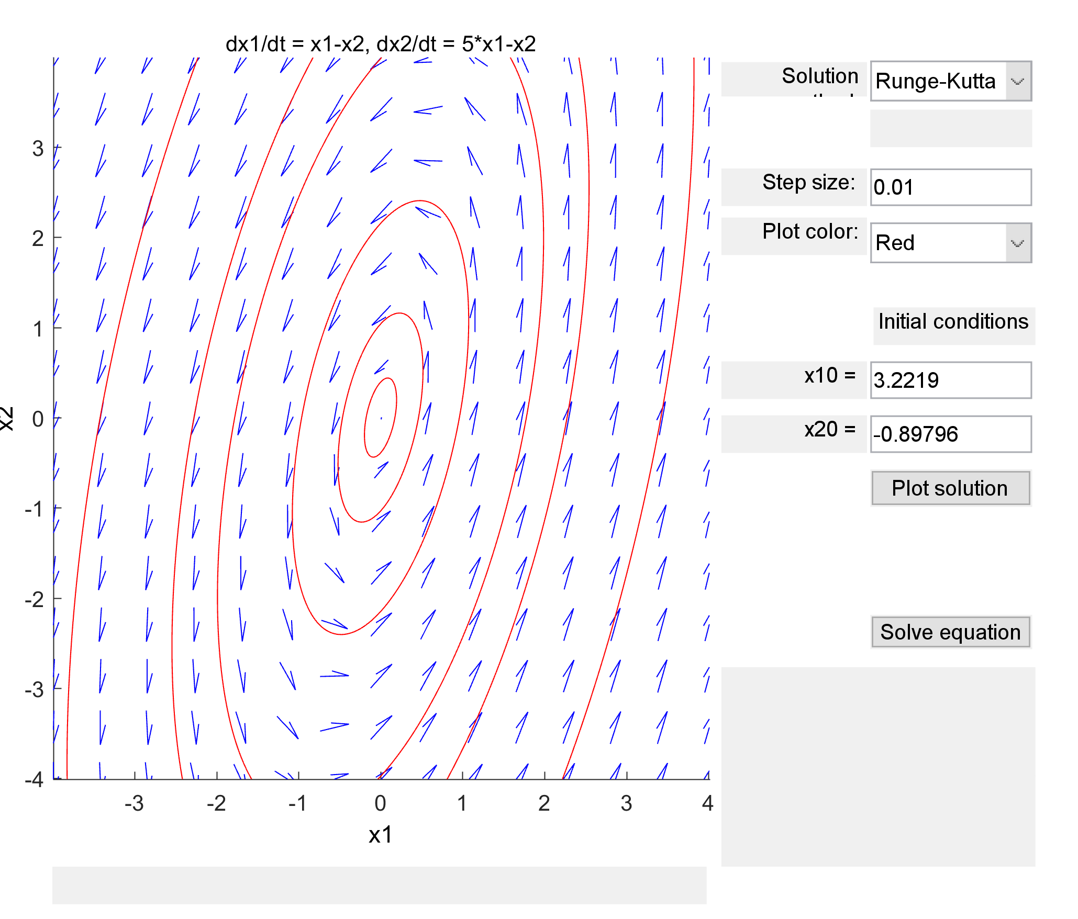

c) This is a stable center point with counter clockwise direction

d)

Since the eigenvalue is purely imaginary, it must be a stable center point.

4.9 |dx/dt = [13 6; 3 20] x|

a) Equilibrium point at x1 = 0, x2 =0

b)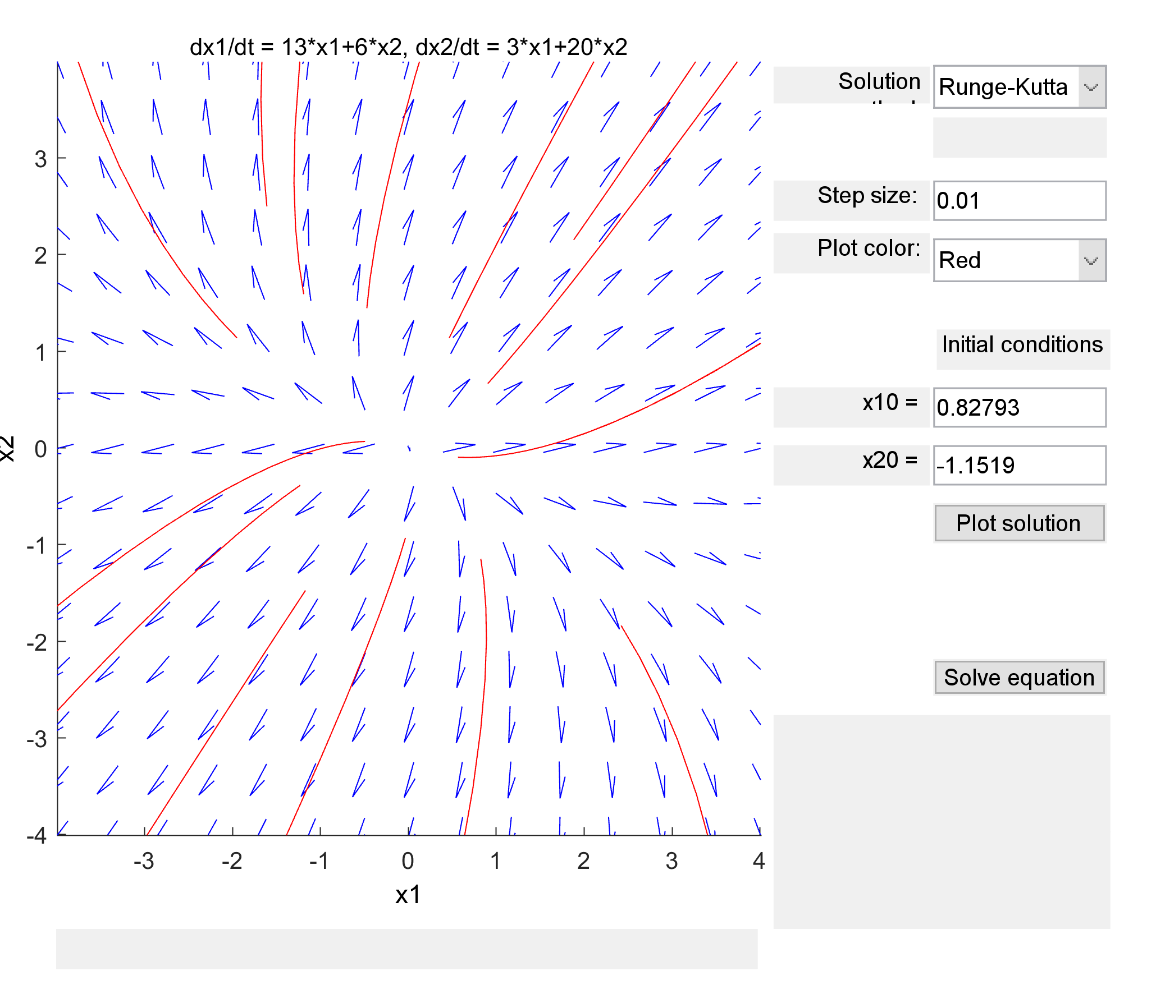

c) This is an unstable node.

d)

Since both eigenvalues are greater than zero, it must be an unstable node.

4.10 |dx/dt = [-13 -6; -3 -20] x|

a) Equilibrium point at x1 = 0, x2 = 0

b)

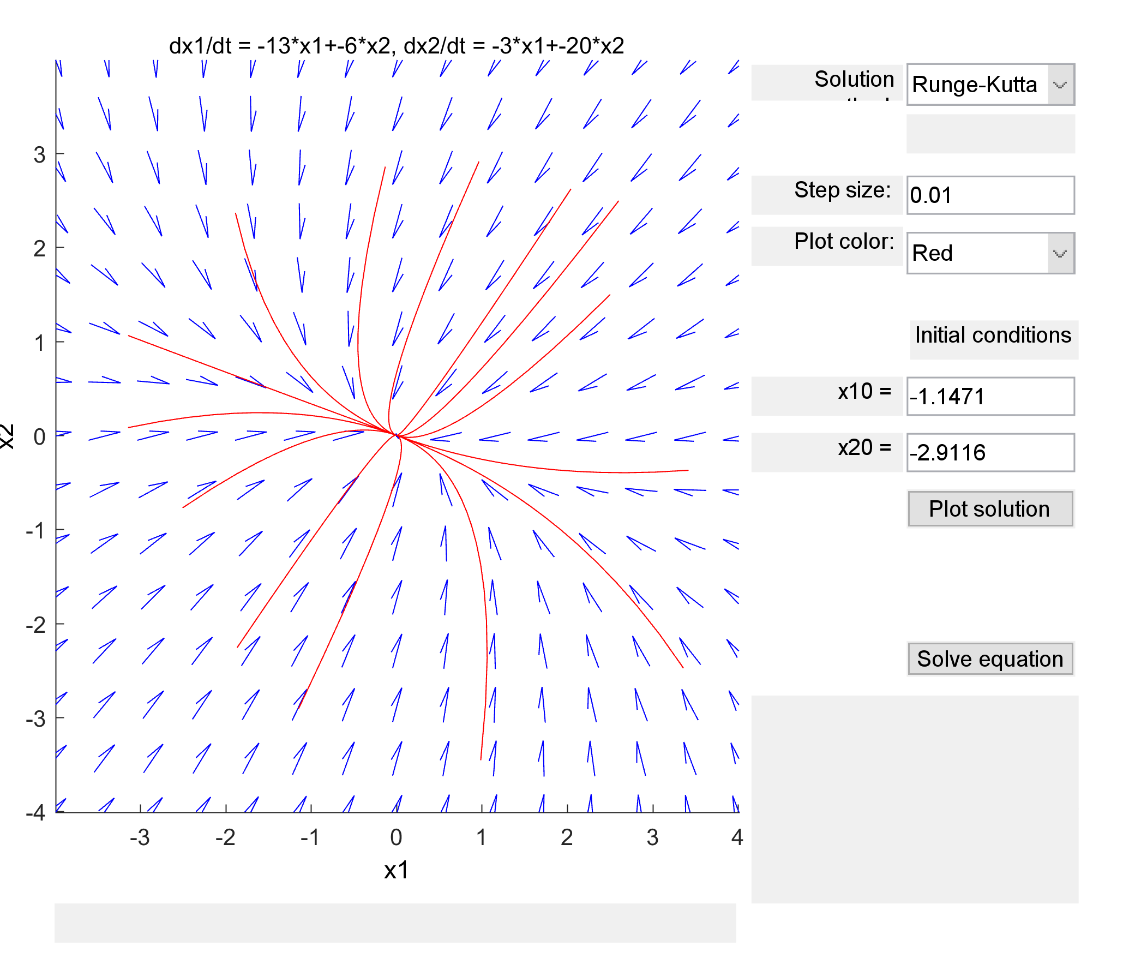

c) This is an asymptotically stable node.

d)

Since both eigenvalues are below 0, the equilibrium point must be an asymptotically stable node.