# Exercise 1

a)

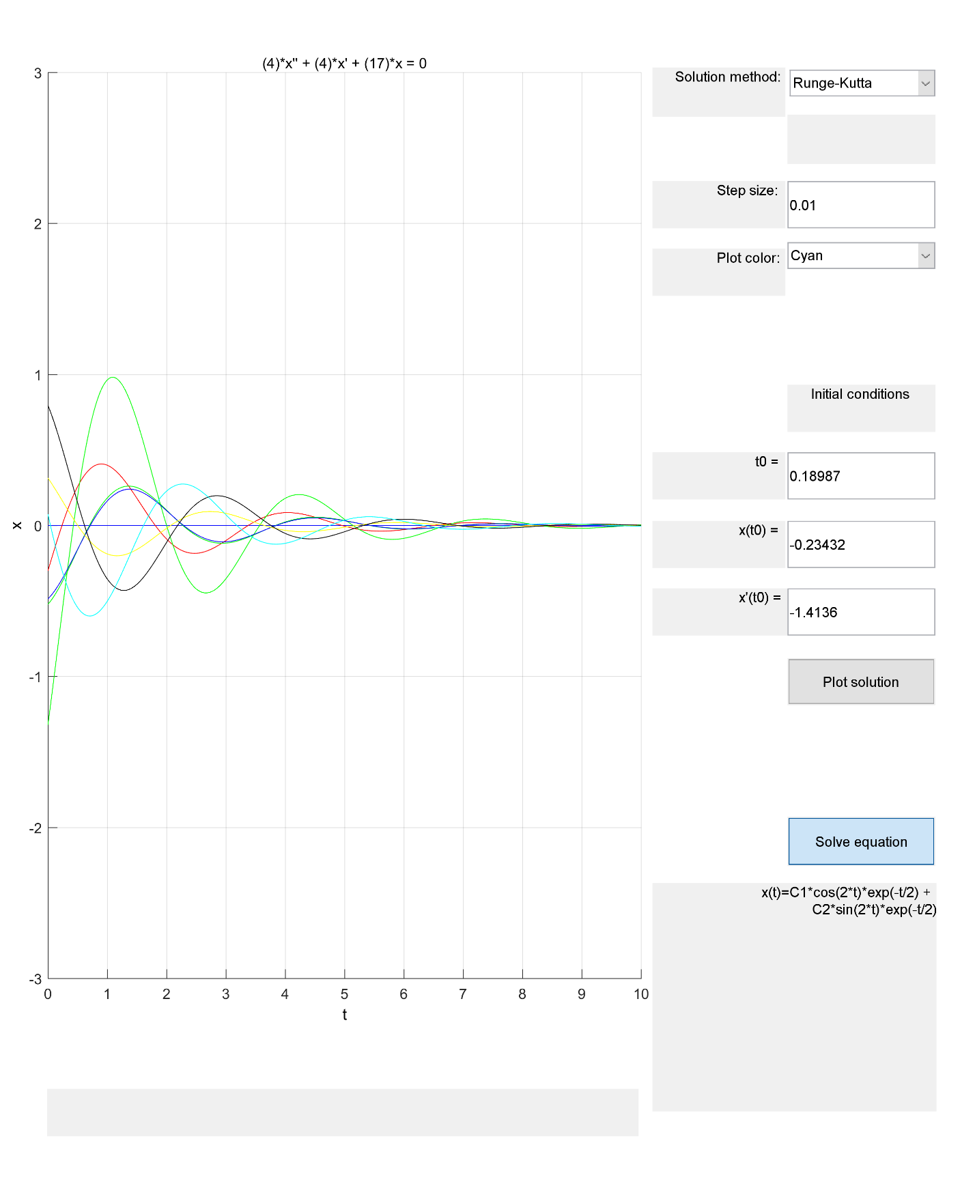

Each of the 6 solutions decays while oscillating.

b) 100% of solutions decay while oscillating.

c)

Solution is x(t) = c1*e^(-t/2)*cos(2t) + c2*e^(-t/2)*sin(2t). This makes sense because this system will always decay if it is oscillating.

# Exercise 2

a)

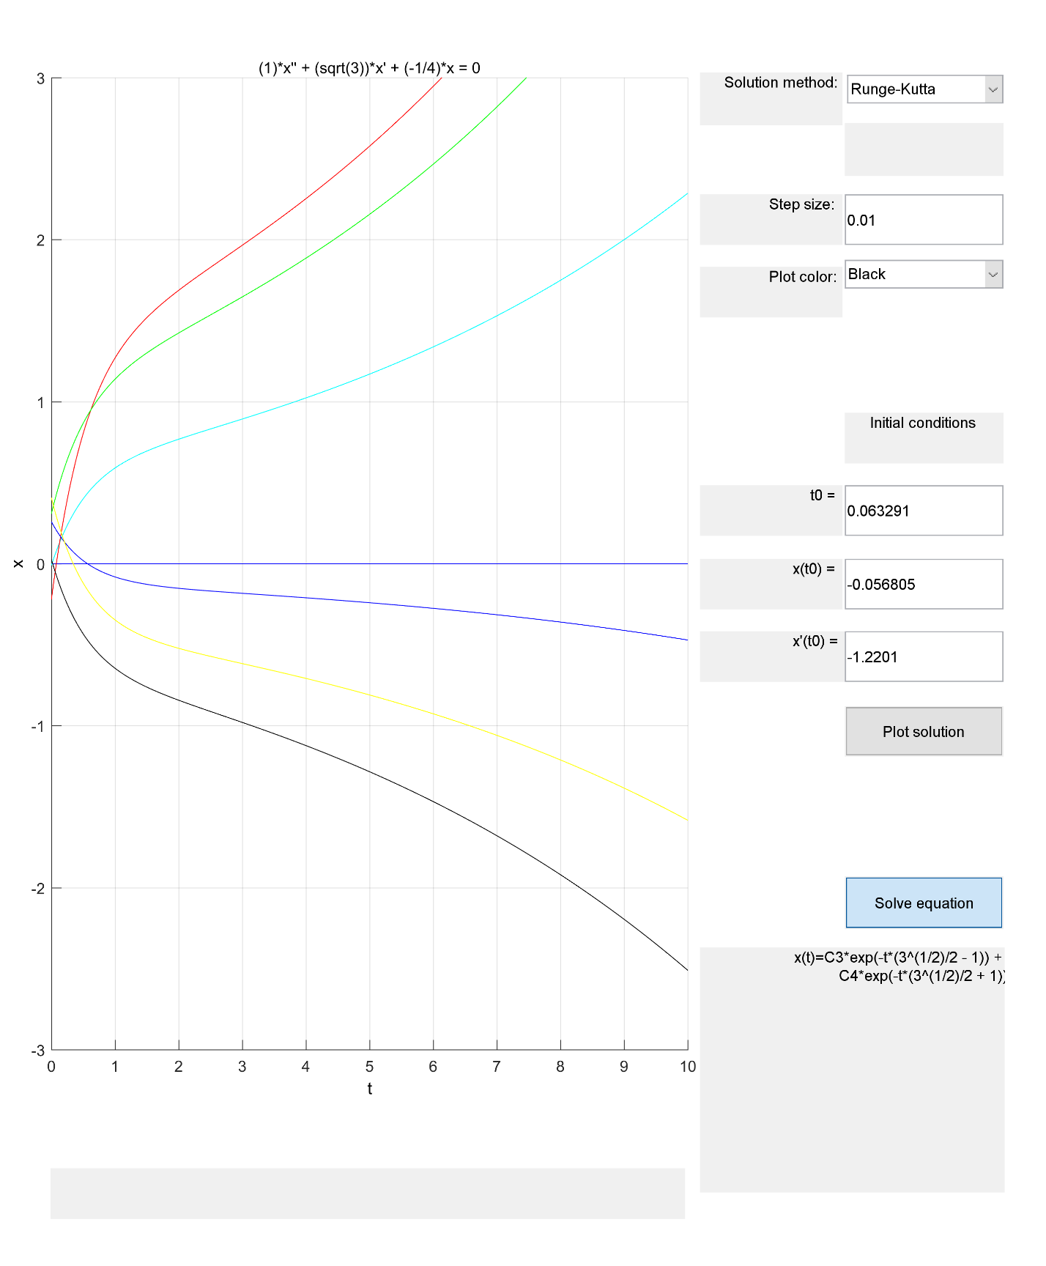

Each of the 6 solutions grow.

b) 100% of solutions grow.

# Exercise 3

a)

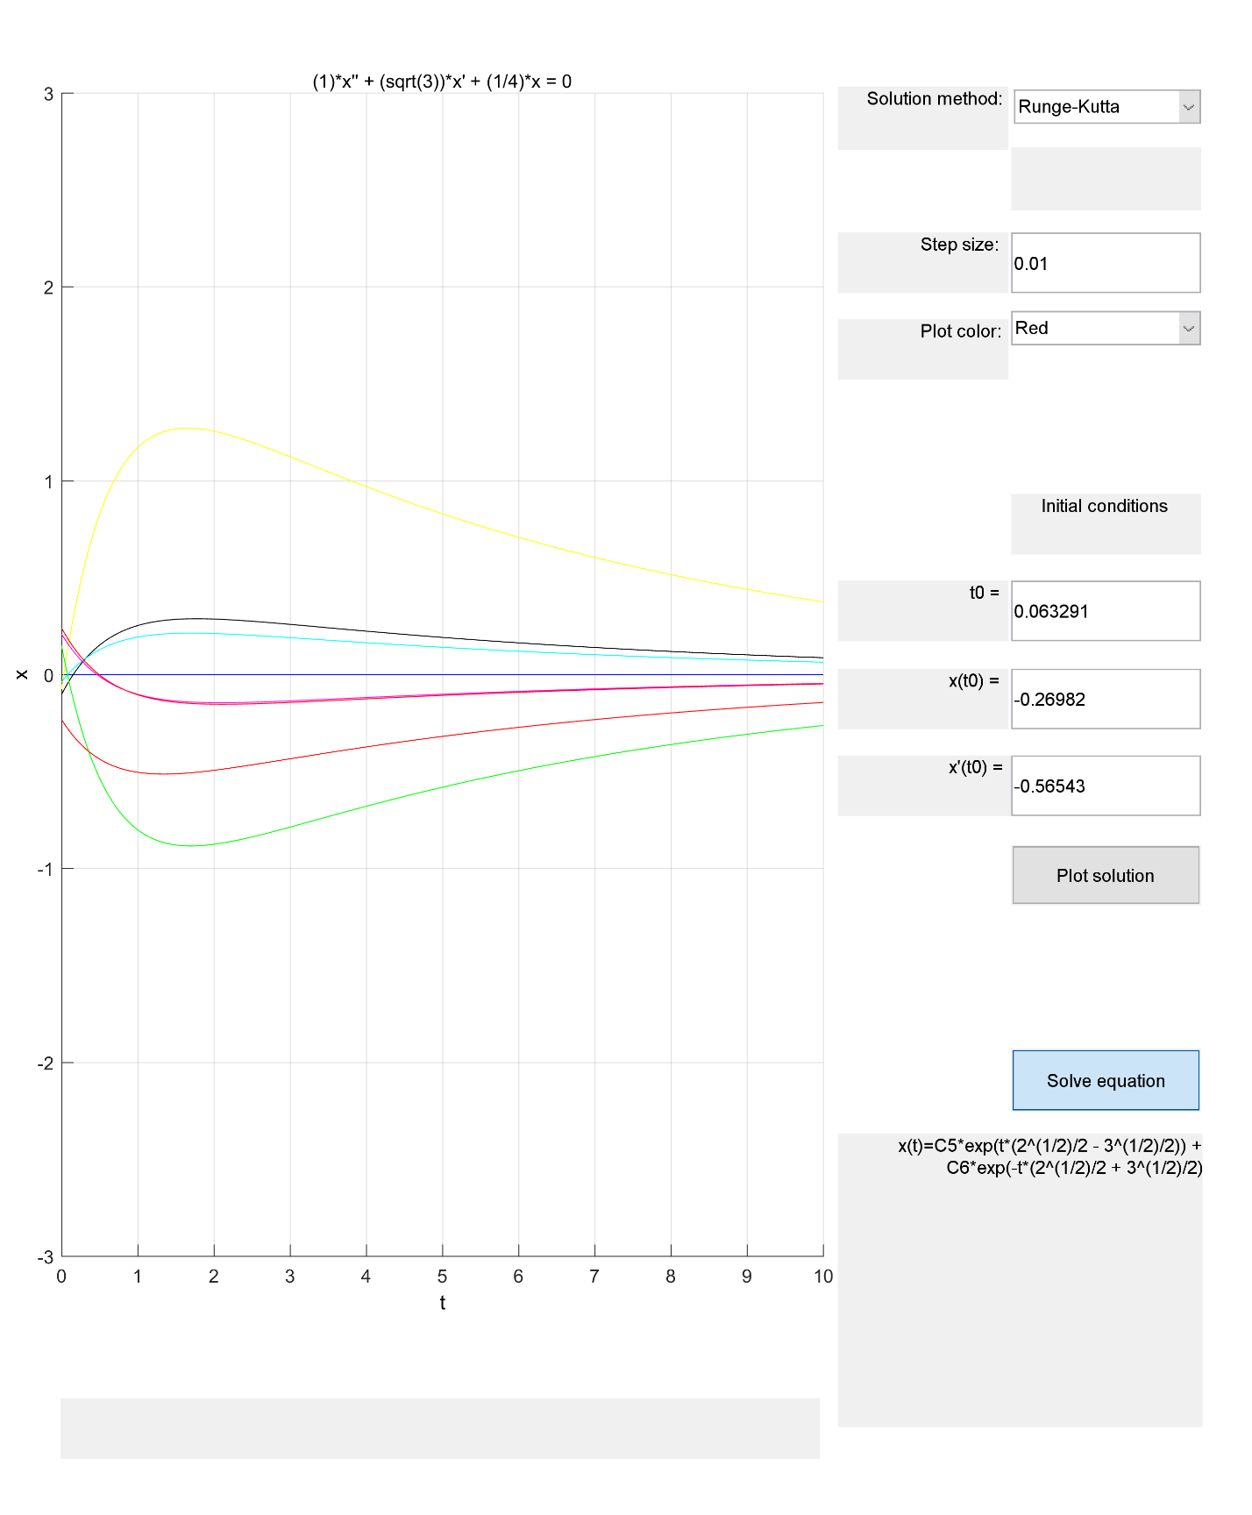

Each of the 6 solutions are decaying.

b) 100% of the solutions are decaying.

# Exercise 4

a)

$$y\left(t\right)=c_{1}e^{-t}\sin\left(2t\right)+c_{2}\sin\left(t\right)+c_{3}e^{-t}\cos\left(2t\right)+c_{4}cos⁡(t)$$

b)

If c2 and c4 are equal to zero, the solution will decay while oscillating. Otherwise if c2 and c4 are both not equal to zero, the limit of the solution as t 🡪 infinity is neither decaying or growing, it is just oscillating.

Since c2 and c4 must be fixed to zero, while c1 and c3 can be anything for the solution to decay while oscillating, while c1, c2, c3, and c4 can be anything for the solution to simply oscillate, the probability for the solution to decay is much lower than the solution to oscillate as t 🡪 infinity. For this reason, I will estimate a 1% probability for the solutions to decay while oscillating, 0% for solutions to grow, grow while oscillating, or decay.

# Exercise 7

