Joshua Tan

CS 383 Assignment 1

**Quick Start**

Welcome to my version of Pong! This document will provide you with the steps needed to get the game up and running.

1. Download the Zip file containing the code from BBlearn.

2. Extract the Zip file into an easily accessible directory. I would recommend your desktop.

2a. Open the game by double clicking on “Pong Clone.exe”. Good luck and have fun!

2b. Open Unity, if you do not have Unity installed, Unity installation directions are included below

3. Click on the open option on the toolbar and select the “Pong” folder you extracted earlier.

4. On your keyboard, press CTRL+B to build and run the program. Alternatively, you can find this option in the “File” option of the toolbar.

5. Change your settings in the window that appears, or simply press the “Play!” button.

6. The game will boot up and begin playing. Good luck and have fun!

**Installing Unity**

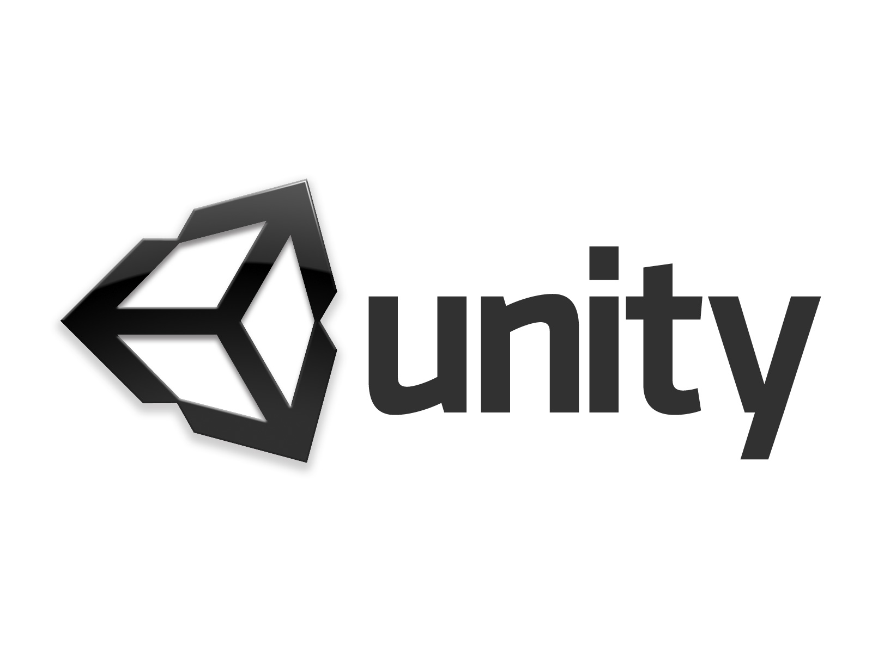

1. Navigate to <https://store.unity.com/download>.

2. Check the box to accept the terms and conditions. This will allow you to click on the “Download Installer for Windows” button. Click on the link “Choose Mac OS X” if you are using that system.

3. Go to “Downloads” on your computer and look for the Unity installer. Once you find it, right-click it and select “Run as an administrator” (This step applies for Windows users. If you are using a mac, just run

open the file as usual)

4. Follow the steps as prompted by the installation wizard.

5. Once finished, you may have to reboot your computer. After that you are ready to start on the instructions above at part 2b.