Kubernetes

Multiple Vm Machines with Vagrant

Can you spin more than one server using vagrant?

The path – vagrant folder ( desktop)

PS C:\Users\Forex\OneDrive\Desktop\Worker_Node 1 -Josh>

$ vagrant destroy <VM-name>

$ vagrant up

Now SSH in to the guest machine with command:

$ vagrant ssh

Install Apache webserver in it. If the VM is Deb-based, run:

$ sudo apt install apache2

If it is RHEL-based system, run this:

$ sudo yum install httpd

Start Apache service:

$ sudo systemctl enable --now httpd

Terraform is working now on windows

Revise Docker – 30 Minutes

Revise Docker-Compose – 30 Minutes

Kubernetes Concept

Before Kubernetes, company used to have what we call monolithic application.

Let take an example of Geico which has many applications.

<https://www.geico.com/>

For instance, in the above, the SNS, Payments etc all were located in the same server.

If you wanted to make a change in any of the application, I have to work on the main code containing all the applications.

This was not effective because in most cases, while making the changes some functions will likely stop working.

No interaction was available among the applications. For instance on AWS, EC2 can interact using EFS while in different availability zone.

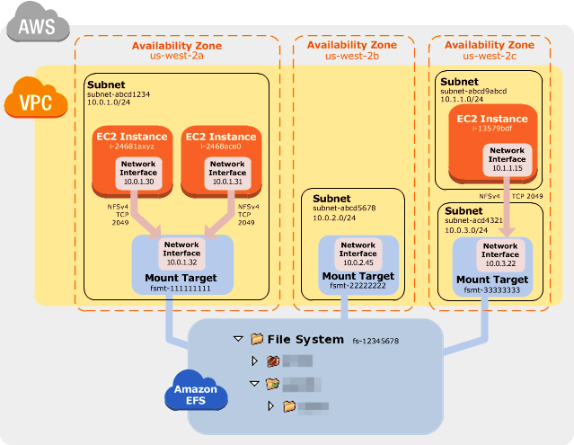

There was a huge dependency among the applications because they were all in the same one main code base.

How was this issue solved?

This was solved using microservices.

This is the ability to deploy services separately and ensuring each service has its own code service.

Meaning each service is deployed in different a server.

Communication is done using Json, a where each server sends files to other and messages generated can be shared among the application.

The issue of dependency was completely solved.

The issue of communication among the application was also solved.

With microservices, it became easier to make the necessary changes without affecting the rest of the application.

<https://www.geico.com/>

Challenges of Microservices

Although microservices solved the dependency, functionality, and communication issues, it became obvious that deploying each service on a separate server was going to be a challenge.

This means, having servers for the following microservices:

* Mail Server
* Payment Server
* Location Server
* Customer Service server
* Notifications Server
* Passenger Management Server

This is a great way to distribute the services.

However, scaling became an issue. This is because some services may not require the entire server to function while others needed more than one server.

Again, it became impossible to deploy anything else in the server because each server is occupying the entire server.

There were issues with over and under utilization of the servers.

Downscaling became a problem for the servers that are being underutilized because at the end of the day, each service must occupy an entire server.

Upscaling was okay, because you could just add more servers, but downscaling became the main challenge.

Upscaling could be done with just adding another server. Even after adding the second server, the underutilization was still an issue.

This issue of underutilization pf the server was solved using Docker.

Docker give each service a different environment.

These services could be dockerized to exist in one server and still be in their own standardized and unique environment.

This also brought another advantage because the only way the services will be down is if the entire server fails.

An example of a docker application structure

* Ubuntu – mail
* Centos6 – Notifications
* Centos7 – Payment
* Redhat – location services etc

All running on the same system

The issue of underutilization was solved

Upscaling is also not an issue because you could add containers if wanted. (Docker Compose)

Good job, we have containerized all the applications and they are now independent from each other, can scale, underutilization issue has been solved and we are good to go.

**Another problem Arises**

Many companies have many microservices

Google can have over 500 microservices

Geico can have over 300 microservices

Amazon can have over 10000 microservices

This means containerizing 10,000 services which is not an issue.

Who is going to manage 10,000 containers to ensure the following:

* Assessment of the containers to make sure they are fine
* The health check of the container?
* If one container goes down, how do I monitor that?
* If one container goes down, how do I know which one it is?
* If I know which one it is, how do I deploy another one?

This is where Kubernetes orchestration tool came in.

You can also use Docker Swarm

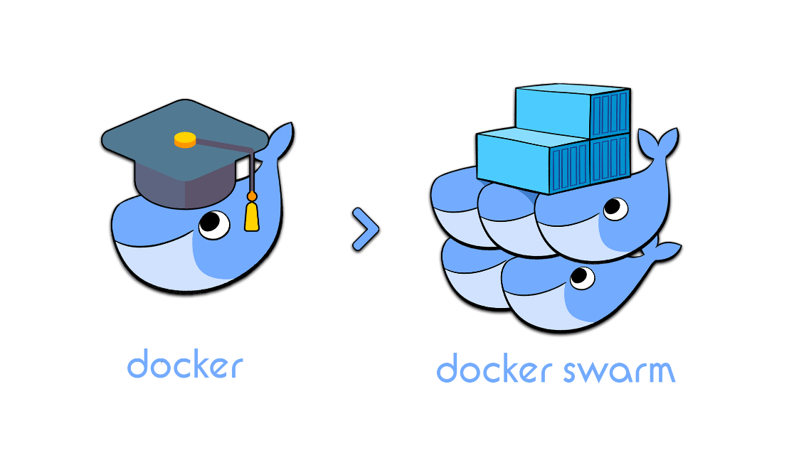

However, Kubernetes has way more services than any other container orchestration tool that is out there.

A lot of options and flexibility while using Kubernetes.

Without Kubernetes, you have to manually go and scale the containers in accordance to the load size.

You also must manually remove or add containers

Somebody must monitor the containers performances manually.

It was very difficult to even know how many containers are running in each node.

Kubernetes manages all containers – You do not have to worry about managing containers as Kubernetes will do it. Scaling will be taken care. You just launch the new deployment with number of containers specified and Kubernetes will take care of everything.

Resources usage was also taken care of. You can define how much resources each container should use and if it goes beyond the defined resources, Kubernetes will launch a new container.

Networking – All containers in Kubernetes cluster can interact as if they are in one network regardless of them being in 100 different nodes.

Rolling updates on the applications or containers is very easy. You can do that using blue-green features in Kubernetes.

Load balancing is another feature of Kubernetes – When having a replica of the containers inside the node, you can balance the load accordingly.

Health check – Kubernetes is self-healing. It checks the health of the containers and if one is not working accordingly, it will launch another healthy container and therefore there is never a downtime.

It is a cluster. You have a master and several nodes

Nodes are the workers

The master schedule deployment of containers, schedule the new containers, monitoring everything and keep track of logs (what needs to be done in the application), while the nodes do the processing of the work that is required by the application. Both the master and the nodes work together, and they act as if they are one system.

You can create a new worker(node) by just using a command through the master.

What is a Pod

A pod is a container.

A single pod has one container.

However, a pod can have more than one container. For instance, there are containers that cannot exist alone.

Like PhP and WordPress Containers.

You can also create a replica in your deployment and a pod can have like 2 to 3 replicas.

You can either deploy a pod or a deployment.

Deployment takes care of the number pods in the cluster.

When you create a deployment, it automatically creates pods in the cluster.

While creating the deployment you specify the image to use, in the container and the pods automatically will be created.

Simply, deployment help us to deploy number of pods and the images to be inside the pods.

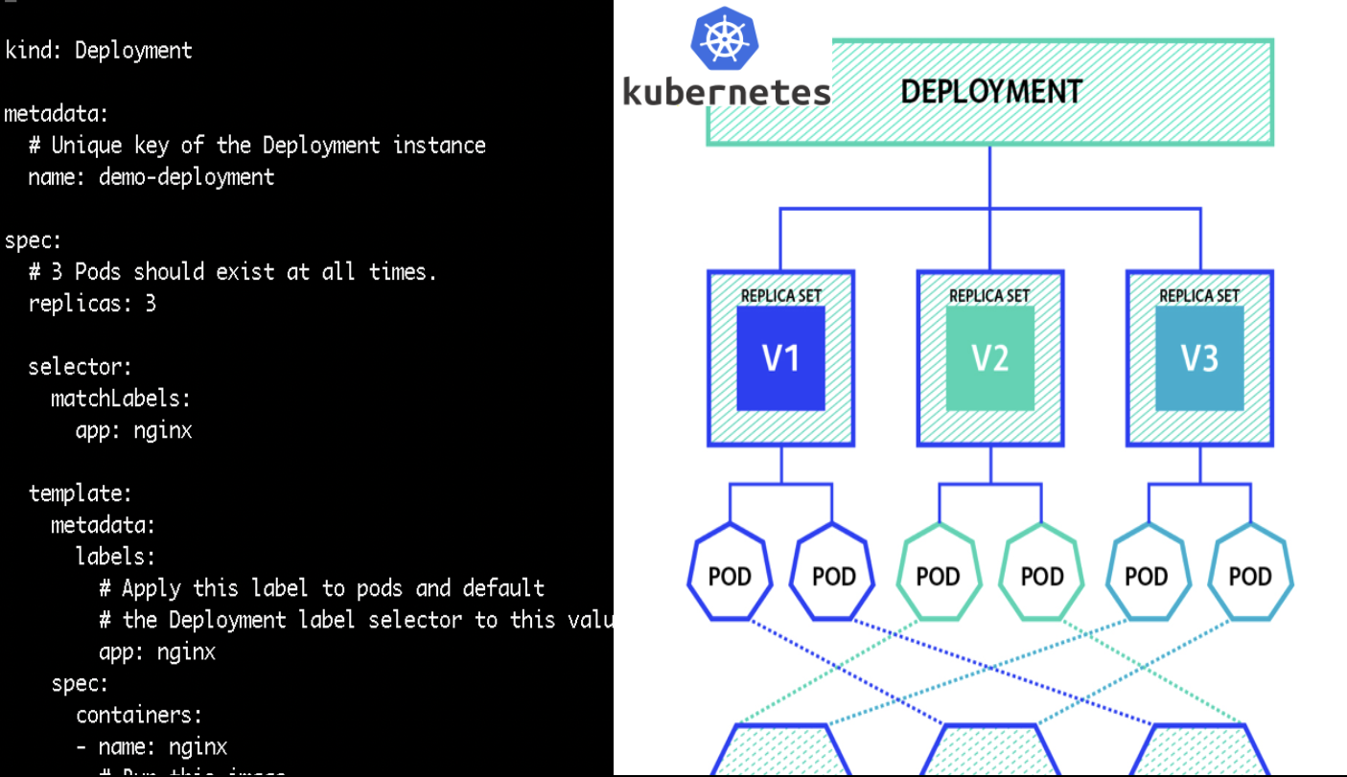

This is a simple deployment

Simply, in deployment you must have

* Number of pods
* Number of Replica
* The image to be in each pod

The Kubernetes is always in the server.

How will a user access an application that is inside the pod in Kubernetes cluster?

Let say geico is in pods in Kubernetes cluster

As a user, you will click geico.com on the web browser, which will be pointing to a server that will be having the application. However, the application will be inside a pod and also inside the replica if specified in the deployment.

The information a user requires can be accessed through any of the IP addresses available on the master or the nodes.

However, you cannot access the Kubernetes cluster (master or the pods) directly.

This is where the importance of the service comes in.

What is a service?

A service is an internal load balance for all the pods that are running.

Types of Load Balancers

* Application Load Balancer
* Network Load Balancer
* Classic Load Balancer
* Gateway Load Balancers

In each deployment there is a service. The service work is just to expose the pods to the users on the web browser.

A problem

Although all the pods **have the same application**, how does the SERVICE know which pod to send the request?

First time request will be distributed randomly.

However, as the requests increase, the service will choose which pods is less active and that where the request will be sent to, for load balancing purpose.

You go on web browser and you send your request

The domain name (Ip Address) will be pointing to the service which will distribute the load to different pods.

Another problem

What if you want to access information from geico/car insurance and then from Geico/boat insurance?

These are two different services that will be contained in two different pods.

How does the service know which pod to send the request in the cluster?

Ingress is the solution.

It will direct the request to the correct service.

Geico.com/car insurance

Geico.com/boat insurance

Ingress will receive your request through the Url and determines which service to send the request to.

Sime hands on

* Any bear metal servers – Any generic server – For instance, a server on Virtual machine-like centos, Ubuntu
* Minikube – virtualized environment – everything is done for you and is great to practice Kubernetes commands.
* Kops – shortcut for installing Kubernetes on aws but only limited to aws and do not have instances that fall under the free tier account.
* Kubernetes on GCP – This is the easiest way to practice Kubernetes. Remember Kubernetes is a product of google. It will work like a charm on GCP.

Install Minikube and Kubectl on Ubuntu 20.04

Increase the memory and number of cpus

1. Open Virtual Box.
2. Click the name of the virtual machine that you want to make your CPU available to, then click the "Settings" button at the top of the window.
3. Click the "System" heading on the left side of the Settings window.
4. Click the "Processor" tab at the top of the window.
5. Drag the slider next to "Processor(s)" to the right until the value matches the number of processors or processor cores installed in your computer.
6. Drag the slider next to "Execution Cap" to the right until the value reads "100." This allows VirtualBox to use all of your processor's resources.
7. Click "OK," then double-click the virtual machine to turn it on.

As you can see I have 2 CPUs

What you will need to install minikube

* 2 CPUs or more
* 2GB of free memory
* 20GB of free disk space
* Internet connection
* Container or virtual machine manager, such as: [Docker](https://minikube.sigs.k8s.io/docs/drivers/docker/), [Hyperkit](https://minikube.sigs.k8s.io/docs/drivers/hyperkit/), [Hyper-V](https://minikube.sigs.k8s.io/docs/drivers/hyperv/), [KVM](https://minikube.sigs.k8s.io/docs/drivers/kvm2/), [Parallels](https://minikube.sigs.k8s.io/docs/drivers/parallels/), [Podman](https://minikube.sigs.k8s.io/docs/drivers/podman/), [VirtualBox](https://minikube.sigs.k8s.io/docs/drivers/virtualbox/), or [VMware](https://minikube.sigs.k8s.io/docs/drivers/vmware/)

Let install the minkube

<https://www.youtube.com/watch?v=hg1OCbVhuNw>

https://kubernetes.io/docs/tasks/tools/install-kubectl-linux/#install-kubectl-binary-with-curl-on-linux