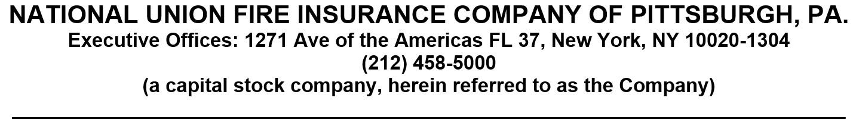

Policyholder: {$data.account.data.firstName} {$data.account.data.lastName}
Quote Number: {$data.quoteNumber}
SEAT BELT [[AND AIR BAG]] BENEFIT RIDER
This Rider is attached to and made part of the Policy [[as of the Policy Effective Date shown in the Policy’s Master Application]][[ effective [[Month Day, Year]]. It applies only with respect to accidents that occur on or after that date. ]] It is subject to all of the provisions, limitations and exclusions of the Policy except as they are specifically modified by this Rider.
Seat Belt Benefit. The Company will pay 100% of the appropriate Maximum Amount under this Rider when the Insured suffers accidental death such that an Accidental Death benefit is payable under the Policy and the accident causing death occurs while the Insured is operating, or riding as a passenger in, an Automobile and wearing a properly fastened, original, factory-installed seat belt.
[[Air Bag Benefit. The Company will also pay 100% of the appropriate Maximum Amount under this Rider if a Seat Belt Benefit is payable under this Rider and if the Insured is positioned in a seat protected by a properly functioning, original, factory-installed Supplemental Restraint System that inflates on impact.]]
Verification of the actual use of the seat belt, at the time of the accident,[[ and that the Supplemental Restraint System inflated properly upon impact]] must be a part of an official report of the accident or be certified, in writing, by the investigating officer(s).
Automobile - as used in this Rider, means a self-propelled private passenger motor vehicle with four or more wheels which is of a type both designed and required to be licensed for use on the highways of any state or country. Automobile includes, but is not limited to, a sedan, station wagon, or jeep-type vehicle and, if not used primarily for occupational, professional or business purposes, a motor vehicle of the pickup, panel, van, camper or motor home type. Automobile does not include a mobile home or any motor vehicle which is used in mass or public transit.
[[Supplemental Restraint System - as used in this Rider, means an air bag which inflates for added protection to the head and chest areas.]]
The President and Secretary of National Union Fire Insurance Company of Pittsburgh, Pa. witness this Rider:
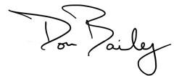 | 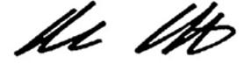
President | Secretary

