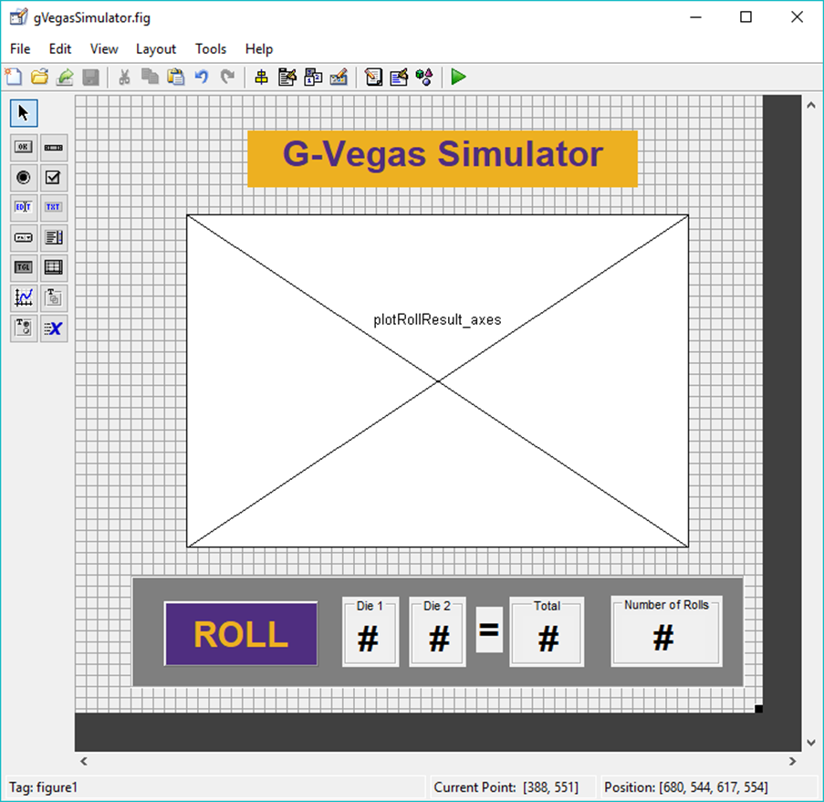

**A**

**B**

**E**

**F**

**G**

**H**

**C**

**I**

**J**

**K**

**L**

**M**

**D**

1. title_text
2. plotRollResult_axes
3. dieControl_panel
4. roll_pushbutton
5. die1_panel
6. die2_panel
7. dieTotal_panel
8. numRolls_panel
9. die1value_text
10. die2value_text
11. equals_text
12. dieTotal_text
13. numRolls_text