Name: Joshua Layne

ID#: 400014516

**Screenshots:**

**Screenshot 1:**

Figure : Screenshot1

**Screenshot 2:**

**Screenshot 3:**

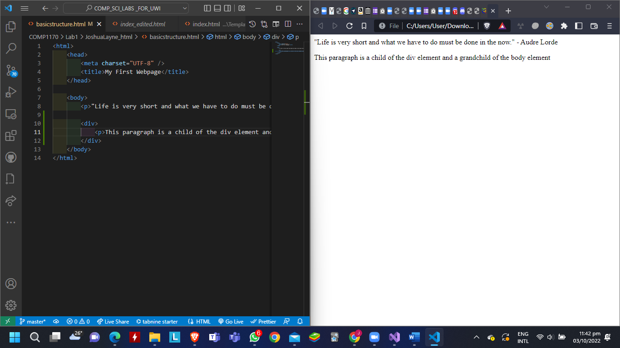

**Screenshot 4:**

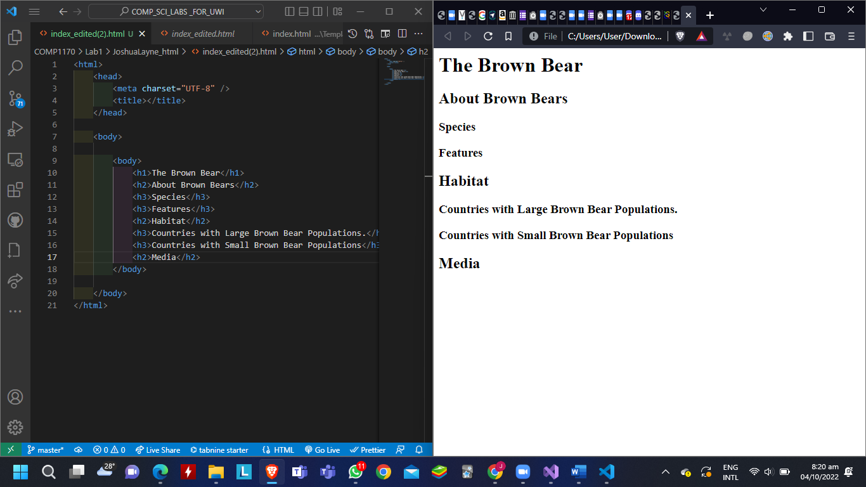

**Screenshot 5:**

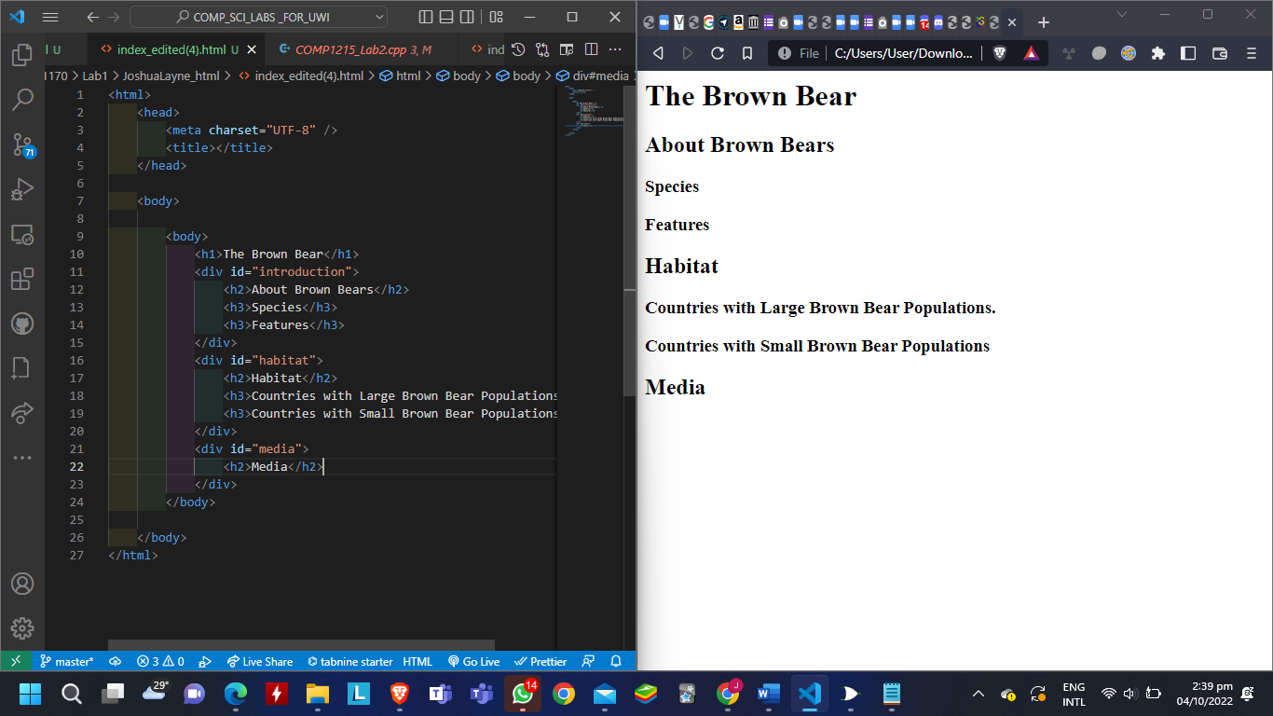

**Screenshot 6:**

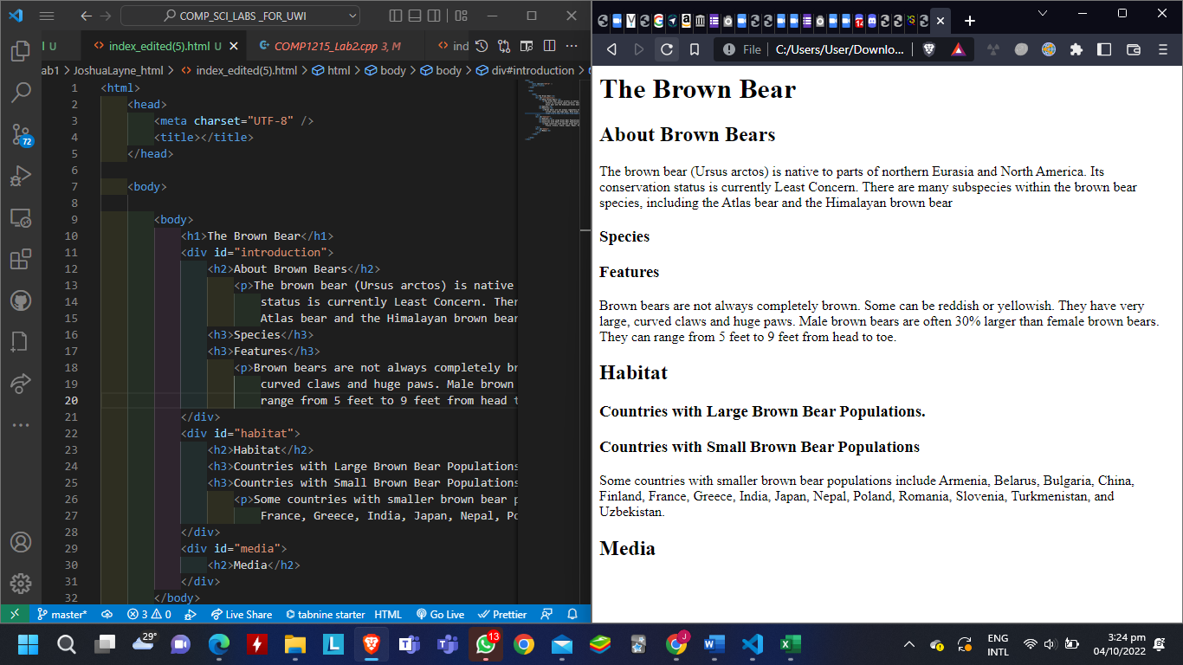

**Screenshot 7:**

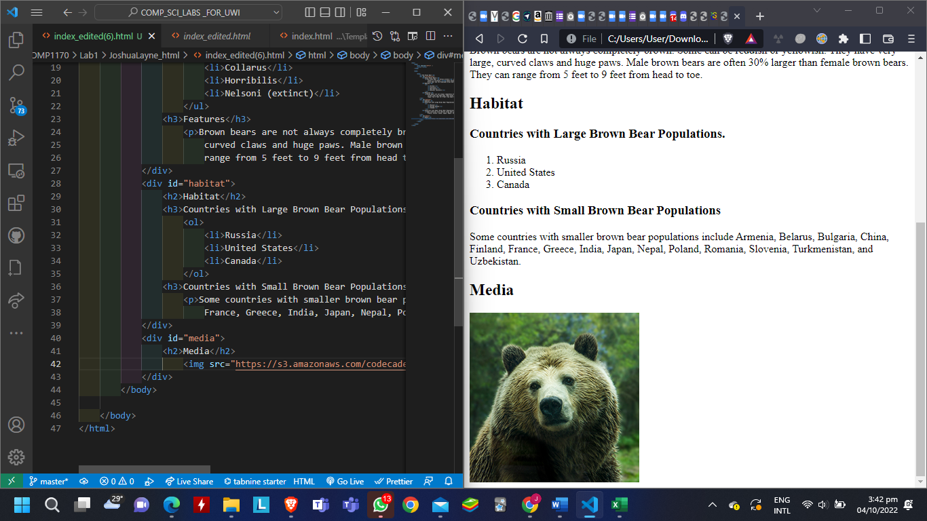

**Answers to Questions:**

Exercise 1:

1. It could be any information, text, or other elements between the tags.
2. No, they do not count as content.
3. 1. A – opening tag
   2. B – closing tag
   3. C – content
   4. D – element

Exercise 2:

1. Yes because it is an element within another element.
2. To place the paragraph in a separate section from the rest of the body.
3. They can inherit behaviour and styling from their parents

Exercise 3:



1. They are used to group elements together by dividing the web page into sections.

Exercise 4:

1. No, the “id” attribute may be used with other elements like img and button to give them an ID.
2. Attributes may be used to provide information, change style or embed content.
3. Other attributes are the:
   1. size attribute for font
   2. href attribute for the “a” element
   3. src attribute for the “img” element

Exercise 5:

1. span is used to separate text that is inline from other text on the same line.
2. Content that is inline is limited to that particular line while blocks of content can span the space of multiple lines of code.
3. So we could apply different effects to certain pieces of text separate from the rest of the text.
4. See above.

Exercise 6:

1. The text appears with the same indent as the list but as plain, unlisted text.
2. No, it does not

Exercise 7:

1. Yes, it can contain other things than text
2. No, one can use other things like letters.

Exercise 8:

1. Because it being there instructs the browser to include video controls
2. Yes, we can.