* TE: Tris10ph8 EDTA7mM
  + EDTA binds calcium/magnesium
* TE’: Tris10ph8 EDTA10mM
* Free Mg = Mgin – EDTA
* Binding constant for Mg/EDTA: 10-6
* DNA conc unit = copies

Cp/ct/cq

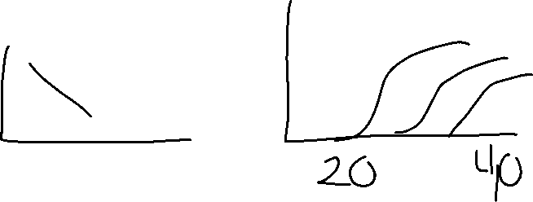

copies

* Higher cp = less copies
* Cp = crossing point
* K = input DNA\*efficiencycp
  + Eff =# copies/cycle